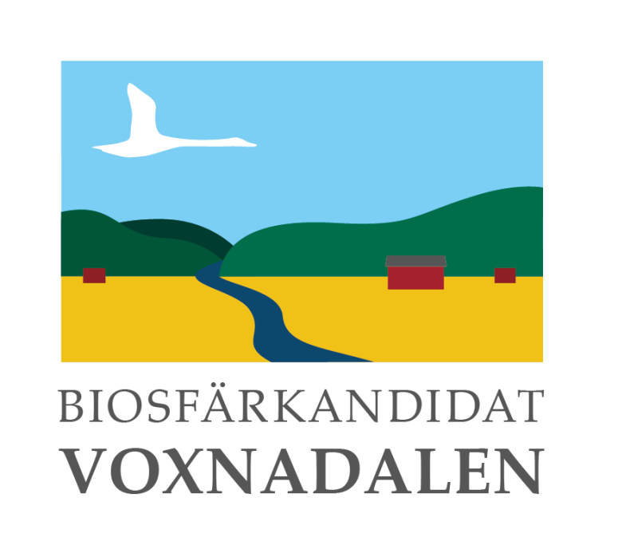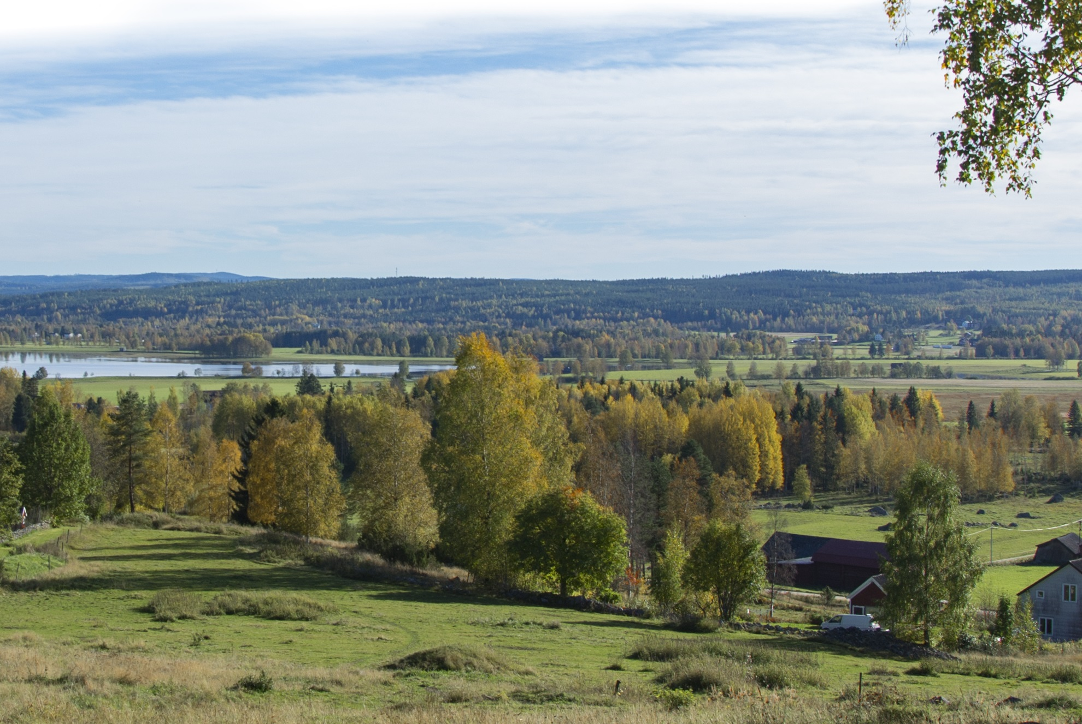
pag Nomination to UNESCO for Biosphere Reserve status of Voxnadalen, Sweden, 2018

pagImprint
________________________________________________________________________
Application documents and contact details are available on our website:
www.voxnadalen.org

Editors:
Hanna Alfredsson (Coordinator Biosphere Candidate Voxnadalen)
Fia Johannessen (Ovanåker Municipality)

Authors:
Hanna Alfredsson (Coordinator Biosphere Candidate Voxnadalen), Katarina Eriksson (Balder Arkeologi), Olle Berglund (Biosphere Coordination Office), Jens Hansen (former coordinator Biosphere Candidate Voxnadalen), Fia Johannessen (Ovanåker Municipality), Daniel Jansson (Bollnäs Municipality), Kent Hägg (Swedish Forest Agency), Jan Hedman.

Maps:
Annika Ottenbäck, Jens Olsson, Marie Eriksson and Fia Johannessen (all Ovanåker Municipality)

Photograph on front cover:
View over Lake Sässman. Photography: Jonas Löf.

_________________________________________________________________
Acknowledgements
We are grateful to EVERYONE who has contributed ideas or expertise, provided inspiration or taken time to give us their views on the two draft documents. Your help has improved the application immensely. Our thanks also to Edsbyn Photography Club for providing photos for the application.

INTRODUCTION
Biosphere reserves are areas of terrestrial and coastal/marine ecosystems, or a combination thereof, which are internationally recognized within the framework of UNESCO’s Programme on Man and the Biosphere (MAB) They are established to promote and demonstrate a balanced relationship between humans and the biosphere. Biosphere reserves are designated by the International Coordinating Council of the MAB Programme at the request of the State concerned. Individual biosphere reserves remain under the sovereign jurisdiction of the State where they are situated. Collectively, all biosphere reserves form a World Network in which participation by States is voluntary.
The World Network is governed by the Statutory Framework adopted by the UNESCO General Conference in 1995 which presents the definition, objectives, criteria and the designation procedure for biosphere reserves. The actions recommended for the implementation of biosphere reserves are set out in the "Seville Strategy" and were further developed in the Madrid Action Plan (2008-2013). These documents should be used as basic references for the completion of this nomination form.
The information presented on this nomination form will be used in a number of ways by UNESCO:
[label=)]
1. for examination of the site by the International Advisory Committee for Biosphere Reserves and by the Bureau of the MAB International Coordinating Council;
2. for use in a world-wide accessible information system, notably the UNESCO-MABnet and publications, facilitating communications and interaction amongst persons interested in biosphere reserves throughout the world.
The nomination form consists of three parts:
Part one is a summary indicating how the nominated area responds to the functions and criteria for biosphere reserves set out in the Statutory Framework, and presents the signatures of endorsements for the nomination from the authorities concerned. Part two is more descriptive and detailed, referring to the human, physical and biological characteristics as well as to the institutional aspects. Part three consists of two annexes: the first annex will be used to update the Directory of Biosphere Reserves on the MABnet, once the site has been approved as a biosphere reserve. The second annex will be used to provide promotional and communication materials of the biosphere reserve. Tables, illustrations and maps as appropriate throughout the nomination form are welcomed.
The form should be completed in English, French or Spanish. Two copies should be sent to the Secretariat, as follows:
1. The original hard copy, with the original signatures, letters of endorsement, zonation map and supporting documents. This should be sent to the Secretariat through the Official UNESCO channels, i.e. via the National Commission for UNESCO and/or the Permanent Delegation to UNESCO;
2. An electronic version (on diskette, CD, etc.) of the nomination forms and of maps (especially the zonation map). This can be sent directly to the MAB Secretariat:
pag
Contents

Part II
Summary
Chapter 1

Proposed name of the biosphere reserve
Voxnadalen
Chapter 2

Name of the country
Sweden

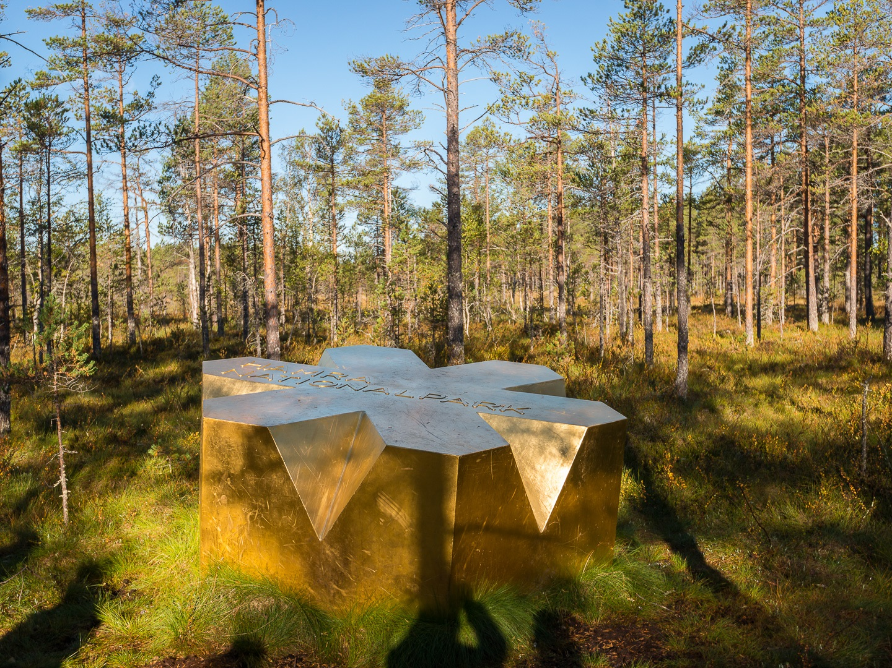
Figure 2.1: Hamra National Park. Photography: Stefan Person
Chapter 3

Fullfillment of the three functions of Biosphere Reserves

3.1 Conservation - contribute to the conservation of landscapes, ecosystems, species and genetic variation.
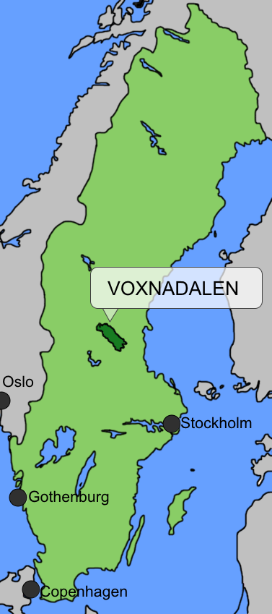
Figure : The location of the planned biosphere reserve in Sweden
The planned biosphere reserve is XXX ha in size and is situated in the northern Scandinavian zone of coniferous forest. Currently, there are relatively few biosphere reserves in this part of the world.
The geographical area of the planned biosphere reserve largely encompasses the catchment area of the River Voxnan and involves two Swedish provinces: Hälsingland and Dalarna (Fig. 3.1). The geographical delimitation is thus largely based on the natural conditions of the area, in contrast to administrative borders. This emphasises that the natural conditions are an essential basis in the sustainable use of the landscape.
Extensive boreal woodlands dominate the north-western and less populated parts, while open farmland is predominant in the south-easterly more densely populated areas. River Voxnan runs through the whole area. The river has its source in the province of Härjedalen and its outflow into the River Ljusnan, corresponding to a total distance of 190 km (Fig. 3.2). Hänvisa till en annan karta där Voxnan syns?

Extensive woodlands
Woodlands cover 80-90% of the planned biosphere reserve. Most of the forests are impacted by humans, mainly through forestry work. Nevertheless, several core areas of the forest remain, chiefly in the form of protected areas. In the older part of Hamra National Park (1382 ha), which was established as early as in 1909, one of the few untouched coniferous forests in mid-Sweden is still standing (Fig. 3.5). Many of the nature reserves and Natura 2000 sites in the planned biosphere reserve contain forests with characteristics of natural woodland, where old pines (Pinus sylvestris) grow, several hundred years of age and scarred by fire; there are old mixed coniferous forests, an abundance of dead wood and many rare species of mosses, lichens, fungi and insects. Some of the insects encountered in the forests of the Grytaberg area (Table 7.2) are only rarely found and registered in other parts of the country. A total of 37 red listed species of insects have been observed in Grytaberg.

Figure 3.2: Mid-Sweden and the outer borders of the planned biosphere reserve

Parts of the woodlands are areas of National Interest for nature conservation and outdoor recreation. This means that the nature and outdoor recreation values of the woodland are estimated to be of weight for the whole country. Specific regulations are stated in Swedish environmental legislation (Section 9.3) concerning areas of national interest for nature conservation and outdoor recreation. In the forests of the area, there are also many cultural heritage sites, remains of the historical use of the forest; these include trapping pits and the bottom layer of old charcoal kilns. The multitude of charcoal production sites illustrate the significance of forest use during the era of iron production and industrial iron mills (Section 9.1).
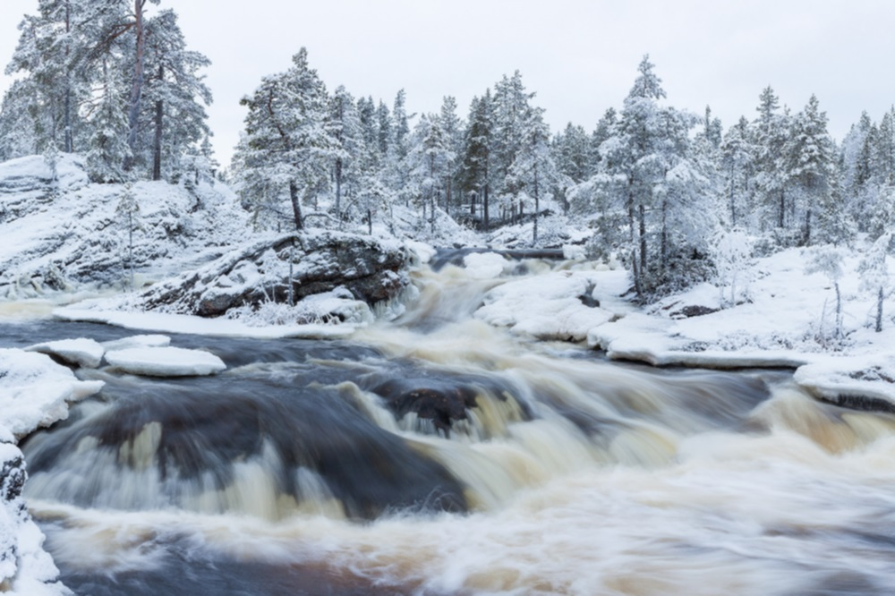
Figure 3.3: A beautiful winter scene at Hylströmmen rapids in the River Voxnan. Photography: Johnny Eng

River Voxnan – a life-giving artery through the landscape
The River Voxnan runs like a life-giving artery through the planned biosphere reserve. The river glistens with added splendour along the Hylströmmen rapids (Fig. 3.3); with its drop of 23 metres, it is the highest waterfall of southern Norrland. From the 1970s on until the mid-1990s, a long-term conflict raged between those who advocated for the regulation of Hylströmmen for hydroelectric power and those in support of keeping Hylströmmen intact. This political issue was determined in 1993, when the government decided to designate the parts of the River Voxnan that are situated upstream from Vallhaga (i.e. including Hylströmmen) as an area of national interest for protected water (Fig. 9.3). This means that no new hydro power, regulation of water or transfer of water for the purpose of producing energy is permitted in the area. The upper parts of the River Voxnan are thus today the only long unregulated forest river left, with rapids and waterfalls, in southern Norrland.
The western part of River Voxnan is also a nature reserve (Fig. 4.5), which includes the river and all land within 10 metres of the shore and an extended area by Hylströmmen. The same area, or parts of it, is an area of national interest for nature conservation and outdoor recreation; it is furthermore included in EU’s network of Natura 2000 sites. Further, the River Voxnan is designated as Valuable Waters in the National Strategy for Protection of Natural and Heritage environments – intermediate objective 1, Flourishing Lakes and Streams.
Many red-listed species live in the River Voxnan and its tributaries, among others, freshwater pearl mussel (Margaritifera margaritifera) and noble crayfish (Astacus astacus). These are of considerable interest to conservation objectives both nationally and at a global level. Heritage environments alongside the River Voxnan and its tributaries, primarily the numerous remains from the log-driving era (Section 9.1), illustrate the history of the area and are a reminiscence of one of the foundation stones of the development and prosperity of the region (Section 10.6).
A large number of lakes and wetland environments occur in the area, many of these are significant localities for nesting and visiting birds. The Sässman area (Natura 2000) is a mosaic landscape of cultivated fields, deciduous forests, tarns and wetlands (Fig. 4.2), where over 200 different kinds of birds have been observed. Within easy access of the community, the Sässman area is thus one of Hälsingland’s most interesting localities for migrating birds. Many rare and red-listed birds have been sighted here. Several of the wetland environments also have high botanical values; the occurrence of rare orchids and plants that require lime soils establish these plant localities as the most important rich fen environments of the region.

The landscape of the summer farms – a core value
The planned biosphere reserve is situated in the mid-Swedish woodlands and include the provinces of Hälsingland and Dalarna. In this part of Sweden, the transhumance practice of summer farming (Fact file 1, Section 10.6) is a characteristic feature and an important part of the cultural heritage of the area.
The history of summer farming can be traced back to the Middle Ages. Today, only a small proportion of the old summer farms are still farmed in the traditional way. However, the Gävleborg and Dalarna Counties belong to the parts of the country that still have the largest acreage of summer farm pasture in Sweden. In Gävleborg County, the best-preserved summer farm buildings, with their pasture and cultivated fields, are situated in the planned biosphere reserve. These areas of summer farms originate from a period between the eighteenth century and the mid-twentieth century. Together with the surrounding forests, with paths and roads between the summer farms and villages, boundary marks and traces of grazed land, an interesting entirety is formed that is unique in Sweden. Well-kept meadows and pastureland surrounding the summer farms have high natural values. Within the area, there are two Natura 2000 sites and one culture heritage reserve (Table 7.2), with well-preserved meadows and semi-natural pastureland where there are haybarns and summer farm buildings (Fig. 3.4), and a flora that thrives on maintained land. Consequently, the summer farms of the area constitute important core values for the planned biosphere reserve, in reference to both natural values and the heritage environment.
[Sorry. Ignored \begin{fruta} ... \end{fruta}]

Diversity of species and protected areas
In sum, the planned biosphere reserve contains a number of protected areas; together, these cover a manifold of valuable ecosystems and cultural heritage sites. In total, there is one National Park (Hamra National Park) in the area, 16 nature reserves, 25 Natura 2000 sites, one cultural heritage reserve (Våsbo Fäbodar Summer Farm) and one UNESCO World Heritage Site (The decorated Farmhouses of Hälsingland).
Land owners and forestry companies, moreover, have voluntarily set aside productive woodland for nature conservation reasons. A total of approximately 7,700 ha of woodlands have been set aside from forestry work through voluntary nature conservation agreements, settled between landowners and involved authorities. Today, most of the forest owners of the area are certified according to the certification system of FSC (Forest Stewardship Council) and/or PEFC (Programme for the Endorsement of Forest Certification). Setting aside forest for nature conservation purposes is also conducted voluntarily in accordance with these certification programmes.
So far, a total of 266 nationally red-listed species (ArtDatabanken – The Swedish Species Information Centre) and 16 internationally red-listed species (IUCN) have been observed in the area. Among the species listed in the EU Birds Directive and the EU Habitats Directive, 97 and 38 species, respectively, have been observed in the area.

3.2 Development - foster economic and human development which is socio-culturally and ecologically sustainable

Local activity and partnerships
In the area, different initiatives are undertaken by a range of stakeholders to promote sustainable development, including the municipalities, different authorities, the local business sector and voluntary sector organisations. The proposed biosphere reserve (Fig. 3.2) involves four municipalities: Ovanåker, Ljusdal, Bollnäs and Rättvik (Table 6.2; Fig. 6.1). Sweden’s municipalities are politically and democratically-controlled organisations for local self-government and have primary responsibility for management of the biosphere reserve.
The municipalities involved work on various sustainability issues based on Sweden’s national environmental objectives (page fig_A2030ochMiljomal). In adopting local environmental objectives, the municipalities are adapting Sweden’s national environmental objectives to local circumstances and challenges (Appendix Local environmental objectives). Rättvik Municipality was quick to embark upon a political process to integrate the 2030 Agenda and the Sustainable Development Goals (SDGs) into work on sustainability at a local level. Ovanåker, Ljusdal and Bollnäs municipalities are also members of the non-profit making National Association of Swedish Eco-municipalities (Sveriges Ekokommuner, SEKOM). SEKOM is a national collaborative organisation for municipalities, county councils and regions whose aim is to foster community development that is ecologically, socially and financially sustainable.
The local environmental objectives have generated initiatives to reduce the impact of the municipalities on the climate, including energy efficiency measures and the introduction of fossil fuel-free energy systems in municipal buildings. The municipalities’ Energy and Climate Advisers give residents free, independent advice on energy efficiency. Ovanåker, Ljusdal and Bollnäs municipalities have also invested in charging points for electric cars. These are located in the larger urban areas and are easily accessible.
Action is also being taken to increase the proportion of organic and locally-produced food in municipal kitchens (schools, care homes etc.). As part of Rättvik Municipality’s ‘Reclaim’ (Återtag) project, cattle from the local college for land-based studies are allowed to graze on the municipality’s grassland. The meat is then served in schools and serves as an example of a closed, locally-produced system. In Bollnäs Municipality kitchens, the proportion of the ingredients that are locally-produced is currently amongst the highest of all municipalities in Sweden.
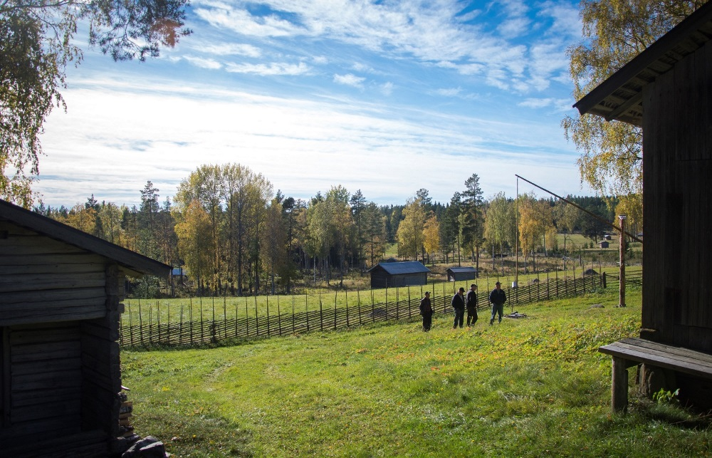
Figure 3.4: Våsbo Fäbodar Summer Farm cultural heritage reserve. Animals graze here as they did before, but the buildings are now mainly used as holiday homes. Photography: Jonas Löf.
There is some collaboration between the local municipalities around sustainability. For example:
• Work on the Development Plan for Fishery Resources and Water Conservation in the Ljusnan-Voxnan Catchment Area (Utvecklingsplan för fiskresursen och vattenvård i Ljusnan-Voxnans avrinningsområde) is being undertaken as a joint project by Bollnäs, Ljusdal and Ovanåker municipalities. The main aim is to produce a new fisheries conservation plan that will improve ecological values in Voxnan river and its tributaries
• The "Fishing in the Middle of Sweden" (FIMS) project, which aims to attract European recreational anglers to the area, is funded by Region Gävleborg and the municipalities in Hälsingland province, including Ovanåker, Ljusdal and Bollnäs
• The municipalities’ Energy and Climate Advisers work together on various awareness campaigns targeted at the general public
• Region Gävleborg runs a collaboration platform for all the municipalities in the region, including Ovanåker, Ljusdal and Bollnäs, and Gävleborg County Administrative Board. The platform runs regional environmental, energy and climate-related projects
Designation as a biosphere reserve and the work of the associated body set up during the candidacy process (Section 13) will significantly boost collaboration between the municipalities and partnerships with other stakeholders. Broader collaboration between the various players in the area, including municipalities, authorities, businesspeople and voluntary sector organisations, will lead to a series of positive synergies in local and regional work on sustainability.
To implement the 2030 Agenda and the SDGs, the various sectors and players need to work together by sharing knowledge, expertise and resources. This can break down silo mentalities that create barriers between sectors. In this context, the proposed biosphere reserve (the organisation) has an important role to play in bringing the various players together and encouraging collaboration. The proposed biosphere reserve will thus complement existing authorities and organisations by acting as a neutral forum for collaboration between the various stakeholders in the area. This way of working is better able to stimulate an exchange of knowledge, learning and collaboration across non-traditional boundaries, both geographically (e.g. across municipal boundaries) and administratively (e.g. between authorities, special-interest organisations, companies and voluntary sector bodies).
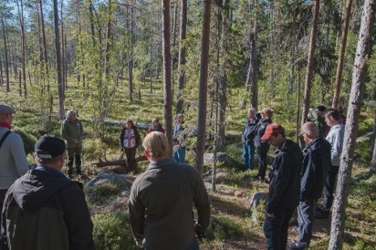
Figure 3.5: Representatives of municipalities, authorities, companies and special-interest organisations gathered in Hamra National Park to discuss the proposed biosphere reserve. Photography: Kent Backeby.

Entrepreneurial spirit and an active community life
Characteristic of Voxnadalen is its entrepreneurial spirit and small-scale business activity, and also strong social networks in the form of Free Churches and sports clubs. The areas around the two largest urban centres, Edsbyn and Alfta (Fig. 3.2) have evolved over the years from farming communities into industrialised communities. The many small businesses and the larger-scale industrial activity are very much associated with the forest, the area’s greatest natural resource. In addition to forestry and timber processing activity, there are many companies and businesses involved in engineering and the development of modern technology. The area’s two biggest firms, Svenska Fönster and Edsbyverken, are at the forefront nationally in terms of their attention to environmental and social issues. For example, Svenska Fönster and Edsbyverken, which manufacture windows and office furniture respectively, were the first companies in Sweden to offer products with the Swan ecolabel (the Swan is the official ecolabel for the Nordic countries). The state-owned ecolabelling company Miljömärkning Sverige is responsible for both the Swan and the EU Flower, operating on a non-profit basis on behalf of the government. The companies take their social responsibility in the area seriously, providing support for local clubs and societies, outdoor recreation and health promotion.
Volunteer-run community activity is a major force for stimulating engagement and a sense of fellowship in Voxnadalen, where the number of clubs and societies is amongst the highest in Sweden. Virtually every type of interest is catered for. Organisations range from major sports clubs with hundreds of members and impressive facilities to small, specialist groups with a few dozen active enthusiasts. Clubs, societies and businesses often come together on joint tourism projects, where they work with each other to help more people discover the potential of Voxnadalen’s natural environment. One example of a partnership between local companies, associations, private individuals and Ovanåker Municipality was the joint project to build Sweden’s first indoor bandy arena in Edsbyn in 2001. Another example was the initial development of the "Fishing in the Middle of Sweden" project, which is now run as a cooperative. The many Free Churches in the area are also important centres of voluntary activity, particularly in respect of social issues such as the reception and integration of refugees. Local history societies play an important role in managing and promoting the cultural heritage sites in the area. Several of the decorated Hälsingland farmhouses (Fig. 3.8) are managed on a voluntary basis by local history societies.

Diverse ecosystem services

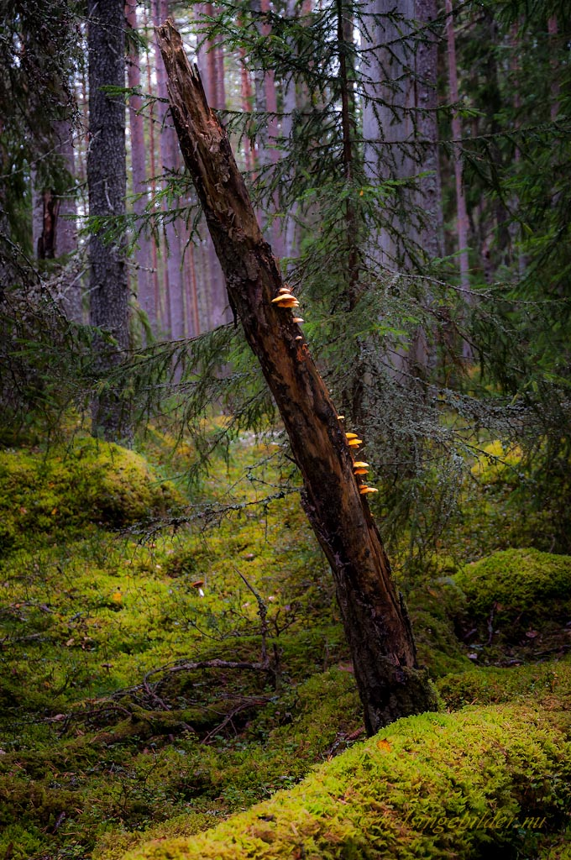
Figure 3.6: Access to deadwood is important for the biodiversity of the forest. Here, in Eco Park at Grytaberg, this dead tree is still upright. Photography: Stefan Persson.
Historically, the ecosystem services that forests, watercourses and cultivated land have generated for farmers have had a significant role to play in the economy, development and cultural history of the area. This is evidenced by the unique, well-preserved Hälsingland farmhouses that are now a valuable historical record of the area’s development. The Decorated Farmhouses of Hälsingland were designated a World Heritage Site by UNESCO in 2009.
The areas around the two largest urban centres, Edsbyn and Alfta, have evolved from farming communities into industrialised communities. Despite this, the ecosystem services generated by forests, watercourses and cultivated land still have an important role to play in the economy and development of the area.
The innovation of new wood-based products is important for our development of a society independent of fossil fuels. A substantial portion of the economy in the region is directly related to the bioeconomy, and it is felt that there is great potential in the region for continued development in this field (Gävleborg Region – conditions and opportunities for a future bioeconomy’ / Region Gävleborgs förutsättningar och möjligheter i en framtida bioekonomi, NiNa Innovation, 2016). Good access to high-quality forest products, considerable expertise in and experience of handling different types of biomass, and a tradition and long experience of processing forest products are amongst the region’s strengths. The domestic Scots pine (Pinus sylvestris) that grows in Hälsingland, known as Hälsingefuran (‘Hälsingland pine’), has several sought-after properties that are directly associated with the climate in the area. Hälsingland pine (Fact file 7) is a well-known watchword for quality and particularly sought after in the furniture and woodworking industries. Svenska Fönster, the local joinery company (800 employees) mainly uses timber (Hälsingland pine) of local origin. Each day, 25 tonnes of processed timber are despatched from Svenska Fönster’s Edsbyn factory.
Access to peaceful, undeveloped areas, and the right to unlimited public access to the countryside (allemansrätten, Section 9.3), generate cultural ecosystem services and provide a basis for the growth of nature tourism. Outdoor recreation also has health benefits, gives people an understanding of their natural surroundings and is a factor in regional development, and these are also the basis of Sweden’s 10 national objectives for outdoor recreation (Governmental decision, December 2012). The objectives aim to guarantee opportunities for people to enjoy the natural environment and pursue outdoor activities. Amongst the 10 objectives are ’a natural environment accessible to everyone’, ’a high level of engagement and partnership working for outdoor recreation’, ’sustainable regional growth and rural development’ and ’outdoor recreation for good public health’. The proposed biosphere reserve is thus well placed to contribute to the fulfillment of these objectives.
Walking in the countryside is an increasingly popular pastime in Sweden, with most people saying they like to walk to experience the peace and tranquillity that nature offers. The Helsingeskogen cooperative was formed recently with the aim of developing the local system of trails for walking, cycling, skiing and snowmobiling, etc. The Biosphere Coordination Office established during the process of candidacy for biosphere reserve status (Section 13) helped to set the cooperative up.
Fishing tourism, particularly that involving visitors from abroad, has also been shown to generate valuable income for rural areas (‘Recreational fishing and fishing tourism for rural development’ / Sportfiske och fisketurism för landsbygdens utveckling, Report 2017/18, the Swedish Board of Agriculture and the Swedish National Road and Transport Research Institute). The ’Fishing in the Middle of Sweden’ project has been a success locally and has already generated sales of approximately SEK 2.6 million and 3,300 guest bednights in the project area.

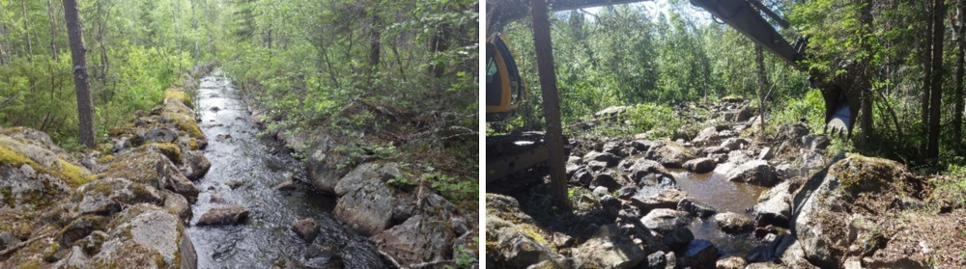
Figure 3.7: Restoration of Kalvsån river, previously cleared for log driving. To the left, the river straightened for the transportation of timber; to the right, the same river during the restoration process. Photography: Peter Hallgren, Fiskevårdstjänst.
Taking action to improve the ecological conditions for fish and other aquatic organisms in Voxnan river and its tributaries (Section 11) is very important for ensuring that fishing tourism in the area continues to develop. Ovanåker, Ljusdal and Bollnäs municipalities are currently developing new fishery conservation plans for Voxnan and its tributaries. A good deal of work has already been done on water conservation (Fig. 3.7).
The Decorated Farmhouses of Hälsingland World Heritage Site, the well-preserved summer farm settings and the open, cultural landscape provide a basis for the continued development of cultural tourism in the area. The tourism offer relating to the World Heritage Site is continually being developed, to include concepts such as ‘stay at a Hälsingland farmhouse’. During the 2017 summer season, the Site had around 120,000 visitors and held over 200 events. It consists of seven selected Hälsingland farmhouses, three of which are located within the proposed biosphere reserve. Within the proposed reserve, a brown and white-signposted Hälsingland Farm Trail (Stora Hälsingegårdars väg) links several Hälsingland farms and other tourist attractions (Fig. 3.8).
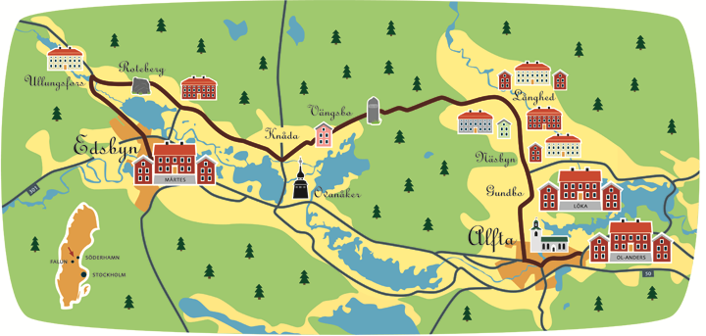
Figure 3.8: Postcard of the brown and white-signposted Hälsingland Farm Trail (Stora Hälsingegårdars väg). Illustrator: Åsa Jägergård.
The summer farms also bring in visitors to the area, and some of them, including Mittjasvallen and Svedbovallen, run visitor programmes. Volunteers from Sweden, and also from other parts of Europe, come to Svedbovallen (in Ljusdal Municipality) to experience the traditional summer farm way of life, looking after animals, milking cows or goats and making dairy products. The resumption of grazing on the summer farms also brings opportunities for local, small-scale and sustainable food production while conserving unique natural and cultural heritage sites.
Hunting is the oldest use of ecosystem services in human history. Although hunting is no longer essential for our survival, it still has a major impact on local food supply and the economy. Elk hunting in the area produces approximately 80 tonnes of pure elk meat each year. Hunting-based tourism in the area, and especially the hunting of brown bears, has been shown to generate valuable income. The almost sacred elk hunting week at the beginning of September attracts over 1,000 hunters annually. A high proportion of these are people who have moved away from home but come back so that they can keep in touch with the place where they were born.

Three focus areas
During the biosphere reserve candidacy process, three focus areas have been developed (Section 13) based on the natural and cultural assets of the area. The three focus areas are ’Forest as a sustainable resource’, ’Living water’ and ’An open, living landscape’ (Section 13). The focus areas will guide the work and indicate the specific areas in which the proposed biosphere reserve can act as a model for sustainable development.

3.3 Logistic support - support for demonstration projects, environmental education and training, research and monitoring related to local, regional, national and global issues of conservation and sustainable development

3.3.1 Research
It is the intention of the planned biosphere reserve to actively support research, environmental education and demonstration projects, as well as to attract research projects to Voxnadalen, concerned with sustainable development.
No universities are located in the planned biosphere reserve. The nearest universities are The University of Gävle (Gävleborg County ), Dalarna University (Dalarna County) and Mid Sweden University (Jämtland and Västernorrland Counties). However, the Universities are all within commutable distance from Voxnadalen, either by car or by public transport. Research is conducted at these Universities within several fields that are of relevance for the primary objectives of the planned biosphere reserve (Section 13).
The University of Gävle conducts research on built environments, with the goal of improving energy efficiency and increasing material efficiency in view of a transition to more sustainable and climate neutral energy systems. The University of Gävle are taking part in the conservation of the Decorated Farmhouses of Hälsingland World Heritage Site by promoting research on preservation and energy efficiency of the farm buildings. Tourist related matters are also included in their work. An aim is also to increase interest in the Decorated Farmhouses of Hälsingland by encouraging students to study the World Heritage Sites in their independent projects.
The University of Gävle is renowned for its special competence within Geographical Information Systems (GIS) and is the only University in Sweden offering a postgraduate programme in Geospatial Information Science. Ovanåker Municipality has commenced a collaboration project with the University of Gävle (2017) with the purpose of building a digital tool (GIS-application) for the community planning of the municipality (local planning and structure planning), which takes climate changes into account and modern climate neutral use of energy. This work is performed as a degree project. Ljusdal Municipality has prepared to receive students from educational programmes at the University of Gävle, offering paid internship. The first period of this cooperation between Ljusdal Municipality and the University of Gävle is in the spring of 2018.
In the field of biology, research is conducted on biological diversity, sustainable plant protection, ecology, physiology, plant-associated micro-organisms and insect communication. Subject didactic research is also conducted in this field. Further, research on sustainable fishing is conducted in collaboration with the Gävleborg County Administrative Board and people who work professionally with fishing.
Dalarna University runs a knowledge platform, the Centre for Tourism and Leisure Research (Centrum för besöksnäringsforskning), based on research motivated by the challenges of the tourism industry. The goal is to strengthen the tourism industry and to accumulate knowledge concerning the needs of the tourism industry. The research mainly deals with the development of tourist destinations, marketing of destinations, the tourist industry as a labour market and questions about sustainable development – primarily in rural areas and in small communities. Current research projects include such subjects as: ’Entrepreneurial Behaviour in Micro-Tourism Firms in Rural Areas’, ’Career Paths and Mobility in the Swedish Tourism Industry’, ’Forest-based Experiences’ and ’Swedish Fishing Tourism – Positive Examples and Success Factors’.
Dalarna University conducts interdisciplinary research on systems for solar heating and solar power and combinations of storage systems at the Solar Energy Research Centre (Centrum för solenergiforskning). Research is conducted on Energy Efficiency in Built Environments, focusing on timber construction and renovation with the purpose of energy efficiency. Both these research specialisations collaborate with industry and organisations. These research fields also offer Master’s Degree courses within solar energy technology, building technology and energy technology.
Mid-Sweden University conducts specialised research within, among other subjects, tourism (The European Tourism Research Institute ETOUR) and development of new bio-based and sustainable materials of cellulose fibres, i.e. forest-based raw materials (Fiber Science and Communication Network, FSCN). One purpose of these research centres is to act as arenas for collaboration with financiers and other interested parties.
Current research within tourism research includes ’Slow adventures in Northern Territories’ and ’Gastronomy and Creative Entrepreneurship in Rural Tourism’. The project ’Green Pro - Green Chemicals from Forest and Forest Products’ is conducted at FSCN. Mid Sweden University also conducts research on many other fields of science such as biology.

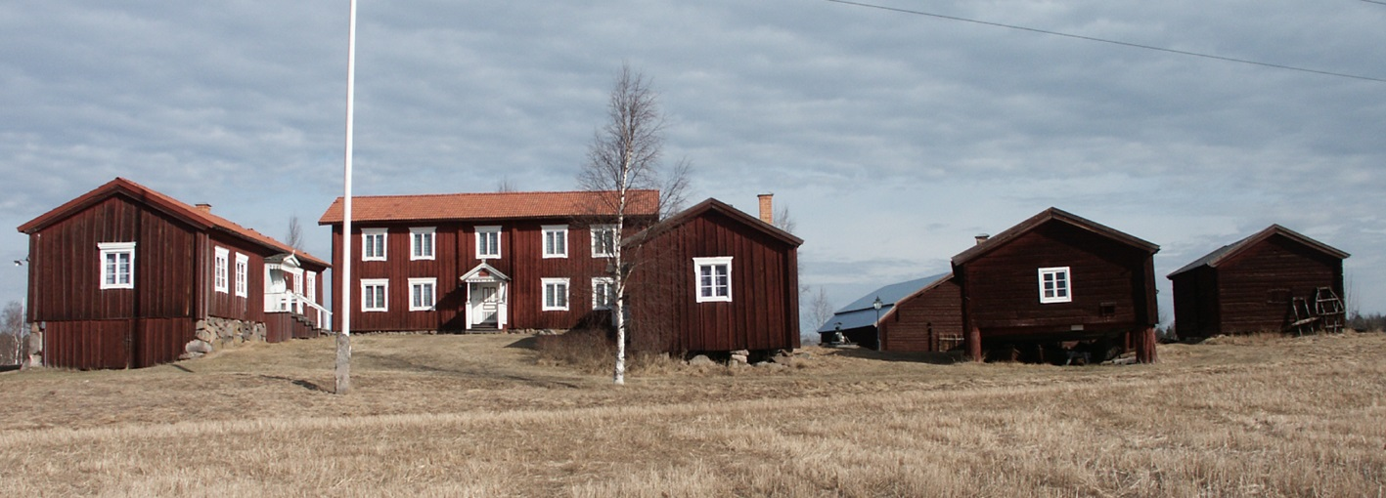
Figure 3.9: The Decorated Hälsingland Farm Löka, situated in the village of Långhed; the three main buildings of the farm are placed to look like a manor house with two detached wings and are surrounded by several outhouses. Photography: Ovanåker Picture Archive.

Collaboration with universities
Contacts have been established with the above-mentioned universities during the candidature for the biosphere reserve, with the purpose of identifying and promoting possibilities of collaboration and to attract interest in research on the area. The following fields of collaboration for education and research have been identified in dialogues between the biosphere reserve organisation and universities:
• Development of tourism based on the forest, rivers and the cultural heritage of the area as recreation for various groups
• Use of the forest as an educational environment for university students and for the integration of people newly arrived in Sweden
• Studies of the quality of water in rivers and streams, investigating possibilities for improvement and assessment during and after restoration work
• Development of GIS applications to create an overview and to map qualities of biotopes, or as a tool for sustainable community planning
• Continue the current research on the Decorated Farmhouses of Hälsingland World Heritage Site
• Research associated with the formation and development process of the biosphere reserve; for example, on conflicts of resources in the area (Section 17.2).
The following forms of collaboration have been identified together with the involved universities:
• Inclusion of researchers representing one or several of the Universities on the board of the biosphere reserve organisation (Section 13 and 17)
• Student projects carried out on questions concerning the planned biosphere reserve at a Bachelor’s, Master’s or Doctoral level. The contribution from the biosphere reserve would be local contacts/network of knowledge and possible financial support through project funding
• Locating student courses and excursions, concerning aspects of sustainability, to Voxnadalen
• Universities can contribute knowledge when courses, seminars and workshops etc. are held in Voxnadalen
• Dissemination of informative examples from the planned biosphere reserve through seminars and relevant courses at the universities

Environmental monitoring
In Sweden, environmental monitoring of forests, water, air and other natural resources is coordinated at a national (Swedish Environmental Protection Agency), regional (The County Administrative Boards and local (associations, municipality) level. The National Inventory of Landscapes in Sweden, NILS, is part of the national environmental monitoring in Sweden. NILS is funded by The Swedish Environmental Protection Agency and it is carried out by The Swedish University of Agricultural Sciences (SLU). The purpose of NILS is to monitor the biological diversity in all Swedish land-based environments and to provide follow-up information for the Swedish national environmental objectives. Information is gathered for NILS through a combination of field surveys and interpretation of aerial photographs. Sampling for NILS is carried out in 631 quadrats (5 x 5 km) in a grid covering the entire country.
The regional environmental monitoring is organised by the County Administrative Boards. During the period 2015-2020, the environmental monitoring of Gävleborg County Administrative Board (the county where the major part of the planned biosphere reserve is located) is specifically engaged in the key topics of freshwater, health, environmental contaminants and farmland. The work concerning the key topic ’farmland’ is focused on surveying the distribution and biological values of grasslands. The work of the County Administrative Board involves assessment of protected areas and the Conservation Programmes for Threatened Species and Habitats.
The Swedish National Forest Inventory is carried out by the Swedish University of Agricultural Sciences and is based on surveys of temporary and permanent sample plots in the forest. Within the planned biosphere reserve, there are around twenty areas containing 4-12 sample plots; an inventory of these is conducted every fifth year. Forest inventories are carried out by the Swedish Forest Agency of e.g. key biotopes, biological diversity and grazing damage of trees.
The quality of the air in the areas is monitored by Östra Sveriges Luftvårdsförbund (East Sweden’s Air Conservation Association), which is a voluntary organisation including members from governmental authorities, municipalities and companies.
Control of receiving bodies of water is conducted by Ljusnan-Voxnans Vattenvårdsförbund, LVVF (Ljusnan-Voxnan Water Conservation Association) and concerns, for example, measurements of the content of nitrogen and phosphorus in lakes, rivers and streams in the area. Within the catchment area of the River Voxnan, there are 5 LVVF-sampling spots for control of receiving bodies of water. Water regulation companies, The Swedish Meteorological and Hydrological Institute (SMHI) and LVVF, measure the water level in around ten of the lakes in the area. SMHI are in charge of meteorological measurements (Section 11.3).
The Swedish Association for Hunting and Wildlife Management (Svenska Jägareförbundet) conduct systematic observations of elk and predatory animals, spending 70,000 work hours within the area every year. In order to keep a check on hunted species and obtain a rough estimate of the development of populations of game, information on shot animals of all species is collected annually. The association also organises surveys of droppings of roe deer and elk every other year and of large predators when needed (latest during 2017/2018). The association is a highly engaged voluntary workforce in the surveying of Sweden’s large predators.
The municipalities are responsible for assessing the quality of water at bathing places in lakes and rivers of the area. Local surveys of natural environment and cultural heritage values are arranged by the municipality, often in the form of projects. For example, Ovanåker, Bollnäs and Ljusdal municipalities have conducted a survey of the River Voxnan and its tributaries (2016-2017). The results from the survey are used to produce new municipal fisheries conservation plans. Ovanåker have also carried out a number of inventories of occurring species of birds, plants and cultural heritage remains in the Sässman Natura 2000 site. The results of the inventory are presented in the form of a detailed landscape analysis (J. Hansen, 2014), which describes how values at Sässman should be preserved and developed.
Forestry companies carry out inventories in their own grounds. Valuable information about the environment and the state of species at a local level also comes from private persons, who are often engaged in voluntary associations.

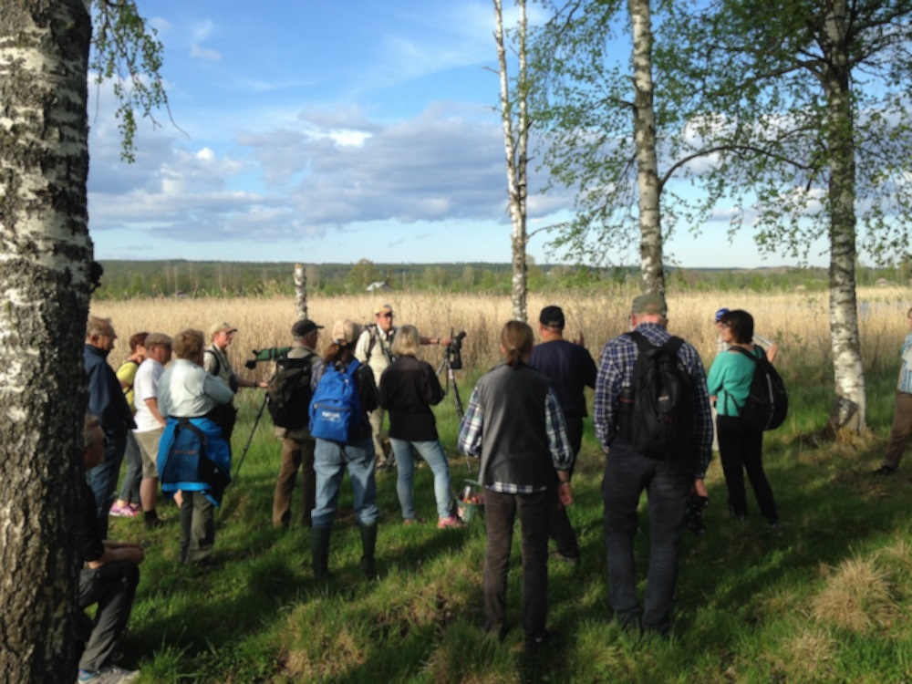
Figure 3.10: A bird watching walk in the Natura 2000 Sässman area for those who are interested. Photo: Jens Hansen

Educational work
Education to promote sustainable development is carried out in the area through teaching in schools, focused authority work and through the commitment of companies and associations.
The educational work that is conducted in schools is an important tool for engaging the interest of children and young people. Many children and youngsters at school agree that questions of sustainability are essential. Some of the schools in the area are connected to the national communication platform Skogen i skolan (’The forest at school’). The pedagogical idea of ’The Forest at School’ project is to link theory with practice in order to enhance the interest of teachers and children to know more about forests. Outdoor pedagogics and use of ’School Forests’ near the school is an important tool in this work. In the planned biosphere reserve, there are School Forests in the communities of Los, Viksjöfors and Edsbyn.
During the biosphere reserve candidature, Ovanåker Municipality in collaboration with the forestry company, Sveaskog, the Swedish Society for Nature Conservation and the Predator Centre the Big Five, have arranged outings to the Eco Park at Grytaberg for both school children and the public. The purpose is to educate children and adults about questions concerning the forest and to inspire people to spend time outdoors in the local area.
Every year, Region Gävleborg and Region Dalarna arrange a three-day long conference for young people, Miljötinget, The Environmental Convention. Miljötinget is oriented towards young people at school (aged 13-18), giving 300 school pupils the chance to take part each year. The aim is to enhance their knowledge of the environment and the climate, as well as providing them with tools to increase their influence in society. Ljusdal Municipality hosted Miljötinget in 2017.
Rovdjurscentret De 5 Stora (The Predator Centre The Big 5) is an independent knowledge and information centre concerned with the large predatory animals. The predator centre arranges a free Predator School for school children. In the predator school, the children learn about Sweden’s large predatory animals and the relationship between humans and these animals. The Predator Centre also run a web-based Predator School. Apart from working with exhibitions, lectures, seminars and dialogue meetings, the centre collaborates with researchers and universities, for instance, regarding studies on people’s feelings of fear of predators.
Guidance for farmers of the area is provided by the County Administrative Boards, among others. The County Administrative Boards run the projects Greppa näringen (Focus on Nutrients), Ekologisk produktion (Organic Production) and Ett rikt odlingslandskap (A varied Agricultural Landscape). The aim of the project Focus on Nutrients is to reduce leaching of nutrients and impact on the environment.
The regionally based (Gävleborg County) business network Företagare för Miljön (Businesses for the Environment) is a collaborative organisation for sustainable, climate friendly and energy efficient business development, looking to the needs of small and medium-sized businesses. The network is intended to stimulate, support and rouse environmental awareness and attention to energy matters through inspiration meetings and education. During 2016, the network also trained local ambassadors.
Every year, the Swedish Association for Hunting and Wildlife Management (Svenska Jägareförbundet) carries outs its Hunting and Wildlife Conservation Commission (governmental decision) through communication work concerning hunting and wildlife management. There is always a readiness to provide public support; for instance, by gathering data for research.
Voluntary organisations in the planned biosphere reserve are engaged in preserving and promoting natural values and the cultural heritage of the area. Local and regional sections of the Swedish Society for Nature Conservation arrange forest outings and lectures, as well as educating private persons in surveying forests with high natural values. Each occasion attracts 10-30 people of all ages.

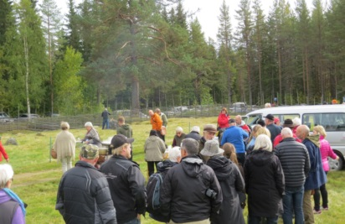
Figure 3.11: As part of the biosphere reserve candidature, a theme day on the use of outlying land in the Våsbo Fäbodar Summer Farm cultural heritage reserve was arranged in the autumn of 2017. Eighty people, interested in summer farming, local food production and the conservation of the open and biodiverse cultural landscape, assembled for the day. The day facilitated open discussions and was an occasion to gather ideas and views from interested persons. Photography: Fia Johannessen.

Biosphere ambassadors and workshops
The planned biosphere reserve intends to support current and new educational operations promoting sustainable development in Voxnadalen, for example by:
• Training Biosphere Ambassadors. The five existing Swedish biosphere reserves have successfully educated Biosphere Ambassadors. The planned Voxnadalen Biosphere Reserve intends to follow their example and be inspired by the positive results of the other biosphere reserves. Material for a training programme for Biosphere Ambassadors, which is adapted to local conditions but still following national guidelines, are to be produced during 2018-2019. The planned training of Biosphere Ambassadors is oriented towards inhabitants and local companies
• Arranging lectures, workshops and theme days. The planned biosphere reserve intends to be a neutral and inclusive arena for the collaboration of interested parties in the area (Section 13). For example, this function can be fulfilled by arranging theme days and workshops that bring different interested parties together over current sustainability challenges (Fig. 3.11)
Chapter 4

Criteria for designation as a Biosphere Reserve

4.1 Encompass a mosaic of ecological systems representative of major biogeographic region(s), including a gradation of human interventions
The planned biosphere reserve is situated in the region of the northern boreal needleleaf forests, in the border zone between the southern boreal zone, an area with low hills and river valleys, and the mid-boreal zone. The latter zone is typical of northern Sweden with high hills and undulating mountainous terrain with outcrops of primary rock. The size (375,100 ha), topography (51-686 metres above sea level) and location of the area, means that it extends over four Swedish plant hardiness zones (zone IV-VII), which is a reason for the rich variation in the vegetation of the landscape.
Below, the ecosystems and types of nature that are present in the area and are characteristic for the bio-geographical region are described. The mentioned nature types are defined according to the standards of Natura 2000.

Forests
Woodland covers 80-90% of the planned biosphere reserve (Fig. 11.1), most of this is production forest. Coniferous trees such as pine (Pinus sylvestris) and spruce (Picea abies), and deciduous trees such as birch (Betula pendula, B. pubescens) aspen (Populus tremula), willow (Salix caprea), rowan (Sorbus aucuparia) and alder (Alnus incana) are the predominant types of trees. Among the types of nature listed in the EU Habitats Directive, the following are found in the planned biosphere reserve: poor coniferous forest (acidic bedrock), rich coniferous forests (alkaline bedrock), western taiga, dry heaths with pine forest, swamp woods, bog woodland, alluvial forests and wooded pasture.

Lakes, rivers and streams
There are many lakes, rivers and streams in the area. The River Voxnan has its source in the province of Härjedalen, and extends throughout the entire biosphere reserve to its outflow into the River Ljusnan, just to the south of Bollnäs (corresponding to a total length of 190 km). The planned biosphere reserve is largely encompassed within the outer limits of the catchment area of the River Voxnan. The following habitat types occur in Voxnadalen and are listed in the EU Habitats Directive: nutrient poor forest lakes, nutrient rich lakes and oligotrophic to mesotrophic standing waters (ävjestrandsjöar), along with peatland lakes, brooks and streams.

Wetlands
Wetlands are characteristic of mid Sweden and northern Sweden. Many of the wetlands of the area are important localities for nesting and visiting birds, or valuable localities for plants and rare flora. Types of nature in the planned biosphere reserve that are specified in the EU Habitats Directive are transitional (open) mires and fens, springs and spring fens, rich fens and aapa mires.

Grassland
Grasslands belong to a large and varied group of environments with an exceedingly rich biological diversity of species. This rich biological diversity, which is often favoured when grassland is maintained, has evolved from the grazed lands of megafauna long before humans started to maintain and use the land. The many thousands of years that grasslands have been used by humans, for animal husbandry and grazing or mowing (Fig. 4.2), has kept up the favourable conditions for biodiversity and species that thrive on maintained land. Nature types occurring in the planned biosphere reserve that are included in the EU Habitats Directive are siliceous grasslands, molinia (fen) meadows, tall herb fringe communities and lowland hay meadows. In many parts of the area, the semi-natural pastureland and hay meadows are at times exposed to flooding.

Farmland
The farmland of the area is mainly located in the south-eastern parts adjacent to the River Voxnan (Fig. 11.1). The most common crop rotation for cultivation is oats and cereals with seeded forage plants, followed by three or four years of forage plants. Fodder for animals is primarily grown, but bread cereals and oilseeds too. Solitary trees, outcrops of non-arable land and clearance cairns, along with small bodies of water and wetlands are important small biotopes that benefit biodiversity in the farmland.

Communities
The south-eastern parts of the area are relatively built-up areas with a larger population compared with the sparsely populated north-easterly parts (Fig. 4.1). There is thus a natural gradient in the human impact on the area. The two largest communities of the area, Edsbyn and Alfta, are situated near the River Voxnan in the south-eastern parts of the area. Even here, in these two communities, the quiet and calmness offered by nature and the forest is always close at hand.

Figure 4.1: Distribution of the population in the planned biosphere reserve. Marked surfaces show where inhabitants live. Data from 2014.

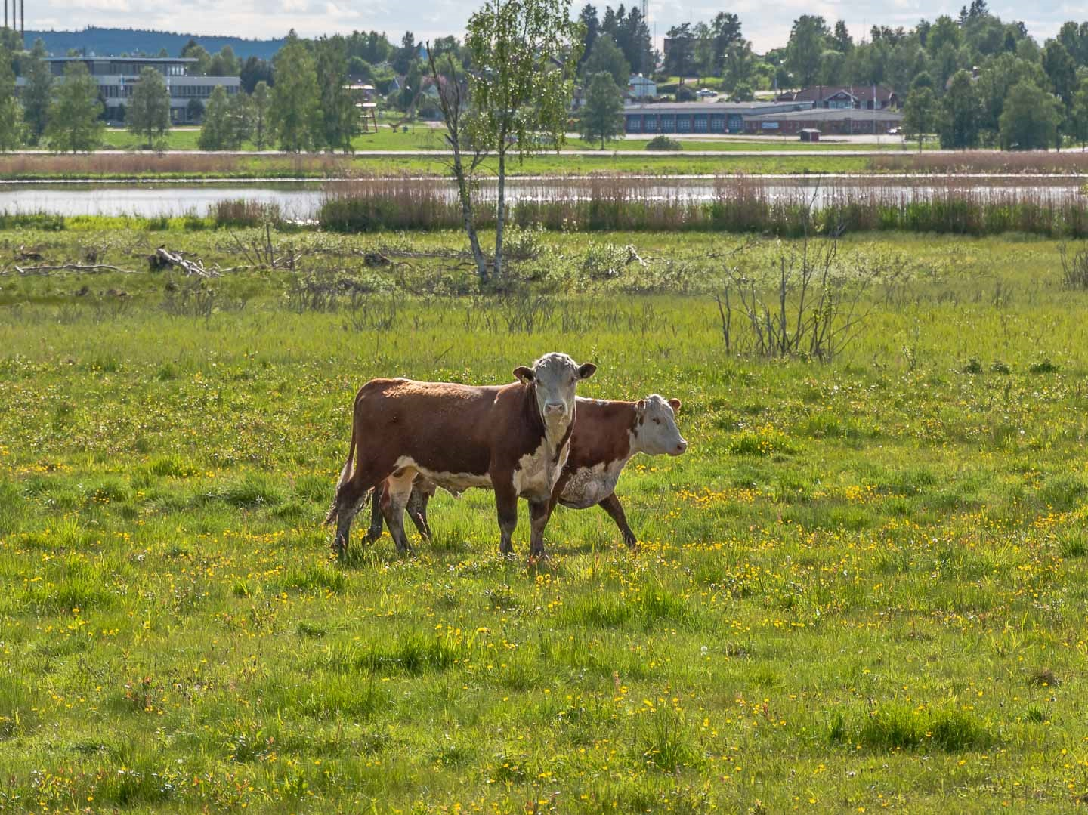
Figure 4.2: Cattle grazing in the Sässman Natura 2000 site, keeping the landscape open. Parts of the community of Edsbyn can be seen in the background. Photography: Stefan Persson.

4.2 Be of significance for biological diversity conservation
Within the planned biosphere reserve, 266 species nationally red-listed in ArtDatabanken (The Swedish Species Information Centre) and 16 species internationally red-listed in IUNC, have been observed. These belong to the categories critically endangered (CR), endangered (EN), vulnerable (VU) and near threatened (NT). Most likely, more red-listed species occur in the area, particularly small invertebrates such as insects.
Among species listed in the EU Habitats Directive, 38 species have been observed in the area while the number of types of nature amount to 20. Several species and habitats are prioritised (p); these include wolf (Canis lupus) and wolverine (Gulo gulo), as well as the nature types aapa mires, bog woodland and siliceous grassland. At least 97 species listed in the EU Birds Directive have been seen to be nesting or visiting in the area.
Below, some of the species that occur in the area are described together with the national and international red-listing. Nature types that are significant for preserving the biological diversity at a local, regional or global level are also mentioned. For a more detailed description of species or groups of species of particular interest for environmental objectives, see Section 11 and 14.

Forests
All five of the large predators in Sweden are present in the planned biosphere reserve, these are wolf, Canis lupus VU/LC; bear, Ursus arctos NT/LC; lynx, Lynx lynx VU/LC; wolverine, Gulo gulo VU/LC; and golden eagle, Aquila chrysaetos NT/LC). In this respect, the area is unique among the existing biosphere reserves of Sweden; but at the same time, this offers a challenge for sustainable wildlife management.
In woodland with characteristics of natural forest, several rare and nationally red-listed species of moss, lichen, fungi, insects and vascular plants have been observed. A total of 37 red-listed insects have been noted only in the Eco Park at Grytaberg (Section 7.4); several of these have only rarely been registered in other parts of Sweden. The rare fairy slipper orchid (Calypso bulbosa NT), which is associated with woodland, also occurs in the planned biosphere reserve.
All species of woodpecker that currently occur in Sweden have been found in the planned biosphere reserve, including the critically endangered white-backed woodpecker (Dendrocopos leucotos CR/LC), which has been observed while foraging in the area on several occasions (latest 2016).

Lakes, rivers and streams
Robust populations of otter (Lutra lutra NT/NT) occur in the area, for instance, around the Hylströmmen waterfall (Section 7.4), in the parts of the River Voxnan that are not regulated for hydroelectric power. There are also strong populations of noble crayfish (Astacus astacus CR/VU) and regenerating populations of freshwater pearl mussel (Margaritifera margaritifera EN/EN). Since 1900, the populations of noble crayfish have been reduced by 97%, while regeneration of freshwater pearl mussel only occurs in 1/3 of the current Swedish populations.

Wetlands
The wetlands of the area are important localities for nesting and visiting birds. One of the most prominent bird localities is the Sässman area (Section 7.4), which is located within easy access of the community. Here, 200 kinds of birds have been sighted (nesting, visiting or staying for a temporary rest), 97 of these have been observed to be nesting at the site (2013). Red-listed birds that have been seen in the area include the curlew (Numenius arquata, NT/NT), ruff (Calidris pugnax VU/LC) and meadow pipit (Anthus pratensis, NT/NT). There are several rich fens in Voxnadalen; these are environments with an unusually rich flora of, for example, orchids.

Grasslands
The abundantly varied and well-kept grasslands are characterised by an extremely rich biodiversity, particularly in the case of plants, insects (including pollinating insects) and birds. Species associated with continuous management that have been observed in the area include the vascular plants greater bur-marigold (Bidens radiata, VU/) and field gentian (Gentianella campestris, EN/), as well as the birds corn crake (Crex crex, NT/LC) and curlew (Numenius arquata, NT/NT).

Farmland
Some birds are highly associated with farmland; for example, the red-listed skylark Alauda arvensis, NT/LC). The skylark prefers an open landscape with a large proportion of fields where crops grow; it nests primarily in farmland. Today, the skylark is threatened by the discontinuation of farms, but also by certain agricultural activities (e.g. the mowing of fields during the nesting season).

Communities
Apart from their association with farm buildings, several species are drawn to built areas such as towns and communities. These include common swift (Apus apus, VU/LC), barn swallow (Hirundo rustica, LC/LC) and house sparrow (Passer domesticus, LC/LC, although falling population trend). Mammals that live in gardens, parks and green areas of communities include the common hedgehog (Erinaceus europaeus, LC/LC, although falling population trend) and squirrel (Sciurus vulgaris, LC/LC).

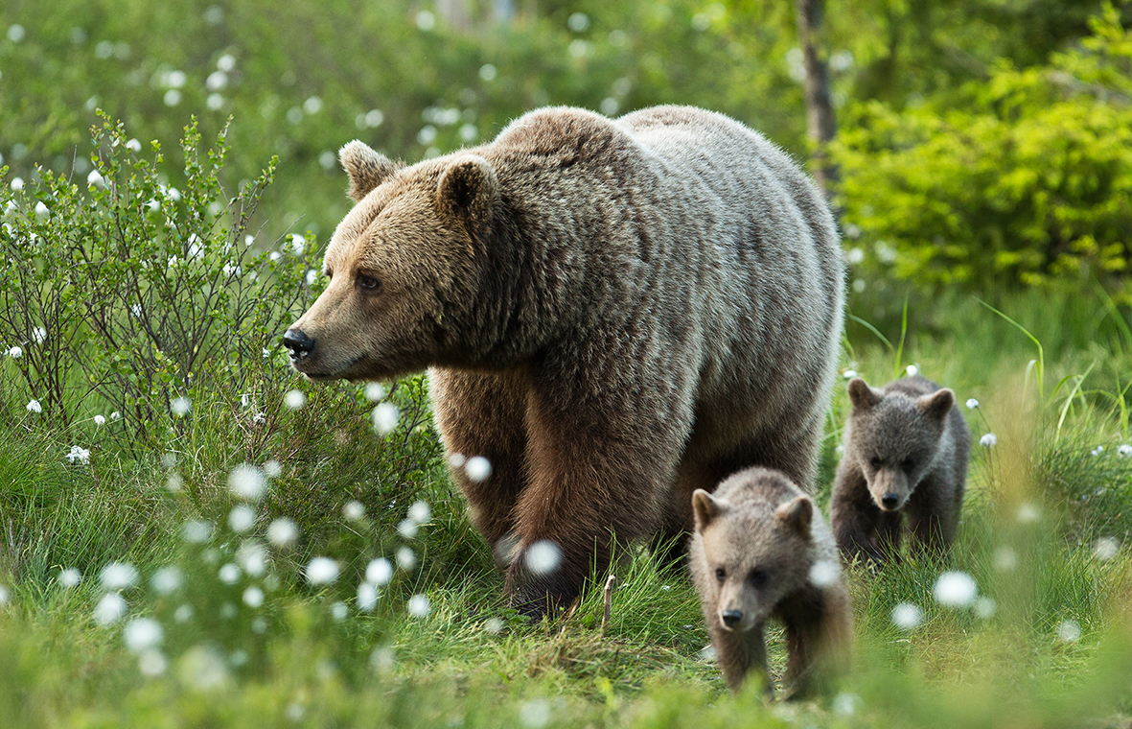
Figure 4.3: A female bear with two cubs. Photography: Håkan Vargas

4.3 Provide an opportunity to explore and demonstrate approaches to sustainable development on a regional scale

Local activity and partnerships
The four municipalities involved – Ovanåker, Ljusdal, Bollnäs and Rättvik – have primary responsibility for management of the area. The municipalities are actively engaged in long-term work on sustainability based on Sweden’s national environmental objectives. Sweden’s environmental objectives consist of an overall generational goal, 16 environmental quality objectives including clarifications and 28 milestone targets (page
Table 4.1: @
xref fig:A2030ochMiljomal on input line 2341) Page ref verkar inte funka. In adopting their own local environmental objectives (Appendix Local environmental objectives), Ovanåker, Ljusdas and Bollnäs municipalities are adapting Sweden’s national environmental objectives to local circumstances and challenges. Rättvik Municipality was quick to embark upon a political process to instead integrate the 2030 Agenda and the Sustainable Development Goals (SDGs) into local environmental objectives. Ovanåker, Bollnäs and Ljusdal municipalities are also members of the non-profit National Association of Swedish Eco-municipalities (Sveriges Ekokommuner, SEKOM). SEKOM is a national collaborative organisation for municipalities, county councils and regions whose aim is to foster community development that is ecologically, socially and financially sustainable. Please see Section 15.1 for a more detailed description of the municipalities’ work on sustainability.
Some joint work is already being done by a number of the municipalities on various sustainability issues. Ovanåker, Ljusdal and Bollnäs municipalities are working together on a new water and fisheries conservation plan for Voxnan river and its tributaries (‘Development plan for fishery resources and water conservation in the Ljusnan-Voxnan catchment area’ / Utvecklingsplan för fiskeresursen och vattenvård i Ljusnan-Voxnans avrinningsområde). The Energy and Climate Advisers of the three municipalities work jointly on various campaigns to raise awareness and educate residents on issues around energy use and climate change. A new regional collaboration platform was recently introduced to assist the municipalities’ work on environmental strategy.
The proposed biosphere reserve body (Section 17.1.8), which has been developed and launched during the candidacy period, will provide an additional boost to the collaboration between municipalities, authorities, companies, special-interest organisations and voluntary sector bodies. Broader collaboration between the various players in the area creates the conditions for a range of positive synergies in local and regional work on sustainability.

Entrepreneurial spirit and an active community life
There is a strong entrepreneurial spirit in the area and a positive climate for businesses. The larger companies and the many small-scale businesses operate mainly in the forestry and timber processing sectors, but some are also involved in engineering and the development of modern technology. Several of the area’s biggest companies are at the forefront nationally in terms of their attention to environmental and social issues.
A substantial portion of the economy in the region is directly related to the bioeconomy, and it is felt that there is great potential in the region for continued development in this field. The continued development of a biobased economy is an important factor in our development of a society independent of fossil fuels.
Volunteer-run community activity is a major force for stimulating involvement in Voxnadalen, as the area in which the biosphere reserve is situated has one of the highest numbers of clubs and societies in Sweden. Virtually every type of interest is catered for. Clubs, societies and businesses often come together on joint tourism projects, where they work with each other to help more people discover the potential of Voxnadalen’s natural environment.

Three focus areas
The proposed biosphere reserve is largely based on the catchment area of the River Voxnan. The north-western, sparsely-populated parts are dominated by large areas of boreal forest, while the south-eastern, more densely-populated sections are mainly open, agricultural landscapes. The river Voxnan flows through the entire area. During the candidacy process for biosphere reserve status, we have developed three focus areas based on these natural assets and the cultural values of the area.
The three focus areas are ’Forest as a sustainable resource’, ’Living water’ and ’An open, living landscape’ (Section 13). The focus areas will guide the work and also indicate the specific areas in which Voxnadalen can act as a model reserve for sustainable development.

4.4 Have an appropriate size to serve the three functions of biosphere reserves
The proposed biosphere reserve extends over XXX ha, of which XXX ha are lakes and watercourses. Of the total area, approximately XXX % is core area and XXX% buffer zone (Fig. 4.5). The remaining land and water are in the transition area. All three zones contain diverse ecosystems and habitats but also historic buildings such as the Decorated Farmhouses of Hälsingland World Heritage Site and the Våsbo Fäbodar Summer Farm cultural heritage reserve. Together, these will ensure that the biosphere reserve fulfills the three functions (see Section 4.5 for a more detailed description).

4.5 Through appropriate zonation

”(a) a legally constituted core area or areas devoted to long term protection, according to the conservation objectives of the biosphere reserve, and of sufficient size to meet these objectives”
There are 27 core areas in the proposed biosphere reserve (Section 7.4). The core areas coincide with existing protective structures that have been established under Swedish environmental legislation. In total, the core areas include a National Park, 10 nature reserves, 18 Natura 2000 sites, one cultural heritage reserve and three World Heritage Sites. Several (five) of the nature reserves are also Natura 2000 sites. Of the total area of the proposed biosphere reserve, approximately 2% is core area. As the zonation is based on existing regulations and protective structures, the proposed biosphere reserve will not entail any new restrictions on rights of ownership, use and land use and outdoor access rights. Please see Section 9.3 for a more detailed description of the rules on land use in the core areas.
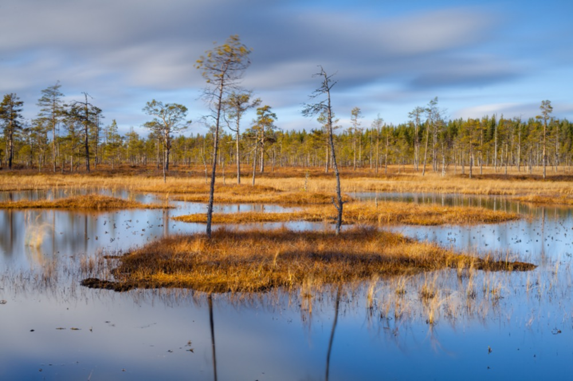
Figure 4.4: Peatlands, Hamra nationalpark. Photography: Johnny Eng
Several of the core areas are protected on account of their significant woodland assets. The oldest part of Hamra National Park, established as early as 1909, is one of the few untouched areas of coniferous forest in mid Sweden. In 2011, the Park was substantially extended to include a contiguous mire complex consisting of fen, streams, small tarns, quagmire and islets with pine trees (Fig. 4.4). Other areas of forest, under protection as nature reserves, feature natural woodland including mixed conifers, fire-affected pine trees that are several hundred years old, large amounts of deadwood and rare species.
The Natura 2000 sites include several different types of peatland, which are often very interesting in terms of birdlife and/or flora. One of the Natura 2000 sites is covered by the EUs Birds Directive (an SPA), 11 by the EU Habitats Directive and five by both directives. The northern and middle sections of the River Voxnan are nature reserves and/or Natura 2000 sites. The Decorated Farmhouses of Hälsingland World Heritage Site and the Våsbo Fäbodar Summer Farm cultural heritage reserve are protected to ensure the preservation of these historical heritage environments. A detailed description of all core areas is given in Appendix 19.1.1.

”(b) a buffer zone or zones clearly identified and surrounding or contiguous to the core area or areas, where only activities compatible with the conservation objectives can take place”
The proposed biosphere reserve has 10 buffer zones, which surround and in some cases link together several of the core areas (Section 7.4). The buffer zones coincide with existing areas of national interest for nature conservation, outdoor recreation and/or conservation of the heritage environment and SOOs (large unexploited areas). Both the areas of national interest and the SOOs have been established under Swedish environmental legislation. ‘National interest’ means that any change of use of land or water must not damage the natural or cultural environment but ongoing use of the land (e.g. for forestry and hunting) is still permitted. A SOO environment must be protected as far as possible against actions or activity that could have a significant impact on its character.
One buffer zone coincides with the Eco Park at Grytaberg, which has been established on the basis of a woodland nature conservation agreement. Nature conservation agreements are voluntary, time-limited agreements made between a landowner (in this case Sveaskog) and an authority (the Swedish Forest Agency, County Administrative Board or a municipality), and are intended to conserve or develop the natural values of woodland areas.
The buffer zones together comprise approximately XXX 33% of the total area of the proposed biosphere reserve. Please see Section 9.3 for a more detailed description of the rules on land use in each of the buffer zones.

Figure 4.5: The zonation of the proposed biosphere reserve, showing the extent of the core areas, buffer zones and transition area.

”(c) an outer transition area where sustainable resource management practices are promoted and developed”
The outer transition area comprises approximately XXX 73% of the total area of the proposed biosphere reserve. The population of the transition area is about XXX 13,300. Most of the urban areas, with associated industry, are concentrated in the south-eastern part of the transition area. This includes the principal urban centres, Edsbyn and Alfta, which are the most heavily populated. The transition area also includes diverse ecosystems ranging from forest, grazing land and farmland to wetlands, lakes and watercourses, but also many historical buildings such as the Hälsingland farmhouses and summer farms. There are therefore several opportunities for demonstration projects that test and demonstrate models for sustainable resource use in a range of contexts – for example:
• The innovation of new products from local forest products, and continued development of a biobased economy
• The reinstatement of ecological values in watercourses that have been impacted by human activity, e.g. log driving, carrying out this work with due regard to cultural heritage and the development of the tourism offer
• New types of summer farming activity and local, small-scale, sustainable food production
• Safeguarding, learning about and communicating the legacy of traditional expertise in the area, e.g. regarding the cultivation of outfields
• The development of opportunities that connect the area’s natural assets and cultural values with ecotourism and growth, outdoor recreation, health and integration
• The development of working models that foster local and regional collaboration between municipalities, authorities, businesses and voluntary sector bodies

(d) Please provide some additional information about the interaction between the three areas.
The core areas, buffer zones and transition area of the proposed biosphere reserve will interact in several respects. The overall biodiversity of the different zones will be linked through diverse ecological processes, both on land and in the limnic environment.
The residents of the transition area are dependent on the ecosystem services generated in the various zones. Many of the core areas are popular recreation areas that generate cultural ecosystem services in the form of experiences of the natural environment, cultural heritage experiences, outdoor recreation and berry and mushroom-picking opportunities. Many tourism businesses use one or all three zones for various nature-based experiences, including recreational fishing, dog sledding, horse-riding, canoeing and wild game watching.
Forest products from the buffer zones and the transition area are processed by many of the sawmills, businesses and woodworking companies in the transition area, creating employment for local people.
Thriving farming businesses in the buffer zones and transition area mean local people can be supplied with locally-produced food. This in turn makes it possible to continue grazing cattle at summer farms and other heritage sites, helping to preserve the area’s unique natural values and cultural heritage.

4.6 Organizational arrangements should be provided for the involvement and participation of a suitable range of inter alia public authorities, local communities and private interests in the design and the carrying out of the functions of a biosphere reserve

4.6.1 Describe arrangements in place or foreseen
Ovanåker Municipality is the entity with legal responsibility for Biosfärkandidat Voxnadalen (’Biosphere Candidate Voxnadalen’), the project responsible for biosphere reserve candidacy. At the start of the official candidacy process in 2014, a special Steering Group was set up consisting of representatives of the offical management bodies for the area, special-interest organisations and voluntary sector groups (Section 13.4). The Group’s task has been to lead the work on the application for biosphere reserve status. The following have been members of the Steering Group from 2014 to 2017:
• Ovanåker Municipality, 7 seats (4 elected politicians, 3 officers)
• Ljusdal Municipality, 2 seats (1 elected politician, 1 officer)
• Bollnäs Municipality, 2 seats (1 elected politician, 1 officer)
• Gävleborg County Administrative Board, 2 seats (1 officer each from nature conservation and cultural heritage sections). Sweden’s County Administrative Boards represent the state at county level. Manages all the core areas in the proposed biosphere reserve
• Region Gävleborg, 1 seat (officer). Regional, politically-controlled organisation with responsibility for regional development
• Swedish Forest Agency, 1 seat (officer). National agency responsible for forest and forestry issues
• Federation of Swedish Farmers, 1 seat. Politically independent, special-interest organisation and trade association for agricultural, forestry and rural development issues
• Mellanskog, 1 seat. Association of forest owners, owned by its members, i.e, private forest owners
• Swedish Society for Nature Conservation, 1 seat. Voluntary sector organisation and the biggest environmental group in Sweden
In addition to the Steering Group, a Working Group has been established comprising a Coordinator, a Project Manager and other officers from Ovanåker, Ljusdal and Bollnäs municipalities. The Working Group is responsible for the practical work of writing the application, keeping people informed about the candidacy and undertaking extensive work to build support for the venture.
Rättvik Municipality support the proposed biosphere reserve but has not been a part of the Steering Group or the Working Group. Rättvik Municipality has instead been involved in the process through presentations to the Rättvik Municipal Council and two separate opportunities to comment on the application (Section 13.4).
During the candidacy period, the Steering Group has produced a proposed organisational structure (Section 17.1.8). The organisation was launched in spring 2018, with the Steering Group handing over to the initial Management Board of the proposed biosphere reserve. The Board’s task is to agree the biosphere reserve’s development and operational plans, activities and allocated funds. The following organisations are members of the Board for 2018-2019, and are elected for a two-year period:
• Ovanåker Municipality, 1 seat, elected politician
• Ljusdal Municipality, 1 seat, elected politician
• Bollnäs Municipality, 1 seat, elected politician
• Region Gävleborg, 1 seat, officer. Regional, politically-controlled organisation whose responsibilities include regional development
• University of Gävle, 1 seat, Department of Biology
• Dalarna University, 1 seat, Centre for Tourism and Leisure Research
• Mellanskog, 1 seat. Association of forest owners, owned by its members, i.e, private forest owners
• Swedish Association for Hunting and Wildlife Management, Gävleborg, 1 seat. Member organisation focussing on hunting and wildlife issues. Manages aspects of wildlife conservation on behalf of the Swedish government
• Swedish Society for Nature Conservation, Gävleborg, 1 seat. Voluntary sector organisation and the biggest environmental group in Sweden
• Federation of Swedish Farmers, Gävleborg, 1 seat. Special-interest organisation and trade association for agricultural, forestry and rural development issues.
• Swedish Association of Summer Farmers, 1 seat. Voluntary sector body that aims to support summer farming as a business activity

4.6.2 Have any cultural and social impact assessments been conducted, or similar tools and guidelines been used?
No, no specific cultural or social impact assessments have been undertaken as part of our candidacy for biosphere reserve status. The Swedish Discrimination Act (2008:567) aims to combat discrimination and promote equal rights and opportunities irrespective of sex, transgender identity or expression, ethnicity, religion or other belief, disability, sexual orientation or age. An important and self-evident objective for Voxnadalen is that all activity carried out within the proposed biosphere reserve must be fully inclusive and combat discrimination.

4.7 Mechanisms for implementation

Does the proposed biosphere reserve have:

(a) mechanisms to manage human use and activities in the buffer zone or zones?
Yes, there is Swedish legislation regulating human activity and the use of resources in all the buffer zones of the proposed reserve. Land use in the buffer zones is primarily regulated by the Swedish Environmental Code (Miljöbalken, MB), the Planning and Building Act (Plan- och bygglagen, PBL), the Swedish Forestry Act (Skogsvårdslagen) and the Heritage Conservation Act (Kulturmiljölagen). Please see Section 9.3 for more details.

(b) a management policy or plan for the area as a biosphere reserve?
It is primarily the four municipalities involved (Fig. 6.1), alongside a large number of national and regional authorities, that have the main management responsibility in the area, for example in respect of land and water use (Section 9.3). The politically-controlled regional councils Region Gävleborg and Region Dalarna are responsible for coordinating and streamlining work on regional development, in accordance with regional development strategies (RUS’s). Region Gävleborg’s development strategy (‘New Opportunities 2013-2020’ / RUS - Nya Möjligheter 2013-2020) integrates all three aspects of sustainable development - the environmental, the social and the economic.
The body that will be responsible for the UNESCO remit that accompanies designation as a biosphere reserve is in the process of producing a five-year development plan. A draft of the Development Plan for Voxnadalen Biosphere Reserve 2020-2025 is appended to this application (attached). The completed development plan will include measurable, time-bound impact objectives for the biosphere reserve as a whole and for each of the three focus areas. The process and timetable for the completion of the plan is set out in Section 17.4.

(c) a designated authority or mechanism to implement this policy or plan?
The biosphere reserve’s Management Board has ultimate responsibility for the implementation of the development plan (Section 17.4). The practical work will be coordinated from a Biosphere Coordination Office, which is currently staffed by a Coordinator and a Project Manager employed by Ovanåker Municipality. Ovanåker, Ljusdal and Bollnäs municipalities will also provide staff for the Working Group. Please see Section 17.1.8 for a more detailed description of the body that will be responsible for implementing the biosphere reserve development plan.

(d)programmes for research, monitoring, education and training?

Research
There are no higher education institutions within the proposed biosphere reserve. However, the University of Gävle (Högskolan i Gävle, HiG), Dalarna University (Högskolan Dalarna, HD) and Mid Sweden University (Mittuniversitetet, MiUn) are within commuting distance of Voxnadalen, either by car or by public transport. The universities also offer several distance-learning programmes. The three universities conduct research in several areas (Section 16) that ties in with the overall objectives and three focus areas of the proposed biosphere reserve (Section 13). During the biosphere reserve candidacy process, contact has been established with the three universities with the aim of identifying areas for collaboration so as to link additional research to Voxnadalen (Section 16).

Environmental monitoring
Environmental monitoring of Sweden’s forests, water, air, wildlife and other natural resources is coordinated at the national level by the Swedish Environmental Protection Agency, at the regional level by the County Administrative Boards and at the local level by the municipalities. The monitoring is undertaken in order to check progress being made towards Sweden’s 16 national environmental quality objectives. Please see Section 16 for more details.

Education
There are various educational initiatives focussing on sustainability in the area, including teaching in schools, targeted agency initiatives and input from local businesspeople and special-interest organisations. Sweden’s five existing biosphere reserves have successfully trained a number of Biosphere Ambassadors. The proposed Voxnadalen Biosphere Reserve has been inspired by this example and plans to replicate the concept. Please see Section 16 for more details.
[pages=-,fitpaper]text/Cha5blank.pdf
Part III
Description
Chapter 6

Location (coordinates and map(s))

6.1 Provide the biosphere reserve’s standard geographical coordinates (all projected under WGS 84).

Table 6.1: Coordinates of the planned biosphere reserve

Cardinal points: | Latitude | Longitude
Most central point | 61 31’49 | 15 30’10
Northernmost point | 61 59’33 | 14 32’29
Southernmost point | 61 4’45 | 15 59’23
Westernmost point | 61 48’56 | 14 18’49
Easternmost point | 61 19’50 | 16 26’50

6.2 Provide a map(s) on a topographic layer of the precise location and delimitation of the three zones of the biosphere reserve (Map(s) shall be provided in both paper and electronic copies). Shapefiles (also in WGS 84 projection system) used to produce the map must be attached to the electronic copy of the form.
The planned biosphere reserve is largely encompassed within the outer limits of the catchment area of the River Voxnan (Fig. 6.1). The part of the catchment area that belong to Härjedalen Municipality, which is also where the River Voxnan has its source, is not included in the planned biosphere reserve. In all, the biosphere reserve encompasses four partnering municipalities, two administrative counties and two provinces (see Fact file 2, Table 6.2). The municipalities of Ovanåker and Ljusdal constitute the largest proportion of the biosphere reserve. The biosphere reserve is divided into core areas, buffer zones and transition areas (Fig. 6.2). For maps and a list of attached digital shape-files, see Section 19.

Table 6.2: Administrative division of the planned biosphere reserve

Municipality | Administrative County | Province
Ovanåker | Gävleborg | Hälsingland
Ljusdal | Gävleborg | Hälsingland and Dalarna
Bollnäs | Gävleborg | Hälsingland
Rättvik | Dalarna | Dalarna

[Sorry. Ignored \begin{fruta} ... \end{fruta}]

Figure 6.1: figure
Municipalities included in the planned biosphere reserve.

Figure 6.2: Zones of the planned biosphere reserve with core areas, buffer zones and one transition area. All core areas are surrounded by buffer zones. See Section 19.1.1 for maps showing greater detail.

Chapter 7

AREA (see map)

7.1.-3. Core Area, Buffer Zone, Transition Area

Table 7.1: Area distribution, total and per zone, for the planned biosphere reserve

 |  | Marine*
 | Terrestrial | (if applicable) | Total
Area of core area(s) | 7278 ha | 733 ha | 8011 ha
Area of buffer zone(s) | 107 317 ha | 7 482 ha | 114 799 ha
Area of transition area(s) | 243 152 ha | 17 190 ha | 260 342 ha
Total | 350 470 ha | 24 671 ha | 375 141 ha

*As in previous Swedish biosphere applications, this is interpreted as limnetic

7.4 Brief rationale of this zonation in terms of the respective functions of the biosphere reserve. If a different type of zonation also exists indicate how it can coexist with the requirements of the biosphere reserve zonation.
The zone division of the planned biosphere reserve follows a nationally adapted model used for previously nominated biosphere reserves in Sweden. With a basis in UNESCO’s guiding document for biosphere reserves (The Statutory Framework of Biosphere Reserves and the Seville Strategy), the national model takes Swedish law as its point of departure. The zone division into core areas, buffer zones and transition areas is thus based on existing regulations and protective structures. Consequently, the planned biosphere reserve will not entail any new restrictions concerning ownership, right of use of one’s own land or the land of others, or Swedish outdoor access rights (allemansrätt) (Section 9.3).
Core areas shall constitute protected areas in accordance with UNESCO’s guidelines. The core areas of the planned biosphere reserve include one National Park, 10 nature reserves, 18 Natura 2000 sites, one cultural heritage reserve and one World Heritage Site (Fig. 7.1, Table 7.2). Any enterprises within the core areas are therefore restricted to activity that is compatible with the aims of the respective protected areas. The core areas thus contribute to fulfil the preservation function of the biosphere reserve.
In accordance with UNESCO’s guidelines, core areas should be surrounded by and/or contiguous with buffer zones. Buffer zones of the planned biosphere reserve include areas of national interest (riksintresse, RI) for nature conservation, cultural heritage and outdoor recreation, as well as one area covered by a nature conservation agreement (naturvårdsavtal) with the landowner and one so called SOO area (large unexploited area) (Fig. 7.1, Table 7.2). For a detailed description of how regulations of land use in core areas and buffer zones fulfil zone division requirements of biosphere reserves, see Section 9.3.
The transition area includes all remaining land within the planned biosphere reserve. The planned biosphere reserve is largely encompassed within the outer limits of the catchment area of the River Voxnan (Fig. 6.1).

Figure 7.1: Map showing the numbered core areas in Table 7.2

3GROEN!30!white
Table 7.2: Short description of core areas of the planned biosphere reserve. Nature reserve UF means that designation process is underway. SPA stands for Natura 2000 according to the EU Birds Directive och SCI stands for Natura 2000 according to the EU Habitats Directive. RI: national interest.
No | Name | Area (ha) | Type of protection | Type of Buffer zone | Description
white No | Name | Area (ha) | Type of protection | Type of Buffer zone | Description
Continued on next page
1 | Voxnan | 1043 | Natura 2000 (SCI), partly nature reserve | RI nature conservation, RI outdoor recreation | The River Voxnan extends through the entire planned biosphere reserve. Hylströmmen rapids with its fall of 23 metres is southern Norrland’s highest waterfall.
2 | Stormyran-Blistermyran | 1524 | Natura 2000 (SCI) | RI nature conservation | Large and varied complex of peatlands with ancient trees and very rich bird life.
3 | Fågelsjö Gammelgård | 6 | World Heritage Site | RI nature conservation, RI outdoor recreation | The World Heritage Site farm Bortom Åa (page fr_BortomAa) is a representative of a globally unique collection of more than 1,000 decorated Hälsingland farmhouses and approx. 400 decorated rooms in their original place.
4 | Näveråsen | 20 | Nature reserve, Natura 2000 (SCI) | RI outdoor recreation | Mixed coniferous woodland with charcteristics of ancient forest; spruce (Picea abies) and pines (Pinus sylvestris) many hundreds of years old tower like old lichen-clad giants.
5 | Gryssjömyran | 235 | Nature reserve | RI nature conservation, RI outdoor recreation | A mosaic landscape of peatlands, small tarns and forest islands, in parts impacted by fire, pines that are many centuries old.
6 | Gryssjöån | 83 | Nature reserve UF | RI nature conservation RI outdoor recreation | The stream Gryssjöån runs through the wetlands of Gryssjömyran (no 5). Traces of the log-driving epoch occur (Section 9.1), and of beaver (Castor fiber) in the form of beaver lodges and dams.
7 | Hamra | 1382 | National Park, partly Natura 2000 (SPA, SCI) | RI nature conservation RI outdoor recreation | A mixture of untouched forest, large peatland complexes with pine-covered islands and unexploited streams. The oldest part of the national park is one of the few unexploited forests in mid-Sweden.
8 | Fågelsjö | 2 | Natura 2000 (SCI) | RI outdoor recreation | Mixed coniferous forest, rich field layer of herbaceous plants and valuable orchids.
9 | Näverheden | 138 | Nature reserve | RI outdoor recreation | Natural forest with ancient mixed coniferous trees interspersed with deciduous trees, peatlands and small pools. The nature reserve is the habitat of the three-toed woodpecker (Picoides tridactylus), the capercaillie (Tetrao urogallus), black grouse (Lyrurus tetrix) and hazel grouse (Tetrastes bonasia).
10 | Börningsberget | 102 | Nature reserve, Natura 2000 (SCI) | RI outdoor recreation | Old mixed coniferous forest with up to 300-year-old pines with fire scars. The nature reserve includes a forest museum with charcoal-burners’ huts, tools, sledges and other equipment for forestry work.
11 | Långtjärnsmyrarna-Flåmhalsen | 95 | Natura 2000 (SCI) | RI nature conservation | Complex of peatlands with unusually rich flora including several rare plants that thrive on lime soils. One of Hälsingland’s most interesting plant habitats.
12 | Lappmyråsen | 30 | Natura 2000 (SCI) | RI nature conservation, RI outdoor recreation | A mosaic of forested and open fens with small forested hills. Forest vegetation rich in herbaceous plants. Locality for vascular plants typical of lime soils and for many rare types of moss, lichen and fungi.
13 | Tornmyran | 118 | Nature reserve, Natura 2000 (SPA, SCI) | RI nature conservation | Varied flark fen with almost unaffected hydrological conditions, which contributes to the high nature values. The area has an interesting and valuable fauna of wetland birds such as waders, passerines and wild ducks.
14 | Hägenlammsmyran | 457 | Nature reserve, Natura 2000 (SPA, SCI) | RI nature conservation, RI outdoor recreation | Large and contiguous complex of mixed peatlands, including rich fens with localities for several kinds of orchid. Abundant occurrence of breeding and visiting birds.
15 | Fräkentjärn | 13 | Natura 2000 (SCI) | RI nature conservation | Peatland area, in parts rich fen, vegetation associated with the lime bedrock of the area. One of the most valuable localities in Gävleborg County of extremely rich fen and a classical plant locality for orchids e.g. lady’s slipper (Cypripedium calceolus).
16 | Nätsjöbäcken | 138 | Natura 2000 (SCI) | RI nature conservation | Varied and calcareous peatland complex with high botanical values.
17 | Grytaberget | 303 | Natura 2000 (SPA, SCI) | Nature conservation agreement (Eco Park) | Areas of natural forests with several rare kinds of moss, lichen, fungi and insects. Also, a rich bird life with various kinds of woodpecker and grouse.
18 | Bursjöberget | 67 | Nature reserve | Nature conservation agreement (Eco Park) | Forest severely affected by fire with plenty of 250–300-year-old pine trees on a steep bouldery east slope. A pine forest grows below the slope having slightly lower natural values where the area was intentionally burnt in 2006 to promote conservation.
19 | Grytabergsbranten | 52 | Natura 2000 (SPA, SCI) | Nature conservation agreement (Eco Park) | Woodland with characteristics of natural forest containing a large proportion of deciduous trees and a rich flora. The old forests are the habitat of various kinds of woodpeckers and grouse as well as moss, lichen and fungi.
20 | Våsbo fäbodar | 22 | Cultural heritage reserve | RI nature conservation, RI heritage environment conservation | The environment at Våsbo Fäbodar Summer Farm represents part of the daily landscape as it appeared to the nineteenth century farmers of Hälsingland (Section 9.1). Well preserved summer-farm buildings, well-kept pasture and meadows with rich flora.
21 | Morabo | 1 | Natura 2000 (SCI) | RI nature conservation, RI heritage environment conservation | Long continuity of use has produced grassland that is poor in nutrition but rich in species. A locality for threatened vascular plants and meadow fungi. The cultural history values of Morabo are high.
22 | Sässmanområdet | 644 | Natura 2000 (SPA) | RI nature conservation, RI heritage environment conservation | Voxnan meanders gently through the Sässman area surrounded by a mosaic landscape of cultivated fields, deciduous forest, tarns and wetland. Rich bird life and one of Hälsingland’s most interesting localities for migrating birds.
23 | Pallars | 3 | World Heritage Site | RI heritage environment conservation | The World Heritage Site farm Pallars (p. fr_Pallars), is a representative of a globally unique collection of more than 1,000 decorated Hälsingland farmhouses and approx. 400 decorated rooms in their original place.
24 | Jon-Lars | 2 | World Heritage Site | RI heritage environment conservation | The World Heritage Site farm Jon-Lars (p. fr_JonLars) is a representative of a globally unique collection of more than 1,000 decorated Hälsingland farmhouses and approx.400 decorated rooms in their original place.
25 | Tälningsbrännan | 493 | Nature reserve UF | Large unexploited area | Area of wilderness with pine forest.
26 | Stormyran-Grannäsen | 1039 | Natura 2000 (SPA, SCI) | RI nature conservation | Large complex of wetlands with bog- and fen land, tarns, streams and areas of dry land. Rich bird life with e.g. waders and grouse.
27 | Tulpans | 1 | Natura 2000 (SCI) | RI nature conservation, RI heritage environment conservation | Meadows and semi-natural pasture with a rich flora of species indicating a long continuity of use.

Chapter 8

Biogeographical region
The valley of the River Voxnan, Voxnadalen, is situated in the region of the northern boreal needleleaf forests, between the southern boreal zone, an area with low hills and rivers, and the mid-boreal zone. The latter zone is typical of northern Sweden with high hills and undulating mountainous terrain with outcrops of primary rock.
Chapter 9

Land Use

9.1 Historical
The history of the region is characterised by a considerable variation in land use. Differences occur in the land use of the north-western parts and the south-eastern parts of the planned biosphere reserve. This is mainly due to characteristics of the terrain, variations in types of soil and the size of the population. The parts situated on an elevation higher than the marine limit (ML, see Fact file 3, Fig. 9.1) have traditionally not been as attractive for settlement and cultivation as the sedimentary soils of the river valley (areas below ML).

Early land use
Humans have moved around in the area since the early Stone Age, around 5000-3900 BC. Initially, land was used in an extensive way across vast areas, for hunting, fishing, trapping and gathering. Seasonal mobility occurred between different settlement sites. Mainly, these sites were situated along coasts, by the side of lakes and rivers and in the river valleys. This is a settlement pattern that continues throughout the history of the area.
The terrain consisted of forests of pine (Pinus sylvestris), birch (Betula pendula, B. pubescens) and hazel (Corylus avellana). The late Stone Age (3900-1700 BC) was a lively period in Hälsingland’s history, with intensive contacts in various directions, and people moving over extensive parts of the region. The main means of subsistence was still hunting, gathering and fishing; hunting elk appears to have been an important part of the culture. Around 2000 BC, a hunting culture with an even higher degree of mobility seems to have taken over, which would have involved a more extensive use of the landscape.
[Sorry. Ignored \begin{fruta} ... \end{fruta}]

The emergence and development of farming and summer farms in the region
At the end of the late Stone Age and in the early Bronze Age (2300 BC-1100 BC) some of the population became farmers and cattle herders. Archaeological finds in the area around Alfta indicate that agriculture, combined with use of forest resources, was introduced to the south-eastern parts of the region as early as the Bronze Age (1100 BC-500 BC). This was a period when large areas were grazed, including forests and shoreside meadows. The intensive grazing probably also meant that there was a greater need for collecting leaves. Cultivation may have started during this period. The increasing intensity of grazing started the gradual transformation of the land into an open cultural landscape. With woodland grazing, a tradition of land management was founded that continued for many thousands of years.
In the early Iron Age (500 BC-AD 550), land use was characterised by grazing of extensive areas, cultivation close to the farms, haymaking and gathering of leaves. The landscape of this period was most likely highly dominated by meadows, and pollarded or coppiced trees. Grazing in the forest continued to be predominant. Animals started to be stabled during the same period, which provided the conditions for permanent and manured fields. When the use of iron became common at Iron Age farms, it was easier to reap winter fodder for the animals. Finds of burials dating from this period indicate that areas around Ovanåker and Alfta were permanently settled, and that people were occupied with cultivation of grain, sheep husbandry, timber work, fishing and hunting of furred animals.
Two global natural catastrophes (probably volcano eruptions) occurred in the years AD 536-537 and around AD 542, which caused crop failures, severely affecting human society for a long time. Land use appears to have changed radically due to these crises; many farms were abandoned and a large number of fields became overgrown. Not until the late Iron Age did a phase of recovery occur.

Figure 9.1: The marine limit is 230 metres above the present-day sea level in the planned biosphere reserve.
During the late Iron Age (AD 550-1050), a new system of transhumance was established, with a home farm and a summer farm (fäbod). The summer farm could be located at a great distance from the home farm (where people lived in the village). The summer farm usually consisted of a cottage with a stove, a shed for the animals and a cellar. Cows and smaller animals were grazed on the grassland and woodland surrounding the summer farm (on the outlying land). Such a system of summer farms was a way to maximise grazing resources for the farm animals. The new system of summer farms intensified grazing in the outlying land, but allowed the grass near the home village to be harvested for winter fodder. This was harvested as hay and stored in barns located in the meadows. Meadows and other grassland were spread over quite large areas, which meant that there was one barn for each hayfield. Summer farms continued to be a predominant part of animal husbandry during the Middle Ages (AD 1050-1500). In the western parts of the region, however, farmland was still of less importance for the economy and subsistence. In these parts, the first summer farms and fields were probably only established in the thirteenth century.
At the beginning of the sixteenth century, there was a steady expansion of settlement and farmland. This meant that 200 farmers lived in each of the parishes Alfta, Arbrå and Ljusdal in 1535, making these church parishes the largest in Hälsingland. Bollnäs and Ljusdal were also among the parishes with the greatest number of villages. Early tax records dating from the sixteenth century specify that the parishes in southern Hälsingland should pay tax in cloth and skins, while the northerly parishes should pay tax in grain. An interpretation of this is that cultivation of grain was the principal production in northern Hälsingland, and cultivation of flax along with hunting and trapping was the main subsistence in the southern parts. More or less the same sites were settled in the seventeenth and eighteenth centuries as during the late Iron Age, and later settlement expanded from these established locations.
The land, with hayfields and meadows, of farms that were settled at an earlier date was often spread over large areas in an unsystematic way due to ancient standards, while the land belonging to farms of a later date was more geographically clustered. Meadows dominated the open cultural landscape much more so than cultivated fields. However, from the middle of the eighteenth century, meadows were converted into cultivated fields in line with technical agricultural advancements.
An early method of crop rotation, termed svaljord in Swedish, alternating flax, grain and grass was typical for this region and for Hälsingland generally during this period. This kind of crop rotation meant that the nutrition of the soil did not deteriorate, thus yielding a better harvest. In the first year, flax was sown in fields that were not manured, only ploughed. The following year, the field was manured and cereals were sown. After that, several years of grass followed. Large amounts of flax were grown by this method of svaljord agriculture. Flax cultivation in the region and in Hälsingland was considerable from the eighteenth century until the time of World War II, particularly during the first half of the nineteenth century.
The system of summer farms was at its height during the nineteenth century and was largely concentrated to areas of poor soils on moraine land on the outer edges of the central settlement. Historical maps from the middle of the eighteenth century, of the parishes of Alfta, Bollnäs and Ovanåker, show that all the woodlands belonged to summer farms. By the middle of the nineteenth century there had been almost a twofold increase in the number of summer farms. At the end of the nineteenth century, practically all land that was possible to cultivate was ploughed. However, the use of summer farms along with hunting and fishing lost its economic importance during the course of the twentieth century. In Hälsingland, the total acreage of cultivated land peaked during the 1930s, after which cultivation gradually became less important. Throughout the course of time, Alfta, Ovanåker and the entire lower part of the River Voxnan valley has been considered as extremely fertile and traditionally said to be the ’granary of Hälsingland’.

Forest use
Forest management was introduced to the region during the Bronze Age (1100-500 BC), at least in the south-eastern parts. In the late Iron Age (AD 550-1050), slash-and-burn farming was practiced in the forests to establish new fields for cultivation around the settled villages. At the same time, extensive iron production (seventh century) started up in the region. There was a demand for iron, which was malleable and durable. During this period, there was a strong increase in iron production in Hälsingland, and it grew in economic importance, for instance along the valleys of the River Voxnan. The iron ore was extracted from the bogs of the area. Large amounts of charcoal were produced by burning forest raw material; it was used for the process of refining the iron ore in hand built bloomery furnaces. Plenty of remains of earth pits or mounds for burning charcoal can still be seen in the region today; these are all testimonies of ancient use of the woods.
Owing to the Black Death, agricultural crisis and failure of crops in the Middle Ages (fourteenth century), large-scale production of iron became a survival strategy for the farmers of the region. In some parts, the large-scale iron production continued until the nineteenth century. In the eighteenth century and early nineteenth century large iron works, like those in the villages of Svabensverk and Voxnabruk, were established in the woodlands. This caused a great increase in charcoal-related work in the region, resulting in deforestation of large areas.
The wave of industrialisation that occurred in the nineteenth century involved the construction of large sawmills in Hälsingland. Forest management was further intensified through the development of new economic politics, along with continuous expansion of settlement, when woodland was utilised for building housing for workers. During the course of the twentieth century, the woodlands gradually transformed into cultivated production forests. It was only in the latter part of the twentieth century that demand arose for preserving the remaining natural forests.

Settlement of Forest Finns
Migration of people referred to as ’Forest Finns’ or ’burn-beating Finns’ to areas of coniferous forest in Scandinavia commenced in the late sixteenth century and early seventeenth century. The Forest Finns originally came from Savolax in Finland. Thousands of Forest Finns settled in woodlands in mid- and north Sweden. Towards the middle of the seventeenth century, they also settled in parts of Norway and New Sweden in North America. Since Finland was part of the Swedish nation during this period (thirteenth century until 1809), the Forest Finns were in a strict sense also Swedes.
Pioneers among the Forest Finns sought out uninhabited areas of state owned common land. Forest Finns who came later, usually found that the state owned common land was already occupied. Instead, they bought a piece of woodland from farmers. Some of the Forest Finns settled in the forests of summer farms, either by buying land from the joint owners of the summer farm, or by taking over the management of the summer farm in exchange for the use of its land and housing (termed as vallvaktare – pasture keepers). This system of pasture keepers was peculiar to the Finn Forests of southern Hälsingland, and particularly the forests of Bollnäs.
Slash-and-burn agriculture, which made it possible to farm land that was entirely forested, was the Forest Finns’ primary means of making a living during the first settlement phase. Areas of spruce forest were chosen, since spruce (Picea abies) thrives on rich soils and was therefore an indicator of soils suitable for slash-and-burn agriculture. In the early spring, trees were cut down or ringbarked; the trees were then left to dry for a period of one to two years. Around the time of midsummer in the third year, the ground was burnt and swidden rye was sown on the field when the ashes had cooled. In a favourable year, one litre of seed could yield 100 litres of rye.
Slash-and-burn agriculture requires extensive areas; only one to two crops could be harvested from the same place. After a few years, the swidden fields were then abandoned or reused as fields for other cultivation. Rich grass grew on swidden fields the first years after they were abandoned, making them attractive land for pasture; they could be either mowed or used for grazing. Other important means of subsistence for the Forest Finns included cattle husbandry, cultivation, fishing and hunting.
The Finnish settlements constituted islands of habitation in previously entirely unpopulated woodlands. However, during a period of 200 years, the economic resources of the Forest Finns deteriorated at the same rate as more timber was needed for the iron works. Owners of the ironworks regarded Forest Finns as competitors for forest resources and timber needed for producing charcoal. When the state realised the economic possibilities of iron production, they started to favour this group at the expense of the new settlement of the Forest Finns.

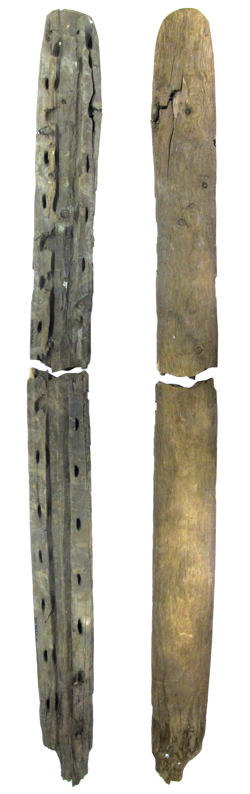
Figure 9.2: figure
A runner for a sledge found to the north of Edsbyn, dating from 3500 BC. The picture shows the runner from above and beneath. Photography: Joakim Wehlin

Water use
Lakes, rivers and streams of the area have historically functioned as important waterways from a variety of aspects. Sledges were useful in wintertime for transportation. The remains of Hälsingland’s oldest sledge, dating from 3700 BC, have been found in Ovanåker parish (Fig.
Table 9.1: @
xref fig:SladMede on input line 1103). refhänvisningen verkar inte funka här?
In the Middle Ages, a substantial expansion of settlement occurred along the water system of the region; this meant that extensive areas became deforested and settled, for example Alfta and Bollnäs. The environment in and around the rivers and streams started, during this period, to be affected by the construction of water mills used for a variety of purposes (thirteenth century). From a historical perspective, the use of water power has been of considerable significance for the production of flax and linen in the region. Flax processing was mechanised even during the seventeenth and eighteenth centuries. Water powered flax processing mills replaced heavy manual stages of the work. In 1825, there were around 1500 water powered flax processing mills in Hälsingland. Water power was invaluable for the iron works too. During the Middle Ages and the sixteenth century, the state had interests in fish trapping in the River Voxnan valley, for example, eel fishing in Bollnäs, Ljusdal and Alfta Kyrkby.
In the nineteenth century, transporting timber by floating it in waterways, log driving (flottning), developed into an important business in the region. The routes for driving logs in the River Voxnan and its tributaries made it possible to transport timber to the sawmills of the district, where the raw material of the forest could be transformed into planks and boards for construction work. The driving of timber was made easier by smoothing the river bed, removing stones and other protruding hindrances, straightening streams and making them narrower (with stone lining). In 1854, the owners of the iron works, Voxna Bruk, built a steam powered saw mill at the mouth of the Rivers Ljusnan and Voxnan. A large-scale state-funded enterprise of adapting the Voxnan into a route for driving timber then commenced. In 1869, a log-driving company started up; they took charge of all log driving in the river in exchange for a fee from the sawmills. Around a hundred years later, the log-driving epoch of the region ended (1966), when the labour-intensive log driving was no longer profitable. Throughout the course of this epoch, around 4-5 million logs had floated down stream to the coastal sawmills during a few hectic summer weeks each year. The log-driving epoch had an extensive impact on the cultural landscape of the region (Section 10.6), as well as on the ecology of the waterways (Section 11.6).
In the mid-twentieth century, large-scale construction started of hydroelectric power stations and regulating dams in Voxnan and its main tributaries. Today, there are 8 hydraulic power stations and regulating dams that have greatly impacted the cultural landscape of the region and the ecology of the waterways (Section 11.6).

9.2 Who are the main users of the biosphere reserve? (for each zone, and main resources used). If applicable, describe the level of involvement of indigenous people taking into account the “United Nations Declaration on the Rights of Indigenous Peoples”.
No land use within the planned biosphere reserve is related to the indigenous people, the Sami’s traditional reindeer herding, or other related conflicts of interest. The main users of each zone are described below.

Core areas
The core areas mainly constitute a place for outdoor life and recreation (cultural ecosystem services). It is permitted to pick berries and mushrooms in the core area (provisioning ecosystem services), as long as it is not specified otherwise in the regulations of each core area. Hunting and fishing (with fishing licence) may be permitted in certain cases. Some of the core areas covered by Natura 2000 regulations are inhabited and the inhabitants can use their land in agreement with the current regulations.

Buffer zones
Buffer zones are used for outdoor life, recreation, for picking berries and mushrooms, and for hunting and fishing. Several villages and small communities, permanently inhabited or only inhabited in summer months, are situated in buffer zones. A large proportion of the buffer zones consist of woodlands, used by private forest owners and larger companies for forest raw material. 40% of the private owners are women (2010). The proportion of farmland in the buffer zones is small.

Transition areas
The major part of the inhabitants of the planned biosphere reserve live in the transition area. In addition, a great number of visitors come to the area each year. Access to outdoor life, recreation, mushroom and berry picking, as well as hunting and fishing is excellent even in the transition area. Within close range of communities, there are several popular open-air recreation areas with signposted walking trails. Woodlands are used for timber by private forest owners and larger companies. A large proportion of the development area is farmland.

9.3 What are the rules (including customary or traditional) of land use in and access to each zone of the biosphere reserve?
The starting points for the national zonation model (Section 7.4) are UNESCO’s guidance on biosphere reserves (The Statutory Framework of Biosphere Reserves and the Seville Strategy) and existing Swedish legislation. Swedish environmental legislation and other general rules governing land use are outlined below, both in general terms and in relation to each zone.

The Planning and Building Act (Plan- och bygglagen)
All planning relating to land, water and construction is regulated by the Swedish Planning and Building Act (PBL). Swedish municipalities have a ”planning monopoly” – this means that they themselves decide how land in their areas is to be used and developed. Under the terms of the PBL, all municipalities must have a current Structure Plan (ÖP) that states how areas of land and water are to be used and the nature of urban development across the municipality. An ÖP must also show how the municipality will safeguard national interests in the local area (see buffer zones).

The Swedish Environmental Code (Miljöbalken)
Swedish environmental legislation is set out in the 1999 Swedish Environmental Code (MB). The aim of the MB is to promote sustainable development so that future generations are able to live in a positive, healthy environment. The law contains various provisions that together help to maintain the varying natural environment in all the zones of the proposed biosphere reserve. Selected examples are given below.
MB Chapters 1-6 contain several overarching provisions, including the general provisions. The general provisions are implemented through the designation of areas of national interest for nature conservation, conservation of the heritage environment and outdoor recreation.
MB Chapters 7-8 contain provisions on the protection of nature; for example, Chapter 7 supports the designation of nature reserves. Chapter 7 also contains the ”shore protection provisions”. The shore protection provisions cover all lakes and watercourses, irrespective of size, and ensure that an area 100 m in each direction from the shore is protected from exploitation (e.g. the erection of new buildings). In special cases, shore protection areas may be extended to 300 m each side of the shoreline. The aim of shore protection is to preserve public access to shore areas for recreation and to protect plants and animals who live on or near shores or in the water. Applications for exemption from the shore protection provisions can be made to the County Administrative Board.
MB Chapter 8 presents the Species Protection Ordinance (Artskyddsförordningen), whose detailed provisions relate to the protection of species and the regulation of the import, export, transportation, storage, trade, preparation and display of species from the wild. The Species Protection Ordinance implements a significant number of the regulations contained in the EU Habitats Directive and the EU Birds Directive.
MB Chapter 11 regulates water operations and structures. Projects such as the construction of dams, installations to regulate water level and the abstraction of ground water generally require a permit from the Land and Environment Court or the County Administrative Board.
MB Chapter 12 contains regulations relating to the duty to consult. Those proposing actions or activity that may have a significant impact on the natural environment but are not covered by permit or notification requirements in other MB provisions must submit a notice of consultation to the County Administrative Board or the Swedish Forest Agency. The duty to consult with the authorities may apply to activity such as the clearance of vegetation from lakes and watercourses, quarrying for domestic use, energy forestry and organised outdoor events.
The MB also contains provisions on environmentally-hazardous activities, health protection, waste and producer responsibility.

The Heritage Environment Act (Kulturmiljölagen)
Protecting and conserving our heritage environments, buildings and ancient remains is a national responsibility, as stated in the Swedish Heritage Environment Act (Kulturmiljölagen, KML). The aim of the KML is to safeguard a diverse cultural heritage for future generations. The KML provides particularly strong protection for ancient monuments and remains. It has the power to designate certain buildings as historic buildings, which can be considered the highest level of protection a building can have. There are several historic buildings in the proposed biosphere reserve.

Hunting and fishing
In Sweden, the hunting of game is regulated by the Hunting Act/Hunting Ordinance (Jaktlagen/Jaktförordningen). Hunting takes place on most agricultural or forestry land that has not been set aside to be left unmanaged. Sections of the EU Habitats Directive and EU Birds Directive have been partially incorporated into the Hunting Act/Hunting Ordinance.
Recreational fishing is regulated by the Fisheries Act (Fiskelagen) and the Fishing, Aquaculture and Fishing Industry Regulation (Förordningen om fisket, vattenbruket och fiskenäringen), as well as the regulations issued by the Swedish Agency for Marine and Water Management (Havs- och Vattenmyndigheten).

Outdoor access rights and other customary rights
The Swedish allemansrätten gives everyone the right to access to the natural environment and can be seen as part of the country’s national heritage. This right has been upheld in the Swedish constitution since 1994. In practice, it confers both rights and responsibilities on those enjoying the countryside. The guiding principle for use could be said to be encapsulated in the motto ”don’t disturb – don’t destroy.” Every person is entitled to cross another person’s property (i.e. land and water), on foot at least, and also to access the land for short periods for such purposes as gathering berries or mushrooms or camping overnight in a tent. In return, we have certain responsibilities in terms of showing consideration to landowners, nature and wildlife and other people. Access is not permitted to private land close to housing or cultivated land if there is a danger that crops might be damaged.
Another customary Swedish right is general grazing rights in the outlying parts of a forest (Lag 1933:269 om ägofred). This means summer farmers may allow their animals to graze freely on forest pasture, although the right is currently seldom used.

Core areas
The core areas of the proposed biosphere reserve coincide with existing legally-protected areas (a National Park, nature reserves, Natura 2000 sites, a cultural heritage reserve and a World Heritage Site). The core areas in the biosphere reserve and their formal protected status are shown in Section 7.4. A detailed description of all core areas is given in Appendix 19.1.1.

National Parks
An area with national park status enjoys the highest possible level of protection to ensure the conservation of its unique natural assets. Land in national parks is owned by the state and managed by the County Administrative Board. The proposed biosphere reserve includes Hamra National Park, where forest and bog land have mostly been left unmanaged. Controlled burning is sometimes carried out to maintain specific natural assets in the national park. Ditches in the park have also been filled in to recreate the original hydrological conditions.
The park is open to the general public and easily accessible. Visitors may roam freely across the entire national park area. The regulations applying to Hamra National Park stipulate what activities are permitted or not permitted within the park and what visiting members of the public can or cannot do. For example, visitors are allowed to pick flowers, berries or mushrooms for their own use and also camp overnight in a tent for two consecutive nights. Activities not permitted include damaging or removing living/dead plant material, moss or lichen or driving a motor vehicle anywhere other than on a public road. Hunting (except mink culling) is also forbidden.

Nature reserves
The land in a nature reserve may be owned by a municipality, privately owned or state owned and its management may be the responsibility of the County Administrative Board or a municipality. When a nature reserve (or a national park) is established, all or some of the ownership rights are transferred from the landowner to the state in return for financial compensation.
Each nature reserve is subject to unique regulations that aim to protect the unique natural values of the area in question. The regulations may be targeted at landowners or the general public, and they must not prohibit more than is strictly necessary to conserve and foster the natural and recreational values of the area. For example, fishing and hunting are permitted provided that there is no specific reason to protect a valuable species. There is often a ban on cutting down forests, digging, quarrying or impacting the ground in some other way and on erecting buildings. However, some management tasks, such as controlled burning, clearing excessive undergrowth, constructing walking trails and traditional haymaking and grazing are allowed if they are necessary for conserving the area’s natural values.
A nature reserve can also serve to meet recreational needs. Visitors can roam freely across all parts of all the nature reserves in Voxnadalen. As in Hamra National Park, members of the public can pick flowers, berries and mushrooms for their own use unless otherwise indicated in the specific regulations for an individual reserve.

Natura 2000
Natura 2000 sites form part of the EU network of protected areas and are designated under the terms of the EU Habitats Directive and the EU Birds Directive. The County Administrative Boards are responsible for management, protection and oversight, and must produce a conservation management plan for each separate Natura 2000 site. Land use such as farming may be permitted at a Natura 2000 site, but there must be no risk of significant impact on the natural values that the site has been established to protect. The decision as to whether a particular use of land may continue or be permitted in a Natura 2000 site is made on an individual case basis by the County Administrative Board. Natura 2000 does not normally entail restrictions on hunting or fishing.

Cultural heritage reserves
In a cultural heritage reserve, a heritage environment is given protection against deterioration and damage through the regulations set out as part of the decision-making process. There is one cultural heritage reserve in the proposed biosphere reserve – Våsbo Fäbodar Summer Farm. The management plan for Våsbo Fäbodar Summer Farm stipulates continued and careful use of land and buildings using traditional methods. The reserve is managed by the County Administrative Board.

World Heritage Site
Three of the seven decorated farmhouses listed as a UNESCO World Heritage Site are located within the proposed biosphere reserve. Sweden’s ratification of the World Heritage Convention and acceptance of the World Heritage Site nomination constitutes a promise to preserve the unique Hälsingland farmhouses. All the villages where the World Heritage Site farmhouses are situated are also covered by specific area regulations that give every building in the villages individual protection. It was Ovanåker Municipality’s work on a comprehensive buildings survey between 1998 and 2001 that led to the adoption of specific area regulations that apply to particular villages with large numbers of cultural assets.

Buffer zones
The buffer zones in the proposed biosphere reserve coincide with existing areas of national interest for nature conservation, outdoor recreation and heritage environment conservation, an SOO (large unexploited area) and an area with a nature conservation agreement. The buffer zones in the biosphere reserve are listed along with their formal status in Section 7.4.

Areas of national interest for nature conservation, conservation of the heritage environment and outdoor recreation
An area designated as being of national interest for nature conservation, outdoor recreation and heritage environment conservation is an area whose natural, recreational or heritage environment values are so significant that they are important for the country as a whole. These national interests are regulated through the general provisions in Chapter 3 of the Environmental Code, and the interests must be given priority over other general or individual interests when determining issues around land use. Requests for changes in land or water use must not lead to material damage to natural or heritage environments. Exactly how a particular national interest is to be upheld is clarified during permit application processes. Ongoing uses of land in areas of national interest, such as forestry, are not prohibited.
The national interest may even be seen as passive in so far as it does not require any positive action to be taken, such as retaining areas of open cultivated land, for the designation to remain valid. The Swedish Environmental Protection Agency (Naturvårdsverket) is responsible for designations of areas of national interest for nature conservation and outdoor recreation while designations of areas of national interest for heritage environment conservation are the responsibility of the Swedish National Heritage Board (Riksantikvarieämbetet). Responsibility for the areas of national interest is shared by the relevant County Administrative Boards and municipalities.

Large unexploited areas (Stora opåverkade områden)
Chapter 3 of the MB (Environmental Code) stipulates that large areas of land and water that are only slightly or not at all affected by development projects or other intrusions in the environment (stora opåverkade områden, SOO) must be protected against actions or activity that could have a significant effect on their character. Municipalities have to show in their Structure Plan which areas have SOO characteristics. Ovanåker Municipality has designated one SOO in its Thematic Structure Plan – Wind power and large unexploited areas (Tematisk översiktsplan - Vindkraft och stora opåverkade områden).
A SOO reported in a municipal Structure Plan has no absolute legal protection, but municipalities, governmental bodies and stakeholder groups may argue for a SOO to be given consideration and protection when dealing with matters requiring permits (such as the construction of wind turbines or new, larger roads, or establishing extraction sites, storage areas and tips).

Woodland nature conservation agreements
Woodland nature conservation agreements are voluntary agreements made between a landowner and an authority (the Swedish Forest Agency, County Administrative Board or a municipality). Agreements are valid for a fixed period of no more than 50 years. These agreements are put in place to conserve and develop the high natural values already in place.
Sveaskog, the state-owned forestry company, is establishing ‘eco parks’ on the basis of a conservation agreement between Sveaskog (the landowner) and the Swedish Forest Agency. Sveaskog has 37 eco parks in Sweden, and one, the Eco Park at Grytaberg (2,700 hectares), is part of the proposed biosphere reserve. An eco park must be at least 1,000 hectares in size, and at least 50% of the forested area must not be used for forestry but either left undisturbed or managed so as to enhance its natural values. In parts of an eco park where the natural values are low, or where they may take a long time to restore, forestry activity may continue even after the eco park has been established provided due attention is given to the environment. The ecological objectives for the management of the Eco Park at Grytaberg are set out in Sveaskog’s eco park plan for Grytaberg.

The Swedish Forestry Act (Skogsvårdslagen) and other voluntary commitments
Forestry in Sweden is regulated by the Swedish Forestry Act (Skogsvårdslagen), which sets out how the forestry industry should take account of natural and heritage environment assets. The Swedish Forest Agency is responsible for processing and reviewing applications for felling and for monitoring felling activities and action taken for regeneration. The law states that reafforestation, or any other action to facilitate natural regeneration, must be undertaken no later than three years after felling. Swedish forestry policy is based on the principle of ‘freedom with responsibility’, meaning that in order to protect areas of productive forest land, landowners are expected to voluntarily set aside land with substantial numbers of natural, cultural or social assets without financial compensation. The voluntary set-aside land must consist of at least 0.5 hectares of contiguous productive forest land.
County Administrative Boards state an opinion on any proposals for felling that affect high natural values, areas adjoining farmland or particularly valuable watercourses, lakes and wetlands. In addition, felling applications affecting known occurrences of species protected under the Species Protection Ordinance must be referred by the Swedish Forest Agency to the County Administrative Board for comment.
Forest owners who have signed up voluntarily to the Forest Stewardship Council (FSC) and Programme for the Endorsement of Forest Certification (PEFC) schemes adhere to the commitments made by each of these organisations. The FSC and PEFC work to promote a balance between the environmental, social and financial interests in forestry. The inclusion of forestry in various environmental and quality standards (including the FSC and PEFC) these days has driven an increase in the proportion of land set aside voluntarily. The FSC standard requires at least 5% of land holdings to be set aside for nature conservation purposes.

Figure 9.3: The Environmental Code prohibits hydropower power stations and water regulation or water diversion schemes for power generation purposes within the area of protected watercourses of national interest.

The transition area
The transition area is subject to the same overarching rules and environmental legislation set out above. Forestry in the transition area is regulated by the Swedish Forestry Act. The majority of private forest owners and major companies are also members of the FSC and PEFC. Within the transition area there are private forest owners who have entered into fixed-period nature conservation agreements with the Swedish Forest Agency or County Administrative Board.
Small areas of land and water that are valuable habitats for endangered species or species deserving of protection can be given statutory protection through the establishment of biotope protection areas. The conservation of small biotopes is very important for biodiversity. There are several woodland biotope protection areas in both the transition area and the buffer zones.
In addition to the biotope protection areas agreed by the County Administrative Board, the municipality or the Swedish Forest Agency on a case by case basis, there are areas throughout the country that have general protection by virtue of biotope protection area status. Avenues of mainly mature deciduous trees, springs with surrounding wetlands, clearance cairns, stone walls and non-arable outcrops are all examples of the types of natural sites that are covered by general biotope protection.
Parts of the River Voxnan’s catchment area have also been designated as protected watercourses of national interest, Fig. 9.3. The area of national interest covers the Voxnan plus its headwaters and tributaries upstream of Vallhaga power station. Chapter 4 of the Environmental Code prohibits hydropower schemes, water regulation and water diversion schemes for power generation purposes within the specified area.

9.4 Describe women’s and men’s different levels of access to and control over resources.
The majority of forest owners in the area are men, which is representative of the situation in the country as a whole (61% men, 2012). The same applies to ownership of agricultural land. This division of ownership is evidence of the survival of the traditional patriarchal system in which men and women took responsibility for different areas. In the case of hunting and fishing too, men have traditionally been involved to a greater extent than women. However, there is increasing interest in hunting amongst women and young people in Sweden.
Women and men will have equal access to the area’s ecosystem services. Two of the five municipalities involved in the proposed biosphere reserve (Ovanåker and Ljusdal) have signed the Council of European Municipalities and Regions’ ’European Charter for Equality of Women and Men in Local Life’. By doing so, they have committed themselves to working actively towards gender equality as a fundamental right, to abolishing stereotypical perceptions of gender and to achieving balanced representation of women and men in various decision-making processes.
Chapter 10

Human population of proposed Biosphere Reserve

10.1.-3. Core Area, Buffer Zone, Transition Area

Table 10.1: Number of inhabitants in the planned biosphere reserve

Area | Permanently | Seasonally
Core area(s) | 560 | 200
Buffer zone(s) | 1350 | 700
Transition area(s) | 11330 | 3600
Total | 13240 | 4500

10.4 Brief description of local communities living within or near the proposed biosphere reserve
The population of the planned biosphere reserve amounts to ca Ny Siffra? 13,200 people, most people live in the transition area (Table 10.1). The major part of the built-up areas are concentrated in the River Voxnan valley and its connected lake system, while the rest of the population is spread out in smaller villages. These villages are usually located along main roads.
The two largest communities (≥ 2000 inhabitants) are Edsbyn and Alfta (Table 10.2, Fig. 10.1). There are several small communities (50-199 inhabitants) in the area. The river valley, Voxnadalen, is in its entirety a sparsely populated rural area with approximately 8 inhabitants/km2, which can be compared with the national average and the EU average of ca 22 and ca 115 inhabitants/km2, respectively.
The population largely comprises ethnic Swedes. During the past years, there has been an increase in the number of people born in other countries. In 2015, this group was 7% of the total population. The main part of the population consists of people of working age (20-64). Predictions for the future indicate that the proportion of people over 65 will increase, while there will be a decrease of the number of people of working age. The latter is a relatively common trend in Sweden’s rural areas. However, the number of people of the ages 0-19 is estimated to continue to be fairly stable during the coming 15 years.
The majority of the population works in the industries of the area, or at any of the numerous small companies. Local industries and small companies largely encompass forestry industry, engineering businesses and modern technology. Two of the largest private employers, Edsbyverken and Svenska Fönster, have a long history; they were established in 1899 and 1962, respectively. Both companies are located in Edsbyn.

10.5 Name(s) of the major settlement(s) within and near the proposed biosphere reserve with reference to the map (section 6.2):
The names, population and geographical location of the main inhabited areas are shown in Table 10.2 and in Fig. 10.1. Two communities, Bollnäs (12,842 inhabitants) and Sveg (2,547) are situated close to the planned biosphere reserve, on the south-eastern and north-western side, respectively (Fig. 3.2).

Table 10.2: Communities in the planned biosphere reserve.

Community | Inhabitants
Edsbyn | 3985
Alfta | 2155
Roteberg | 393
Los | 387
Runemo | 263
Viksjöfors | 244
Ovanåker | 212
Freluga | 194
Voxnabruk | 135
Ullungsfors | 130
Hamra | 93
Norra Knåda | 93
Södra Knåda | 63
Söräng | 65
Bodåker | 64
Tandsjöborg | 61
Långhed | 55
Edstuga | 55
Ämnebo | 51

Figure 10.1: Communities with at least 50 inhabitants in the planned biosphere reserve.

10.6 Cultural significance
From a historical perspective, ecosystem services that are generated by forests, waterways, and farmland have had considerable influence on the economic and cultural historical development of the area. Favourable economic conditions, in combination with the absence of a powerful aristocracy, provided space for a strong and homogeneous group of independent farmers. Today, the area is characterised by a strong spirit of enterprise, entrepreneurship and strong social networks in the form of, for example, Free Churches and sports associations.

Forest use and the log-driving epoch
Forest use has a central role in Voxnadalen’s cultural history. The forest provided the farmers of the area, not only with timber, material for fences and birch bark for roofs, but also forest pasture for the animals, winter fodder from mowing the peatlands and gathering leaves. Bog-iron ore and charcoal, important raw materials for iron production, were other products of the forest. The forest continues to be an important source of income for the area even to this day.
In a historical perspective, hunting and gathering in the forest were vital means of subsistence for the first inhabitants. Hunting continued to be an important source of meat and skins. Today, hunting is a significant leisure activity in the area and a way of life for many people.
There are still many signs of the historical use of the forests of the river valley. Near the River Voxnan, there are plenty of remains of charcoal production sites (Fig. 10.2) from the time when forest resources supplied the iron works with the charcoal that was necessary for processing iron. Charcoal burners worked in the forests, burning timber into charcoal, right up until charcoal was replaced by coal.
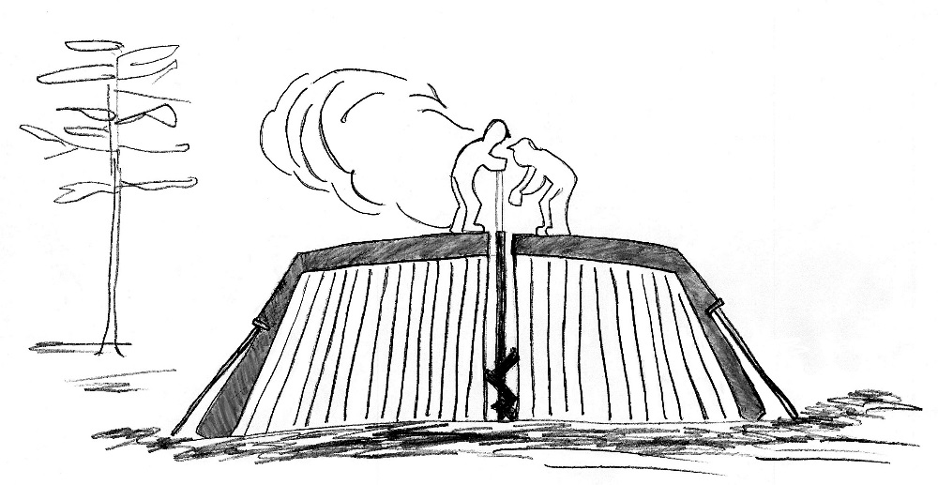
Figure 10.2: A cross-section of a charcoal stack that is lit at the centre. The timber is placed standing on end and is then covered with earth and brushwood to prevent the air-flow. Illustration: Fia Johannessen
The farmers of Hälsingland have a long tradition of handling timber. Consequently, the industrialisation that swept over the country in the nineteenth century was here based on forestry work. Large sawmills were constructed, but initially the establishment of modern sawmills was inhibited by the iron industry that needed charcoal for the iron works. In the mid-nineteenth century, the farmers started to sell rights to cut timber on their property, at the same time as there was an increasing demand for timber in other countries. Local raw materials supplied by Hälsingland farmers thus became attractive. The profit from timber and sales of timber rights provided a good income; the farmers had more money than ever to spend.
Log driving along the River Voxnan became a considerable industry in the nineteenth century and early twentieth century. The log-driving epoch had a severe impact on the cultural landscape. Waterways were cleared of stones and other hindrances to facilitate the transport of timber. Stone and wooden structures were built on a large scale to steer the timber. Sometimes side streams were blocked, which affected the flow and depth of the water. The labour-intensive log driving was often dangerous work that was performed during a few hectic weeks in the early summer (Fig. 10.4). Log driving was finished in the end of July when the so-called rump (sw. rumpan) passed down the river. This was when the log drivers went down the river in boats to make sure that no timber had become stuck or had been left behind on land.
Log driving in the River Voxnan ended (in the 1960s) when it was no longer profitable, after an epoch that had lasted almost a hundred years. Many remains of the log-driving epoch (Fig. 10.3) can still be seen in the waterways of the area. A 7-kilometre walking trail has been created alongside the River Voxnan as a reminder of the epoch when the river was an important route for transporting timber. Information panels about the log-driving epoch and the natural environment by the river are set up along the trail.

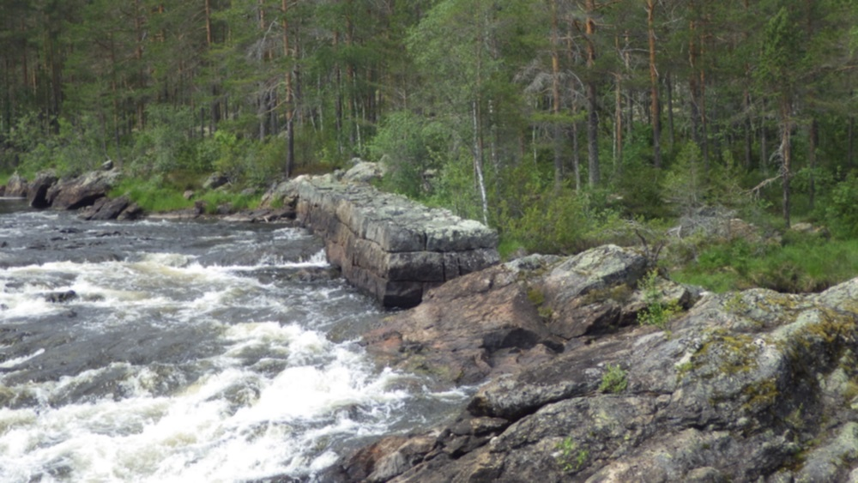
Figure 10.3: Historical remains of the log-driving epoch include built-up banks along the river. The picture shows a particularly substantial stone banking at the Hylströmmen rapids. Photography: Anders Persson/Linda Jonsson

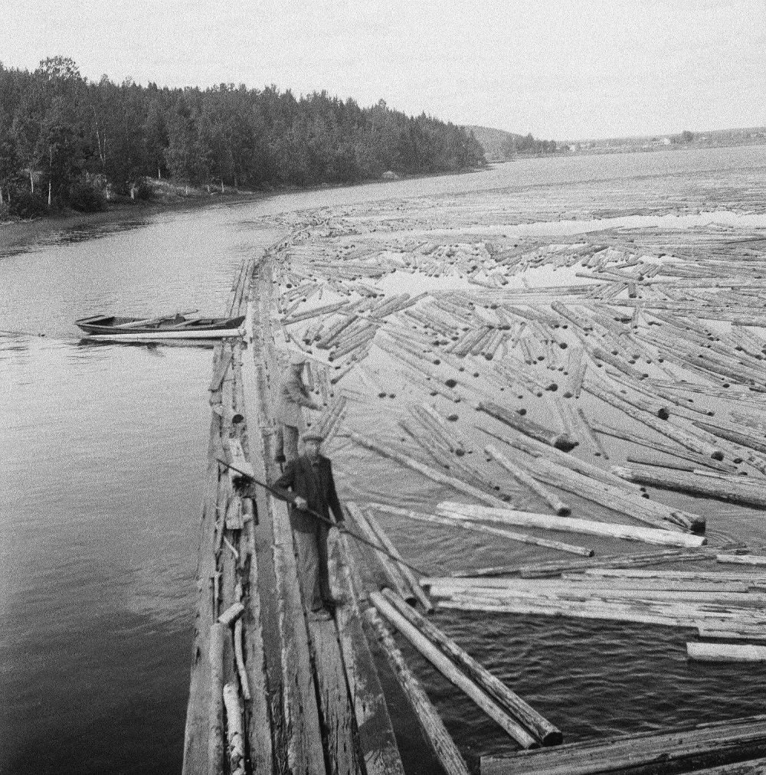
Figure 10.4: Log driving in 1952 at Mödänge in the southern part of the River Voxnan. Photography: Georg Gagnehed, with permission from Ovanåker Local History Society.

The settlement of Forest Finns
The settlement of Forest Finns during the end of the sixteenth century and early seventeenth century has affected the cultural history of the area. Forest Finns were in actual fact Swedes during this period, but their background and culture differed from Swedish tradition.
The Forest Finns brought their own building traditions. A characteristic of the Forest Finns was their smoke cottage with its large stone oven, a so-called smoke oven, placed in the corner of the building. The smoke cottage had no chimney, instead the smoke was led through a wooden flue from the ceiling out through the roof. The big smoke oven stored the heat efficiently and it only needed to be fired up once a day. If the house was constructed correctly, the smoke was not troublesome. Other buildings of the Forest Finns were the smoke sauna, and the drying house that was used to dry swidden rye.
The Forest Finns spoke an east Finnish dialect, which can still be traced in Forest Finnish place names. Many bogs, tarns and hills still have Finnish names. Forest Finnish food, for example porridge made of barley flour and water (Motti), is still eaten today. Motti used to be food for the poor, but today it is made for festive occasions such as ‘Homecoming events’ and ‘Forest Finn Evenings’.
The Finn Forest Museum in Skräddrabo (25 km to the south of Alfta) is the only cross-Scandinavian museum with Forest Finnish culture as its theme. The ambition of the Finn Forest Museum is to collect information and material from the Finn Forest regions in both Sweden and Norway. Currently, the museum has an exhibition consisting of 300 objects, and it has an extensive reference library.

The landscape of barns and summer farms
Throughout the course of the centuries, the agriculture of Hälsingland adapted to the climate, the fertility of the soil and the terrain; the whole landscape was used for farming. Hälsingland was more suited for animal husbandry than for growing crops due to a short season for cultivation and a scarcity of fertile soil. A characteristic for the mid-Swedish woodlands (including Hälsingland and Dalarna) is the transhumance practice of summer farms. This is a distinguishing feature of this region and an essential part of its culture. The practice of summer farms was a way for the farmers to maximise possibilities of grazing for the animals of the farm. The history of summer farms can be traced back to the Middle Ages.
Whereas the home farms were located in the villages, which grew up along the river valleys and along waterways, the summer farms were situated far away from the home farm, often in elevated parts of the landscape. Most of the summer, the animals of the farm grazed in the forests of the summer farm, which usually consisted of a cottage with a stove, a shed for the animals (a small barn) and a cellar. As a result of this, the fields of the villages could be used for growing crops and hay. In the summer months, the summer farm was a lively work place. The maids walked long distances with the animals (cows and goats) to get there. Since each summer farm consisted of several buildings and different summer farms were often placed close to each other, this meant that small villages were formed in the forest. Several place names in Voxnadalen indicate that early summer farms gradually transformed into permanent villages.
The milk was processed at the summer farm into less perishable milk products (butter and cheese), which could be stored for the winter when cows and goats stopped milking. Summer farms were the work places of women, who had the heavy responsibility for the life and health of the animals. Butter that was produced during the summer was an essential part of the economy of the farm. Butter from Hälsingland was considered particularly good and was sold to neighbouring towns and industrial sites, which provided ready money for the household. The traditional system of summer farms was most spread during the nineteenth century and gradually declined during the twentieth century, when farming was modernised and it became more practical to graze the animals at the home farm.
Nowadays, only a tiny proportion of the old summer farms in the mid-Swedish woodlands are farmed traditionally. However, within the planned biosphere reserve, the best-preserved summer farm environments of the county still remain. Parts of the biosphere reserve are therefore designated as of national interest for heritage environment conservation. Most of these summer farms, with their meadows and cultivated fields, date from a period between the eighteenth century and the beginning of the nineteenth century. Among these summer farms, Våsbo Fäbodar Summer Farm has been designated a cultural heritage reserve (2008), also constituting one of the core areas of the planned biosphere reserve. Distinctive features at Våsbo include well-preserved buildings and well-kept land with a rich flora. The cultural heritage reserve is thus a worthy representative for how summer farming in Hälsingland would have been at the end of the nineteenth century.
The ancient farm landscape is an important part of the Swedish cultural heritage. Buildings that belonged to the old farming society were numerous and have often become redundant in the modern agriculture of our present day. The multitude of barns was part of the landscape, but these are now disappearing from the farmland, even in Voxnadalen. Unlike southern Sweden where the barns usually stood close to the rest of the farm buildings, the northern Swedish barns stood in the meadows. When meadows and other fields that were mown were commonly spread over large areas, there was one barn for each hayfield. Hay was stored in the barn until winter and was transported to the farm on a sledge.
The first barns were built of round logs. At the beginning of the twentieth century, it became more common to use sawn timber for building barns. The ‘clump barn’ (klumplada) is an ancient type of barn mainly occurring in Ovanåker. This type of barn is often small (2 x 3.5 m), with a low roof and a small door centrally placed on the long side of the building. The large number of barns are an essential part of the scenery; they have a direct connection with the history of the area since they are evidence of the location of old meadows.

Flax and linen
Hälsingland has a long tradition of linen production and was previously one of Sweden’s most prominent producers, with the quantitatively largest production. Linen had an important role in the cultural history of the area, which is symbolised by the flax flower, used as an emblem for the Hälsingland County (Fig. 10.5).
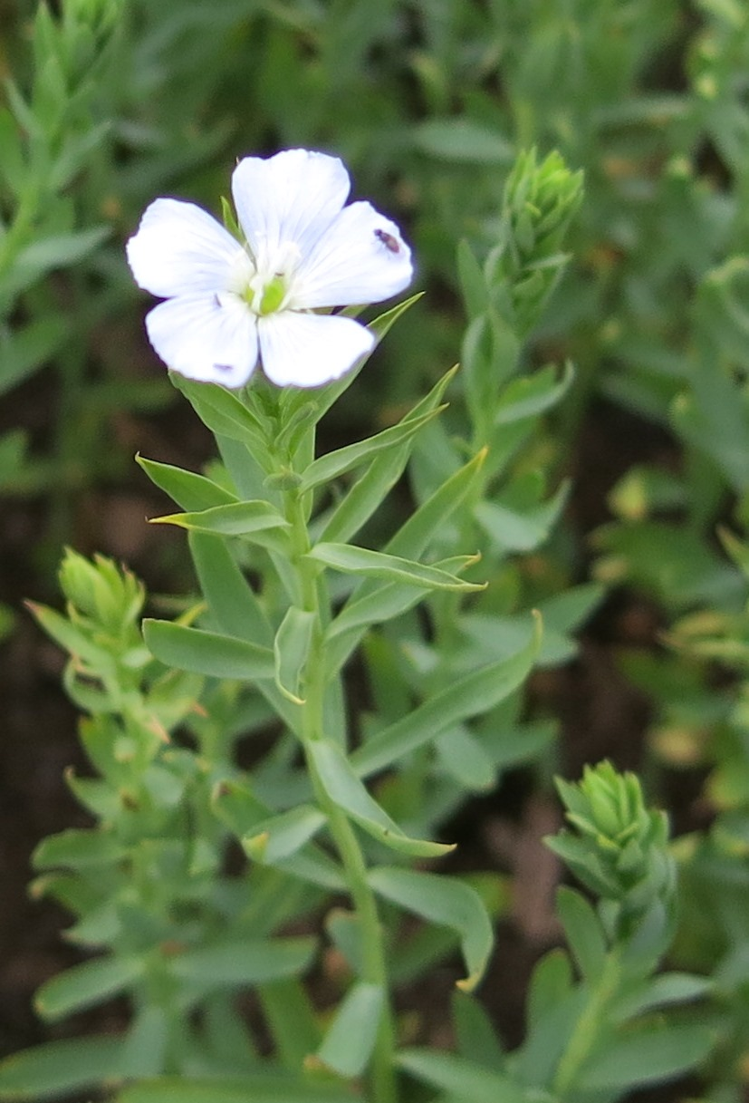
Figure 10.5: Flax flower (Linum usitatissimum). Photography: Fia Johannessen
Use of plant fibres for producing cloth has an ancient history. In historic times, flax (Linum usitatissimum) was grown for household use almost all over Sweden. However, there was not enough in some parts of the country. The demand for linen was instead covered by surplus from other areas. Surplus cultivation of flax occurred in Hälsingland as early as in the Middle Ages. There was a considerable upswing in the production as a result of years of peace in the eighteenth century – a favourable period for domestic business generally – this continued during the nineteenth century and on until the Second World War. Growing flax was particularly important during the nineteenth century; cultivation was concentrated to places such as Voxnadalen during this period. The significance of flax cultivation and the linen industry for the area diminished when cotton weaving had its breakthrough in the 1850s.
Processing flax was labour intensive work involving several stages. Rivers and streams of the area became important for flax processing even as early as the seventeenth and eighteenth centuries, when water powered flax processing mills could replace several heavy stages of the work.
Flax and linen were a vital part of the farmers’ economy and prosperity. Merchants from coastal towns purchased linen cloth from the farmers. Export records from the ports of Hudiksvall and Söderhamn show that several million aln (old length unit, 1 aln = 59.38 cm) fixa som fotnot istället? of linen were exported annually. In addition, the farmers themselves travelled to markets to sell their linen products as well as butter from the summer farm. In this way, the linen production provided ready money for consumption and for paying tax in an economy that still depended on self-subsistence. Linen was also needed at home at the farm; linen was the main textile in use before the introduction of cotton.
There is no contemporary large-scale or economically profitable production of linen in Sweden as a whole. However, the knowledge about growing, processing and refining flax is kept alive in Hälsingland by local enthusiasts and Hälsingland’s flax association, Hälsinglands Linförening. The company Växbo Lin, located just outside the planned biosphere reserve, weaves, sews and sells linen products; thus keeping up the valuable cultural heritage of the area.

Buildings and local characteristics
Building traditions in Hälsingland have undergone a long and interesting development from the Middle Ages until the present day. Medieval times were strongly influenced by the introduction of Christianity; many stone churches were constructed in the region during this period (for example, Alfta Church). Churches represent the most prominent of our medieval monuments.
The art of timber construction has had a consequential cultural impact on the building tradition of the area. Many preserved timber buildings in the provinces of Hälsingland and Dalarna were built in the Middle Ages. These timber buildings are all raised log cabins, in Swedish called härbre, which were free-standing small buildings used for storage. Knowledge of dwelling houses of this period is therefore limited. Medieval timber constructions are also preserved in several of the churches.
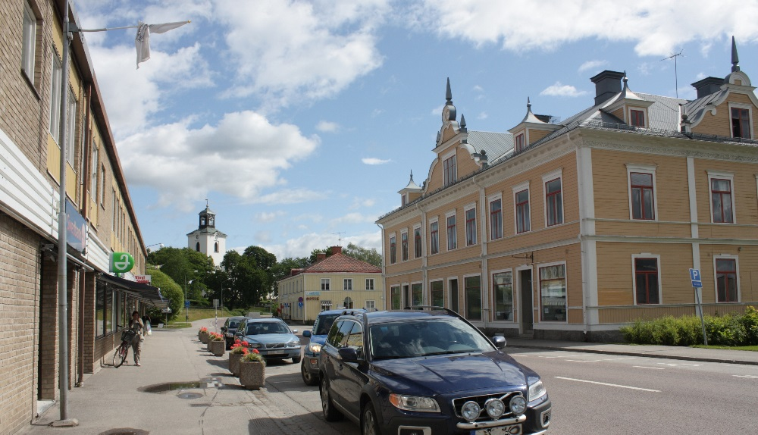
Figure 10.6: Alfta town centre with typical late nineteenth century buildings. Alfta Church can be seen in the background. Photography: Picture Archive of Ovanåker Municipality
A usual seventeenth- and eighteenth-century layout of a farm was to place the buildings around four sides of a yard to close it in. A common kind of farmhouse was called a parstuga in Swedish, a paired cottage, it had a room on each side, with a hall and a smaller room in the middle. Each building of the farm had its specific function either for dwelling or for various farm purposes.
In the mid-eighteenth century, the farmers in Hälsingland became more affluent, which resulted in a considerable population increase. A marked expansion in the construction of buildings most likely occurred during this period. The last decades of the eighteenth century were, moreover, a period when it became usual to build and decorate buildings for the sole purpose of having festive gatherings. The farms of the Hälsingland farmers were renowned for their size; during this period, the authorities started to criticise the farmers, stating that the buildings were too large – it was considered a waste of timber.
In the nineteenth century a change of ideal occurred in the building tradition. Instead of farms with four buildings surrounding a yard, there was a shift to constructing buildings on three sides of a yard. One main farmhouse was flanked by two detached wings, making the farms look like manor-houses. The buildings were larger and were built in two and sometimes three storeys. Another common feature was to join the farmhouse with the barn via an indoor connection. The grandest examples of this style of building can be found in Voxnadalen. It became popular to paint the outside of the house red; previously, the houses were grey and tarnished by the sun. In the late nineteenth century it became fashionable to paint the farmhouse in pale oil colours. After the commencement of the industrial era, the appearance of houses altered further when mass-produced sawn timber and other building details meant that the houses could be decorated with fretwork and large verandas. Furthermore, this was the golden age for painted interior decorations (Section 10.6).
Travellers in Hälsingland were often astonished when they saw the elaborately designed farms – but why did the farmers build such big houses, more than they needed for practical purposes? The large farms were sometimes called ’wooden palaces’ or ’timber castles’, but today they are called Hälsingegårdar ’Decorated Farmhouses of Hälsingland’. The tradition of building decorated farmhouses in Hälsingland most likely arose because of several coinciding reasons.
• Tradition – The large houses of the Hälsingland farmers were mentioned as early as the seventeenth and eighteenth centuries.
• Easy access to suitable raw material (pine timber) – in the nineteenth century an ordinary freehold farm owned approximately 100-500 ha of forest land.
• Trading conditions and economic surplus – the proceeds from flax and forestry industries provided ready money for paying workers and the purchase of tiled stoves, bricks/roof tiles, doors and windows. Further, farming was more profitable here than in other regions of northern Sweden (Norrland).
• Surplus labour during certain times of the year – in the winter, the farmer himself and his farmhands could saw the timber themselves in the forest.
• Fashion and ambition – people were inspired by the new buildings and interior decoration of neighbours and relatives.
• Status – Owning a large elaborately decorated farmhouse was an important status symbol.
Currently, seven of the approximately 1000 large magnificent decorated Hälsingland farmhouses have been listed by UNESCO as a World Heritage Site (2012). Three of these seven are situated within the planned biosphere reserve (Fact files 4, 5 and 6). Decorated Hälsingland farms are valuable historical testimonies and a unique signum for the cultural history of the area.
The strong and free position of the land-owning farmers was unique in a European perspective. Even so, there was also immense poverty among some groups such as landless people, soldiers and craftspeople. The number of cottages and other simple dwellings, often called utanvidsbebyggelse in Hälsingland, increased during the nineteenth century. These buildings stood on non-freehold property and were attached to freehold farms, industrial estates and vicarages. Many of these buildings are still standing and are used as houses to live in.
During the late nineteenth century Alfta and Edsbyn grew into small towns with social classes, including merchants and an upper class. Even now the typical architecture of the merchant houses characterises Alfta and Edsbyn; small wooden palaces, often architect designed, with elements of rococo and classicism (Fig. 10.6).
Compared with the farm villages, the milieu of the industrial estates of the iron mills would have constituted an entirely different world. The iron mills had a substantial influence on economy, supplies of raw materials, building traditions, architecture, geographical mobility and social mobility. Large amounts of slag, a waste product from iron production, were produced by the iron mills. The slag was used as a building material; houses were built of slag stones. These characteristic slag stone buildings can be seen in the old industrial estates of Voxnadalen.

Characteristics of Hälsingland farmhouses and decorative painting
The building tradition of Hälsingland differs considerably from the rest of Sweden, but even within Hälsingland there are distinct differences in form, expression and details. Farmers of Hälsingland probably spent more of their economic surplus on their houses than was usual in other parts of the country. Decorative interior painting occurred as early as the sixteenth century, and from the seventeenth century onwards, several travellers’ accounts mention the well-built and handsome farms of Hälsingland. Initially, the interior painting (Fig. 10.7) was produced on tapestries, but it became more common to paint the decorations straight on the walls in the early eighteenth century.
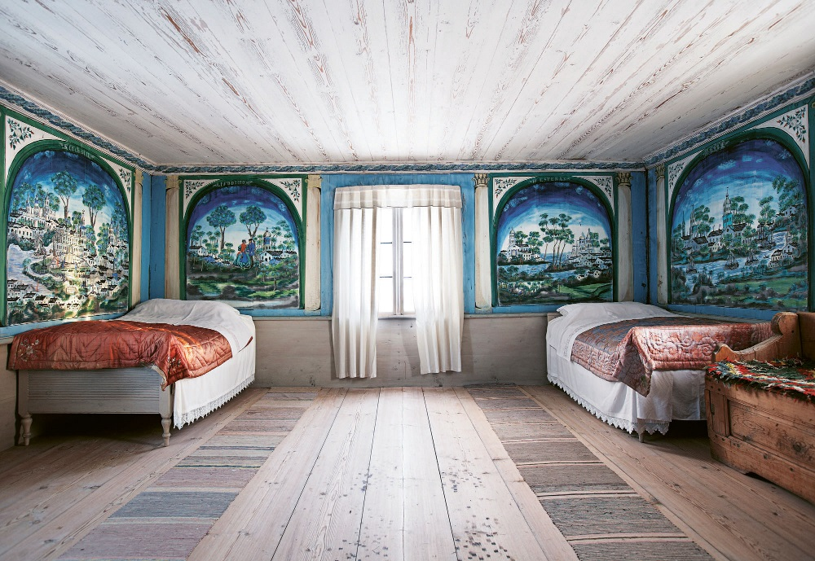
Figure 10.7: Wall paintings in a bedchamber in the World Heritage Site farm Pallars in Långhed. Photography: Jakob Dahlström
Homes entirely covered with decorative paintings became common in the beginning of the nineteenth century, although the golden age of decorative interior painting occurred in the mid-nineteenth century, when people in Hälsingland earned additional income from forestry work. Farmers who built and managed Hälsingland farms were often open to new ideas concerning interior decoration and fashion. Many interior decorators came from Dalarna, but a local tradition arose in Ovanåker – ’Ovanåker painting’. Typical features of Ovanåker painting included columns, draperies and urns with flowers. Interior decoration with wallpaper also occurred at an early stage. Wallpaper was a costly but cherished feature of the decoration, often placed side by side with decorative paintings.
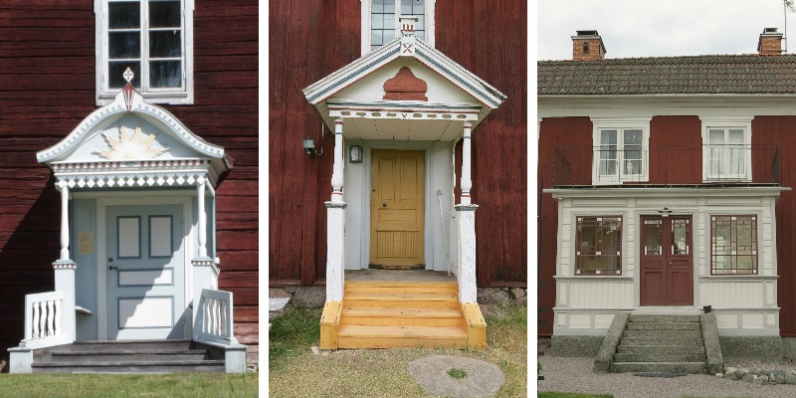
Figure 10.8: A magnificent porch signified status. Typical mid-nineteenth century porches are shown to the left (Ol-Anders, Alfta) and in the middle (Löka, Långhed). To the right (Pallas, Roteberg) is an example of a porch that was rebuilt at the turn of the century, to become a veranda suited to the ideals of the time. Photography: Fia Johannessen
The entrance to the house was important, so the farmers of Hälsingland built grand porches to mark status and quality (Fig. 10.8). These magnificent porches have become a unique signum for Hälsingland. Many of the farmhouses in Voxnadalen have porches with a profusion of moulding, dentils and tassels (Classicism).
Decorated Hälsingland farmhouses with their impressive porches, carpentry work and interior painting are a central part of the cultural heritage of the area. The large number of well-preserved decorated interior features in their original position in nineteenth century farmhouses is unique to Hälsingland and Sweden. Due to the exceptional interior painting and building traditions of the decorated Hälsingland farms, these seven farms became a World Heritage Site in the summer of 2012.
[Sorry. Ignored \begin{fruta} ... \end{fruta}]
[Sorry. Ignored \begin{fruta} ... \end{fruta}]
[Sorry. Ignored \begin{fruta} ... \end{fruta}]

The role of religion and Free Churches
The Free Church movement, which started over 150 years ago, is strong in the region around Alfta and Edsbyn in Voxnadalen. Before the twentieth century, Sweden had no freedom of religion; the church was both a secular and ecclesiastic institution of power. In the middle of the 1800s, there was an outbreak of religious devotion and pietism in Hälsingland, challenging the state church’s monopoly of people’s faith. The separatists were called ’Erik-Jansarna’ after their self-appointed prophet Erik Jansson. This religious revolt was directed towards the state, which still prosecuted people who wanted to pursue their religion freely, even if this was a Christian faith. Alfta was one of the main strongholds of the Erik-Jansarna. As a result of religious persecution, a great number of Erik-Jansare migrated over the Atlantic to establish the settlement Bishop Hill in Illinois, America. This was the commencement of the extensive emigration from Hälsingland that occurred. Furthermore, it opened the door for the Free Church era.

Food tradition
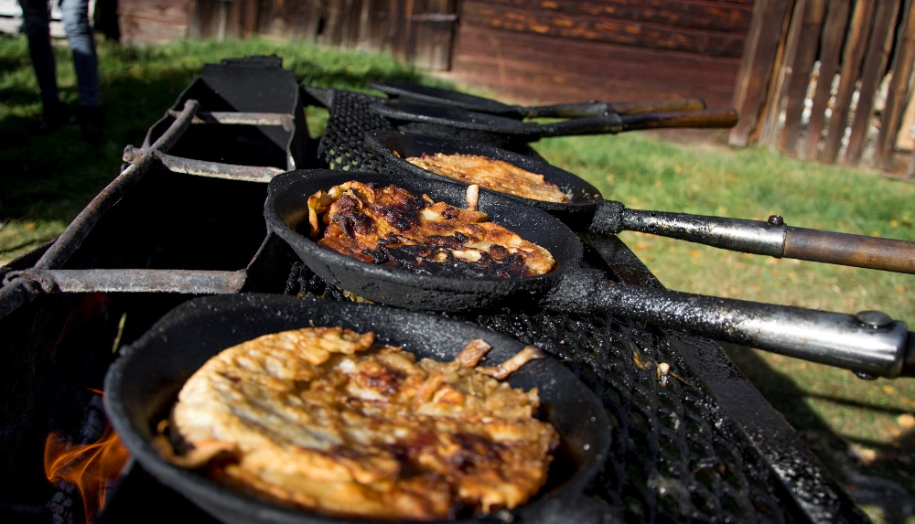 figurePreparing kolbulle (Charcoal burner’s thick pancake with pork); it is fried in a hot pan over an open fire or on a barbeque. Photography: Ovanåkers kommun
Historically, the food of the region is mainly based on milk products. In the old days, the farmers only ate butter as a delicacy on festive occasions. Butter made in Hälsingland by the girls at summer farms was celebrated and considered particularly good. A dish with a special place in the food tradition of the region is Hälsingeostkakan (Hälsingland curd cake). The recipe is slightly different depending on where in Hälsingland it is served. Hälsingland curd cake is traditionally eaten as a pudding; it is heated in cream and served warm with whipped cream, fruit syrup, jam or fresh berries. Another common traditional dish is kolbulle (Charcoal burner’s pancake), this is like a thick pancake that is fried in a pan over an open fire, pork is either an ingredient or is served with the Charcoal burner’s pancake .
There are several local food producers in the area, who make and sell their own cheese, honey, Swedish hard bread, jams and/or meat from animals grazed on semi-natural pasture. A few of Voxnadalen’s food producers have entered the Swedish championship in the craft of cooking and have been awarded prizes, both gold and silver medals, for their products. For example, Lotta-Boden in Loos were awarded prizes (in 2014, 2015 and 2016) for their cloudberry jam, raspberry jam and spruce-tip preserve. Hard bread baked by Söromsjöss Gårdsbageri (farm bakery) was another winner.

Folk music
Folk music is a strong tradition in the area; even today, it is in a state of continuous development, played by musicians of all ages. The tradition of playing folk music is strongest in Hälsingland and Dalarna. A gathering of folk musicians (Bingsjöstämman) is held annually near the southern border of the planned biosphere reserve. Typical for folk music is the large number of musicians; the audience of the music are often amateur musicians themselves. Folk dance is another tradition closely associated with folk music.

Sports
Organised activities in associations, societies and clubs comprise an important and active part of life in Voxnadalen, largely within sports. There are several successful sports clubs with elite players and participants at both national and international level, particularly in orienteering, archery, frisbee and motocross. Bandy (Fig. 10.10) has a central role in the sports tradition in the region of Edsbyn, Bollnäs and Ljusdal. With the attraction of two elite level club teams (Edsbyns IF Bandy and Bollnäs GIF Bandy), thousands of spectators and supporters follow the matches. Sweden’s first indoor arena for bandy was built in Edsbyn, popularly spoken of as ’the Bandy Church’.
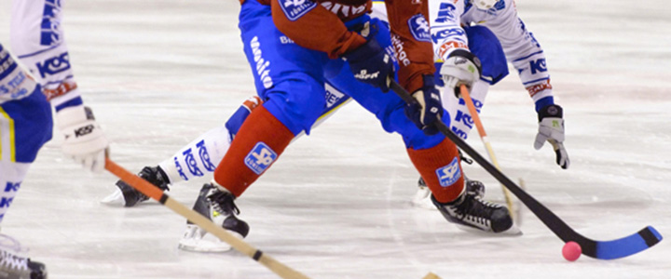
Figure 10.9: Bandy. Photography: Christer Åsentorp

Art
Johan Erik Olsson (1865-1944), also known as Lim-Johan, is one of the most renowned and celebrated naïve artists of our time. Lim-Johan was born and grew up near Edsbyn. His art was not known during his lifetime; it was found by chance when his home was cleaned out after he had passed away. A few of his works of art were burnt, as they were considered worthless. Only 28 paintings remain and Lim-Johan’s art is now estimated to be worth millions (SEK). A modern artist and author is Erik Olof Wiklund (born 1989 in Alfta). His art and literature are often based in local history and in the encounter between history and contemporary conditions.
A tour of art galleries, displaying the art of both amateur artists and professional artists, is arranged annually in the region of Edsbyn and Alfta. There are several active artisans in the area who produce textile crafts, metalwork and pottery. The Viksjöfors ballet (Viksjöfors) arrange dance activities, for instance, an annual dance gathering that attracts people from the whole world. There are also several small museums in the area.

10.7 Specify the number of spoken and written languages (including ethnic, minority and endangered languages) in the biosphere reserve.
The language spoken in the area is mainly various Swedish dialects; these include the dialects Ovanåkersmål, Alftamål, Oremål, Härjedalska as well as Bollnäs-, Ljusdals- and Färiladialekt. Among these dialects, it is really only those who speak Oremål who might be described as bilingual. All the dialects have their roots in ancient Nordic language. Just outside the planned biosphere reserve, in Härjedalen Municipality, there is an area with a minority of Sami-speaking people.
Refugees and migrants from other countries bring their languages to the region. Consequently, other languages spoken in the involved municipalities are Tigrinya, Arabic, Somali, Dari and several other languages. Schools provide home-language education for children with a native language other than Swedish, with the purpose of improving their language skills in Swedish as well as their native language.
Chapter 11

Biophysical Characteristics

11.1 General description of site characteristics and topography of area
The landscape of the area is characterised by distant blue mountains, vast forests and peatlands with a covering of pine trees. The River Voxnan runs through the landscape, which is interspersed with a multitude of lakes, and the open countryside along the valleys is dotted with decorated farmhouses (Hälsingegårdar) and barns. The river Voxnan has its source in the province of Härjedalen and feeds the River Ljusnan down-stream from the community of Bollnäs.
The area is situated in the border zone between the south boreal zone, with its low hills and river valleys, and the mid-boreal zone with undulating mountainous terrain and outcrops of primary rock. The main part of the river valley, Voxnadalen, is located at an elevation above the marine limit (Fact file 3, p. fr_InladsisHK). Soils in this area can therefore be characterised as moraine deposit and sediment that was never washed by the sea (Fig. 11.3). Vegetation is dominated by coniferous forests interspersed with deciduous trees. The open farmland is mainly situated on well-sorted soils along the River Voxnan, along main waterways and in the glacial valleys. Besides the River Voxnan, the numerous lakes and smaller rivers and streams contribute to the character of the countryside (Fig. 11.1). Within the area, there is 30,000 ha of wetlands, which corresponds to 8% of the total surface. The wetlands are mainly located in the northern and western parts of Voxnadalen. Most of these are poor fens, but because of the bedrock in the surroundings of Los (Section 11.4), extreme rich fens are found in these parts.

Figure 11.1: Map of land use in the planned biosphere reserve.

11.2 Altitudinal range

11.2.1 Highest elevation above sea level
Highest point: Skaftåsen 686 metres above sea level.

11.2.2 Lowest elevation above sea level
Lowest point: Outlet into the River Ljusnan, 51 metres above sea level.

11.2.3 For coastal/marine areas, maximum depth below mean sea level
–

11.3 Climate
Voxnadalen is situated in climate zone Dfc (Köppen climate classification). This means a cold temperate climate with precipitation all times of the year. Precipitation increases in the higher parts of the landscape. The weather is often changeable, with cool summers and less than four months per year with an average temperature of ≥ 10 ∘C. Cold winters and plenty of snow are characteristic for the area. The vegetation period is estimated to around 130 – 150 days per year.
The average annual temperature in the region of the catchment area of the River Voxnan during the normal period 1961-1990 was approximately 3 ∘C. The number of sunshine hours is around 1,700 per year and the average annual precipitation is 600-800 mm. Average values specified in Section 11.3.1-11.3.3 are based on data from meteorological stations in Edsbyn A and Hamra A (Table 11.1).

11.3.1 Average temperature of the warmest month
Edsbyn: 15.8 ∘C (July)
Hamra: 14.7 ∘C (July)

11.3.2 Average temperature of the coldest month
Edsbyn: -6.2 ∘C (January)
Hamra: -5.3 ∘C (January)

11.3.3 Mean annual precipitation, recorded at an elevation of
Edsbyn: 585 mm, 184 MASL
Hamra: 671 mm, 454 MASL

11.3.4 Is there a meteorological station in or near the proposed biosphere reserve? If so, what is its name and location and how long has it been operating?
There are several meteorological stations in the planned biosphere reserve; these are managed by the Swedish Meteorological and Hydrological Institute (SMHI).

Table 11.1: SMHI’s meteorological stations in the planned biosphere reserve

Name of | Position | Elevation | WMO- | In use | Meteorological obs.
station | (lat; lon) | MASL | number | from date | A | B | C | D | E
Edsbyn A | 61.3613; 15.7175 | 184 | 2-338 | 1995-09-01* | X | 15 min | X | X
Hamra A | 61.6606; 14.9948 | 454 | 2-329 | 1995-12-01* | X | 15 min | X
Fågelsjö A | 61.7984; 14.6477 | 410 | - | 1961-01-01 |  | 24 h |  |  | X
Los D | 61.7256; 15.1783 | 406 | - | 1967-10-01 |  | 24 h |  |  | X
Lobonäs D | 61.5338; 15.3444 | 220 | - | 1961-01-01 |  | 24 h |  |  | X

*These two stations have replaced earlier stations, see Table 11.2. Distance between old and new stations in Edsbyn, 6.5 km; and in Hamra, 100 m.

11.3.4.0.2 Legend for meteorological observations:

A: Air temperature
B: Precipitation (in liquid form) every 15 minutes, every 24 hours
C: Precipitation intensity (15 min), wind speed, wind direction, wind in gusts (max/h), relative humidity, air pressure, visibility, current weather. All parameters are measured per hour, except precipitation intensity and wind in gusts.
D: Total cloud cover per hour
E: Type of precipitation, snow depth, both measured per 24 hours

Table 11.2: Meteorological stations no longer in use

Name of | Position | Period of use
Station | (lat; lon)
Edsbyn | 61.3784;15.8352 | 1941-01-01 – 1996-01-31
Hamra | 61.6577;14.9943 | 1901-02-01 – 1911-01-01, 1973-03-01 – 1995-11-30
Finsthögst | 61.3161;15.4969 | 1893-02-01 – 1954-01-31

11.4 Geology, geomorphology, soils
The bedrock of the area is dominated by granite and belongs to the category of acid rocks. However, deviations of the bedrock do occur. In the surroundings of Loos, there are occurrences of greenstone and diabase (alkaline rocks). A zone of sedimentary and metamorphic rock extends from the western side of Alfta up towards Los (Fig. 11.2).
Voxnadalen is mainly situated above the marine limit (Fact file 4, Fig. 9.1). Traces from the Ice Age of the glacial ice are clearly visible in the landscape, for example in the form of large erratic boulders and eskers (long ridges of glacial sediment). Moraine, consisting of unsorted sediment deposited by the glacial ice, is the dominating type of soil (Fig. 11.3). A zone of glacial sediment extends alongside the major part of the River Voxnan and its tributaries. In the surroundings of the communities Edsbyn and Alfta, there are also patches of post-glacial deposits of sand and gravel. Smaller areas consisting of organic layers of peat are dispersed like islands in the landscape. The soil of the upper part of the ground is dominated by podsol with a medium to thick leached horizon.
Schist containing graphite and sulphite also occurs in areas of sedimentary rock. Graphite is mined in Kringelgruvan located just to the north of Edsbyn. There are around ten abandoned mines in the area and prospecting for minerals has been conducted at 50-100 sites. Mineral finds encountered at these sites include sulphide minerals (e.g. Cu, Zn, Pb and Co), iron oxides, graphite, uranium and molybdenum. No mining of uranium has been conducted in the area.
Slag heaps are sometimes encountered in the surroundings of the old iron mills. Large quantities of slag, produced as a waste product of iron production, often accumulated in heaps. The vast volumes of slag occurring in the surroundings of the community of Voxnabruk have affected the soil. Today, several kinds of plants that thrive on lime soils (otherwise unusual in the area) can be found at these locations.

Figure 11.2: Map of bedrock in the planned biosphere reserve.

Figure 11.3: Map of soil types in the planned biosphere reserve.

11.5 Bioclimatic zone:

Table 11.3: Aridity index resulting from the use of P/ETP
Mean annual precipitation (P)/mean annual potential evapotranspiration (ETP)

 | Average annual | Aridity index |  | Core | Buffer | Transition
Areas | rainfall (mm) | Penman | (UNEP index) | area(s) | zone(s) | area
Hyper-arid | P < 100 | < 0,05 | < 0,05
Arid | 100–400 | 0,05–0,28 | 0,05–0,20
Semi-arid | 400–600 | 0,28–0,43 | 0,21–0,50 | X | X | X
Dry Subhumid | 600–800 | 0,43–0,60 | 0,51–0,65 | X | X | X
Moist Sumhumid | 800–1 200 | 0,60–0,90 | > 0,65
Per-humid | P > 1 200 | > 0,90

The planned biosphere Rrserve is located within the bioclimatic zone Nordic Taiga.

11.6 Biological characteristics

11.6.1 Forests
REGIONAL
Woodland covers 80-90% of the planned biosphere reserve, most of this is production forest for timber raw material. Pine (Pinus sylvestris) is predominant in elevated areas, while the proportion of spruce (Picea abies) increases along the valley sides. Deciduous trees are common where the character of the forest is more natural, particularly in woods affected by fire in recent times. Forest management has lately favoured a greater extent of deciduous forest, especially birch (Betula pendula, B. pubescens). aspen (Populus tremula), willow (Salix caprea), rowan (Sorbus aucuparia) and alder (Alnus incana) are other common deciduous trees. Clumps of deciduous trees also commonly occur in proximity to farmland and settlement.
Among the types of nature listed in the EU Habitats Directive the following are found in the planned biosphere reserve: western taiga (p), rich coniferous forests, poor coniferous forest, wooded pasture, swamp woods (p), bog woodland (p), dry heaths with pine forest and alluvial forests (p). The letter (p) signifies priority habitats in the directive.
Several forests in Voxnadalen have characteristics of natural forest. These woods commonly contain coniferous trees that are several hundred years old (≤ 300 years), fire impacted forest and a rich supply of dead wood in the form of both fallen and standing dead trees. The ancient coniferous forest in Hamra National Park (protected since 1909) is one of the very few practically untouched forests in mid-Sweden.
The region also encompasses several old and unexploited deciduous forests and swamp woods. Many of these areas were places where farmers in older times cut peat (Section 12.1). These sites have now instead developed into fens with deciduous trees and swamp woods with high natural values, since the fragmented open surfaces have become overgrown again after the peat cutting days were over.
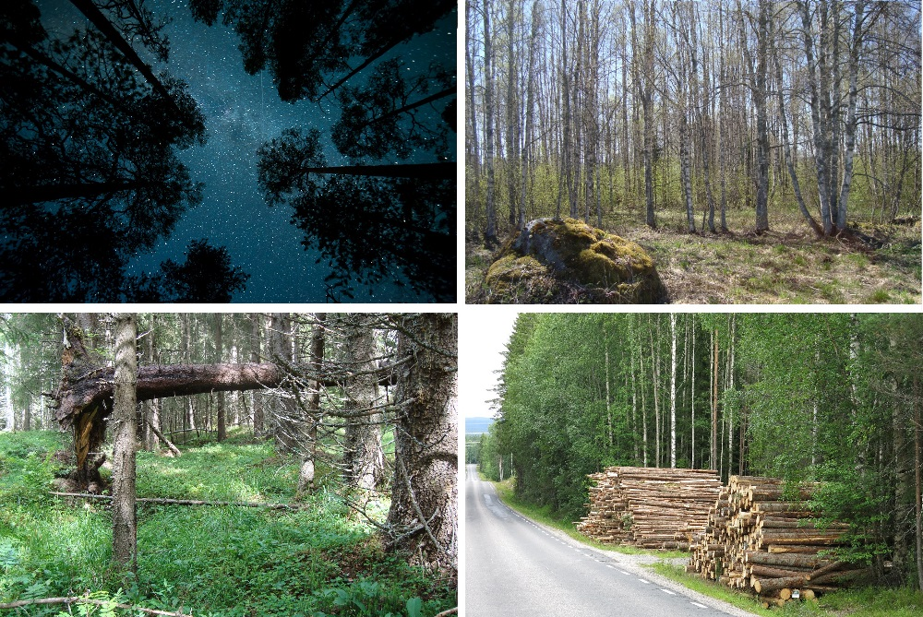
Figure 11.4: The forest dominates the countryside in Voxnadalen. Top left: night sky in Hamra National Park Photography: Kent Backeby. Top right: Birch forest in the Sässman area. Photography: Jens Hansen. Bottom left: Coniferous forest near Häsboån Photography: Katarina Eriksson. Bottom right: The forests of Voxnadalen are actively used for cutting timber. Photography: Fia Johannessen.

Characteristic species
All large animals and herbivores that occur in Sweden can be found in the forests of the region; these include the brown bear (Ursus arctos), wolf (Canis lupus), lynx (Lynx lynx), wolverine (Gulo gulo), golden eagle (Aquila chrysaetos) elk (Alces alces) and roe deer (Capreolus capreolus).
In forests with characteristics of natural woodland, there are many wood-living insects that are dependent on dead wood in various stages of decomposition and trees scorched by fire. The Eco Park at Grytaberg (Section 7.4) has a particularly interesting insect fauna with over 37 red-listed species. There are also many unusual fungi, mosses and lichens; for example, the fungi Inonotopsis subiculosa (extremely rare), Phellinus pini and Carbonicola anthracophila, as well as lung lichen Lobaria pulmonaria, can be found in the area.
Spring pasque flower (Pulsatilla vernalis), ghost orchid (Epipogium aphyllum, Fig. 11.5) and creeping lady’s-tresses (Goodyera repens) are examples of characteristic plants. Birds that are common in the coniferous forests of the area are various kinds of grouse (capercaillie Tetrao urogallus, black grouse Lyrurus tetrix, hazel grouse Tetrastes bonasia and willow grouse Lagopus lagopus) and owls (great grey owl Strix nebulosa, Ural Owl Strix uralensis, boreal Owl Aegolius funereus and Eurasian Pygmy-owl Glaucidium passerinum). Siberian Jay (Perisoreus infaustus) and northern goshawk (Accipiter gentilis) also occur. Other common birds of prey in the woodlands are sparrowhawk (Accipiter nisus), common buzzard (Buteo buteo) and honey buzzard (Pernis apivorus).
Many waders enjoy the sides of small shallow tarns near wooded wetlands, for instance wood sandpiper (Tringa glareola) and green sandpiper (Tringa ochropus). Areas where peat used to be cut, which have now developed into fens with deciduous trees and swamp woods, have a very rich fauna of birds. All species of woodpecker occurring in Sweden have been seen here. Several kinds of warblers thrive in these environments too, e.g. garden warbler (Sylvia borin), common whitethroat (Sylvia communis), lesser whitethroat (Sylvia curruca), icterine warbler (Hippolais icterina), thrush nightingale (Luscinia luscinia) and river warbler (Locustella fluviatilis).
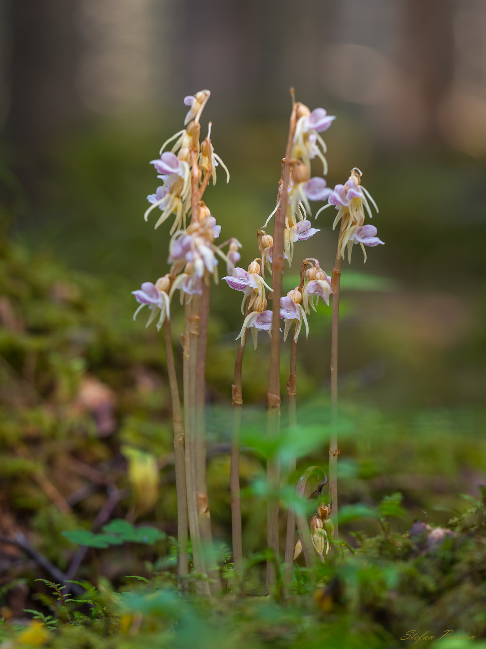
Figure 11.5: Ghost orchid Epipogium aphyllum. Photography: Stefan Persson

Natural processes and human impact
Human impact on the forests of the region dates back to the Iron Age (Section 9.1) and in historical times, the forest has been used intensively for timber raw material. At the end of the Second World War, forestry was mechanised, which involved changes and intensification of forest use. During the 1950s, an even-aged stand management system came to be the dominant forestry method in Sweden, and still is today.
The even-aged stand management system means that a new generation of trees are planted at the same time in a stand. During growth, the stand is managed through clearance and thinning. Finally, it is all felled and a new stand is planted, after which the cycle is continued. In this period, focus was on economy and growth, which was also reflected in Swedish legislation. The result was that very little consideration was given to the natural environment. Thus, the forest landscape became much more uniform; there was a marked reduction in the amount of dead wood and other structures that create variation in the forest landscape, with reference to both habitats and microclimates. The lack of regard for nature in forestry work that continued for most of the twentieth century has resulted in the loss of habitats for many forest species.
Many of the older forests (more than 120 years old) were felled in the twentieth century. This means a decrease in the occurrence of late successional stages in the forest landscape, causing less favourable conditions for many species that are adapted to late successional stages of the forest. Consideration for natural values in connection with forestry work has increased considerably over the last decades; a better balance between production- and environmental objectives has been achieved (Section 14.1).
During the same period, other natural disturbances such as forest fires and floods have been minimised, which has affected the ecology of the forest. Lightning strikes igniting dead wood and dry moss and lichen on the ground layer have been an important natural process throughout time. Many plant, insect and fungi species are adapted to fire-impacted environments and are dependent on them for their regeneration. The impact of forest fires on the ecosystem, however, has diminished when humans have controlled fires more efficiently. Many fire dependent species are now red-listed.
During the twentieth century, large areas of Swedish woodlands were drained; this was often state funded work and performed as political unemployment measures. The purpose of draining away the water by digging ditches was to increase forest growth. These days, drainage of woodland requires permission from the authorities and thus only occurs to a limited degree.
However, modern forest management methods, with abundant stands of young forest at a suitable grazing height, have favoured cervids (elk and roe deer). This creates problems when young forests of deciduous trees and pines are damaged due to grazing. When spruce forests are regenerated, planting spruce on land that was traditionally pine forest has therefore been supported. Hunting of cervids, mainly elk, keeps them well under their biological capacity. A condition for such an intensive hunting of cervids is well-functioning cooperation and well-considered management plans for maintaining a qualitative population of game.
The wolf is one of the large predatory animals of the woodlands; it was previously almost extinct in Sweden. The last Swedish wolf was observed in Sarek-Padjelanta in 1976, before a new group of wolves migrated from the Finnish-Russian population at the end of 1970s. Wolves have now re-established themselves in the landscape, but the Swedish wolves risk inbreeding if the population is too severely culled and if there is no new migration. Illegal hunting of wolves and other large predators has occurred in the region.
Deposition of nitrogen air pollution impacts the ecosystem of the forest. In forest land where growth is dependent on the supply of nitrogen, a limited deposition of nitrogen can increase biological production and forest growth. However, too much nitrogenous pollution leads to leaching of excess nitrate out of the soil, polluting ground and surface water. Organisms adapted to conditions where there is a limited amount of nitrogen risk being excluded by organisms favoured by greater access to nitrogen. Nitrogen pollution is an international problem; 85% of the deposition of nitric oxides over Sweden originates from the pollution of other countries.
Current climate changes constitute a global challenge. Climatic alterations in temperature and precipitation affect the biological diversity of forest environments in several ways. For instance, species that are sensitive to dry conditions are limited when summer droughts become more common. Fewer cold winters may mean that some species are pushed northwards in an increasing competition with species more adapted to a southerly climate. Thicker forests due to rapid growth may also affect the composition and number of species in the vegetation of the ground layer and field layer.
A warmer climate in conjunction with a longer vegetation period increases growth in forests, while new challenges arise, which affect forest condition and forest maintenance. There is an increased risk of damage to forests when the climate becomes warmer; more harm may, for example, be expected from insects and grazing animals, and storms may cause greater havoc when the ground is only frozen for shorter periods of time.

11.6.2 Lakes, rivers and streams

Figure 11.6: Names of the main rivers, streams and lakes.

Within the planned biosphere reserve, there are 700 lakes that are larger than 1 ha. Several of these are forest lakes poor in nutrients, although naturally nutrient-rich lakes do occur too. Another kind of lake that occurs in the area is defined as oligotrophic to mesotrophic standing waters (Ävjestrandsjö). Ten lakes of a size between 500 and 600 ha occur in the area, e.g. Lake Mållången and Lake Storhamrasjön. A handful of these lakes are situated within Natura 2000 areas and nature reserves, as well as in the Eco Park at Grytaberg.
In addition to the lakes, there are numerous rivers, streams and brooks (Fig. 11.6). The River Voxnan runs like a vital artery through the entire planned biosphere reserve. Tributaries that feed the Voxnan amount to around 1,000 km, and hundreds of streams and brooks flow into the Voxnan. Many of the watercourses possess high natural values and are located within Natura 2000 sites, nature reserves and in Hamra National Park. Characteristic of many of these rivers and streams are the rapids that sometimes become waterfalls. Hylströmmen rapids, which is part of the Voxnan, is considered to be the highest waterfall in south Norrland, with a drop of 23 metres (Fig. 11.7).
Among the habitat types of the EU Habitats Directive occurring in the planned biosphere reserve are nutrient poor forest lakes, nutrient rich lakes and oligotrophic to mesotrophic standing waters.

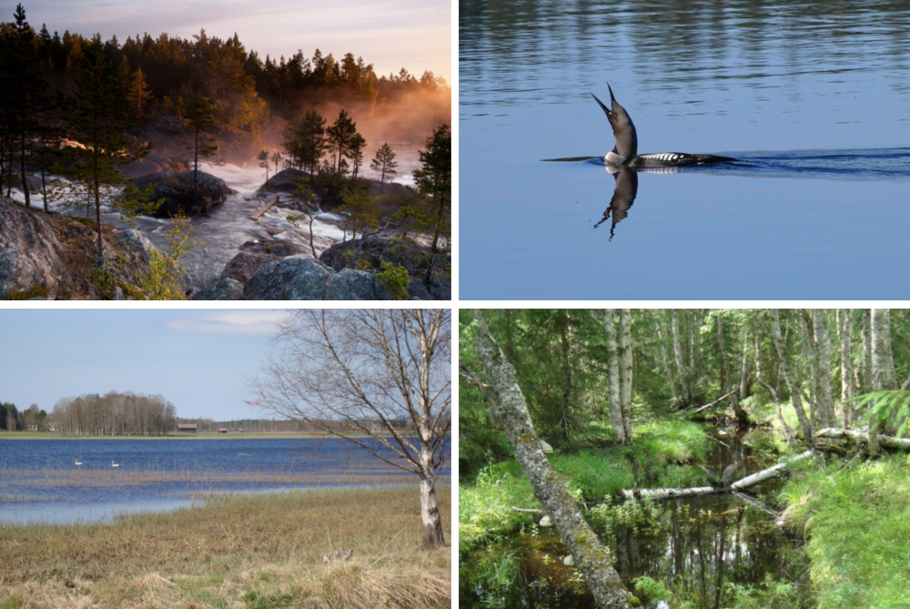
Figure 11.7: Voxnadalen is a well-watered countryside. Top left: Hylströmmen. Photography: Kent Backeby. Top right: Black-throated diver (Gavia arctica) has a characteristic call and is common in the area. Photography: Björn Olander. Bottom left: The Sässman area. Photography: Olle Berglund. Bottom right: The stream Häsboån runs through a forested landscape. Photography: Ovanåker Municipality picture archive

Characteristic species
REGIONAL
Several rare species live in the rivers and streams of the region, e.g. the freshwater pearl mussel (Margaritifera margaritifera), European eel (Anguilla anguilla) and noble crayfish (Astacus astacus). Typical fish species for the area, which are also popular for fishing, include brown trout (Salmo trutta), Arctic charr (Salvelinus alpinus), grayling (Thymallus thymallus), perch (Perca fluviatilis) and northern pike (Esox Lucius). Alongside the River Voxnan and its tributaries, signs of the work of beavers (Castor fiber) can be seen in the form of gnawed and felled trees and beaver dams. Stable populations of otter (Lutra lutra) occur in the area, e.g. by the side of Hylströmmen rapids.
Birdlife around rivers and streams is rich. The white throated dipper (Cinclus cinclus) is a characteristic bird that nests beside the running water of rapids and waterfalls. When hunting for food, it runs along the bottom of the stream. The red throated diver (Gavia stellata) is another typical bird often seen in forest lakes in the region.
Several rare plants can be found in the shoreside vegetation, e.g. marsh clubmoss (Lycopodiella inundata), pillwort (Pilularia globulifera) and (Persicaria foliosa).

Natural processes and human impact
Gradual increasing vegetation of lakes and wetlands is a natural process. This can be seen in the accumulation of peat in many places in Voxnadalen. Throughout history, humans have had an impact on the lakes, rivers, streams and brooks of the region (Section9.1).
Clearance that was carried out in the Voxnan, and in several of the tributaries, during the log driving epoch has considerably affected the morphology, hydrology and ecology of the waterways. The transformation of a naturally varied river or stream to become a transport route for timber meant that it was straightened, protruding stones were removed and shallows and forks were blocked.
As a result of this intervention, the speed of the water flow increased, causing fine sediment and gravel to be gradually washed away. Consequently, natural river floors for the mating of fish like salmon (S. salar) and trout (S. trutta) disappeared. When boulders and stones were removed, places used by the fish for resting and protection also vanished. Further, the interventions reduced the interaction between the water and the shore zone, which affected the growth of shoreside vegetation and the composition of species. In addition, when the structure of the river bed became more homogeneous and the water flow increased, organic material (e.g. fallen leaves) no longer stayed in place in the streaming water. Many small animals that are dependent on organic material have therefore been at a disadvantage, which eventually through the interconnected food web has affected the amount of fish in the water.
The Voxnan and several of the lakes are regulated and affected by hydroelectric power stations, which has resulted in great impact on the ecology of the ecosystems. Regulating dams constitute barriers for the biological dispersal of plants and animals, and the changing water levels affect the plant and animal life of shore zones negatively. Nutrients are accumulated in the sediment of the dam, causing diminishing nutrient supplies in downstream watercourses. The power stations act as barriers for the migration of several kinds of fish and other freshwater organisms. Several kinds of fish are at risk of perishing in the turbines of the power station.
Steep sandy eroded riverbanks afford the landscape a special character. The erosion of these steep sandy riverbanks was previously a common and natural process along the River Voxnan. Due to regulation for hydroelectric power and clearance of log-driving routes, this process has been severely reduced. Natural and periodical floods along the sides of rivers and streams have also become much less because of regulations for hydroelectric power.
Pollution from traffic and shipping, along with industries and forestry work has caused acidification (from sulphur dioxide, nitric oxide and ammonia) of lakes and watercourses. Accelerating acidification has a negative impact on plant and animal life in rivers, streams and brooks. Organisms such as molluscs, mussels and crustaceans are particularly sensitive in this respect. Most of the pollution that is deposited over Sweden is brought here by the wind from other countries and from international shipping. Some of the lakes are still vulnerable to acidification or have become acidified and have a weak buffering capacity. Acidification has, however, become less and the lakes of the region are in much better condition, not needing any specific liming operation.
In the community of Voxna, downstream in the River Voxnan, the lakes are partially affected by the leaching of nutrients from agriculture. A number of watercourses and lakes in the more densely populated parts of the catchment area display less satisfactory status concerning phosphorus and nitrogen values. The problem of eutrophication can be seen in the depletion of oxygen in the bottom of lakes, poor transparency and a high content of chlorophyll. Apart from this, no greater problems of eutrophication occur in the region.
Increasing accumulation of loose organic material in many lakes and watercourses has been noted in Sweden, Northern Europe and North America over the past two decades. A larger extent of leaching of organic material from soils has caused increased colouring (brownification) of many bodies of water. According to estimates of the degree of colouring in the River Voxnan, this has increased since measurements started in the beginning of the 1960s. A higher content of loose organic material in the water may, for example, cause problems for the quality of drinking water. Underlying causes can partially be connected with climate changes. Nevertheless, a range of factors are probably at work here.

11.6.3 Wetlands
REGIONAL
The wetlands of the region amount to 350 km2 in the form of peatlands, fens and swamp woods. Types of nature in the planned biosphere reserve that are specified in the EU Habitats Directive (p, priority) are transitional (open) mires and fens, springs and spring fens, rich fens and aapa mires (p). The largest wetland complexes are located to the north-east and north-west of Los and to the south of Edsbyn. Most of these are poor fens with an associated flora consisting of few species. In the surroundings of Los and to the north of Edsbyn, however, there are rich fens and extremely rich fens with a flora much richer in species. Several of the peatlands of the area are included in nature reserves or Natura 2000 sites. There is also a large peatland area in Hamra National Park.

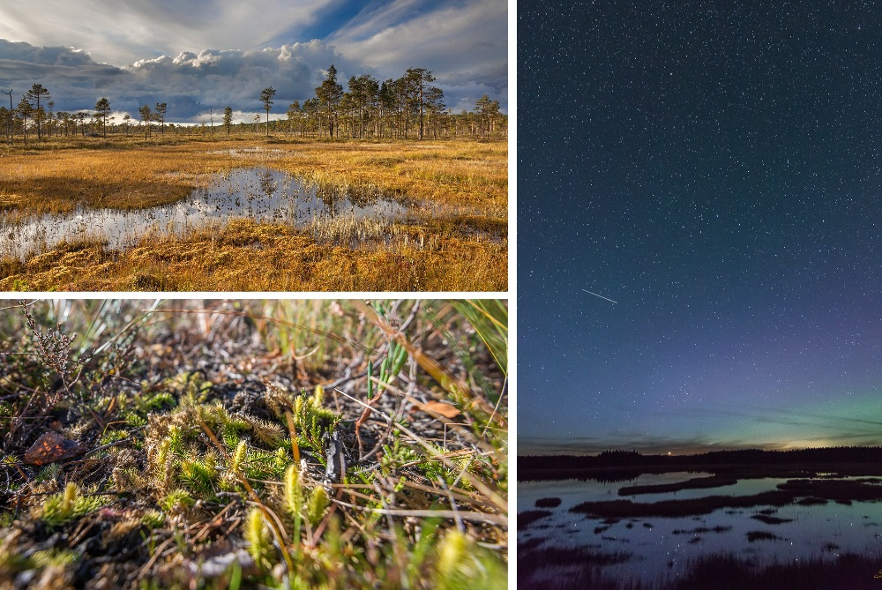
Figure 11.8: Many of the wetlands of the area have high botanical values and/or valuable bird localities. Top left: Hamra National Park. Photography: Johnny Eng. To the right: Night sky over Hamra National Park. Photography: Stefan Persson. Bottom left: Marsh clubmoss Lycopodiella inundata. Photography: Stefan Persson.
.

Characteristic species
Several of the wetlands of the planned biosphere reserve are locations of botanical interest. The lime soils of the extremely rich fens have favoured a typical flora of rare plants that thrive on lime soils, such as various sedges (capitate Sedge Carex capitata and fibrous tussock-sedge Carex appropinquata), orchids (fragrant orchid Gymnadenia conopsea, narrow-leaved marsh-orchid Dactylorhiza traunsteineri and early marsh-orchid Dactylorhiza incarnata) and clubmosses (Lycopodiaceae Fig. 11.8).
Many of these wetland areas are also well-known localities for birds; one such area is the Sässman area (Natura 2000, Section 7.4), situated near the community of Edsbyn. Common birds in the Sässman area include various kinds of wild ducks (Teal Anas crecca, wigeon Anas penelope and shoveler Anas clypeata), waders (wood sandpiper Tringa glareola, greenshank Tringa nebularia, common snipe Gallinago gallinago and lapwing Vanellus vanellus), birds that like shoreside meadows (yellow wagtail Motacilla flava and meadow pipit Anthus pratensis), warblers (river warbler Locustella fluviatilis, grasshopper warbler Locustella naevia and reed bunting Emberiza schoeniclus) and owls (short-eared Owl Asio flammeus and long-eared owl Asio otus).
On old and partially waterlogged fields near wooded fens and swamp woods, such birds as corncrake (Crex crex), whinchat (Saxicola rubetra), northern wheatear (Oenanthe oenanthe) and European goldfinch (Carduelis carduelis) can be seen. Marsh harrier (Circus aeruginosus), hobby (Falco subbuteo) and kestrel (Falco tinnunculus) can be seen hunting in the area.

Natural processes and human impact
In historical times, the wetlands of the area were impacted by humans when they were drained. Authorisation is now necessary for new drainage, which is now only performed to a limited extent. In Hamra National Park, the work of filling in old ditches and dams is now carried out instead.
Traditionally, wetlands have been mowed for harvesting fodder. Peat was commonly cut from peatlands; it was dried and used in barns as bedding for the animals. The used peat was then thrown on the manure heap and used to fertilise the fields.

11.6.4 Grasslands
LOCAL
Grasslands in the form of semi-natural pasture and hay meadows are very rich in species. Many of the species are adapted to continual management of the land, through either grazing or mowing. Apart from indicating long continuity of grazing and mowing, the presence of species favoured by this kind of long-term land-use implies that the land has not been subject to fertilising or other measures to promote production (e.g. seeding of forage plants). Good light conditions and soils that are deficient in nutrients have created favourable conditions for a rich herbaceous flora. The rich vegetation has in turn favoured a prolific insect and butterfly life, which ultimately benefits birdlife.
Nature types occurring in the planned biosphere reserve that are included in the EU species and habitat directive are siliceous grasslands, molinia (fen) meadows, tall herb fringe communities and hay meadows. Among these, hay meadows are the most biodiverse. Along the lower parts of the River Voxnan, there are a large number of freshwater shore-side meadows that are regularly flooded, these areas are often environments extremely rich in species.

Characteristic species
Species that are indicative of maintained land, where fertilisers have not been used, are characteristic for semi-natural pasture and hayfields. Examples that can be found within the planned biosphere reserve are alpine bistort (Bistorta vivipara), greater bur-marigold (Bidens radiata), meadow rue (Thalictrum simplex), needle spike-rush (Eleocharis acicularis), bitter-vetch (Lathyrus linifolius) and field gentian (Gentianella campestris).
Fungi found in the area indicating unfertilised managed land include dark purple earth tongue (Microglossum atropurpureum) and honey waxcap (Hygrocybe reidii). Typical species among insects in the grassland of the area include various kinds of caddis flies (such as spotted caddis fly Semblis phalaenoides), butterflies (ex. brimstone Gonepteryx rhamni, speckled wood Pararge aegeria, red admiral Vanessa atalanta, panthea moth Panthea coenobita, forester Adscita statices and red-necked footman Atolmis rubricollis) along with long-horned beetles (Cerambycidae).
Common birds of the open grazed or mowed cultural landscape of the river valley of Voxnan are skylark (Alauda arvensis), whinchat (Saxicola rubetra), northern wheatear (Oenanthe oenanthe), reed bunting (Emberiza schoeniclus), ortolan bunting (Emberiza hortulana) and hen harrier (Circus cyaneus).

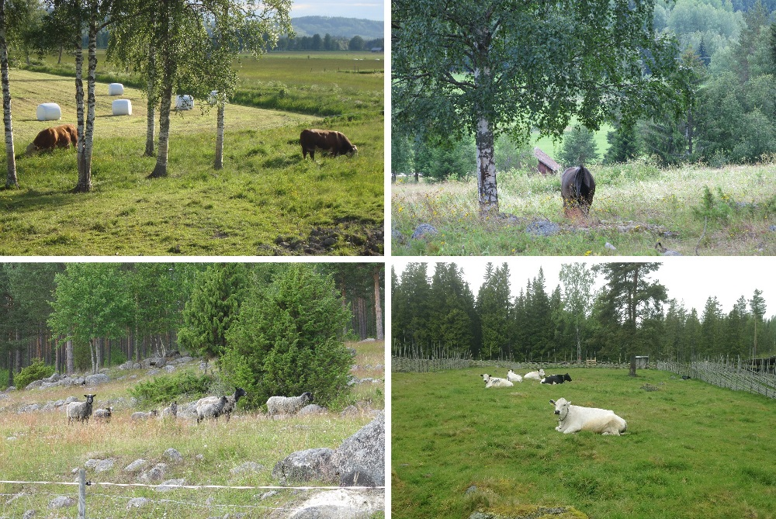
Figure 11.9: Grassland that is maintained through grazing or mowing is often rich in plant and animal life. Top left: Semi-natural pasture in the Sässman area that is kept open by cattle. Photography: Jens Hansen. Top right: Nowadays horses are important for keeping the grasslands open. Photography: Fia Johannessen. Bottom left: Sheep on semi-natural pasture land. Photography: Fia Johannessen. Bottom right: Mountain cattle grazing the fields of a summer farm. Photography: Jens Hansen.

Natural processes and human impact
The biodiversity of grasslands has been favoured by conditions resulting from thousands of years of continuous management and use for grazing and haymaking. However, if the land-use ceases, the open landscape gradually becomes overgrown and the forest grows up in just a few decades. Thus, the biodiversity of plants, insects and birds, dependent on an open and well-kept landscape, is diminished. Today, hay meadows, which are among the most biodiverse grasslands, are few and small. Discontinuation of management of farmland, combined with changed and more intensive land use, has undermined the conditions for many species that are favoured by well-managed grassland. This is a trend that occurs in Voxnadalen and in Sweden generally.

11.6.5 Farmlands
REGIONAL In the planned biosphere reserve there is a large area of contiguous farmland in the south-eastern parts of Voxnadalen, particularly in the surroundings of the two largest communities, Edsbyn and Alfta (Fig. 11.1). Farmland that is incorporated in parts of the landscape otherwise dominated by forest occurs but to a lesser extent. The farmed landscape is varied and has been created through the interaction of humans and grazing animals over several thousands of years.

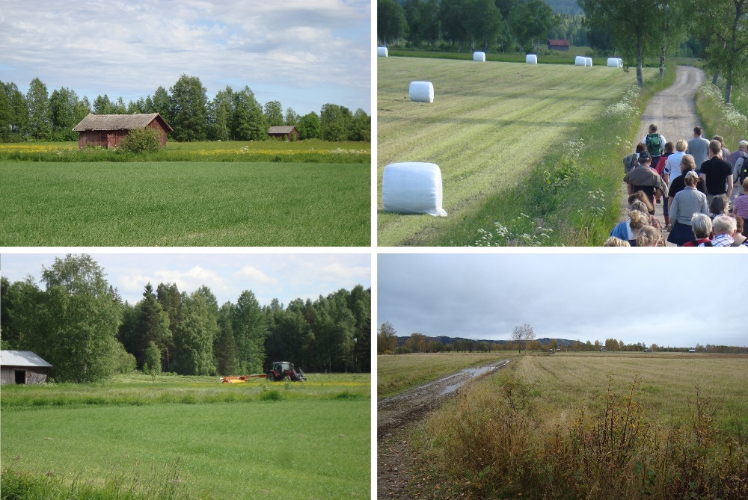
Figure 11.10: The farmland of Voxnadalen is mainly located in the south-eastern parts of the area near the communities of Edsbyn and Alfta. Top left: The multitude of barns is an important part of the cultural heritage of the farmland. Top right: A farmland walk. Bottom left: Mowing hay for fodder. Bottom right: The Sässman area consists of a mosaic of cultivated fields and wetlands. Photography: Jens Hansen.
.

Characteristic species
Crops grown in the area are oats, barley and wheat for cereal production; for forage production meadow fescue, timothy and red clover are grown. There is hardly any characteristic flora of weeds any longer, due to efficient cleansing of seeds and application of herbicides. Cattle are kept for their milk and meat products, while sheep supply meat and fleece products. Today, the proportion of horses kept for leisure purposes is on a steady increase; grazing horses have become more and more significant for the conservation of the open cultural landscape.

Natural processes and human impact
Agricultural transformations, in progress since the post-World War II era, have had consequences for the appearance of the landscape. Many small-holdings have had to be discontinued and are replaced by large farm units and specialised farming enterprises. One reason for this is that the terms that are set for prices generate a low income for the produce. In Gävleborg County, abandonment of farmland commenced in the middle of the twentieth century. As a result of the abandonment of farmland, the previously farmed landscape has become overgrown to a certain degree. Moreover, forests have been planted on some of the old farmland.
The mosaic landscape essential for many species has been severely diminished and replaced by large areas of the same type of land, with sharper borders between the different types of land. Old solitary trees, non-arable outcrops and trees that bear fruit, nuts or berries occurring in the rest of the farmed landscape are therefore extremely valuable biotopes for butterflies, birds, bats and medium sized mammals.
Drainage of fields, application of chemical fertilisers and seeding of selectively bred crops also affect the conditions for biodiversity. Farmers of the area have used varying amounts of herbicides, which may affect biodiversity in a negative way.
Land that was previously farmland is now developed for housing. Around 5% of the old farmland has disappeared as a result of the expansion of built areas in Gävleborg County during the period between 1998 and 2010. Maintaining existing farmland is vital, in order to meet an increased demand for locally produced food as well as to uphold Sweden’s self-sufficiency.

11.6.6 Communities
LOCAL Communities are dominated by buildings, roads and other hard surfaces as well as planted green spaces. Built-up areas within the planned biosphere reserve encompass industries that have a long history, such as saw mills. More modern industries have mainly been established in the surroundings of the two largest communities Edsbyn and Alfta. Green areas such as parks, churchyards, private gardens and outdoor recreation areas near communities are pleasurable for the inhabitants and constitute valuable habitats for many plants and animals. However, the general maintenance of these areas determines which species that are favoured or not.

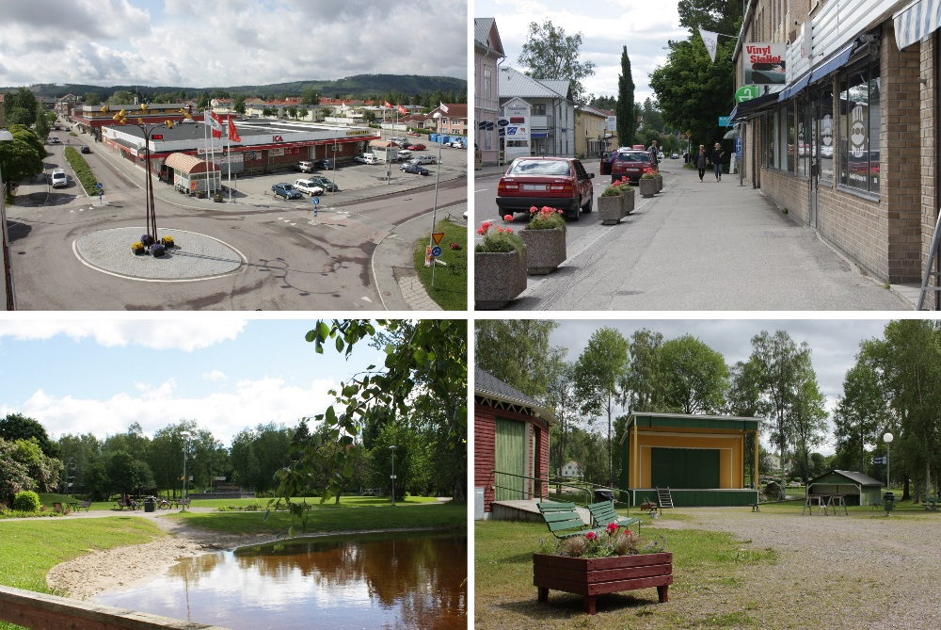
Figure 11.11: Edsbyn and Alfta are the two largest communities of the planned biosphere reserve. Top left: Edsbyn town centre. Top right: Alfta town centre. Bottom left: Öjeparken in Edsbyn. Bottom right: Sports and Folk Park, Forsparken, in Alfta. Photography: Ovanåker Municipality Picture Archive

Characteristic species
Deciduous trees are common in green areas and gardens in the communities, mainly maple (Acer platanoides), birch (Betula pendula) and rowan (Sorbus aucuparia). Common toadflax (Linaria vulgaris), lupin (Lupinus polyphyllys, invasive species), rosebay willowherb (Chamerion angustifolium) and tansy (Tanacetum vulgare) are typical plants that have spread alongside railway lines and roads.
The hedgehog (Erinaceus europaeus) and the squirrel (Sciurus vulgaris) are part of the fauna of densely populated areas. In the summer months, the characteristic call of swifts (Apus apus) can be heard over the roof-tops, along with the beautiful song of the blackbird (Turdus merula) and the willow warbler (Phylloscopus trochilus). Other common birds in built-up areas are barn swallow (Hirundo rustica), house martin (Delichon urbicum) and house sparrow (Passer domesticus).

Natural processes and human impact
Floods are the most outstanding and significant natural processes that affect communities of the region along the River Voxnan. The Swedish Civil Contingencies Agency (Myndigheten för samhällsskydd och beredskap, MSB) has named Edsbyn as one of 18 communities in Sweden with the highest risk for floods. Climatic changes entail an increased risk for floods and sudden downfalls of rain.
When the log-driving routes were cleared along the River Voxnan during the log-driving epoch (Section 9.1), this increased the tendency of flooding in the communities. It is natural when the water rises for an unexploited river or stream to overflow its banks and expand into shore-side forests, wetlands and natural high-water diversions of the watercourse. A river that is permitted to flow into these buffer zones, all along its course, can thus distribute and mitigate the strong energy involved in the increased flow in an effective way. Rivers and streams impacted by log driving have lost much of this natural buffer capacity, which increases the risk for floods downstream.
Chapter 12

Ecosystem Services

12.1 If possible, identify the ecosystem services provided by each ecosystem of the biosphere reserve and the beneficiaries of these services.
Ecosystem services are the products and services provided by nature’s various ecosystems that contribute to our well-being. In accordance with the Millennium Ecosystem Assessment framework (MEA) and the Economics of Ecosystems and Biodiversity initiative (TEEB), ecosystem services are divided into four categories:
1. Supporting services – the naturally-occurring processes and states that are fundamental to the other three ecosystem services (e.g. biogeochemical cycles, soil formation, photosynthesis in plants, biodiversity, ecological relationships and ecosystem stability).
2. Regulating services – the benefits obtained from the regulation of natural processes (e.g. the reduction of run-off and water flow through absorption by vegetation, pollination by insects and mycorrhizal recirculation of the earth’s nutrients).
3. Provisioning services – the various products obtained from the ecosystems (e.g. forest products, mushrooms and berries, game meat and drinking water from surface and ground water sources)
4. Cultural services – the intangible benefits obtained from the ecosystems (e.g. physical and mental health, recreation, and spiritual and aesthetic experiences of the natural environment). In the section below, we describe the ecosystem services generated by the various ecosystems in the proposed biosphere reserve. The descriptions do not reflect a comprehensive analysis of ecosystem services as no such analysis has yet been carried out.

12.1.1 Forests
The ecosystem services generated by forests are dependent on the supporting ecosystem services such as soil formation, nutrient cycling, photosynthesis in plants and overall biodiversity. The forests help to regulate climate and the water cycle (regulating ecosystem services) by storing organic carbon in the developing biomass and in the soil profile, and through trees and other vegetation taking up water. Carbon storage in biomass can play an important role in reducing the amount of carbon dioxide (a greenhouse gas) in the atmosphere and thereby limit ongoing climate change (global climate regulation). However, the extent to which a forest functions as a carbon sink (net storage of carbon) or carbon source (net emission of carbon) is dependent on several factors, including the forest’s stage of succession and how forestry operations are managed. The use made of forest products is also important in this context; longlasting products (such as timber for construction) has a more beneficial effect on the climate than short-lived products (such as paper).
Another regulating ecosystem service in a forest is the natural, biological control of pests through predation and parasitism. For species that are biological control agents, a forest can be an important habitat for the various stages in their life cycles (e.g. egg-laying locations, habitats for larval stages or overwintering sites for adults).
Provisioning ecosystem services from the biosphere reserve’s forests include foods, in the form of mushrooms, berries and game meat, and forest products such as timber, biofuels and other raw materials that are processed by local sawmills and woodworking businesses. The wood from the domestic pine (Pinus sylvestris) that grows in Hälsingland’s forests has several sought-after properties that are directly associated with the climate in Hälsingland (Fact file 7). Hälsingefura – Hälsingland pine – has long been a well-known watchword for quality, particularly in the furniture and woodworking sectors.
The innovation of new wood-based products has an important role to play as we develop a society independent of fossil fuels. A substantial portion of the economy in the Gävleborg Region is directly related to the bioeconomy, and the region is felt to have great potential for continued development in this area (see Region Gävleborgs förutsättningar och möjligheter i en framtida bioekonomi, NiNa Innovation, 2016; ’Gävleborg Region – conditions and opportunities for a future bioeconomy’).
Cultural background is also very important in terms of how people relate to the forests and the natural environment as a whole. For many people newly arrived in our country, forests and the natural environment are seen as ‘the unknown’ and associated with danger and uncertainty. As the green industries now have significant labour requirements, a variety of ways need to be found to guide new arrivals into the forestry industry, so that they can be seen by employers as a useful resource. In this context, providing opportunities to visit and work in forests will assist with integration.
The cultural ecosystem services, which are used by those resident in the area as well as visitors, include access to a wide variety of outdoor recreational activities such as riding, running, skiing, orienteering, mushroom and berry-picking and hunting. Increasing numbers of tourism companies are setting up in the area and using the forest for activities such as horse-riding, wildlife watching from hides, dog sledding and hunting. Being out in our natural environment contributes to our general feeling of well-being, both physical and mental. Forests are thus an important resource for outdoor recreation and public health, developing the tourism sector and creating a range of partnership opportunities. Forests that are species-rich with a large number of rare species and the remains of cultural sites from times gone by also contribute to the biosphere reserve’s natural and cultural heritage.
[Sorry. Ignored \begin{fruta} ... \end{fruta}]

12.1.2 Lakes and watercourses
The supporting ecosystem services generated by lakes and watercourses include algal photosynthesis and the overall biodiversity of water environments. The regulating ecosystem services generated by lakes and watercourses includes the ability of the ecosystems to regulate and deal with environmental toxins and to filter and purify water by trapping it in sediment and organisms. The primary production of the watercourses helps with climate regulation as atmospheric carbon dioxide is taken up and stored in the biomass of the algae and aquatic plants. Submerged aquatics, trees and riparian vegetation regulate water flow and prevent erosion as plant roots bind sediment and stabilise layers of soil.
Historically, the main provisioning ecosystem services provided by the area’s watercourses have been their function as reservoirs for households, agriculture and industry. These days, however, most of the water supply to industry and agriculture and for drinking comes from ground water reservoirs. The lakes and watercourses in the area also provide the local population and visitors with fish for household consumption. There is no commercial fishing within the proposed biosphere reserve.
Local people and visitors to the area utilise the watercourses’ cultural ecosystem services in various ways including for canoeing, boat trips, swimming, bird-watching, recreational fishing and waterside nature walks. Several local tourism companies use the Voxnan and other watercourses for activities such as beaver safaris, canoe trips and guided fishing excursions.
The overall diversity of species and the remains of various cultural sites both in and around the lakes and watercourses contribute to the natural and cultural heritage of the area.

12.1.3 Wetlands
The supporting ecosystem services generated by wetlands are similar to those outlined in respect of lakes and watercourses. The overall biodiversity of the wetlands is rich, and these environments are often very valuable breeding and resting sites for birds and/or home to rare plants. Wetlands generate regulating ecosystem services in the form of water purification and climate control, and also have a very important ability to store water. This ability helps to reduce sudden high water flows and thus also reduces the risk of flooding and erosion (Section 11.6).
Residents and visitors can pick cloudberries (Rubus chamaemorus) from the peatlands in the area (provisioning ecosystem service). In earlier times, wetlands also generated provisioning ecosystem services for the farmers in the area. Peat from the peatlands was used as litter in barns, while some of the vegetation was cut for animal fodder.
Wetlands make a major contribution to cultural ecosystem services as they are often popular recreational areas. Several of these areas have long been recognised by ornithologists and are popular for bird-watching. Amongst these are the Sässman area around Edsbyn and the Freluga, Edstuga and Rönnäs areas near Bollnäs.
From an international perspective, in having a degree of human impact that is low in global terms, the area’s wetlands are unique, and are thus also valuable representatives of the area’s natural and cultural heritage.

12.1.4 Grasslands
The supporting and regulating ecosystem services generated by grasslands (semi-natural pasture, hay meadows and shore grasslands) are mostly the same as those outlined for other ecosystems.
As with wetlands, the shore grasslands generate regulating ecosystem services in the form of water purification and regulation of water flow. The area experiences repeated flooding, and the shore grasslands absorb the water due to their ability to store water. At the same time, nutrients are taken up by the vegetation, lessening the leakage of nutrients to nearby watercourses.
The semi-natural pasture and hay meadows are not ploughed, and so store more carbon in the soil than fields that are ploughed. These lands have therefore been recognised as significant in terms of the climate. The species-rich flora of grasslands provides good conditions for a variety of pollinating insects, which are important for the supply of locally-grown crops and foods from the area.
The semi-natural pastureland, including the shore grasslands bordering the Voxnan that are intermittently partially flooded, provides the area with good grazing land (provisioning ecosystem services) for meat production. There is now only limited haymaking on these lands.
Many people find the open cultural landscape aesthetically appealing, and the grasslands are usually easily accessible to both residents and visitors. This landscape thus generates excellent opportunities for recreation and outdoor activities (cultural ecosystem services). Rich in birdlife, the shore grasslands are well-known, popular bird-watching locations.
The natural pastureland and the hay meadows are part of the traditional, open farmed landscape resulting from the interaction of people and grazing livestock. Because of this, the grasslands are an important aspect of our cultural heritage that contribute both to the local identity of the landscape and also to a sense of place.

12.1.5 Farmland
The supporting ecosystem services (e.g. photosynthesis and soil formation) and regulating ecosystem services (e.g. insect pollination and biological pest control) generated in the farmed landscape are important for local food production.
Important provisioning ecosystem services generated by the cultivated land include animal feed from grassland, grain and protein crops, food from cereal production, fruit and berry cultivation and meat production (cattle and sheep). Cheese is made from goat’s milk and cow’s milk in several places nearby and is often sold in unstaffed ‘cheese kiosks’ adjoining a farm.
Many people find the open farmed landscape aesthetically appealing. Walking, hunting and riding are just a few examples of popular recreational activities (cultural ecosystem services) taking place in areas adjoining this agricultural landscape.

12.1.6 Communities
Forested areas close to built-up areas, shared green spaces and private gardens in densely-populated areas generate several ecosystem services. Depending on the varieties, flower planting in parks and gardens can create the conditions enabling pollinating insects to spread through the area. The large numbers of deciduous trees in the built-up areas are important habitats for birds and insects, and they also purify the air by absorbing particles and regulate the climate by providing shade and taking up carbon dioxide. Vegetation close to built-up areas also helps to regulate and purify water as trees and other ground cover absorb water while areas without hard man-made surfaces allow water to inflitrate the soil. This means there is less need to drain off surface water.
The growing of fruit and vegetables in private gardens provides locally-produced food (provisioning ecosystem services), while shared green spaces and private gardens contribute towards cultural ecosystem services. There are popular outdoor recreation areas adjoining several of the built-up areas, with marked trails, wind shelters and barbecue areas. The trails are used for a range of outdoor activities, including walking, running, skiing, orienteering, horse-riding and motocross.

12.2 Specify whether indicators of ecosystem services are used to evaluate the three functions (conservation, development and logistic) of biosphere reserves. If yes, which ones and give details.
We have not produced a comprehensive analysis of the indicators to be used to evaluate the conservation, development and logistic functions of the proposed biosphere reserve as part of our candidacy. However, there are a number of possible, locally-applicable indicators that can be used for the above purposes, which may be included in the development plan currently being produced (Section 17.4).
• Regulating ecosystem services – degree of soil erosion; frequency and extent of flooding in areas close to built-up areas; water quality; and number of pollinating insects.
• Provisioning ecosystem services – water quality and access to water; access to locally-produced food; rate of woodland growth; status of fish and game populations; number of companies associated with the area’s provisioning ecosystem services; and questionnaires targeted at business owners and residents in the area.
• Cultural ecosystem services – tourism statistics; number of initiatives promoting outdoor recreation, health etc.; number of participants in events promoting recreation, health, etc.; number of companies and associations etc offering nature-based experiences; and questionnaires and interviews targeted at residents, visitors and business owners in the area.
Section 16.1 includes a description of the agencies and organisations responsible for the regular measuring and monitoring of indicators such as water quality, air quality, climate and water flow in the area.

12.3 Describe biodiversity involved in the provision of ecosystems services in the biosphere reserve (e.g. species or groups of species involved).
The overall biodiversity of the area is essential for the functioning of the ecosystems and their capacity to generate ecosystem services. A high diversity of species helps to create resilience in an ecosystem, i.e. it assists its capacity to manage external pressures in the form of human impact or natural disturbances. The key groups of species that are particularly important for the ecosystem services in the proposed biosphere reserve are given in Tables 12.1 to 12.4.

Table 12.1: Supporting ecosystem services and the species and/or species groups that are important for providing them.
3GROEN!30!white
Ecosystem services | Species and species groups
Primary production  – Transformation of solar energy into organic material through photosynthesis. | Ground vegetation, e.g. plants, grasses and cultivated crops  Conifers, e.g. Scots pine (Pinus sylvestris) and Norway spruce (Picea abies)  Deciduous trees, e.g. birch (Betula pendula, B. pubescens), aspen (Populus tremula) and rowan (Sorbus aucuparia)  Algae and other submerged aquatic vegetation
Biogeochemical cycles | Microorganisms, fungi and soil fauna (e.g. protozoa, insects, worms and arachnids)
Habitats  – Species that are important for maintaining habitats for other organisms. | Ground vegetation, e.g. flowering plants in woodland and semi-natural pasture.  Grazing livestock, e.g. cattle, sheep and horses.  Conifers, e.g. Scots pine (P. sylvestris) and Norway spruce (P. abies)  Deciduous trees, e.g. goat willow (Salix caprea), aspen (P. tremula) and birch (B. pendula, B. pubescens)  Fish, e.g. brown trout (Salmo trutta) and Atlantic salmon (Salmo salar)
Biodiversity  – Includes the range of species for the whole area, including its genetic diversity. However, the table shows only those species groups that are particularly richly represented in the area. | Larger predators  Birds  Insects  Flowering plants  Fungi  Lichens  Fish  Bivalve molluscs
Soil formation  – Organisms that help to form new soil | Microorganisms, fungi and soil fauna (e.g. protozoa and insects, worms, arachnids and other invertebrates)

Table 12.2: Regulating ecosystem services and the species and/or species groups that are important for providing them.
3GROEN!30!white
Ecosystem services | Species and species groups
Regulation and purification of water  – Species that regulate and purify water by absorbing water and nutrients and by regulating water flow. | Ground vegetation and scrub  Conifers and deciduous trees  Rushes and reeds  Peat and mosses  Freshwater algae and submerged aquatic vegetation  Freshwater aquatic fauna, e.g. bivalve molluscs
Climate regulation  – Species that contribute to climate regulation by absorbing carbon dioxide for carbon storage in biomass and soil. | Ground vegetation and scrub  Conifers and deciduous trees  Algae and other submerged aquatic vegetation
Purification of air quality  – Speces that purify the air by absorbing airborne contaminants. | Ground vegetation and scrub  Conifers and deciduous trees
Pollination and seed dispersal  – Species that help to pollinate both commercially-important and naturally-occurring plants and organisms that disperse seed. | Wild bees, solitary wasps, bumble bees, sawflies, dipterans, butterflies and other pollinating insects, birds and rodents
Erosion control  – Species that bind sediment through root networks. | Ground vegetation, especially grasses and bushes  Conifers and deciduous trees  Submerged aquatic vegetation and bushes
Biological pest management  – Species that provide natural control of pests through predation. | Predaceous insects, parasites (e.g. ichneumons), birds of prey, predatory animals and insectivorous birds.
Storm and wind protection, and protection from waves in rivers and lakes.  – Species that reduce the negative impact of wind and/or waves. | Ground vegetation  Bushes, conifers and deciduous trees  Submerged aquatic vegetation

Table 12.3: Provisioning ecosystem services and the species and/or species groups that are important for providing them.
3GROEN!30!white
Ecosystem services | Important species and species groups
Drinking water  – Species groups that are important for water purification as they filter water that then becomes part of the ground water used for drinking water. It might be argued that these species contribute to the regulating service of water purification, but we have chosen to include them additionally under this heading. | Ground vegetation, including different species of grass and bushes  Conifers and deciduous trees  Algae and submerged aquatic vegetation  Aquatic fauna, e.g. bivalve molluscs
Food from the plant kingdom  – Species that are grown for commercial purposes or for domestic consumption. | Crops such as various cereals, root vegetables, other vegetables, fruit and berries
Meat and dairy products  – Species that are important for the production of meat and dairy products. | Various grasses and plants that are eaten by grazing livestock  Cattle, sheep and goats
Food from fish/freshwater organisms that are harvested for commercial purposes or for domestic consumption | Species of fish such as European perch (P. fluviatilis), pike (Esox lucius), grayling (Thymallus thymallus), brown trout (S. trutta), burbot (Lota lota), vendace (Coregonus albula), pike-perch (Sander lucioperca), whitefish (Coregonus maraena), Arctic charr (Salvelinus alpinus) and roach (Rutilus rutilus)  Crayfish (European crayfish Astacus astacus)
Animal feed  – Species used for animal feed. | Primarily different species of grass and legumes
Manure  – Species that directly or indirectly help produce animal manure. | Various grasses eaten by grazing livestock  Crops grown for animal feed  Cattle, sheep, goats and horses
Game  – Species that are commonly hunted. For domestic consumption or for retail. | Roe deer (Capreolus capreolus), elk (Alces alces), hare (Lepus sp.) and grouse (Tetraoninae sp.)
Wild mushrooms and berries  – Edible species that are picked, primarily for domestic consumption | Edible species of mushrooms and berries such as chanterelles (Cantharellus sp.), trumpet chanterelles (Craterellus tubaeformis), ceps (Boletus edulis), bilberry (Vaccinium myrtillus), lingonberry (V. vitis-idaea), cloudberry (Rubus chamaemorus) and raspberry (Rubus idaeus).
Wood  – Species used as pulpwood and timber. | Norway spruce (P. abies), Scots pine (P. sylvestris), lodgepole pine (P. contorta), aspen (P. tremula) and birch (B. pendula, B. pubescens)
Biofuels (firewood, woodchip)  – Species used as fuel, either for commercial purposes or for domestic use. | Norway spruce (P. abies), Scots pine (P. sylvestris), Lodgepole pine (P. contorta), aspen (P. tremula) and birch (B. pendula, B. pubescens)

Table 12.4: Cultural ecosystem services and the species and/or species groups that are important for providing them.
3GROEN!30!white
Ecosystem services | Important species and species groups
Outdoor recreation and tourism  – Species that contribute to outdoor recreational experiences such as bird-watching, hunting and fishing. This includes species that also contribute to local tourism by attracting visitors. | For this service, the area’s overall biodiversity is important in itself. Species groups of specific importance include the following:  Birds such as geese, waders and birds of prey that attract bird-watchers and tourists.  Fish popular for recreational fishing such as pike (E. lucius), European perch (P. fluviatilis), grayling (T. thymallus), brown trout (S. trutta) and Arctic charr (Salvelinus alpinus).  European otters (Lutra lutra), European beavers (Castor fiber), gray wolves (Canis lupus), brown bears (Ursus arctos) and Eurasian lynx (Lynx lynx).  Vegetation generally, rare and endangered species specifically.  Big and small game.
Mental/physical health  – Species that help to enhance people’s physical and/or mental health. | For this service, the area’s overall biodiversity is important in itself. Green spaces generally have a positive effect on both physical and mental health, particular in urban areas where greenery in parks and gardens have an important role to play.
Cultural and natural heritage  – Species that are important for the area’s cultural and/or natural heritage. | For this service, the area’s overall biodiversity is important in itself. However, several red-listed species are seen as particularly important for the cultural and natural heritage of the area. These include plant, insect and bird species that benefit from traditional management.
Sense of place  – Species that contribute to an enhanced sense of place in the area. | The area’s overall biodiversity is important for this service, as are the general character and landscape of the area. The open man-made landscape of the river valley, the wetlands and the extensive forests are distinctive characteristics of the region.
Aesthetics and inspiration  – Species that are aesthetically appealing and help provide inspiration for cultural practitioners and others. | The area’s overall biodiversity is important for this service, as are the open cultural landscape in the river valleys, watercourses and wetlands, and the extensive forests.
Expertise/teaching  – Species that are used or feature in teaching and/or help to maintain expertise in ecology. | The area’s overall biodiversity is especially important for this service. The most common animals and plants (e.g. types of tree) are important in the general teaching of science in compulsory schooling. Other more specific species groups are flora, fauna, predators, birds, fish and insects that benefit from traditional management.

12.4 Specify whether any ecosystem services assessment has been done for the proposed biosphere reserve. If yes, is this assessment used to develop the management plan?
A comprehensive landscape analysis of the Sässman area (Natura 2000, Table 7.2) has been carried out at the instigation of Ovanåker Municipality. The analysis will be used as a knowledge base to help conserve and develop the different functions and natural and cultural values of the area. This will include enhancing opportunities for bird-watching by making the area more accessible and constructing a new bird observation tower.
A comprehensive survey of the River Voxnan and its tributaries has recently been undertaken (2016-2017). The survey assessed the status of stocks of fish and other aquatic organisms, and mapped migration barriers and sections cleared for log driving. This was partly made possible by a partnership between Bollnäs, Ljusdal and Ovanåker municipalities and will result in new municipal fisheries management plans for the River Voxnan and its tributaries.
Several smaller surveys and studies of areas of forest with high natural values have been undertaken as part of our candidacy for biosphere reserve status. Together with the above, they provide an important knowledge base to support the production of municipal management plans and the specific development plan to be produced for the biosphere reserve (Section 17.4).
Chapter 13

Main objectives for the Biosphere Reserve’s designation

13.1 Describe the main objectives of the proposed biosphere reserve, integrating the three functions (conservation, development and logistic), presented below (sections 14 to 16), including components of biological and cultural diversity. Please specify the indirect pressures and/or organizational issues.

Overall vision
The overall vision for the proposed biosphere reserve is Voxnadalen – a significant part of the world. We will achieve this vision through the considerate conservation and use of the reserve’s unique natural and cultural heritage assets, for the benefit of both people and the natural environment.

The three functions
The proposed biosphere reserve will contribute to the three chief functions of conservation (Section 14), development (Section 15) and logistic support (Section 16) that have been laid down for all biosphere reserves through the Seville Strategy and UNESCO’s Statutory Framework of the World Network of Biosphere Reserves.
• Conserve Voxnadalen’s unique habitats, ecosystems and cultural heritage, and where possible reinstate natural and cultural heritage assets that have been lost
• Develop the community in Voxnadalen in a way that is socio-culturally and ecologically sustainable, so that the area is seen as an attractive place in which to live and work
• Support research, demonstration projects and learning in sustainable community development by working in partnership with higher education institutions and linking more research to the area
Indirect factors that can affect achievement of the proposed biosphere reserve’s objectives include global environmental challenges, such as climate change and air pollution, and national/global changes in the economy and political circumstances.
There may also be organisational challenges that affect how well the proposed biosphere reserve’s objectives are fulfilled. Persuading stakeholders with different perspectives to work together is a challenge in itself. Success requires good coordination and a long-term approach that engenders mutual trust. A Biosphere Coordination Office with at least one Coordinator will help to achieve long-term continuity for this work.
Maintaining a constant interest and involvement in factual matters is a major challenge, particularly if dependent on a small number of enthusiasts; this can create vulnerability in an organisation. To ensure that the proposed biosphere reserve’s organisational structure is not dependent solely on the commitment of one individual enthusiast, the entity with legal responsibility will be a municipality (Section 17.1.8).

13.2 Describe the sustainable development objectives of the biosphere reserve.

Voxnadalen Biosphere Reserve as a forum for collaboration – for and by local stakeholders
The UN has stated that in order to implement the 2030 Agenda and the Sustainable Development Goals (SDGs), different sectors and players need to work together by sharing knowledge, expertise and resources (SDG 17; Partnerships for the goals). This can break down silo mentalities that create barriers between different sectors while stimulating collaboration – both geographical and administrative – across non-traditional borders. In this context, biosphere reserves have an important role to play in bringing different sectors and players together.
The Swedish government aspires to be at the forefront of the implementation of the 2030 Agenda both nationally and internationally. Experience from Sweden’s five existing biosphere reserves suggests that the reserves are well suited to functioning as core strategic areas to learn from, support and invest in when implementing the 2030 Agenda in Sweden (Sveriges Biosfärområden - arenor för implementering av Agenda 2030/ Swedish Biosphere Reserves as arenas for implementing the 2030 Agenda, Schultz, L and Heinrup, M, 2017).
The main objective of the proposed Voxnadalen Biosphere Reserve is to act as a neutral, inclusive and dynamic forum for collaboration, for the benefit of residents and local and regional stakeholders. The biosphere reserve will work on issues that the municipalities have no power over, lack the muscle to deal with or are unable to resolve themselves for some other reason, and issues that the voluntary sector are very keen to work on but have no resources for. We will achieve collaboration by taking an integrated approach that incorporates all three aspects of sustainable development – the environmental, the social and the economic – into the process.

General objectives and input into the Global Strategy of the Man and Biosphere Programme
The proposed biosphere reserve has established several general objectives to enable it to contribute to the three functions of conservation, development and logistic support (Section 13.1). These are based on the Lima Action Plan (LAP) for UNESCO’s Man and the Biosphere Programme. The objectives are SMART, i.e. specific, measurable, agreed, realistic and time-bound (Table 13.1).
3GROEN!30!white
Table 13.1: General impact objectives for Voxnadalen Biosphere Reserve.
 | General objectives  (up to 2025) | Performance indicators | Actions  (as per Lima Action Plan, LAP)
white | General objectives | Performance indicators | Actions
1 | Voxnadalen Biosphere Reserve is a model reserve for sustainable development through its active contribution to environmental agreements at the global (Agenda 2030), national (Sweden’s national system of environmental objectives) and local (regional and local environmental objectives) level. | Number of initiatives/activities that contribute to global, national and local environmental agreements and that are implemented, communicated and disseminated. | LAP A1.1, A1.2
2 | Voxnadalen Biosphere Reserve contributes examples of good practice in sustainable community development practice to the World Network of Biosphere Reserves. | Number of examples of good practice identified and communicated via the World Network of Biosphere Reserves; number of participants from Voxnadalen at EuroMAB, NordMAB and other network gatherings. | LAP A4.4
3 | Voxnadalen Biosphere Reserve instigates cross-sector collaboration at the local, regional and national level to promote biodiversity and cultural heritage and for the benefit of local people. | Number of joint projects that combine conservation and development. | LAP A1.3
4 | Voxnadalen Biosphere Reserve tests ecosystem-based measures with the aim of alleviating the effects of climate change. | Number of projects relating to climate change undertaken in Voxnadalen. | LAP A1.4
5 | Voxnadalen Biosphere Reserve helps to identify, manage and disseminate knowledge about ecosystem services and to promote their long-term functionality and benefit to local people. | Number of projects relating to ecosystem services undertaken in Voxnadalen. | LAP A7.1
6 | Voxnadalen Biosphere Reserve acts as a bridge between the research and education taking place in higher education institutions and practical application by the area’s stakeholders. Establishing partnerships with higher education institutions connects research and education with Voxnadalen and the outcomes lead to skills development for the reserve’s stakeholders. | Number of joint projects between higher education institutions and Voxnadalen Biosphere Reserve that provide new knowledge; number of developmental measures emanating from research; number of activities in/for/about the biosphere reserve; number of educational programmes/courses and number of attendees. | LAP A4.1, A4.2, A4.5
7 | Voxnadalen Biosphere Reserve is seen as a neutral, inclusive and natural partner by private and voluntary sector stakeholders in Voxnadalen, who contribute to the biosphere reserve’s activities and help to fulfill its objectives. | Number of collaborative projects between the private/voluntary sectors and the biosphere reserve; number of companies etc that align themselves with the biosphere reserve and its values; number of companies that take part in educational programmes. | LAP C5.1, C6.1, C6.2
8 | Voxnadalen Biosphere Reserve is based on inclusive and open processes in terms of its organisation, the production of its development plan and its activities. | Local participation from a broad range of backgrounds on Voxnadalen Biosphere Reserve’s Board and Focus Area Groups; number of attendees at Voxnadalen Biosphere Reserve’s annual open meeting; number of attendees from a broad range of backgrounds at specific activities; number of trained Biosphere Ambassadors. | LAP A2.3
9 | Voxnadalen Biosphere Reserve’s Coordinator, other staff and players in the biosphere reserve take part in educational and other activities to enhance their skills and in regional and thematic network gatherings as part of the World Network of Biosphere Reserves. | Number of participants/number of participating organisations. | LAP B1.1, B1.2, B2.1
10 | Voxnadalen Biosphere Reserve instigates and is involved in transboundary cooperation with other biosphere reserves (‘twinning’). | Number of ongoing or completed twinning arrangements. | LAP B6.1
11 | Voxnadalen Biosphere Reserve takes part in activities organised by Biosphere Programme Sweden and Sweden’s biosphere reserves and in EuroMAB and NordMAB networking gatherings. | Number of participants. | B2.1
12 | Voxnadalen Biosphere Reserve enables local businesspeople and entrepreneurs to take part in study visits and networking gatherings at other biosphere reserves, both national and international. | Number of businesspeople and entrepreneurs from Voxnadalen who take part. | C6.1, C6.2
13 | Voxnadalen Biosphere Reserve is a nationally known brand for the area, and is used to promote products and services that are in line with the values of the biosphere reserve and national guidelines. | Number of products and services that are promoted using the biosphere reserve’s brand and values. | C7.2
14 | Voxnadalen Biosphere Reserve makes documents, data, performance reports and other reports available on its website. | Digital access via the internet to documents, data and other material. | LAP D1.1
15 | Voxnadalen Biosphere Reserve has a communications strategy and communicates in a way that is readily comprehensible. | Number of visitors to the biosphere reserve’s website; number of documents downloaded; number of followers and shares on Facebook and Instagram; number of mentions in the media. | LAP D2.2
16 | The Voxnadalen Biosphere Reserve organisation has long-term, stable core funding and generates additional income through external project funding and collaboration with external funders who can help achieve the biosphere reserve’s objectives. | Annual operational plan with secured core funding is agreed and put into practice; number of partnerships with potential funders; number of project funds applied to and success rate; proportion of the organisation’s activity funded through external partnerships and projects. | LAP A5.1, A5.2, C3.1, C3.2
17 | Voxnadalen Biosphere Reserve creates new opportunities for local entrepreneurs and businesspeople through education, incentives and public procurement. | Number of companies that align themselves with the biosphere reserve and its values; number of companies that take part in educational programmes; number of mechanisms established to connect businesspeople to the biosphere reserve; number of new companies; number of local companies with public procurement contracts. | LAP C6.1, C6.2

Three focus areas that guide the work
During the candidacy process for biosphere reserve status, we have developed three focus areas to guide our work. The focus areas are based on the natural and cultural features of the area and represent the areas where Voxnadalen is well placed to provide the World Network of Biosphere Reserves with examples of good practice. The three focus areas are ’Forest as a sustainable resource’, Living water’ and ’An open, living landscape’.
Overarching visions for each focus area have been devised by the Steering Group formed as part of the biosphere reserve candidacy process (Section 13.3). As several of the visions for the three focus areas overlap, there are also several possible synergies between them. Specific, measurable, agreed, realistic and time-bound (i.e. SMART) objectives will be devised for each of the three focus areas and will form part of the Voxnadalen Biosphere Reserve development plan (Section 17.4).
In addition to contributing to the implementation of the 2030 Agenda, the activities undertaken as part of each focus area will also help achieve Sweden’s national environmental objectives (page fig_A2030ochMiljomal) and local environmental objectives (Appendix Local environmental objectives).
Sweden’s national environmental objectives consist of an overall generational goal, 16 environmental quality objectives and 28 milestone targets. The regional and local environmental objectives are an adaptation of the national environmental objectives to local circumstances. Several of the national environmental objectives overlap with the objectives of the 2030 Agenda.

Forest as a sustainable resource
The Global Goals: SDG 8 Decent work and economic growth, SDG 13 Climate action, and SDG 15 Life on land.
The Swedish national environmental objectives: 1 Reduced Climate Impact, 12 Sustainable Forests, and 16 A Rich Diversity of Plant and Animal Life.
The Voxnadalen landscape is dominated by forest. Forest can be used for many purposes, from recreation, nature tourism and education to large-scale forestry and industrial purposes. There is a long tradition in the area of using the ecosystem services generated by the forest, and this has been, and remains, very important for the economy and development of the area. The forest is a resource we can use to help in the transition to a society that is not dependent on fossil fuels and a biobased economy. However, conflicting objectives and interests present many challenges – conflicts arise between the use of the forest and conservation objectives relating to the forest’s biodiversity, cultural heritage and social values. The overarching visions for the ’Forest as a sustainable resource’ focus area are:
• Help ensure that the use and processing of the forest’s natural resources is ecologically, socially and financially sustainable. This relates in particular to the forestry sector’s adaptation to climate change and reduced climate impact, concern for the environment and reduced forest damage, greater variation in methods of land use and enhanced public amenity value
• Safeguard and develop the skills and traditions of the forest owners in the area and the pride they take in the forest, forestry and production of high-quality forest products. Connecting the entrepreneurial spirit and innovativeness of private forest owners and businesspeople in the forestry industry with research from institutions of higher education will promote innovation-driven development that will lead to new products and services based on local timber
• With the biosphere reserve’s extensive, easily-accessible forests, quiet areas and cultural values as a starting point, support partnerships between outdoor recreation, public health, integration and learning, sustainable nature and cultural tourism and growth, for the benefit of local people and visitors
• Help to disseminate knowledge of the value of the ecosystem services generated by the forest and to safeguard, raise awareness of and communicate the heritage environments of the forest
• Help to disseminate information about the country’s major predators, particularly to people visiting the countryside

Living water
The Global Goals: SDG 6 Clean water and sanitation, SDG 7 Affordable and clean energy, SDG 8 Decent work and economic growth, SDG 13 Climate action, and SDG 14 Life below water.
The Swedish national environmental objectives: 7 Zero Eutrophication, 8 Flourishing Lakes and Streams, 9 Good-quality Groundwater, 11 Thriving Wetlands, and 16 A Rich Diversity of Plant and Animal Life.
The River Voxnan passes through the proposed biosphere reserve like a vital artery. Along with around 1,000 km of major tributaries, hundreds of small streams and over 700 lakes, it brings a special character to the landscape. Throughout history, the watercourses have been used for log driving and harnessed to provide renewable energy. However, although contributing to the economy and development of the area, our historical use of the watercourses has also degraded the ecological environment of many aquatic species. This has led to a series of conflicting objectives and interests, between the use of the watercourses to generate energy and the conservation of heritage environments (remains of log-driving sites) and objectives relating to the biodiversity, fishery resources and tourism development of the watercourses. The overarching visions for the ’Living water’ focus area are:
• Help ensure that use of the area’s watercourses, lakes and wetlands is ecologically, socially and financially sustainable. This relates in particular to the biodiversity and ecological status of the watercourses and their water-conserving function
• Support the work of reinstating the ecological environment in watercourses impacted by log driving. Here, the biosphere reserve will pioneer an integrated partnership between nature conservation, heritage environment conservation and tourism, where all aspects of the work are equal
• Support the work of making existing hydropower stations in the Voxnan and its tributaries environmentally compatible
• Work with voluntary associations and business to develop nature tourism and outdoor recreation along and around the Voxnan and the many lakes in the area, and support partnerships between outdoor recreation, public health, integration and learning
• Help to disseminate knowledge of the value of the ecosystem services generated by watercourses and wetlands, and help to safeguard, raise awareness of and communicate the heritage environments of lakes and watercourses

An open, living landscape
The Global Goals: SDG 2 Zero hunger, SDG 13 Climate action, and SDG 15 Life on land.
The Swedish national environmental objectives: 4 A Non-Toxic Environment, 7 Zero Eutrophication, 13 A Varied Agricultural Landscape, and 16 A Rich Diversity of Plant and Animal Life.
The traditionally-managed semi-natural pastureland and hay meadows have high levels of biodiversity, maintained through the grazing of livestock and land use by farmers. Today, parts of the open, species-rich agricultural landscape are threatened by encroaching vegetation, while other arable land is lost to development. The loss of arable land means fewer options for producing food locally and for farmers to make a living. The summer farming that was previously so common has also influenced the economic, social and cultural development of the area. There is now a danger that these traditional skills will be lost. The overarching visions for the ’Open, living landscape’ focus area are:
• Help ensure that use of the open, cultural landscape dependent on traditional management and Voxnadalen’s agricultural district is ecologically, socially and financially sustainable. This relates in particular to adaptation to climate change, biodiversity and remains of cultural sites, local food production and the ability of rural areas to thrive
• Safeguard the traditions of summer farming and the use of outfields and associated local expertise in order to conserve and develop the unique natural and cultural heritage of the area and bring it alive
• In working to preserve and develop the area’s unique natural and cultural heritage assets, the biosphere reserve will pioneer an integrated partnership between nature conservation, cultural heritage preservation, landowners, farmers, the local food sector and the tourism industry
• With the Decorated Farmhouses of Hälsingland World Heritage Site, well-preserved summer farm sites and other natural and cultural heritage assets in the open landscape as a starting point, support the partnership between outdoor recreation, public health, integration and learning, sustainable nature and cultural tourism and growth
• Help to disseminate knowledge of the value of the ecosystem services generated by the open, cultural and agricultural landscape and help to safeguard, raise awareness of and communicate the cultural heritage aspects of the open, cultural landscape
• Support the work of helping to achieve and maintain a favourable conservation status for Sweden’s larger predators (wolves, bears, lynxes, wolverines and golden eagles), while ensuring that there is no tangible negative effect on domestic animal husbandry and taking into account socio-economic issues (in line with the Swedish government’s legislative proposal A Sustainable Policy on Predators)

13.3 Indicate the main stakeholders involved in the management of the biosphere reserve.

Public managers of the biosphere reserve
The proposed biosphere reserve involves four municipalities (Table 13.2, Fig. 6.1). It is these municipalities, in combination with a large number of national and regional authorities, that have primary responsibility for managing Voxnadalen, for instance in relation to use of land and water (Section 9.3). In addition, the politically-controlled regional councils Region Gävleborg and Region Dalarna are responsible for organising and streamlining regional development work in the area in line with regional development strategies.

Table 13.2: Area and population of municipalities in the proposed biosphere reserve.

 | Area | Population | People/km2
Ovanåker | 47% | 84% | 6
Ljusdal | 38% | 5,1% | 0,43
Bollnäs | 4,2% | 10,8% | 8,72
Rättvik | 2,4% | 0,1% | 0,21

Managers of the UNESCO remit
A special board has been set up to manage UNESCO’s remit following designation as a biosphere reserve. The Management Board’s task is to agree the biosphere reserve’s development and operational plans, activities and allocation of funds. The Board has no official managerial rights over the biosphere reserve, but there are several organisations with management responsibility amongst its members. The following are members of the Board for 2018-2019, and are elected for a two-year period:
• Ovanåker Municipality (Ovanåkers kommun), 1 seat, elected politician
• Ljusdal Municipality (Ljusdals kommun), 1 seat, elected politician
• Bollnäs Municipality (Bollnäs kommun), 1 seat, elected politician
• Region Gävleborg, 1 seat, officer. Regional, politically-controlled organisation whose responsibilities include regional development
• University of Gävle (Högskolan i Gävle), 1 seat, Department of Biology
• Dalarna University (Högskolan Dalarna), 1 seat, Centre for Tourism and Leisure Research (Centrum för Besöksnäringsforskning)
• Mellanskog, 1 seat. Forest owners’ association, owned by its members (private forest owners)
• Swedish Association for Hunting and Wildlife Management, Gävleborg, 1 seat. Member organisation focussing on hunting and wildlife issues. Manages aspects of wildlife conservation on behalf of the Swedish government (the Hunting and Wildlife Conservation Commission/Jakt- och Viltvårdsuppdraget)
• Swedish Society for Nature Conservation (Naturskyddsföreningen), Gävleborg, 1 seat. Voluntary sector organisation and the biggest environmental group in Sweden
• Federation of Swedish Farmers (Lantbrukarnas Riksförbund), Gävleborg, 1 seat. Special-interest organisation and trade association for agricultural, forestry and rural development issues
• Swedish Association of Summer Farmers (Föreningen Sveriges Fäbodbrukare), 1 seat. Voluntary sector body that exists to support summer farming as a business activity
Please see Section 17.1.8 for a more detailed description of the organisational structure.

The added value of a biosphere reserve in Voxnadalen
Various sustainable development initiatives are currently being implemented by municipalities (Section 15), various national and regional authorities, private businesses and voluntary sector organisations. Designation as a biosphere reserve would strengthen these initiatives and enable them to shift up a gear, and in addition Voxnadalen will contribute to the Lima Action Plan (LAP). During the candidacy process, the added value to be provided by a biosphere reserve in Voxnadalen was identified as follows:
• The body that will be tasked with managing the UNESCO remit that comes with the award of biosphere reserve status will help to avoid sectoralised initiatives and identify common goals for various players. This will create a shared platform for partnership working across non-traditional administrative and geographical boundaries
• Municipalities and other managing authorities are in a minority on the biosphere reserve Board. This means that other stakeholders and local people will have greater, straightforward opportunities to get actively involved in the development of the reserve
• The fact that the biosphere reserve body will be separate from the rest of the municipalities’ activity means that the municipalities involved will have greater scope to work with, and prioritise, issues that lie outside the sphere of their core work
• The reserve’s logistic support function (Section 16), together with a Biosphere Coordination Office, will create a clear objective, incentives and resources to connect more research, innovation and learning to Voxnadalen
• The biosphere reserve, together with a Biosphere Coordination Office, will create a suitable framework for the pursuit of long-term projects. This will enable it to help provide continuity in a world that is often project based
• Everyone who shares the biosphere reserve’s values will have access to a worldwide network where they can share knowledge, good practice and practical experiences and have opportunities to embark on national and international partnerships
• Designation as a biosphere reserve alongside the existing World Heritage Site designation for the Decorated Farmhouses of Hälsingland will establish a brand and create a coherent whole for Voxnadalen, with both awards reinforcing the other and contributing to positive synergies

13.4 What consultation procedure was used for designing the biosphere reserve?

The original idea for a biosphere reserve
For over twenty years, Ovanåker Municipality has run a variety of projects in the fields of nature conservation, heritage environment conservation, building conservation and rural development (Fig. 13.1), and together these have paved the way for the Voxnadalen biosphere reserve initiative.
Between 2002 and 2006, Ovanåker Municipality worked with relevant property owners and Gävleborg County Administrative Board on several initiatives aimed at preserving summer farm buildings and meadow barns. The projects came to the attention of the programme officers for the government remit held by the Swedish Biodiversity Centre (Centrum för Biologisk Mångfald, CBM) at the Swedish University of Agricultural Sciences (Sveriges Lantbruksuniversitet). The remit related to aspects of the conservation, enhancement, protection, application and dissemination of traditional expertise, innovation and practices in accordance with the 1992 Convention on Biological Diversity. The ensuing discussions between Ovanåker Municipality, the CBM, the Swedish Environmental Protection Agency and Gävleborg Summer Farm Association (Gävleborgs Fäbodförening) led to the idea of establishing a biosphere reserve: a biosphere reserve was seen as a suitable framework for safeguarding long-term work to conserve and develop the municipality’s natural and cultural heritage assets. Two separate preliminary studies have been conducted since the idea of a biosphere reserve first arose. Both studies, undertaken in 2006 and 2013 respectively, aimed to investigate the potential for establishing a biosphere reserve in parts of Ovanåker Municipality.
blockodd = [fill,color=GROEN!10,align=left, right, minimum height=16mm,rounded corners,text=black] blockevan = [fill,color=GRAA!50,align=left, right, minimum height=16mm,rounded corners,text=black]

Figure 13.1: A range of projects over approximately twenty years have laid the foundations for Ovanåker Municipality’s biosphere reserve initiative.
Alongside the second preliminary study (2013), Ovanåker Municipality conducted a detailed landscape analysis of the Sässman area (Table 7.2). The analysis was carried out in partnership with the relevant farmers and landowners and was also important for building support during the preliminary study itself. For example, meetings and field visits were arranged with the relevant players, and guided field visits for members of the public. The biosphere reserve plans and the landscape analysis were presented at two public meetings and to Gävleborg County Administrative Board. At this stage, the proposal was still for the biosphere reserve to incorporate parts of Ovanåker Municipality only.
Following approval from Biosphere Programme Sweden, the official biosphere reserve candidacy process began in 2014. The consultation process that has subsequently been used to work up the application for biosphere reserve status, and which was used in the Biosphere Candidate Voxnadalen project, is summarised below.

Consultation process as part of the Biosphere Candidate Voxnadalen project
The biosphere reserve candidacy project Biosphere Candidate Voxnadalen (Biosfärkandidat Voxnadalen, 2014-2019) is being run by Ovanåker Municipality. A Steering Group was set up at the start of the official candidacy process to support and lead the work of preparing an application for biosphere reserve status. Alongside the Steering Group, a Working Group has been tasked with writing the application and raising awareness of the proposed biosphere reserve. The Working Group comprises a Coordinator and other officers from Ovanåker, Ljusdal and Bollnäs municipalities.

Representatives from a broad range of stakeholder organisations
The Steering Group has included representatives from authorities, municipalities and volunteer-run special-interest organisations. The composition of the Steering Group has changed over time reflecting an ongoing process of building support. The following have been part of the Steering Group for the whole or part of the 2014-2017 period:
• Ovanåker Municipality, 7 seats (4 elected politicians, 3 officers)
• Ljusdal Municipality, 2 seats (1 elected politician, 1 officer)
• Bollnäs Municipality, 2 seats (1 elected politician, 1 officer)
• Gävleborg County Administrative Board, 2 seats (1 officer each from nature conservation and cultural heritage sections). Sweden’s County Administrative Boards represent the state at county level and manage all the core areas in the proposed biosphere reserve
• Region Gävleborg, 1 seat (officer). Regional, politically-controlled organisation whose responsibilities include regional development
• Swedish Forest Agency, 1 seat (officer). National agency responsible for forest and forestry issues
• Federation of Swedish Farmers, Edsbyn, 1 seat. Politically independent special-interest organisation and trade association for agricultural, forestry and rural development issues
• Mellanskog, 1 seat. Association of forest owners, owned by its members (private forest owners)
• Swedish Society for Nature Conservation, Voxnadalen, 1 seat. Voluntary sector organisation and the biggest environmental organisation in Sweden
The high number of Ovanåker Municipality seats on the Steering Group is due to the fact that the original biosphere reserve proposal included parts of that municipality only. Representatives from Ljusdal and Bollnäs municipalities were a later addition. Rättvik Municipality have not been represented on the Steering Group because in terms of both their geography and their population they constitute only a very small part of the biosphere reserve (Table 13.2). Rättvik Municipality have instead been involved in the process as part of the work to build support and have demonstrated their approval of the proposed biosphere reserve through their responses to consultations and political decisions.
One element of the work of the Steering Group during the candidacy period has been to propose an organisational structure (Section 17.1.8). In spring 2018, the Steering Group handed over to the initial biosphere reserve Management Board (see description of Board composition in Section 13.3).

Information initiatives targeted at other stakeholders and the general public
Open workshops, theme days and other information initiatives have been a feature of the candidacy. Their purpose has been to ensure people are informed about the Man and the Biosphere Programme and the plans for a biosphere reserve in Voxnadalen, and to gather the views of different stakeholders and local people. One example is a day in spring 2017 that was targeted at agriculture and forestry stakeholders. A representative (and farmer) from the East Vättern Scarp Landscape Biosphere Reserve (Biosfärområde Östra Vätterbranterna) was invited to talk about their experiences of the biosphere reserve. There was also a theme day at Våsbo Fäbodar Summer Farm in autumn 2017 related to the ’Open, living landscape’ focus area. The day brought together around 80 people involved in summer farming and the cultivation of outfields, local food production, rural development, nature conservation and the conservation of the cultural landscape.

Host for Biosphere Programme Sweden’s annual workshop
At an early stage in the candidacy process (autumn 2015), Ovanåker Municipality hosted Biosphere Programme Sweden’s annual workshop. Invitations were issued to the municipalities and local associations in the area and Gävleborg County Administrative Board, and the theme for the day was ‘the biosphere reserve as a forum for conflict resolution’.

Two consultation exercises
The application for the proposed biosphere reserve was sent out for comment twice, once in autumn 2016 and again in winter 2017/2018. On both occasions, the application material was sent out to the relevant authorities, municipalities, companies and special-interest organisations and also made available on Ovanåker Municipality’s website. The second consultation exercise was also advertised through several print media outlets. The comments received from both exercises have been very important for the revision of the application.

Face-to-face meetings
During the candidacy period, the Coordinator, the Project Manager and members of the Working Group and Steering Group have visited many different organisations, including higher education institutions and businesses, to discuss responses to the application and/or to discuss options for working in partnership in the biosphere reserve. This helped to broaden the composition of the Steering Group during the candidacy period (e.g. to include the Mellanskog organisation) and to bring two universities onto the Board (Section 13.3).

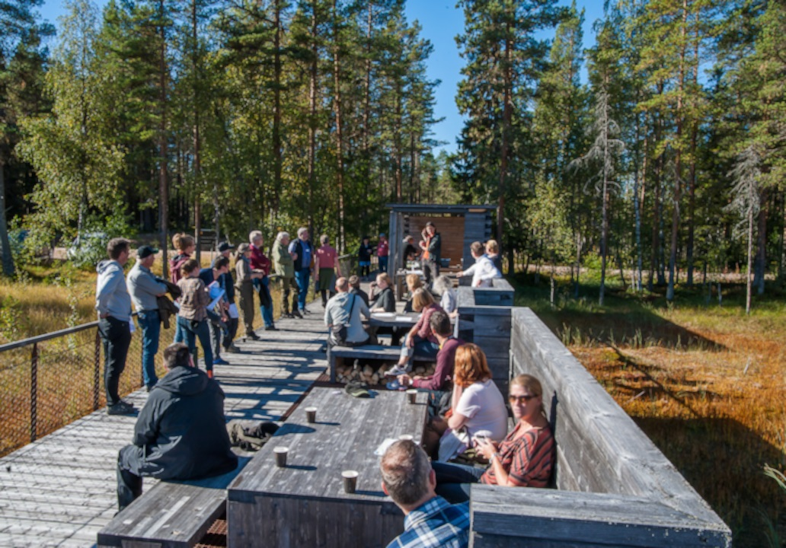
Figure 13.2: The start of the first consultation exercise was marked by a day spent in Hamra National Park. The aim was to draw attention to the biosphere reserve candidacy, bring together the relevant players and facilitate open discussion. Representatives from Biosphere Programme Sweden were also present. Photography: Kent Backeby.

13.5 How will stakeholder involvement in implementing and managing the biosphere reserve be fostered?
To ensure that there is a broad range of participants working on the implementation of the biosphere reserve’s objectives (Section 13.2) and production of development plans etc. (Section 17.4), the biosphere reserve‘s Board will comprise a diverse range of stakeholders (Section 13.3). As each member organisation is elected for a two-year period, the current composition of the Board may partially change over time, particularly in terms of voluntary and private sector representatives.
An annual, open meeting will give the general public and other stakeholders the opportunity to put their own suggestions forward regarding the direction of the work or the organisations to be represented on the Board.
Taking part in Focus Area Groups – which must be dynamic so as to reflect the project work underway at any given time – will enable stakeholders to get involved in the practical development work.
All five of Sweden’s existing biosphere reserves have introduced trained volunteer Biosphere Ambassadors. Voxnadalen plans to learn from their success and do the same (Section 16). Please see Section 17.1.8 for a more detailed description of the organisational structure and how this creates wide-ranging opportunities for involvement and participation in various processes.

13.6 What are the expected main sources of resources (financial, material and human) to implement the objectives of the biosphere reserve and projects within it?

Funding 2018-2019
For the 2018-2019 period, and as part of the Biosphere Candidate Voxnadalen project, core funding for the Biosphere Coordination Office will come from public sources. The following organisations are providing core funding:
• Swedish Environmental Protection Agency (Naturvårdsverket) (state level), SEK 400,000/year
• Region Gävleborg (regional level), SEK 800,000/year
• Ovanåker Municipality, 250,000 SEK/year; Ljusdal Municipality, 100,000 SEK/year; and Bollnäs Municipality, 75,000 SEK/year (local level)
• Total budget, SEK 1,625,000/year The three municipalities also provide staff for the Working Group (Section 17.1.8). As part of the funding from Region Gävleborg, SEK 100,000 has been allocated to each focus area for the organisation of activities in 2018-2019 that will provide additional material for the development plan (Section 17.4).

Funding 2020 and beyond
Core funding for the Biosphere Coordination Office, staffed by at least one Coordinator, will primarily come from public sources. Provided that the area is awarded formal biosphere reserve status, core funding will come from the Swedish Environmental Protection Agency and Ovanåker, Ljusdal and Bollnäs municipalities:
• Swedish Environmental Protection Agency, SEK 400,000/year
• Ovanåker Municipality, SEK 250,000/year
• Ljusdal Municipality, SEK 100,000/year
• Bollnäs Municipality, SEK 75,000/year
• Total budget, SEK 825,000/year
The Swedish Environmental Protection Agency has an agreement with the Swedish Agency for Marine and Water Management (Havs- och Vattenmyndigheten) to jointly ensure funding for all Swedish biosphere reserves, including candidate reserves, for a five-year period leading up to 2020. Any new decision about funding will require an evaluation. The government’s annual spending authorisation for the Swedish Environmental Protection Agency, which sets out how the agency’s funds can be allocated, has long stated that the agency may provide financial support to the Swedish biosphere reserves. Support for the biosphere reserves is thus sanctioned by the government.
Decisions about continued joint funding from Ovanåker, Ljusdal and Bollnäs have been made by the relevant municipal executive committee or municipal assembly.
To enable the biosphere reserve to run projects that are not part of its core activity, project funding will be applied for from central and regional authorities, funds etc. This activity will mainly be the responsibility of the Biosphere Coordination Office. The Biosphere Coordination Office plans to seek project funding to support at least one post in addition to the Coordinator.
Because Ovanåker Municipality is the entity with legal responsibility for the biosphere reserve organisation (Section 17.1.8), the municipality’s various support functions (e.g. staff and financial administration, IT support, premises, transport etc.) and combined skills (staff) will be used and consulted with as part of the day-to-day work. Ovanåker, Ljusdal and Bollnäs municipalities will also provide staff for the Working Group (Section 17.1.8).
Encouraging the various players in the area to get involved at a local level is essential for ensuring that the set objectives are fulfilled. By acting as an umbrella for sub-projects, the Biosphere Coordination Office can support stakeholders who want to apply for external funding and run projects that help to achieve the objectives.
Chapter 14

Conservation Function

14.1 At the level of landscapes and ecosystems (including soils, water and climate):

14.1.1 Describe and give the location of ecosystems and/or land cover types of the biosphere reserve.
For a more detailed description of types of nature and ecosystems mentioned below, see Section 11.6.

Forests
Voxnadalen is largely covered by coniferous forest with interspersed deciduous trees. Spruce (P. abies) and pine (P. Sylvestris) are the most common kinds of coniferous trees, while the most common deciduous trees include birch (B. pendula, B. pubescens), aspen (P. tremula), rowan (Sorbus aucuparia) and willow (Salix caprea). Most of the woodlands of the area grow on moraine soils. Land with moraine also contains boulders of various sizes; the subsoil is sand and gravel. Forests also grow on sandy areas and along ridges by the sides of rivers, streams and lakes.
Among the types of nature listed in the EU Habitats Directive the following are found in the planned biosphere reserve: western taiga (p), rich coniferous forests, poor coniferous forest, wooded pasture, swamp woods (p), bog woodland (p), dry heaths with pine forest and alluvial forests (p). The letter (p) signifies priority habitats in the Directive.

Lakes, rivers and streams
The River Voxnan runs through the whole of the planned biosphere reserve. Lakes, forest tarns, rivers and streams are dispersed over the entire area. Within the planned biosphere reserve, there are 700 lakes that are larger than 1 ha. Lakes, rivers and streams located at an elevation below the marine limit (Fact file 3) are surrounded by fine-grained sedimentary soils (clay, silt, glacial gravel and glacial sand), to a greater degree than those on an elevation above the marine limit.
Habitat types listed in the EU Habitats Directive occurring in the planned biosphere reserve are nutrient poor forest lakes, nutrient rich lakes and oligotrophic to mesotrophic standing waters (ävjestrandsjöar).

Wetlands
Several of the peatlands of the area are extensive and are mainly located in woodlands. The largest complexes of wetlands are located to the north-east and north-west of Loos and to the south of Edsbyn. Old peatlands occur in areas of farmland, but these have often been drained and are farmed. Types of nature in the planned biosphere reserve that are specified in the EU Habitats Directive (p, priority) are transitional (open) mires and fens, springs and spring fens, rich fens and aapa mires (p).

Grassland
Semi-natural pasture and hayfields, which are benefitted by grazing and mowing, belonging to the summer farms of the area are located in woodlands and near rivers, streams and lakes. Other open maintained grassland is mainly situated along the Voxnan, lakes and other rivers and streams occurring on a level below the marine limit.
Nature types occurring in the planned biosphere reserve that are included in the EU Habitats Directive are siliceous grasslands, molinia (fen) meadows, tall herb fringe communities and hay meadows.

Farmland
The major part of the farmland is situated in the south-eastern areas around the communities of Edsbyn and Alfta. In addition, there are smaller areas of cultivation along the western parts of the Voxnan and alongside smaller lakes and streams. Farmland is concentrated in areas below the marine limit where sedimentary soils were deposited by the glacial ice. The open farmland is varied and has been created through the interaction of humans and animals during the course of several thousand years.

Communities
Similar to the farmland of the area, the built environments are concentrated to the south-eastern parts, near the communities Edsbyn and Alfta. Smaller villages and individual farms are dispersed throughout the area, often situated in a border zone between the forest and the open farmed countryside.

14.1.2 Describe the state and trends of the ecosystems and/or land cover types described above and the natural and human drivers of the trends.
For a more detailed description of current conditions and development tendencies in the ecosystems described below, see Section 11.6.

Forests
The forest is and has been an essential economic resource for the region, in historical times (Section 9.1) and until the present day. The largest proportion of the area’s woodlands constitutes production forests shaped by humans. During the twentieth century, very little consideration was given to nature in the forestry work. This created a forest landscape that was relatively homogeneous, with a lack of dead wood and other structures that produce a varied landscape at a habitat and micro-climate level. Many old woods (older than 120 years) were felled during this period, with the result that the conditions deteriorated for several species adapted to later successional stages of the forest landscape.
Other natural disturbances have diminished during the same period, which has affected the landscape in a negative way. Such a natural disturbance that was particularly important for the forest landscape of the planned biosphere reserve is natural forest fires. They marked the landscape in a characteristic way and have largely ceased as a result of efficient fire surveillance.
The above-mentioned changes occurring in the woodlands during the twentieth century, continuing until the environmental adaption of forestry work in the1990s, have contributed to the loss of habitats of many species. Numerous mosses, lichens, fungi, insects and birds that are dependent on dead wood in various stages of decomposition, and on trees affected by fire, are now rare due to the loss of such features of the forest landscape. Among the species that occur in Swedish woodlands, 2,000 have been identified as red-listed by ArtDatabanken (2015) (The Swedish Species Information Centre). The introduction, at the end of the 1990s, of an environmental certification system (FSC and PEFC) for Swedish forestry work has promoted sustainable forestry work considerably, and a better balance has been achieved between production goals and environmental objectives (Section 14.2.4).
In order to limit grazing damage on spruce and pine saplings caused by large herbivores (roe deer and elk), these are culled to a level far below their biological capacity. This is performed through selective hunting as a result of demands from landowners.
Large areas of woodland were also drained during the twentieth century throughout Sweden; today such drainage only occurs to a limited extent. Other human impact on the ecosystems of the forest comprises nitrogen deposition from global air pollution, as well as climate changes; both are global challenges and are not specific only to the planned biosphere reserve.

Lakes, rivers and streams
The ecology of lakes, rivers and streams of the area is impacted by the clearances that were undertaken for log driving (Section 9.3) and by the construction of regulating dams and hydroelectric power stations. The formerly natural flow of the water in the River Voxnan, with rapids and calm water, which created rich and varied habitats for the freshwater fauna, has largely disappeared. Moreover, power stations act as barriers to the migration of fish and other freshwater organisms.
Eutrophication is generally not a significant problem in the catchment area of the River Voxnan; in the south-eastern more densely populated parts of the area, some of the streams and lakes are partially affected by leaching of nutrients from agriculture. A few of the lakes in the area are vulnerable to acidification as a result of global air pollution of acid substances. Acidification has, however, decreased and conditions in many of the lakes in the area have currently improved and no specific liming action is necessary. However, the degree of colouring (’brownification’) has increased in the Voxnan since the measurements started in the beginning of the 1960s. Brownification of bodies of water can partially be linked with the prevalent climatic changes.

Wetlands
The wetlands of the area are mainly affected by draining, which has changed their hydrology. New drainage of land must now be authorised and is therefore no longer performed to any great extent. Today, many of the previously open wetlands are becoming overgrown with bushes and trees when they are not maintained through grazing or mowing. Air pollution (deposition of nitrogen) and climatic changes also lead to increasing temperatures and longer periods of vegetation, which accelerate overgrowth of vegetation.
Woodland springs can be damaged or destroyed during the course of forestry work when heavy vehicles are used. In accordance with FSC and PEFC certification, surveys are now conducted of springs and other features worth protecting, before forestry work is commenced in an area. In the past, peat was also cut in the area, primarily for use on the farm, for example, as bedding for farm animals.

Grassland
Semi-natural pasture and hayfields are characterised by their rich biological diversity with many species favoured by fields that are grazed or mowed. When the fields are no longer maintained, the open cultural landscape becomes overgrown, in Voxnadalen as well as in Sweden generally. This applies chiefly to hayfields, since grazing is today the most common substitute for mowing hay. Among the species that occur in Swedish farmland, around 2,000 have been identified as red-listed by ArtDatabanken (2015) (The Swedish Species Information Centre).
In part, this development is caused by the abandonment of farmland and the transition to large-scale farming with changed and more efficient methods. Overgrowing of fields in the landscape, which were previously open and maintained, is also hastened by climatic changes causing increasing temperatures and a longer annual vegetation period.

Farmland
As in the case of pasture and hayfields, small cultivated fields in the area are also in danger of becoming overgrown. Low set prices for farm produce lead to rationalisation of size (fewer but larger units) and specialisation of farm businesses. For instance, the production of grass/forage plants for animal fodder has decreased in the area, since a smaller number of cattle are kept.
Further, forests have been planted on some of the farmland, and some farmland has disappeared due to expansion of developed areas. Drainage of fields, application of chemical fertilisers, use of herbicides and seeding of selectively bred crops has also affected the conditions for the biodiversity of farmlands.

Communities
The most outstanding and significant natural process along the River Voxnan, affecting communities of the region, is floods. Log-driving routes that were cleared along the Voxnan during the log-driving epoch have contributed to the increased vulnerability of the communities (Edsbyn and Alfta) to flooding (Section 11.6, communities). Climatic changes entail an increased risk for floods. In other respects, there is at the moment a stagnation of development of built-up areas.

14.1.3 What kind of protection regimes (including customary and traditional) exist for the core area(s) and the buffer zone(s)?
Core areas are covered by legislation and specific regulations that apply to the respective protected areas, National Parks, nature reserves, Natura 2000, World Heritage Site and cultural heritage reserve.
The same applies to the buffer zones, which are covered by legislation and specific regulations that apply to areas of national interest for nature conservation, outdoor recreation and heritage environment conservation, the large unexploited area (SOO), in the structure plan of Ovanåker Municipality and the nature conservation agreement (the Eco Park at Grytaberg).
For more detailed description of legislation that covers impact on natural environments and shore zones, as well as specific laws and regulations that apply in the respective zones, see Section 9.3.

14.1.4 Which indicators or data are used to assess the efficiency of the actions/strategy used?
Assessment of efficiency of strategies concerning protected areas is conducted according to guidelines determined by the Swedish Environmental Protection Agency (Naturvårdsverket (rapport 6397 ”Uppföljning av skyddade områden i Sverige”, 2010). Assessment is based on goal indicators, which are linked to types of nature and/or species in each protected area. These goal indicators are to be assessed in intervals of six to twelve years. The County Administrative Boards are responsible for assessment of the efficiency of strategies for protected areas. A list of examples of goal indicators and variables that are used for the assessment of protected areas in Gävleborg County is presented in Table 14.1.

Table 14.1: Goal indicators and variables used by the County Administrative Board of Gävleborg
3GROEN!30!white
Type of nature | Goal Indicators/variable
Lakes | - Acreage  - Regulation of flow based on hydromorphological methods of estimation (Naturvårdsverket, 2007) concerning hydrology  - Development of buildings, landing stages
Rivers, streams, other watercourses | - Acreage  - No obstructions of migration routes– low degree of fragmentation/barrier effect, based on hydromorphological methods of estimation (Naturvårdsverket 2007)  - Occurrence of juvenile freshwater pearl mussel (Margaritifera margaritifera, severely threatened EN)
Grassland | - Acreage  - Canopy cover of trees and bushes  - Number of thick and hollow trees  - Occurrence of typical vascular plants  - Occurrence of typical birds
Peatlands | - Acreage  - Canopy cover of trees and bushes  - Occurrence of ditches for drainage  - Coverage degree of water surface  - Coverage degree of pleurocarp moss, occurrence of typical species and negative indicator species
Forest | - Acreage  - Distribution of tree species  - Hydrological Regime. Based on estimation methods of Water Directive  - Acreage of fire-impacted forest (at regional, district or area level)  - Harvest of timber or significant impact on land in areas left undisturbed.

14.2 At the level of species and ecosystem diversity:

14.2.1 Identify main groups of species or species of particular interest for the conservation objectives, especially those that are endemic to this biosphere reserve, and provide a brief description of the communities in which they occur.
Within the planned biosphere reserve, 266 nationally red-listed species (ArtDatabanken (2015) The Swedish Species Information Centre) and 16 internationally (IUNC) red-listed species have been observed. Among species listed in the EU Birds Directive and the EU Habitats Directive, 97 and 38 species, respectively, have been observed in the area. Several of the species and habitats occurring in the area are included in the Threathened Species and Habitats Programmes (ÅGP), including beetles that live on old dead pine wood, otter (Lutra Lutra) and freshwater pearl mussel (Margaritifera margaritifera) as well as rich fens. A large number of protected species (44) have also been found in the area, e.g. several kinds of orchids and club mosses. No known species are endemic to the planned biosphere reserve.
A selection is presented below of valuable species/groups of species for each ecosystem that are of particular interest for conservation objectives.

Forests
The planned biosphere reserve is located in a part of Sweden where all the large predators are present (wolf Canis lupus VU, bear Ursus arctos NT, lynx Lynx lynx VU, wolverine Gulo gulo VU and golden eagle Aquila chrysaetos NT). In this respect, the area is unique among the existing biosphere reserves of Sweden. The wolf was previously almost extinct in Sweden. The last Swedish wolf was observed in Sarek-Padjelanta in 1976, before a new group of wolves migrated from the Finnish-Russian population at the end of 1970s. Wolves have now re-established themselves in the landscape, but the Swedish wolves risk inbreeding if the population is too severely culled and if there is no new migration.
In the natural forests of the area, there are several species of mosses (e.g. pendulous wing-moss Antitrichia curtipendula), lichens (e.g. Hypogymnia Hypogymnia vittata, wolf lichen Letharia vulpina NT, Carbonicola Carbonicola anthracophila NT and lungwort Lobaria pulmonaria NT), fungi (e.g. red ringrot Phellinus pini NT, Perenniporia subacida VU, Amylocystis lapponica VU and coral fungus Artomyces pyxidatus NT), insects (e.g. longhorn beetles Nothorina punctata NT, Tragosoma depsarium NT and Cixidia lapponica) and vascular plants (e.g. creeping lady’s tresses Goodyera repens NT, whorled solomon’s-seal Polygonatum verticillatum, ghost orchid Epipogium aphyllum NT and Alpine blue-sow-thistle Lactuca alpina). These grow in forests that are characterised by long continuity or by dead wood and trees scorched by fire in various degrees of decomposition.
In some of the deciduous forests, all species of woodpecker that currently occur in Sweden have been found, including the critically endangered white-backed woodpecker (Dendrocopos leucotos CR), which has been observed foraging in the area on several occasions (latest 2016).
In addition, species previously not known in the Swedish forest fauna have appeared, these are wild boar (Sus scrofa) and red deer (Cervus elaphus). Both these species have established themselves in the area and are expected to multiply.

Lakes, rivers and streams
Freshwater species of particular significance for the conservation objectives of the area are European eel (Anguilla anguilla CR), freshwater pearl mussel (Margaritifera margaritifera EN), noble crayfish (Astacus astacus CR) and otter (Lutra lutra NT).
A precondition for the freshwater pearl mussel to breed is that there are reproductive populations of trout (Salmo trutta) or Atlantic salmon (Salmo salar). During the course of its lifecycle, the freshwater pearl mussel passes through a parasitic stage when it attaches itself to the gills of salmon or trout. From a national perspective, salmon and trout have robust populations of least concern (LC) on the red lists. Nevertheless, the occurrence of local populations is affected by hydroelectric power stations, regulation dams and clearance of log-driving routes.

Wetlands
Several of the wetlands of the area are well-known and rich bird localities, where rare and nationally red-listed species occur, including curlew (Numenius arquata NT), lesser spotted woodpecker (Dendrocopos minor NT) and ruff (Calidris pugnax VU).
A particular kind of biological diversity is associated with rich fens and extremely rich fens in regard to vascular plants, mosses, molluscs, fungi, beetles and butterflies. Several kinds of orchid can be seen in the rich fens of the area, such as the remarkable lady’s slipper Cypripedium calceolus. Other kinds of plants that occur in the rich fens of the area are e.g. slender green feathermoss (Hamatocaulis vernicosus NT), angled paludella moss (Paludella squarrosa), baneberry (Actaea spicata) and twayblade (Neottia ovata). Geyer’s whorl snail (Vertigo geyeri NT) has also been encountered in the area.

Grassland
Plants, insects and birds that thrive in a maintained landscape kept open by grazing and mowing are of great significance for the conservation objectives of the area. The following species indicate land that has been continually managed over a long period e.g. the plants greater bur-marigold (Bidens radiata VU), multifid moonwort (Botrychium multifidum NT), spotted orchid (Dactylorhiza maculata) and field gentian (Gentianella campestris EN) along with the fungi honey waxcap (Hygrocybe reidii LC – a signal species), violet coral (Clavaria zollingeri VU) and earth tongue (Geoglossum fallax).
Many birds that are dependent on meadows, shore-side meadows or well-grazed land occur in the area, these include e.g. curlew (N. arquata NT), meadow pipit (Anthus pratensis NT), yellow wagtail (Motacilla flava) and lapwing (Vanellus vanellus). The severely threatened black-tailed godwit (Limosa limosa CR) has also been sighted in the area (2013).
The numbers of bees and bumblebees have decreased severely on a global scale over the past decades. Pollinating insects, for example bees, bumblebees, solitary wasps, sawflies and hoverflies are therefore particularly interesting in reference to conservation objectives.

Farmland
Pollinating insects, for example bees, bumblebees, solitary wasps, sawflies and hoverflies are of particular interest in reference to conservation objectives concerning farmland.
The skylark (Alauda arvensis NT) is a characteristic bird in a farmed landscape, particularly the open landscape with a high proportion of fields where crops grow. Today, the skylark is threatened by the discontinuation of farms and farmed land and by intensification of agriculture.

Communities
Species that are significant for conservation objectives within built-up areas include birds e.g. the common swift (Apus apus, VU), barn swallow (Hirundo rustica) and house sparrow (Passer domesticus). Swifts nest in close proximity to human settlement (e.g. under pantiles on roofs). They are having difficulties in finding suitable nesting places, as a result of changes in roofing methods. House sparrows have diminished in numbers during the past years due to abandonment of farms. Hedgehogs (Erinaceus europaeus) are also highly associated with human settlement and have become fewer in number over the past decades; one reason is that they tend to be run over by traffic, another is pollution.

14.2.2 What are the pressures on key species? In other words: what are the threats (example unsustainable management of forest), their immediate causes (drivers of change like forest change or habitat change), their underlying causes (example overgrazing, fire, pollution), and the main driving forces (example: economic, political, social, external, etc.) and the area(s) concerned?
Pressures on the above-mentioned key species, the causes and driving forces for this have been described in detail in Section 11.6 and are summarised in Section 14.1.2

14.2.3 What kind of measures and indicators are currently used, or planned to be used to assess both species groups and the pressures on them? Who undertakes this work, or will do so in the future?
The Swedish Environmental Protection Agency (Naturvårdsverket) and The Swedish Agency for Marine and Water Management (Havs och Vattenmyndigheten) are responsible for coordination of the monitoring of environmental matters in Sweden and are the driving force in this work. The national programme for monitoring of the environment is divided into 10 programme zones: the mountain landscape, health related environmental monitoring, farmland, coast and sea, landscape, air, coordination of environmental contaminants, woodland, freshwater, wetlands. County Administrative Boards undertake coordination of environmental monitoring at a regional level. Table 14.2 shows selected examples of goal indicators that are used in the regional monitoring of the environment undertaken by Gävleborg County Administrative Board.
In the work of the National Conservation Programmes for Threatened Species and Habitats (ÅGP), the Swedish Environmental Protection Agency, the Swedish Agency for Marine and Water Management, the County Administrative Boards and other involved parties work in partnership to protect threatened species and their habitats. The Programmes focuses the work on a selection of species and habitats. The long-term vision is that these species should become robust populations in functioning habitats.
The Swedish Species Information Centre (2015) (ArtDatabanken) is a knowledge centre concerned with species and habitats, run by the Swedish University for Agricultural Sciences (Sveriges Lantbruksuniversitet, SLU). Estimation and analyses are carried out of the situation and condition of biological diversity in Sweden. Every fifth year, the Swedish Species Information Centre presents a national Red List describing the state of Swedish species. The list of the status of species is based on estimations of population size, occurrences and distribution. Red-listing is an important tool for use in the national work of nature conservation and planning. The Swedish Species Information Centre also runs a project that gathers information from the public about various species, e.g. through the citizen-science project of Species Observation. In addition, The Swedish Species Information Centre is a source of knowledge and an expert authority on questions concerning protection of species.
Municipalities play an important part in the work of determining the state of species and their habitats, and the threats they are exposed to. This is conducted through surveys of natural values of forests and land, along with mapping of biotopes in rivers and streams (Section 14.2.4).
The Swedish Forest Agency conducts surveys and mapping of key biotopes, i.e. woodlands with high natural values and considerable significance for threatened and red-listed species. Forestry companies perform surveys and mapping of natural values on their own grounds.
Since 1938, the Swedish Association for Hunting and Wildlife Management (Svenska Jägareförbundet) has been assigned the task of monitoring the development of species that are permissible to hunt, ranging from a national level to the local level. People who are engaged in associations (for example bird clubs and nature conservation societies) and others also contribute valuable information at a local level about the environment and the state of species.
3GROEN!30!white
Table 14.2: Environmental monitoring. RMÖ (Regional miljöövervakning) = Regional Environmental Monitoring, ÅGP (åtgärdsprogram för hotade arter och naturtyper) National Conservation Programmes for Threatened Species and Habitats.

Habitat/ Group of Habitats/Species | Environmental Monitoring Programme or equivalent | Goal Indicator | Comment
Peatlands | Peatland bird survey-RMÖ | Characteristic birds | Special Protection Area
Forest | Forest-RMÖ | Characteristic species, dead wood, etc.
freshwater pearl mussel (M. margaritifera) | Intensive/extensive monitoring-RMÖ | Number, reproducing population
Horned powder-post beetles (Stephanopachys sp.) | ÅGP | Occurrence after burning
European otter (L. lutra) | Otter-RMÖ | Occurrence | Survey on snowless ground
Drooping woodreed (Cinna latifolia) | ÅGP | Number of tufts
Whorl snails (Vertiginidae) | Together with ÅGP if possible | Occurrence

14.2.4 What actions are currently undertaken to reduce these pressures?

14.2.4.1 Forests
’Sustainable forests’ is one of Sweden’s Environmental Quality Objectives according to the following wording ‘The value of forests and forest land for biological production must be protected, at the same time as biological diversity and cultural heritage and recreational assets are safeguarded’. Environmental objectives and production goals are thus valued equally. One of the most important measures currently taken in Sweden to fulfil the environmental quality objectives is to protect valuable forest environments from intensive forestry management. This is included in the work of the County Administrative Boards of establishing nature reserves, biotope conservation areas and settling nature conservation agreements with land owners (Section 9.3).
In accordance with the Forestry Act, general consideration for the environment should be given during forestry work; for example, protective zones with trees and bushes should be left alongside lakes, rivers and streams, and adjacent to open farmland. Bushes and solitary trees should also be left, such as old and large trees, hollow trees, nesting trees, along with dead and dying trees.
In addition to this, the Swedish Forest Agency and in cooperation with the forestry industry have agreed on shared objectives for the most common biotopes. These objectives include a description of how to recognise the biotope, which natural values that occurs in each biotope and what kind of measures that should be taken to protect these natural values. Likewise, the Swedish Forest Agency continues to identify and register key biotopes. The concept of key biotopes has been established by the Swedish Forest Agency with the purpose of identifying environments that are particularly worth protecting from a nature conservation perspective.
Most contemporary forest owners (private and companies) are certified according to the environmental criteria of the FSC (Forest Stewardship Council) and PEFC (Programme for the Endorsement of Forest Certification Schemes). The FSC’s criteria involve leaving legacy trees (10 per hectare), dead wood should be saved and actively recreated through ring-barking or retaining high tree stumps during the felling. The landowner should voluntarily leave at least 5% of the productive forest, which should not be felled; identified key biotopes must be protected.
In order to imitate spontaneous forest fires to create good conditions for fire favoured species, the certification requires that forests should be burned for the purpose of nature conservation. Owners of large forests who are certified by the FSC should burn 5% of the annual regeneration area on dry healthy land. The County Administrative Board carries out controlled forest burning as part of the disturbance regime of protected areas (National Parks, nature reserves and Natura 2000 sites).
Two of the prominent landowners/forestry companies who own extensive areas of woodland in the region are Sveaskog (state owned) and Bergvik Skog (privately owned). Within the planned Biosphere Reserve, Bergvik Skog has voluntarily set aside around 7,500 ha of woodland for nature conservation, while Sveaskog has preferred to establish Eco Parks (Section 9.3). An Eco Park is a large contiguous area of forest, at least 1000 ha in size, with high natural values and ambitions for nature conservation.
The specific Conservation Programmes for Threatened Species and Habitats (ÅGP) of the County Administrative Board continues. Currently they encompass, for example, beetles that thrive on old dead pine wood, beetles that thrive on recently dead pine wood, fire dependent insects in boreal forests as well as the severely threatened plant spring pasque flower (Pulsatilla vernalis EN).
Increasing attention is being paid to the different values of the forest; these include biological, social and economic values. Based on this, the realisation has grown that it is possible to combine different forest maintenance methods in order to fulfil specific objectives. A debate has been going on in Sweden since the beginning of the twenty-first century concerning forestry methods that do not involve clear-cutting of entire stands of forest. When such methods are used, the land is not laid bare and a sense of forest is preserved. An advantage of not felling the whole stand of trees is that the structures of old forests can be kept, which creates better conditions for species associated with these environments. An increasing understanding has been acquired that different aims can be fulfilled by combining the even-aged stand management system with management not involving complete clear cutting.
Many species have been favoured by the consideration for nature that was introduced in forestry management in the 1990s with environmental certification. These species are more common now than they would otherwise have been. At the same time, general consideration given to nature and all species, in combination with the even-aged stand management system, is not sufficient for all species. Some species survive in the environment created by a management system that does not involve clear-cutting, but others require protection of the area or management in compliance with nature conservation. Ultimately, it is not necessarily at a local population level, but rather at a regional level that access to suitable habitats is essential for the survival of species.
The Swedish Association for Hunting and Wildlife Management (Svenska Jägareförbundet) run one of Sweden’s oldest wildlife conservation programmes through their assigned Hunting and Wildlife Conservation Commission. The association also conducts surveys, supplying local authorities with correct information as a basis for decisions that need to be taken to fulfil the goals of the government policy A Sustainable Predator Policy En hållbar rovdjurspolitik (governmental decision, 2013).

Lakes, rivers and streams
A range of measures have been taken with the purpose of restoring natural environments in waterways that were cleared for log driving. Sizeable stones, for example, have been returned to watercourses and gravel has been placed in riverbeds to stimulate mating. Hydroelectric power stations have in part been adapted to facilitate the distribution of fish through the construction of artificial streams that flow past the migration barrier. Much remains to be done in the work of restoring natural freshwater environments and in the reconstruction of migration routes, which are free of obstructions, for freshwater organisms. In 2016 and 2017, the municipalities of Bollnäs, Ljusdal and Ovanåker conducted a survey of major parts of the River Voxnan and its tributaries. The survey constitutes the basis for new municipal fisheries conservation plans.
The following species are included in the National Conservation Programmes for Threatened Species and Habitats (ÅGP): noble crayfish (A. astacus), freshwater pearl mussel (M. margaritifera), river lamprey (Lampetra fluviatilis) and otter (L. lutra).
The objectives of the Swedish Forest Agency concerning environmental consideration in forestry management may moreover contribute to improving the quality of freshwater environments. Erosion and movement of sediment into watercourses can also be reduced by avoiding too much damage caused by forestry machines. Many freshwater species, for instance mussels, can be negatively affected by a high content of sediment causing cloudiness in the water.

Wetlands
A number of actions have been taken to restore drained wetlands; for example, in Hamra National Park where restoration has taken place in most of the wetlands that required attention. Restoration of wetlands has been undertaken by the County Administrative Board and by forestry companies, separately and jointly. Drainage of areas not previously drained is now an undertaking that must be approved by the authorities and thus only occurs to a limited extent.
Rich fens are included in the National Conservation Programmes for Threatened Species and Habitats (ÅGP). The species geyer’s whorl snail (V. geyeri) occurs in the area and is covered by the Programme for rich fens.
The Swedish Environmental Protection Agency and the County Administrative Boards have together produced a conservation plan for Swedish peatlands. Peatlands that are included in the plan are designated as particularly valuable and are prioritised for protection measures. Several peatlands included in the peatland conservation plan are situated in the planned Biosphere Reserve, especially in the surroundings of Los (Fig. 6.2). Many of the selected peatlands are currently part of the Natura 2000 network and most are on a priority list for designation as nature reserves. Overgrowing of shoreside meadows is prevented in places where mowing or grazing of wetlands is practised (for example in the Sässman area, Table 7.2).

Grassland
EU’s environmental grants facilitate private landowners and farmers to keep their fields mowed or grazed. Consequently, much of the open cultural landscape can continue to be kept open. There is considerable interest among landowners to restore meadowland and pastureland. In protected areas, valuable grassland is maintained, by mowing or grazing, through funding from The Swedish Environmental Protection Agency.
Groups of species associated with the open and maintained cultural landscape are covered by the National Conservation Programmes for Threatened Species and Habitats (ÅGP). These include gentians (Gentianella sp) on semi-natural pastureland, fungi in meadows and pastureland, threatened lichens on timber artefacts in farmland, along with wild bees and small butterflies on dry land and wild bees in meadows.

Farmland
The EU’s environmental grants facilitate private landowners and farmers to keep their fields mowed or grazed. Several species are associated with the open cultural landscape, such as pollinating insects, and are included in the National Conservation Programmes for Threatened Species and Habitats (ÅGP) (see ’Grassland’).
Through the project Focus on Nutrients, Greppa Näringen, run by the County Administrative Board, farmers are provided with guidance and knowledge in order to handle leaching of nutrients, pesticides and herbicides. Measures are also taken at a municipal level. For example, Ovanåker Municipality have devised a detailed landscape analysis for the Sässman area (Table 7.2), which is a unique and living farmed landscape near Edsbyn. Results from the landscape analysis will be used for the protection and development of the area’s natural, cultural and outdoor recreation values. The results will also be used as guidance for farmers/landowners who utilise the landscape.
A national food strategy has been approved by the Swedish government (20 June 2017). It is the first food strategy to encompass the entire food chain. A regional food strategy will be produced for Gävleborg County, due to be finished during the autumn of 2018 and will apply until 2030. The County Administrative Board in Gävleborg are responsible for this regionally adapted food strategy, together with the Region of Gävleborg, the municipalities of the County (including Ovanåker, Ljusdal and Bollnäs) and other involved parties (e.g. The Federation of Swedish Farmers). The purpose of the strategy is to increase the degree of self-sufficiency and security of food supplies, as well as to increase food production while ensuring that relevant environmental objectives are fulfilled, to create development and employment and to reduce vulnerability in the food chain.

Communities
The Structure Plans (Section 9.3) of individual municipalities are important tools for planning the use of land and water in the area. Spaces to be prioritised when creating green zones in the largest communities of the planned biosphere reserve, Edsbyn and Alfta, have been distinguished in the Structure Plan of Ovanåker Municipality. These green zones are planned to be links between other existing green areas.
Several forests in close proximity to communities are valuable recreation areas for walking, running, cycling and skiing etc. Bäck is a popular recreation area, centrally located in Edsbyn; it is included in a woodland nature conservation agreement.

14.2.5 What actions do you intend to take to reduce these pressures?
The actions that have been described in Section 14.2.4 will continue and be developed by responsible authorities and involved parties (e.g. forestry companies) in order to fulfil Sweden’s 17 environmental quality objectives. The aim of the biosphere reserve organisation is to contribute to the work of fulfilling the national environmental quality objectives (Section 13).
All Sweden’s County Administrative Boards are currently, until the autumn of 2018, working to produce action plans for developing green infrastructure. The plans are to act as a basis of knowledge in planning and decision processes of involved authorities. The purpose is to preserve networks of natural values that contribute to functioning habitats for animals and plants, and which might generate ecosystem services.
Ovanåker, Ljusdal and Bollnäs municipalities are producing new fisheries conservation plans for major parts of the River Voxnan and its tributaries. These documents will be integrated into the Development Plan of the planned Voxnadalen Biosphere Reserve (Section 17.4). The plans will suggest measures that should be prioritised in order to increase ecological values in rivers and streams that have been cleared for log driving and in waters affected by hydroelectric power stations and regulation dams.

14.3 At the level of genetic diversity:

14.3.1 Indicate species or varieties that are of importance (e.g. for conservation, medicine, food production, agrobiodiversity, cultural practices etc).
Valuable species to protect in the area are described in Section 14.2.1. No known endemic species occur in the area. The grey wolf (Canis lupus VU), brown trout (Salmo trutta), pine (Pinus sylvestris) and wild forest reindeer (Rangifer tarandus fennicus) are of particular interest for conservation in reference to genetic diversity.

14.3.2 What ecological, economic or social pressures or changes may threaten these species or varieties?

Wolves
The Swedish population of wolves is present in Mid-Sweden with concentrations in, for instance, the Gävleborg and Dalarna Counties (parts of the planned biosphere reserve). Wolves were considered extinct in Sweden during the 1970s but have subsequently become established in the landscape again. Currently (2016/2017), the population of wolves is calculated at approximately 355 individuals. The Swedish population of wolves originates from a limited number of individuals that migrated from the Finnish-Russian population. The population is therefore subject to inbreeding, although the status has improved during the period 2006-2016.
Attacks by predatory animals on domestic animals or dogs during hunting evoke strong feelings among those who are affected. In the area and in the rest of the country, opinions are sometimes expressed in favour of severe culling or eradication of wolves. Poaching of wolves and other large predators has occurred in the area. Despite poaching, the Swedish wolf population grows at an annual rate of 20%. There is also an influential opinion in favour of preserving a robust population of wolves in the area and in the rest of the country.
The Swedish Environmental Protection Agency and the County Administrative Boards have had difficulties in implementing Sweden’s governmental predator policy (En hållbar rovdjurspolitik, Prop. 2012/13:191). The policy involves culling in areas that are densely populated by wolves, keeping the population to between 170 and 270 individuals (at a national level). Today, the County Administrative Boards can decide to perform licenced hunting and predator control of wolves, although various nature conservation societies often appeal against such decisions in court. This has created resignation and distrust of the system among some of the population, contributing to continued sharp conflicts of opinion and a polarised debate between different interested parties.

Brown trout
Genetically unique populations of trout occur in Lake Mållången and in the stream Galvån. Introduction of trout from other genetically foreign populations risks affecting the biological diversity of the indigenous populations of trout at a genetic level. Such a situation might result in losses and changes in the biological diversity at a genetic level and ultimately at a species and ecosystem level.

The Hälsingland pine
The indigenous pine (P. sylvestris), which grows in the area, has long been known far afield for its excellent qualities as timber. Hälsingland pine is a well-known emblem of quality in Sweden. The special quality of the dense timber and high proportion of heartwood has an immediate connection with the climate of the woodlands of Hälsingland (Fact file 7, Hälsingland pine)
In the 1960s, the North American lodgepole pine (Pinus contorta) was introduced to Sweden on a large scale. The lodgepole pine rapidly became popular, since it grows well on elevated areas and on poor land where indigenous trees grow more slowly. Due to its excellent growth, in comparison with indigenous pine, lodgepole pine was considered to contribute to a much more stable supply of timber in the future. Today, lodgepole pine is mainly used as pulpwood for paper etc. Lodgepole pine was judged to be safe to introduce, since its natural regeneration requires fire to ’unlock’ the pine cones for self-seeding.
This point was later re-evaluated as it turned out that the lodgpole pine could regenerate naturally when it had reached around thirty years of age. It competes with pine, spruce and birch on dry, healthy and damp land. There is uncertainty about the long-term effects of this on biological diversity, but lodgepole pine forests contain fewer vascular plants, lichens and insects than ordinary indigenous pine forests.
Currently, there is no evidence of cross-fertilisation between indigenous pine and lodgepole pine. Consequently, there is no known risk for depletion of the indigenous pine due to cross-fertilisation with lodgepole pine.

Nordic dogs and native breeds
Many of the Nordic native breeds are today extremely rare; for example, the Hälsingland sheep and Gästrikland sheep, both indigenous to the region. The transition from small-scale self-sufficient farming to specialised, industrialised agriculture has led to a situation in which the Nordic native breeds are now rare. The presence of large predators may also make animal husbandry difficult for smallholders, who are often interested in preserving Nordic native breeds. Even Nordic hunting dogs, such as the Swedish drever and the Swedish foxhound, are disappearing at a local level when they are no longer commonly used for hunting; one reason for this is the risk of predator attacks.

Wild forest reindeer
In earlier days, wild forest reindeer (Rangifer tarandus fennicus) lived in the planned biosphere reserve. However, the species died out in Sweden during the end of the nineteenth century because of too intensive hunting. One reason for the intensive hunting was that the Sami did not want wild reindeer near their domestic reindeer and paid bounty for reindeer.

14.3.3 What indicators, at the level of the species, are used, or will be used, to assess the evolution of population status and associated use?
The County Administrative Boards are responsible for annual surveys of the populations of large predators (wolf, bear, lynx, eagle and wolverine). The purpose of the surveys is to monitor the distribution, genetic status and size of predator populations and developments over time. Indicators for determining the occurrence and distribution of species include tracking in snow, DNA-analysis of droppings and setting up surveillance cameras.
To determine the status of fish populations, surveys are undertaken by test fishing (electro-fishing) and mapping of biotopes in the rivers and streams of the area. Local fishery conservation area associations are assigned the task of managing and maintaining fishing waters in the area; for example, application of fishing rules, introducing fish into waters.

14.3.4 What measures will be used to conserve genetic diversity and practices associated with their conservation?
General measures to preserve biological diversity are described in Sections 14.2.4 and 14.2.5. The County Administrative Boards will continue to monitor the development of predator populations in the region and take action accordingly. The Predator Centre, The Big 5 in Ljusdal Municipality, arranges exhibitions, lectures, courses, meetings, produces educational publications and supports research on predator related questions.
In order to protect local genetic populations of brown trout, introduction of genetic material of local origin has been conducted. Planned restoration of rivers and streams that were earlier cleared for log-driving purposes will improve the ecological conditions for trout and other freshwater organisms.
The use of lodgepole pine is now regulated in the Swedish Forestry Act (Section 9.3). Forest plantation of lodgepole pine, in areas larger than 0.5 ha, must be notified to the responsible authority and must not be planted within one kilometre of National Parks and nature reserves.
Individual owners of animals and societies that work to protect native breeds play a significant role in preserving Nordic native breeds. Native breeds societies are voluntary organisations that monitor the genealogy of animals and keep a register of animals in a gene bank. Each society has a breeding plan that is approved by the Swedish Board of Agriculture (responsible authority).
The Swedish Association for Hunting and Wildlife Management (Svenska Jägareförbundet) are currently looking into possibilities of re-introducing wild forest reindeer; an idea initiated by a local group of hunters (Färila-Kårböle near the planned biosphere reserve). Several Swedish researchers support the idea of re-introducing the wild forest reindeer into Swedish woodlands. However, in order to continue, an environmental impact assessment is required. A good example is the neighbouring country of Finland, where the species has been successfully re-introduced.
Chapter 15

Development Function

15.1 Potential for fostering economic and human development which is socio-culturally and ecologically sustainable

15.1.1 Describe how and why the area has potential to serve as a site of excellence/model region for promoting sustainable development.
A range of local initiatives and partnership projects on sustainable development are currently undertaken by municipalities and various authorities, as well as by private businesses and volunteer run organisations. Each of the four partnering municipalities in Voxnadalen is actively working on sustainability, addressing environmental objectives adapted to their local circumstances. In each case, the municipality’s local environmental objectives go hand in hand with the visions and objectives of the proposed biosphere reserve (Section 13).

Ovanåker Municipality
Ovanåker Municipality has been working on various broad environmental and sustainability issues for over twenty years, (Fig. 13.1) focussing in particular on the conservation of the area’s rich cultural heritage. Its successful work on building surveys, the adoption of area regulations for villages of historical value (Section 9.3) and building conservation projects in partnership with property owners and users has been a model and source of inspiration for neighbouring municipalities.
In 2009, Ovanåker Municipality adopted a series of locally-established environmental objectives, subsequently revised in 2015 (Lokala Miljömål 2020). To achieve the objectives, the municipality must seek to reduce the climate impact of its work; for example, it must be free of fossil fuels by 2020 (except in the case of fuels for transport). Ovanåker is also working on an ongoing basis to increase the proportion of organic and locally-produced food in municipal kitchens (schools, care homes, etc.); the figure must be at least 50% by 2020.
Ovanåker Municipality is also a member of the National Association of Swedish Eco-municipalities (Sveriges Ekokommuner). This is a collaborative organisation for municipalities, county councils and regions whose aim is to foster community development that is ecologically, socially and financially sustainable.

Ljusdal Municipality
Ljusdal Municipality has implemented an agreement with the County Administrative Board in respect of action on environmental objectives and climate change adaptation. The action is to be taken by 2020 and includes measures that help to bring about reduced climate impact, a higher proportion of organic and locally-produced food in municipal kitchens and improved ecological conditions for aquatic species in the catchment areas of the Ljusnan and Voxnan rivers. Ljusdal is also a member of the National Association of Swedish Eco-municipalities.

Bollnäs Municipality
Bollnäs Municipality is an eco-municipality (member of the National Association of Swedish Eco-municipalities) and has adopted local environmental objectives for the period between 2013 and 2020. The objectives are divided into overall objectives for the municipality’s geographical area, which everyone who lives or is active in the municipality can help to achieve, and environmental objectives for the municipality’s administrative services and companies that show the work Bollnäs Municipality will be doing to meet the overall local objectives. In recent years, a lot of the environmental work has focussed on promoting living watercourses, for example by restoring rivers previously cleared for log driving and addressing migration barriers.
Bollnäs has also been working for a number of years on increasing the proportion of local produce in municipal kitchens. This work has produced results, and the proportion of Bollnäs Municipality’s bought-in ingredients that is locally produced is one of the highest of all municipalities in Sweden. The municipality is keen for this trend to continue, as developing entrepreneurship around food production is important for the future development of the area. The municipality is also undertaking focussed work on the development of the green industries as one of four action areas arising from its enterprise policy.

Rättvik Municipality
Rättvik Municipality was quick to embark upon a political process to integrate the 2030 Agenda and the Sustainable Development Goals (SDGs) into its own work on environmental objectives. The municipality’s current work on sustainability is based on approximately 50 targets derived from the SDGs and adapted to local circumstances. There is also ongoing action to increase the proportion of organic and locally-produced food provided by the municipality. As part of the ‘Reclaim’ (Återtag) project, cattle from the local college for land-based studies are allowed to graze on the municipality’s grassland and the meat is then served in schools, an example of a closed, locally-produced system.
An environmental prize is awarded each year to a private individual or organisation that has made a contribution to the environment in the municipality. From 2018 onwards, the prize is to become a sustainability award so that it will also cover the social and economic aspects of sustainable community development.

Local partnership working
Some joint work is already being done by a number of the municipalities involved on various sustainability issues. Projects include:
• The Development Plan for Fishery Resources and Water Conservation in the Ljusnan-Voxnan Catchment Area (Utvecklingsplan för fiskresursen och vattenvård i Ljusnan-Voxnans avrinningsområde), a joint project by Bollnäs, Ljusdal and Ovanåker municipalities. One of the outcomes will be a new fisheries conservation plan for much of the River Voxnan and its tributaries
• The ’Fishing in the Middle of Sweden’ project, which aims to attract European recreational anglers to the area, is funded by Region Gävleborg and the municipalities in Hälsingland province, including Ovanåker, Ljusdal and Bollnäs
• The municipalities’ Energy and Climate Advisers work together on various awareness campaigns targeted at the general public
• Region Gävleborg runs a collaboration platform for all the municipalities in the region, including Ovanåker, Ljusdal and Bollnäs, and Gävleborg County Administrative Board. The platform runs regional environmental, energy and climate-related projects
It is anticipated that the body managing the biosphere reserve and the incentives created by the UNESCO remit will together help to achieve broader collaboration across geographical and administrative boundaries. This partnership working will help to identify common goals, avoid sectoralised initiatives and create a range of positive synergies in local work on sustainability.
Its proximity to Dalarna province and the Baltic Sea coast and good connections to Stockholm, the Swedish capital, put the proposed biosphere reserve in a strategic location, making it easier to establish contacts and share practical experiences with other parts of the country.

Entrepreneurial spirit and an active community life
Characteristic of Voxnadalen is its entrepreneurial spirit and small-scale business activity, and also strong social networks including Free Churches and sports clubs. The areas around the two largest communities, Edsbyn and Alfta, have evolved over the years from farming communities into industrialised communities. The many small businesses and the larger-scale industrial activity are very much associated with the forest, the area’s greatest natural resource. In addition to forestry and timber processing activity, there are many companies and businesses involved in engineering and the development of modern technology. The area’s two biggest companies, Svenska Fönster and Edsbyverken, which produce wooden windows and office furniture respectively, are at the forefront nationally in terms of their attention to environmental and social issues. For example, both companies were the first in Sweden to offer products with the Swan ecolabel (the Swan is the official ecolabel for the Nordic countries). The companies take their social responsibilities seriously, providing support for local clubs and societies, outdoor recreation and health promotion. In general there is a positive climate for business, and in 2013 Ovanåker Municipality’s services to businesspeople were recognised as amongst the best in the country. Rättvik Municipality has also created new models for advice and guidance to new companies with sustainability at their core.
Volunteer-run community activity is a major force for stimulating involvement and a sense of fellowship in Voxnadalen, where the number of clubs and societies is amongst the highest in Sweden. Virtually every type of interest is catered for. Organisations range from major sports clubs with hundreds of members and impressive facilities to small, specialist groups with a few dozen active enthusiasts. Clubs, societies and businesses often come together on joint tourism projects, where they work with each other to help more people discover the potential of Voxnadalen’s natural environment. One example of a partnership between local companies, associations, private individuals and Ovanåker Municipality was the joint project to build Sweden’s first indoor bandy arena in Edsbyn in 2001. Another example was the initial development of the Fishing in the Middle of Sweden project, which is now run as a cooperative. The many Free Churches in the area are also important centres of voluntary activity, particularly in respect of social issues such as the reception and integration of refugees. Local history societies play an important role in managing and promoting the cultural heritage sites in the area. Several of the decorated Hälsingland farmhouses (Fig. 3.9) are managed by local history societies on a voluntary basis.

Diverse ecosystem services
Historically, the ecosystem services that forests, watercourses and cultivated land/summer farms have generated for farmers have had a significant role to play in the economy, development and cultural history of the area (Section 10.6). This is evidenced by the unique Hälsingland farmhouses (Fact file 4-6) that are now recognised by UNESCO as a World Heritage Site. Although the areas around the urban centres of Edsbyn and Alfta have now evolved from farming communities into industrial communities, the ecosystem services generated by the forests, watercourses and cultivated lands continue to play an important role in the development of the area.
The innovation of new wood-based products has a key role to play as we develop a society independent of fossil fuels. A substantial portion of the economy in the Gävleborg Region is directly related to the bioeconomy, and it is felt that there is great potential in the region for continued development in this field (Region Gävleborgs förutsättningar och möjligheter i en framtida bioekonomi, NiNa Innovation, 2016; ‘Gävleborg Region – conditions and opportunities for a future bioeconomy’). Good access to high-quality forest products, considerable expertise in handling different types of biomass, and a tradition and long experience of processing forest products are amongst the region’s strengths. The biggest employer in the area, Svenska Fönster, with approximately 800 employees, produces windows with the Swan ecolabel (the official ecolabel of the Nordic countries). The majority of the company’s timber is of local origin, with 25 tonnes of processed timber being despatched daily from the Edsbyn factory.
The forests and watercourses do not just provide the area with provisioning ecosystem services. Experiencing the natural environment is important for our physical and mental well-being. Access to peaceful, undeveloped areas and the right to unlimited public access to the countryside (outdoor access rights, Section 9.3) are of unique value in themselves, particularly in a global perspective, whilst also generating cultural ecosystem services and providing a basis for the development of nature tourism. The benefits of outdoor recreation such as health, an understanding of the natural environment and regional development also form the basis of Sweden’s 10 national objectives for outdoor recreation (governmental decision, December 2012). The objectives aim to guarantee opportunities for people to enjoy the natural environment and pursue outdoor activities. Amongst the 10 objectives are ’a natural environment accessible to everyone’, ’a high level of engagement and partnership working for outdoor recreation’, ’sustainable regional growth and rural development’ and ’outdoor recreation for good public health’. The proposed biosphere reserve is well placed to contribute to the fulfillment of these objectives.
According to a study carried out by the Swedish Tourist Association (Svenska Turistföreningen, STF), walking continues to grow in popularity amongst domestic tourists. The main reason people like to walk is to get out into the countryside and experience the peace and tranquillity it offers. The Helsingeskogen cooperative was formed recently with the aim of developing the system of trails in the area for walking, motocross, cycling, etc.. The Biosphere Coordination Office set up during the process of candidacy for biosphere reserve status was instrumental in getting Helsingeskogen started.
Fishing tourism, particularly that based on visitors from abroad, has also been shown to generate valuable income for rural areas (‘Recreational fishing and fishing tourism for rural development’ / Sportfiske och fisketurism för landsbygdens utveckling, Report 2017/18, the Swedish Board of Agriculture and the Swedish National Road and Transport Research Institute). The ’Fishing in the Middle of Sweden’ (FIMS) project has already generated sales of approximately SEK 2.6 million and 3,300 guest bednights in the FIMS-project area. Action to improve the ecological conditions for fish and other aquatic organisms in Voxnan river and its tributaries is very important for the continued development of fishing tourism in the area. A new fisheries conservation plan for Voxnan and its tributaries being produced as part of a municipal initiative will be completed during 2018. Some water conservation measures have already been introduced, but much remains to be done.
The Decorated Farmhouses of Hälsingland World Heritage Site, the well-preserved summer farm settings and the open, cultural landscape provide a basis for the continued development of cultural tourism in the area. The tourism offer relating to the World Heritage Site is continually being developed, to include concepts such as ‘stay at a Hälsingland farmhouse’, and several of the farms are linked by a brown and white-signposted Hälsingland Farm Trail (Stora Hälsingegårdars väg). During the 2017 summer season, the Site had around 120,000 visitors and held over 200 events. The World Heritage Site consists of seven selected Hälsingland farmhouses, three of which are located within the proposed biosphere reserve. Meanwhile, Svedbovallen in Ljusdal Municipality attracts volunteers from both Sweden and abroad keen to experience life on a summer farm and take on tasks such as looking after animals, milking cows and goats and making dairy products. The resumption of grazing on the summer farms also brings opportunities for local, small-scale and sustainable food production while conserving unique natural and cultural heritage sites.

15.1.2 How do you assess changes and successes (which objectives and by which indicator)?
3GROEN!30!white
Table 15.1: How changes and positive impact will be assessed
Area/object | Monitoring done by | Indicators
white Area/object | Monitoring done by | Indicators
Biosphere reserve generally | The municipalities | Outcomes of environmental monitoring  Review against the environmental objectives, Planning and Building Act (PBL) and Heritage Environment Act (KML)
Sustainable use of the natural environment  Nature reserves, Natura 2000 sites, National Park  Biodiversity | Swedish Environmental Protection Agency  Swedish Board of Agriculture  Municipalities | Outcomes of environmental monitoring  Are stewardship plans and protective legislation for the areas being adhered to?  Review against the environmental objectives
Sustainable use of cultural heritage and cultural heritage reserve  Cultural diversity  A multi-dimensional landscape | Municipal planning officers  Swedish National Board of Housing, Building and Planning (Boverket)  County Administrative Boards  County Museums  Swedish National Heritage Board (Riksantikvarieämbetet) | Is the KML being adhered to?  Statistics relating to ancient monuments and remains damaged by forestry  Are the relevant stewardship plans being adhered to?  Review against the environmental objectives  Review against the PBL
Sustainable development of tourism | Swedish National Heritage Board  Region Gävleborg  County Administrative Boards  Agency for Economic and Regional Growth (Tillväxtverket) | Statistics  Are regulations and conservation plans for World Heritage Sites, other tourist attractions and cultural heritage sites being adhered to?  Are guidelines for the development of the tourism sector being followed?
Sustainable energy production | Swedish Energy Agency (Energimyndigheten)  Swedish National Board of Housing, Building and Planning  Municipalities | Increase or decrease in more sustainable energy sources
Sustainable, environmentally-friendly forestry production  Cultural diversity in the forest | Swedish Forest Agency  Forestry companies  County Administrative Boards  Swedish National Heritage Board | Outcomes of environmental monitoring  Are environmental plans for forest conservation and forestry being adhered to?
Sustainable use of water | Swedish Agency for Marine and Water Management  Swedish Chemicals Agency (Kemikalieinspektionen) County Administrative Boards  Municipalities | Outcomes of environmental monitoring and analysis  Review against the environmental objectives
Sustainable fisheries | Fishery conservation area associations  Municipalities | Test fishing  Outcomes of water analysis
Sustainable agriculture and sustainable development of agriculture | Swedish Board of Agriculture  County Administrative Boards  Municipalities | Number of farming units  Number of organic farming units  Number of dairy and livestock farmers  Levels of environmental toxins measured
Locally-produced food | National Food Agency (Livsmedelsverket)  Agency for Economic and Regional Growth  Rural Economy and Agricultural Societies (Hushållningssällskapet)  Municipalities | Contacts with local producers  Monitoring
Public health and cultural ecosystem services | Public Health Agency of Sweden (Folkhälsomyndigheten)  County Administrative Boards  Region Gävleborg | Statistics on those seeking health care  Monitoring and follow-up around public health
A viable and sustainable summer farm system | Gävleborg Summer Farm Association (Gävleborgs Fäbodförening)  County Administrative Boards  Swedish National Heritage Board  Rural Economy and Agricultural Societies | Number of viable summer farms  Review against the stewardship plans  Review against the guidelines on local food production

15.2 If tourism is a major activity

15.2.1 Describe the type(s) of tourism and the touristic facilities available. Summarize the main touristic attractions in the proposed biosphere reserve and their location(s).
Tourism is very important for the area and primarily centres on the Decorated Farmhouses of Hälsingland World Heritage Site and various types of outdoor, wildlife and cultural experiences. Several of the important attractions and tourism stakeholders in the area are described below.

The Hälsingland forests
The area offers abundant opportunities to explore the extensive, and attractive, Hälsingland forests. Hamra National Park attracts approximately 15,000-20,000 visitors annually (2016) who come to enjoy untouched forest featuring trees up to 400 years old, extensive peatlands and unexploited watercourses. The Park offers a range of all-year-round experiences including walking, cross-country skiing on the peatlands and dog sledding. In 2013, Hamra National Park was awarded the Siena Prize by Architects Sweden for its simple but original entrances.
The large number of waymarked walking trails make it easy for residents and visitors to experience what nature has to offer in the area. There are wind shelters and cabins with access to firewood along many of the trails. Several tourism companies, within or close to the proposed biosphere reserve, run businesses based on various types of outdoor and wildlife experiences, e.g. bear-watching from specially-constructed hides, beaver safaris by canoe, elk safaris, horse-riding or horse-drawn carriage tours. Some tourism businesses, e.g. Vargas vildmarkslodge (‘Vargas Wilderness Lodge’ – Ovanåker Municipality) and Tur o Ton (‘Musical Rides’ – Ljusdal Municipality), are holders of the Naturens Bästa (‘The Best of Nature’) quality award. The award is given for responsible experiential tourism in the Swedish countryside and is run by the Swedish Ecotourism Society (Svenska Ekoturismföreningen) working with selected partners. Vargas Vildmarkslodge, which has a high proportion of international guests, is also a previous winner of the Grand Travel Award.

Experiences in and around the Voxnan river
The Voxnan and its tributaries offer visitors interesting and varied outdoor and wildlife experiences and good, accessible fishing. Some of the country’s most renowned inland fishing waters lie within the Voxnan’s catchment area. Svartån and Mållångsboån rivers feature a great deal in the works of the dedicated fly fisherman, nature writer and author Hans Lidman (1910-1976). Lidman’s books sold in great numbers in the Nordic countries in the 1950s and ‘60’s and are still familiar to many, particular in the world of recreational fishing. Species frequently encountered here include brown trout (Salmo trutta), northern pike (Esox lucius), perch (Perca fluviatilis) and grayling (Thymallus thymallus). ’Fishing in the Middle of Sweden’ (FIMS), a cooperative that works to enhance the quality and nature of the fishing-related experiences offered by their members (guides, boat hire companies, etc.), operates within the proposed biosphere reserve and is part-financed by Ovanåker, Ljusdal and Bollnäs municipalities. FIMS’ priority target group is the European recreational fishing market. Several watercourses where fish have been introduced adjoin accessible outdoor recreation facilities.
Another popular destination for visitors to the Voxnan area is the Hylströmmen rapids. In the Hylströmmen nature reserve (Section 7.4), the Voxnan falls 23 metres and so this is considered the highest fall of water in the southern Norrland region. Lucky visitors may get sightings of otters (Lutra lutra). The Voxnan and its tributaries also feature calmer stretches of water and sections of rapids that provide a variety of challenges popular with canoeists. One major company within the proposed biosphere reserve, Voxnabruk Canoeing and Camping (Voxnabruks Kanot och Camping), offers beaver safaris by canoe and various excursion packages along 250 km-long canoeing routes of varying levels of difficulty.
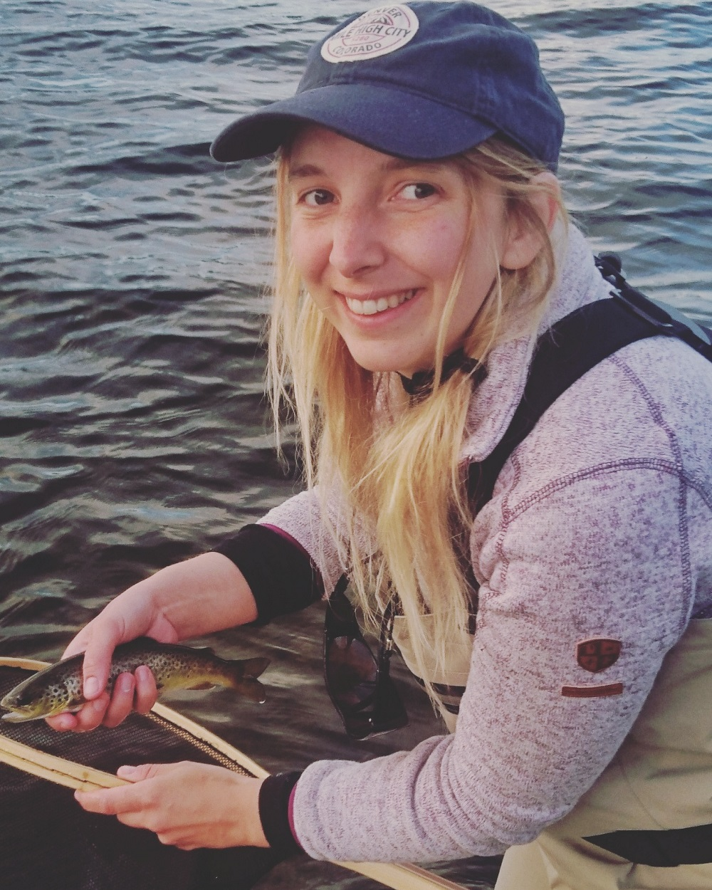
Figure 15.1: A proud angler displaying her freshly-caught brown trout. Photography: Anders Persson

The open, cultural landscape
The main tourism opportunities in the open man-made landscape revolve around the impressive Hälsingland farmhouses and the experiences offered by the summer farms. The area is home to three of the seven decorated farmhouses designated as a UNESCO World Heritage Site in 2012 for their well-preserved, painted interior decoration. The three farms in question are Jon-Lars and Pallars, situated in Långhed outside Alfta, and Fågelsjö Old Farmhouse Bortom Åa which lies north west of Los in Orsa Finnmark (Section 10.6). Adjoining Ol-Anders farm in Alfta is a visitor’s centre for the World Heritage Site combined with a tourist office, café and display area. The visitor’s centre at Ol-Anders also houses a Museum of Emigration, which illustrates the history of emigration from the community in the 19th century and the lives of the first pioneers in the American colony of Bishop Hill. Descendants of people who emigrated often visit the area.
Several of the farms, including the two World Heritage Site farms Jon-Lars and Pallars, are linked by the brown and white-signposted Hälsingland Farm Trail (Stora Hälsingegårdars väg) that runs for 28 km between the communities of Alfta and Edsbyn. The Farm Trail is the only brown and white-signposted route in Gävleborg County and has been designed as a strategic tourism initiative that links the farms with several other tourist attractions, such as well-preserved summer farm sites. A relay race for runners – the Stora Hälsingegårdarsstaffetten – is held each year along the route of the Trail, with changeover points close to the farms.
In the forested areas within and close to the proposed biosphere reserve there are several summer farms that are open to visitors. The Våsbo Fäbodar Summer Farm cultural heritage reserve (Section 7.4) is one of the best-preserved summer farms in the country, with well-maintained buildings, carefully-tended land and a rich flora. Several of the summer farms in the area operate cafés in the summer months, including Mittjasvallen (north of Edsbyn) and Svedbovallen (Ljusdal Municipality). In addition to running the café and selling its own dairy produce, Svedbovallen also has a popular summer volunteer scheme, whereby helpers come both from Sweden and other countries to look after animals and assist with other tasks.

Other visitor attractions
The Inlandsbanan railway line runs from Kristinehamn in central Sweden to Gällivare in northern Sweden, a total of 1,288 km. One of its many stops on its journey across the country is the village of Fågelsjö, which is within the proposed biosphere reserve. There are two attractions close to Fågelsjö: Fågelsjö Old Farmhouse Bortom Åa (Fact file 6) and Hamra National Park. A journey on the Inlandsbanan is popular with tourists, and many people like to hop on and off along its route.
Not far from Hamra National Park, in the village of Los, is another popular visitor destination, Loos Cobalt Mine (Loos Koboltgruva). The mine is beautifully situated in an idyllic wilderness setting amid varied rocky terrain. Visitors can explore a real 18th-century mining environment and learn about the history of cobalt blue and how, in 1751, Axel Fredrik Cronstedt discovered nickel, the chemical element that made the mine famous across the world.
Hälsingland’s biggest vintage car market, Voxna Market (Voxna Marknad), attracts approximately 15,000 visitors to the area each year. Sweden’s biggest folk music festival, Bingsjöstämman, has taken place close to the proposed biosphere reserve on the first Wednesday in July since 1969. The event brings together folk musicians, dancers and music enthusiasts from the whole country.
The local sports club Edsbyns IF Bandy generates approximately 16,000 bednights each year in Ovanåker Municipality alone by virtue of its training camps, competitions and bandy school. The main bandy season is in the autumn and winter, but the annual bandy school attracts approximately 400 young people and their families to the area for three weeks every summer. People attending the bandy school also enjoy tourism services in the area.

15.2.2 How many visitors come to the proposed biosphere reserve each year? (Distinguish between single-day visitors and overnight guests, visitors only visiting the proposed biosphere reserve or only passing on the way to another place). Is there an upward or downward trend, or a particular target?
Most visits to the area take place during the summer and early autumn. As the area lies between other prominent destinations and brands, most visitors are passing through and are therefore single-day visitors. Each year in total, the area has approximately 92,000 day visitors and hosts about 26,000 overnight stays in commercial accommodation. There are approximately 500 guest beds available in the area in hotels, youth hostels, cabins and holiday villages alongside a number of organised camp sites and informal camping options.

15.2.3 How are tourism activities currently managed?
Most tourism activity (61%) is run by civil society (voluntary associations, companies etc.) with support from local municipal tourism bodies. Associations often have cultural or historical links to the area. At the local level, Ovanåker and Ljusdal municipalities have produced their own tourism strategies (in 2016 and 2013-2020 respectively) in order to create clear priorities for the growth and sustainable development of the sector. The local strategies have developed out of a robust bottom-up process that involved interested residents, businesspeople, politicians and municipal officers. Bollnäs Municipality highlights the importance of tourism for its development as a municipality, placing a major emphasis on raising awareness of the major natural and cultural assets of the area, activities in the forests and the area close to the River Ljusnan valley, and a rich cultural life that encompasses strong traditions, Hälsingland farms, music and modern art.
The public authorities and tourism sector in the region have also worked together to produce a regional tourism development strategy (Tourism Strategy for Gävleborg 2009-2020 / Besöksnäringsstrategi för Gävleborg 2009 – 2020). Its vision leading up to 2020 is to become the Swedish region most in demand for Scandinavian experience packages at all times of year.
At the national level, and with a focus on ecological, social and financial sustainability, Sweden’s objectives are to double tourism in Sweden over ten years and for the tourism sector to be a new principal industry for the country by 2020 (‘National Strategy for tourism in Sweden’ / Nationell strategi för svensk besöksnäring).

15.2.4 Indicate possible positive and/or negative impacts of tourism at present or foreseen and how they will be assessed (linked to section 14)?
Tourism has several positive effects on the area, particularly in terms of bringing in additional income and providing fresh employment opportunities. A strong tourism sector predicated on the natural environment and cultural heritage of the area can engender a sense of pride in residents, and this in turn can foster a greater interest in conserving and developing the area’s unique values and identity. For example, an increase in recreational fishing may mean more people (residents, politicians etc) will see the benefit of restoring watercourses to improve their ecology. Increasing the rate of restoration would assist the biodiversity both of the Voxnan and of other watercourses. Predator safaris, such as wolf and bear-watching, bring income into the area and may in the long term help to increase acceptance of the predators. If younger people in the community become aware of the opportunities that increased tourism can bring, they may be more likely to decide to stay in the area or return once they have completed their studies elsewhere. The positive impact can be assessed on the basis of financial parameters and tourism statistics (e.g. number of new tourism or retail businesses, beds available for booking, accommodation occupancy rate, etc.) and through surveys and interviews.
A significant increase in visitor numbers may potentially also have a negative impact on the proposed biosphere reserve’s conservation goals. Generally, litter produced by people visiting the countryside will have a negative impact on wildlife and the natural environment. Other potential impact includes extra pressure on protected and/or more vulnerable natural environments, particularly as tourist activity is often concentrated around specific visitor attractions. However, it is unlikely that visitor pressure in itself would have such a major effect on, say, the nature reserves in the area. From a European perspective, visitor pressure in the protected areas is relatively low. There are also plenty of options for persuading visitors to use specific routes in and around a nature reserve so as to minimise damage, for example by means of marked trails and boardwalks. The impact of the pressure of visitors can be monitored by the nature reserve and National Park wardens, i.e. those in charge of day-to-day management.

15.2.5 How will these impacts be managed, and by whom?
Visitor impact and any action that becomes necessary will be managed by the County Administrative Boards and the municipalities in accordance with the relevant legislation and regulations. Impact can also be managed through targeted information campaigns aiming to ensure people know what their responsibilities are when in the countryside (e.g. outdoor access rights, Section 9.3). Local tourist offices have an important role here in seeing that this information is given to visitors. Trained Biosphere Ambassadors (Section 16) can be very important for increasing awareness of sustainability issues and changing negative patterns of behaviour when people are in the countryside.

15.3 Agricultural (including grazing) and other activities (including traditional and customary)

15.3.1 Describe the type of agricultural (including grazing) and other activities, area concerned and people involved (including men and women).
The following agricultural activities are conducted in the area:
• Animal husbandry for milk production.
• Animal husbandry and pasture management for meat production (cattle and sheep).
• Growing grass and forage plants for hay and silage
• Growing cereals and protein-rich forage
• Growing cereals and oilseeds.
• Transhumance - Summer farming.
• Keeping stables for horses
• Pasture for horses (leisure activity and racing)
The farmland of the area is mainly concentrated in the south-eastern parts of the planned biosphere reserve near the communities Alfta and Edsbyn. Agriculture is also conducted in other villages but to a lesser extent, primarily alongside the River Voxnan and near lakes. Farms in the area are mainly owned and run by men. In the present day, only a few of the old summer farm pastures are grazed.

15.3.2 Indicate the possible positive and/or negative impacts of these activities on biosphere reserve objectives (section 14).
Agricultural activities create means of support and employment, this creates an income for the area and increases the inhabitants’ possibilities of eating locally produced food. Further, a number of positive side effects are produced in regard to the conservation objectives of the area (Section 14). Semi-natural pasture for meat production (cattle and sheep) contributes to preserving the open cultural landscape and the biodiversity of such maintained land (Section 11.6). Summer farms (Section 9.1) that are still in use, although to a much lesser extent than previously, contribute to preserving this cultural heritage, which is significant for the area and for mid-Sweden. From an aesthetical point of view, the open cultural landscape is considered more attractive to be in, since it provides unhindered vision and beautiful scenery, particularly in comparison with overgrown fields that were once farmland. Agriculture thus contributes to the recreational values of the landscape. To summarise, strong agricultural businesses are a prerequisite for the fulfilment of the conservation objectives of the area.
On the other hand, over-intensive farming without consideration for environmental aspects, may have a negative effect on the conservation objectives of the area. Use of fertilisers and pesticides in agriculture may pollute groundwater and other water sources. The leaching of nutrients caused by agriculture is a problem that may, however, be considered moderate in the area. It is also estimated that there is small risk of pollution from pesticides in water sources in the area, at least in comparison with the rest of the country.
The landscape has changed at the same rate as agriculture has been rationalised. The mosaic landscape, so vital for many species, has been lost and is replaced by large areas of the same type of land. Conflicts of interest also arise between different agriculturally related activities and conservation objectives. One example is that it is more difficult to let domestic cattle graze freely because of the risk of attacks by predatory animals (Section 17.2).

15.3.3 Which indicators are, or will be used to assess the state and its trends?
Within regional environmental monitoring (agricultural programme area), it is the responsibility of the County Administrative Boards to monitor and assess farms in the area. Environmental monitoring in the Gävleborg County is mainly concerned with the flora of grasslands and leaching of nutrients (nitrogen and phosphorus) from farmland. National environmental monitoring also provides information about the state and development of agriculture at a County level. The Swedish University of Agricultural Sciences (SLU) conducts studies, of for example, soil chemistry, plant species and butterfly species, on order from the Swedish Environmental Protection Agency and/or the Swedish Board of Agriculture. The Swedish Board of Agriculture also engages the County Administrative Boards to register the size of pastureland and mowed land qualified for environmental support (environmental indicators). Continual evaluation is conducted of how the EU Common Agricultural Policy, CAP, affects the Swedish environment, this work is undertaken jointly by The Swedish Board of Agriculture, National Heritage Board, Environmental Protection Agency and the Agency for Marine and Water Management.

15.3.4 What actions are currently undertaken, and which measures will be applied to strengthen positive impacts or reduce negative impacts on the biosphere reserve objectives?
EU environmental support (Rural Development Programme) provides individual farmers with financial support for management of semi-natural pasture and hay meadows. Specific information with the purpose of improving environmental conditions is also communicated to farmers of the area. This includes projects such as Greppa näringen (’Focus on Nutrients’) (to reduce leaching of nutrients and environmental impact from agriculture), Ekologisk produktion (’Organic Production’) (to stimulate transition to organic production) and Ett rikt odlingslandskap (’A varied Agricultural Landscape’) (to strengthen natural and cultural heritage values in rural areas). The County Administrative Boards are responsible for communication of information.
Small biotopes in farmland (e.g. non-arable outcrops, ditches, clearance cairns and solitary trees) significant for biodiversity are covered by a general biotope protection (Section 9.3). Other small areas of land and water that are significant for biodiversity may be protected as biotope protection areas.
At a national and regional level, work is already conducted on a broad scale to increase positive effects and reduce negative impact on sites in Sweden and in the region. The Swedish government has established an Environmental Objectives Commission in which 17 Swedish authorities are represented (e.g. The Swedish Board of Agriculture, The National Food Agency, The Environmental Protection Agency and The National Heritage Board). United action is taken to speed up the progress of the environmental objectives, among which Ett rikt odlingslandskap (’A varied Agricultural Landscape’) is one of the environmental quality objectives.
In addition, a national food strategy has been approved by the Swedish government (20 July 2017). It is the first food strategy to include the entire food chain. A regional food strategy will be produced for the Gävleborg County, due to be finished during the autumn of 2018 and will apply until 2030 (Section 14.2.4). The purpose of the strategy is to increase the degree of self-sufficiency and security of food supplies as well as increasing food production, ensuring that relevant environmental objectives are fulfilled, to create development and employment and to reduce vulnerability in the food chain.

15.4 Other types of activities positively or negatively contributing to local sustainable development, including impact/influence of the biosphere reserve outside its boundaries.

15.4.1 Describe the type of activities, area concerned and people involved (including men and women).

Forestry work
Forestry work is conducted, by private forest owners and forestry companies, within the buffer zones and the transition area of the planned biosphere reserve. Most of the private forest owners are men.

Hydroelectric power
Parts of the River Voxnan are affected by hydroelectric power stations and regulating dams. The section of the Voxnan to the east of Runemo is included in an area of national interest for energy supplies; the area is part of the governmental hydroelectric power plan. Hydroelectric power stations that are situated further downstream from the outflow of the River Voxnan into the River Ljusnan (outside the planned biosphere reserve) also influence the freshwater environment of the area. They constitute migration barriers for various freshwater species and they affect the natural routes and flow of the water.

Wind power
At the present time, no large-scale wind farms have been constructed in the planned biosphere reserve. However, there are plans to construct a large wind farm in the central parts of the area, affecting the municipalities of Rättvik and Ovanåker. There are also proposals for a wind farm just outside the south-eastern corner of the planned biosphere reserve (near Svabensverk).

Mining
Part of the planned biosphere reserve is a designated area of national interest for minerals. Woxna Graphite AB mines graphite (since 1992) in the area of national interest. In accordance with the Swedish Environmental Code, the company has permission to mine 100,000 tonnes of ore per year at Kringelgruvan, which is situated to the west of Edsbyn. Further mining is planned by Woxna Graphite AB who are licenced to mine for graphite ore in the areas Gropabo, Mattsmyra and Månsberg (Ovanåker Municipality, transition area).

Quarrying
Quarrying of rock, moraine and gravel is conducted within the area. Natural gravel comes from glacial deposits of sand, gravel and stone, mainly occurring in eskers. When the use of natural gravel is phased out, the demand for quarrying rock and moraine may increase. Peat is not currently cut in the area. A peat-cutting business exists in close proximity to the planned biosphere reserve, although this work does not affect the catchment area of the River Voxnan.

Hunting and wildlife management
Hunting occurs on practically all farmland, woodland and waters where it is not prohibited for specific reasons. The majority of hunters are men, owing to the circumstance that the right to hunt is linked with land ownership. However, the proportion of women who hunt is increasing today.

15.4.2 Indicate the possible positive and/or negative impacts of these activities on biosphere reserve objectives (section 14). Have some results already been achieved?

Forestry work
The forest has an important role to play in the transition of society from dependence on fossil energy to a bio-based economy. The effects of forestry work on woodland ecology and the impact on biodiversity are described in Sections 11.6 and 14.1.

Hydroelectric power
Hydroelectric power is a renewable energy alternative with a low impact on the climate in comparison with fossil fuel. The impact of hydroelectric power on the ecology of River Voxnan and on biodiversity are described in Sections 11.6 and 14.1.

Wind power
Wind power is a renewable energy alternative with a low impact on the climate in comparison with fossil fuel. Many people regard wind power as good and a symbol for clean energy, while others are of the opinion that it spoils the scenic landscape.
Large wind farms may cause noise problems. The infrastructure that is needed to construct and maintain the parks, not least in the form of road construction and improvements on road systems, usually involves considerable encroachment on the surrounding natural environment.
Birds and bats also risk colliding with the wings of the wind turbines. Generally, this problem has turned out to be greater for bats than for birds. The death rate of bats at wind turbines is almost entirely limited to species that fly and hunt in open air above the tree-tops. Those birds that appear to be more prone to being killed than would be expected in regard to their presence in the area are birds of prey and gulls.

Mining
Mining may cause problems with dust, noise and pollution of air and waters. Incorrectly handled mining waste can cause extensive environmental problems. The mining industry is a major consumer of energy. Conflicts may arise between mining interests on the one hand and nature interests and outdoor recreation on the other hand.

Quarrying
The quarrying industry may cause problems with dust, noise and vibrations. It may also lead to conflicts with nature interests and outdoor recreation. Eskers, from which natural gravel is quarried, are often significant groundwater reserves and are thus important water supplies. Furthermore, eskers are characteristic features of the landscape and are valuable for outdoor recreation.

Hunting and wildlife management
Good wildlife management creates suitable conditions for game, aiding many less favoured species, creating better conditions for these and thus benefitting biodiversity. For example, hunting of the red fox (Vulpes vulpes) has contributed to positive effects for successful reproduction among wading birds. Other species, such as roe deer (Capreolus capreolus) and capercaillie (Tetrao urogallus), have also been favoured. Well-planned wildlife management, with a firm position among the public, will also keep game populations at an acceptable level for society.

15.4.3 What indicators are, or will be used to assess the state and its trends?
Activities described above are regulated under the Swedish Environmental Code and other laws that have been described in Section 9.3. Developments and tendencies in national and regional environmental monitoring are followed up jointly by The Environmental Protection Agency and The County Administrative Boards (Section 16.1). Indicators used are described in Sections 14.1.4 and 14.2.3.
The construction or expansion of existing wind farms, quarrying and hydroelectric power require permission and must be tried under the Swedish Environmental Code. Application for permission must contain an Environmental Impact Assessment (MKB) describing, among other matters, the effects on nature, environment and outdoor recreation.
The impact of existing mining activity on the environment of the areas is assessed through a set control programme including controlling of groundwater levels and a botanical assessment, sampling water and examining bottom fauna in adjacent peatlands and watercourses.
For activities requiring permission (e.g. quarrying), environmental inspectors at the municipality have responsibility for monitoring conformity with conditions.
The Swedish Association for Hunting and Wildlife Management is responsible for gathering observations of elk and predatory animals, which is a reliable surveying method. The association also monitors the state of all species of game through statistics of shot animals.

15.4.4 What actions are currently undertaken, and which measures will be applied to strengthen positive impacts or reducing negative ones on the biosphere reserve objectives?
In all cases, the above-mentioned activities are covered by and regulated in accordance with the Swedish Environmental Code and/or other laws described in Section 9.3.

Forestry work
Current and planned measures to mitigate the impact of forestry work on woodland ecology and biodiversity are described in Sections 14.2.4. and 14.2.5. Objectives of the planned biosphere reserve that are included in the visions of the focus area ’Forest as a sustainable resource’ are described in Section 13.

Hydroelectric power
Current and planned measures to mitigate the impact of hydroelectric power on the ecology of the River Voxnan and biodiversity are described in Sections 14.2.4. and 14.2.5. The objectives of the planned biosphere reserve included in the visions of the focus area ’Living water’ are described in Section 13.

Wind power
Permission is required for construction of wind power turbines, which must be tried under the Swedish Environmental Code. Applications for permission must contain an Environmental Impact Assessment (MKB)

Mining
Permission is required for mining, which must be tried under the Swedish Environmental Code. Applications for permission must contain an Environmental Impact Assessment (MKB). Mining should be conducted with utmost consideration for nature conservation interests and outdoor recreation interests.

Quarrying
Permission is required for quarrying, which must be tried under the Swedish Environmental Code. Applications for permission must contain an Environmental Impact Assessment (MKB). In order to secure groundwater reserves, the national objective is to minimise and phase out the use of natural gravel, which is to be replaced by rock or moraine.

Hunting and wildlife management
Hunting is primarily regulated by Swedish hunting legislation and through decisions on certain questions taken by involved authorities and the government. In the accomplishment of the environmental objectives ’Sustainable Forests’ and ’A Rich Diversity of Plant and Animal Life’, national and regional objectives should be fulfilled by seeking acceptance among the local population.

15.5 Benefits of economic activities to local people:

15.5.1 For the activities described above, what income or benefits do local communities (including men and women) derive directly from the site proposed as a biosphere reserve and how?

Tourism
The tourism industry generates a significant income for the area and creates employment. During the summer season of 2017, 120,000 visitors came to the Decorated Farmhouses of Hälsingland World Heritage Site and 200 events related to the World Heritage Site were arranged. In addition to the seven Hälsingland farms included in the World Heritage Site, of which three are situated in the planned biosphere reserve, a further approximately 40 Hälsingland farms are open to the public during the summer season.
During 2017, the project FIMS (Section 15.2.1) generated 3,300 overnight stays and a turnover of just over SEK 2.6 million. The number of anglers who bought fishing permits within the FIMS-project area increased from 112 in 2016 to 436 in 2017.
According to a study conducted by The Swedish Tourist Association and Novus, the walking trend continues to grow in Sweden. The study shows that almost a fourth of all Swedes prefer walking if they are having an active holiday in Sweden; walking is becoming a lifestyle. The main reason for Swedes to go walking is to spend time in the countryside. Recently, a cooperative was started with the purpose of creating multi-trails for walking, biking and motocross etc. in Hälsingland. During the candidature, the biosphere reserve organisation has contributed to the establishment of the cooperative.
The main objectives of the planned biosphere reserve (Section 13) include promoting a sustainable tourism industry based on the natural qualities and cultural values of the area.

Farming
Agriculture in the area generates local employment and access to locally produced food. The local environmental objectives of the municipalities include increasing the proportion of locally produced food in municipal kitchens (schools, care homes etc.). The increase of municipal purchase of locally produced food contributes to new enterprises and increase of income for local agriculture. The main objectives of the planned biosphere reserve (Section 13) include promoting development of local food production.

Forestry work
Forestry work generates employment and essential income for the area. Hälsingland is known for its good quality sawn timber; the tradition of refining forest raw material facilitates the production of high quality furniture, wooden interior fittings and special products for conservation of buildings. The parts of the tree that are not sawn into timber are sent, either to the pulp and paper industry, or to become bio-energy. The major industries of the area and a large proportion of small companies are engaged in the forestry industry; there are 200 timber-processing companies only in Hälsingland. Several sawmill industries are located in the planned biosphere reserve. One of the main employers of the area, Svenska Fönster with around 800 employees, produces wooden windows primarily from local timber. Every day, around 25 tonnes of processed timber leave the factory in Edsbyn.

Hydroelectric power, wind power, mining and quarrying
Hydroelectric power generates employment and financial profit for the area, for example by the running of the plant, renovation etc. Planned construction of wind farms would imply new opportunities for employment. Mining and quarrying also create employment.

Hunting and wildlife management
Within the area, the hunting of elk alone generates 100 tonnes of pure elk meat per year. Access to local elk meat contributes to a lower impact on the climate, primarily since consumption of beef is reduced. The actual value of the meat amounts to around SEK 40 million, while fees for hunting have a turn-over of ca SEK 15 million.

15.5.2 What indicators are used to measure such income or other benefits?
Indicators for estimating income from the tourist industry are described in Section 15.2.4. Acreage of farmland and meadowland is used as an indicator for the development of agriculture. The number of newly started companies indicates the development of the business environment.

15.6 Spiritual and cultural values and customary practices:

15.6.1 Describe any cultural and spiritual values and customary practices including languages, rituals, and traditional livelihoods. Are any of these endangered or declining?
Due to the industrialisation, urbanisation and secularisation of the latest decades, many of the earlier cultural and spiritual values have gradually lost their significance. During the twentieth century, the large-scale movement of people that occurred as a result of industrialisation and urbanisation, frequently broke up the old villages and people’s sense of belonging together in the village. At the same time, secularisation was strong and is now predominant throughout Sweden. Nevertheless, in the neighbourhood of Alfta and Edsbyn, the influence of the Free Churches is still strong (Section 10.6). Christianity and Protestantism, along with secularisation, has meant that most traditional beliefs and folklore have been forgotten and can only be found in literature and archives.
The traditional lifestyle of living in large farmhouses and broad use of the landscape still prevail in the area. Even if the traditional use of summer farms (Section 9.1) still only occurs to a lesser extent, the old summer farm traditions are still fairly well-known in the area. Many of the old summer farms are now used as holiday cottages instead, or the land might be used for grazing. The tradition of spending a lot of time in the forest is still strong through outdoor recreation, picking berries, fishing and hunting etc. For example, the week of the elk hunt in the beginning of September is somewhat of a homecoming event for many people. The hunt brings people, with or without previous connection to the area, together on equal terms, independent of gender, age and status. Earlier food traditions have lost their function but are kept up for festive occasions. Traditional crafts, folk music and folk dance still retain a considerable attraction in the area (Section 10.6).
Dialects of the area have been partially transformed. In the eastern parts of the area (Ovanåker, Alfta and Bollnäs), various Hälsingland dialects with roots in ancient Nordic languages are spoken to a certain degree, but the dialects have in part become mixed with Standard Swedish. The dialect, Oremål, occurring in the northern part of Rättvik Municipality (the dialect is difficult to understand for non-speakers) is no longer spoken to any great extent. According to informants, an odd mix of Forest Finnish (an east Finnish dialect) and Oremål was previously spoken in the northern parts of the area, between Ore, Los and Voxna. People in the planned biosphere reserve are highly interested in speaking and preserving their own dialects, which are often considerably wordy dialects.
The Forest Finnish population, who migrated to the area from Savolax in Finland during the seventeenth century (Section 9.1) are now completely assimilated into the Swedish population. Today, the Forest Finnish culture can still be discerned in the form of names of communities and other place names. Buildings that were typical of the Finnish culture, such as smoke cottages, drying houses and saunas, still exist in the countryside, even if there are only a few left. There is still a living knowledge of Forest Finnish traditions in the area.

15.6.2 Indicate activities aimed at identifying, safeguarding, promoting and/or revitalising such values and practices.
The traditional cultural values of the area (e.g. food, clothing, music, buildings, interior design and objects) are brought to light and cared for by the many local history societies (voluntary non-profit societies). A common point for all the local history societies is the interest in a certain place and its history, environment and people. Moreover, there are several specialised local associations that work with particular places or fields of knowledge; for example, Hälsinglands linförening (Hälsingland Linen and Flax Association). Traditional music and dancing is kept living through groups of folk dancers and folk musicians. Every year, folk music gatherings are arranged in the involved Counties, where people who are interested in folk music and folk dancing meet. Folk music gatherings are also popular among tourists. Gävleborgs Fäbodförening, GFF, (Gävleborg Summer Farm Association) works at a broad level to preserve summer farm traditions and to develop the practice of summer farming. The association is attentive to conventions, guidelines and environmental objectives and intends to conduct the work in accordance with these. Knowledge of Forest Finnish customs are preserved by the network FINNSAM. The network arranges conferences and exhibitions, is compiling a research catalogue, studies genealogy of Forest Finns and organises educational journeys. In Ovanåker Municipality, there is a museum on the theme of Forest Finns (The Finn Forest Museum).
The County Administrative Boards work towards protecting and conserving material values and intangible values of the cultural heritage, making them accessible. County museums and Hälsingland’s Museum work for the preservation of the traditional culture of the region displaying it to the public. Local museums, often run by the municipality, are located in Edsbyn, Bollnäs and Ljusdal. They perform preservation work in respect of the traditional culture of each municipality, making it accessible. The municipalities further promote the cultural values of the area through tourist information offices. The long history of the area and the most tourist friendly parts of the cultural heritage are usually brought to attention, e.g. the decorated Hälsingland farmhouses.
The government has given the Swedish Hunting and Wildlife Management Association the responsibility for parts of the Swedish wildlife management; follow-up of plans and decisions, education of hunters and the public about hunting and wildlife management.
Local inhabitants play an important part too, when it comes to preservation of old and local traditions, such as dialects, food, crafts and summer farming. The inhabitants of Voxnadalen are greatly interested in this.

15.6.3 How should cultural values be integrated in the development process: elements of identity, traditional knowledge, social organizations, etc.?
Consideration for cultural values, cultural heritage and traditional values, and integrating these values into the development process of the planned biosphere reserve, is likely to strengthen local identity and social life. Traditional customs and cultural values, such as summer farming, crafts, folk music, folk dancing and folk art etc, can be integrated in the development process through village walks, courses, lectures and workshops, and by using them in the development of sustainable tourism. During the candidature, the biosphere organisation has, together with other organisations in the area, arranged village walks and seminars open to the public, on the topic of maintenance of old buildings, among other themes.
The Decorated Farmhouses of Hälsingland World Heritage Site (Section 10.6), already have a strong profile in the planned biosphere reserve. The World Heritage Site is integrated in the development process of the area, for example, in the sense that the buildings are cared for and maintained, and tourism associated with the farmhouses has grown (Section 15.2). In relation to the biosphere reserve candidature, a report has been written on archaeological sites and cultural environments in Ovanåker Municipality, which will be used in the planning processes of the municipality and will also be possible to read for other people who are interested. Furthermore, a leaflet has been published about the Ovanåker district in prehistoric and mediaeval times, which has been disseminated to the schools of the area, local history societies and the tourist information office. Several of the archaeological sites of the area can be made more attractive to visit by improving accessibility e.g. clearance of vegetation, setting up information panels, leading walking trails past them.
Modern culture in the form of dance, music, art, theatre etc, should also be integrated in the development process with the purpose of stirring and engaging people, creating debate about current questions of sustainability.

15.6.4 Specify whether any indicators are used to evaluate these activities. If yes, which ones and give details.
Indicators to evaluate activity performed as part of the work of the biosphere reserve organisation need to be developed together with other involved parties. The County Administrative Boards supply data concerning acreage of semi-natural pasture and hayfields, which can be used as an indicator of the development of summer farms and the open cultural landscape. Statistics of tourism are supplied by the municipalities and can be used to evaluate the development of tourism in relation to the cultural values of the area.
Chapter 16

Logistic function

16.1 Research and monitoring:

16.1.1 Describe existing and planned research programmes and projects as well as monitoring activities and the area(s) in which they are (will be) undertaken in order to address specific questions related to biosphere reserve management and for the implementation of the management plan (please refer to variables in Annex I).
It is the intention of the planned biosphere reserve to actively support research, environmental education and demonstration projects, as well as to attract research projects to Voxnadalen concerned with sustainable development.
No universities are located in the planned biosphere reserve. The nearest universities are The University of Gävle (Gävleborg County), Dalarna University (Dalarna County) and Mid Sweden University (Jämtland and Västernorrland Counties). However, the universities are all within commutable distance from Voxnadalen, either by car or by public transport. They also offer the possibility of entering distance learning courses. Research is conducted at these universities within several fields that are of relevance for the primary objectives of the planned biosphere reserve (Section 13).

The University of Gävle
The University of Gävle (HiG) conducts research on built environments, with the goal of improving energy efficiency and increasing material efficiency in view of a transition to more sustainable and climate neutral energy systems.
The University of Gävle is taking part in the work of preserving and developing the Decorated Farmhouses of Hälsingland World Heritage Site by promoting research on preservation and energy efficiency of the farm buildings. Tourist related matters are also included in their work. An aim is also to increase interest in the farmhouses by encouraging students to study the World Heritage Site in their independent projects.
The University of Gävle is renowned for its special competence within Geographical Information Systems (GIS) and is the only university in Sweden offering a postgraduate programme in Geospatial Information Science. Ovanåker Municipality has commenced a collaboration project with the University of Gävle (2017) with the purpose of building a digital tool (GIS-application) that takes climate changes into account, introducing modern climate neutral use of energy in the community planning of the municipality (local planning and structure planning). This work is conducted as a degree project (Section 19.6).
Ljusdal Municipality has prepared to receive students from educational programmes at the University of Gävle, offering paid internship. The first period of this cooperation between Ljusdal Municipality and the University of Gävle is in the spring of 2018.
In the field of biology, research is conducted on biological diversity, sustainable plant protection, ecology, physiology, plant-associated micro-organisms and insect communication. Subject didactic research is also conducted in this field. Further, research on sustainable fishing is conducted in collaboration with the Gävleborg County Administrative Board and people who work professionally with fishing.

Dalarna University
Dalarna University runs a knowledge platform for research motivated by the needs within the tourism industry at the Centre for Tourism and Leisure Research (Centrum för besöksnäringsforskning). Their aim is to strengthen the tourism industry, as well as studying the needs of the tourism industry. The research mainly deals with the development of tourist destinations, marketing of destinations, the tourist industry as a labour market and questions about sustainable development – primarily in rural areas and in small communities. Current research projects include such subjects as: ’Entrepreneurial Behaviour in Micro-Tourism Firms in Rural Areas’, ’Career Paths and Mobility in the Swedish Tourism Industry’, ’Forest-based Experiences’ and ’Swedish Fishing Tourism – Positive Examples and Success Factors’.
Dalarna University conducts interdisciplinary research on systems for solar heating and solar power and combinations of storage systems at the Solar Energy Research Centre (Centrum för solenergiforskning). Research is conducted on ’Energy Efficiency in Built Environments’, focusing on timber construction and renovation with the purpose of energy efficiency. Both these research specialisations collaborate with industry and organisations. Master’s Degree courses are offered, in connection with these research fields, within solar energy technology, building technology and energy technology.

Mid-Sweden University
Mid-Sweden University (MiUn) conducts specialised research within, among other subjects, tourism (The European Tourism Research Institute ETOUR) and development of new bio-based and sustainable materials of cellulose fibres, i.e. forest-based raw materials (Fibre Science and Communication Network, FSCN).
These research centres are intended as arenas for collaboration with financiers and other interested parties. Current research within tourism research includes ’Slow adventures in Northern Territories’ and ’Gastronomy and Creative Entrepreneurship in Rural Tourism’. The project ’Green Pro - Green Chemicals from Forest and Forest Products’ is conducted at FSCN. Mid Sweden University also conducts research on many other fields of science such as biology.

Collaboration with Universities
Contacts have been established with the above-mentioned universities during the candidature for the biosphere reserve, with the purpose of identifying and promoting possibilities of collaboration and to attract people who are interested in conducting research work on the area. The following possible collaboration projects have been identified in dialogues between the biosphere reserve organisation and universities:
• Development of the tourism industry of the area based on the forest, rivers and the open landscape as recreation for various groups
• Use of the forest as an educational environment for university students and for integration of people newly arrived in Sweden
• Studies of the quality of water in rivers and streams, investigating possibilities for improvement and assessment during and after restoration work
• Development of GIS applications to create an overview and to map qualities of biotopes, or as a tool for sustainable community planning
• Continue the current research on the Decorated Farmhouses of Hälsingland World Heritage Site
• Research associated with the formation and development process of the biosphere reserve; for example, on conflicts concerning resources in the area (Section 17.2).
The following possible forms of collaboration have been identified during dialogues between the biosphere reserve organisation and involved universities:
• Inclusion of researchers representing one or several of the universities on the board of the biosphere reserve organisation (Sections 13 and 17)
• Student projects carried out on questions concerning the planned biosphere reserve at a Bachelor’s, Master’s or Doctoral level. The biosphere reserve organisation can contribute with contacts/networks of knowledge and possible financial support through project funding
• Locating student courses and excursions, concerning aspects of sustainability, to Voxnadalen
• Universities can contribute knowledge when courses, seminars and workshops etc. are held in Voxnadalen
• Dissemination of informative examples from the planned biosphere reserve through seminars and relevant courses at the university
• Dissemination of informative examples from research work on the planned biosphere reserve through the World Network of Biosphere Reserves (WNBR).

Other research work
Currently, The University of Gothenburg is conducting the interdisciplinary research project Dekorerade interiörer i Hälsingegårdar - en holistisk studie av ett kulturhistoriskt Världsarv ’Decorated interior design of Hälsingland farms – a holistic study of a culture historical World Heritage Site’. The purpose of the study is to improve knowledge on the painted interior decoration of the Hälsingland farms, as well as decoratively painted furniture and patterned textiles. By studying paints, surface treatment and the underlying material of the objects that were decorated, the material that was used and manufacturing techniques can be understood. This can provide knowledge about eighteenth and nineteenth century trading of raw material and access to material. At the same time, the project elucidates how the objects should be handled and preserved in the best possible way. It is conducted in collaboration with local partners such as Hälsingland Museum, The Museum of Ljusdalsbygden, Bollnäs Municipality and the World Heritage Committee.

Other educational centres
The Predator Centre The Big 5 (Rovdjurscentret De 5 Stora) is an independent knowledge and information centre concerned with Sweden’s large predators. Their goal is to be Sweden’s best communicators and conveyors of information about these questions. Apart from working with exhibitions, lectures, seminars and meetings, the centre also cooperates with researchers and the universities of the country; for example, regarding the feelings of fear people experience when it comes to these predators. The centre is based in Järvsö, just to the north of the planned biosphere reserve.
Hälsingland Education Association (Hälsinglands utbildningsförbund) is an association of local authorities formed by the three municipalities of Bollnäs, Nordanstig and Söderhamn. The association is intended as a motor for progression, as an advocate for education and as an arena for development. Hälsingland Education Association is part of UNESCO’s network of vocational training (UNEVOC). The association offers a one-year adult upper secondary level education specialising in local and organic food production and sustainable small-scale farming.

Environmental monitoring
In Sweden, environmental monitoring of forests, water, air and other natural resources is coordinated at a national (Swedish Environmental Protection Agency), regional (The County Administrative Boards) and local (associations, municipality) level. The National Inventory of Landscapes in Sweden, NILS, is part of the national environmental monitoring in Sweden. NILS is funded by The Swedish Environmental Protection Agency and it is carried out by The Swedish University of Agricultural Sciences (SLU). The purpose of NILS is to monitor the biological diversity of all Swedish land-based environments and to provide follow-up information for the Swedish national environmental objectives. Information is gathered for NILS through a combination of field surveys and interpretation of aerial photographs. Sampling for NILS is carried out in 631 quadrats (5 x 5 km) in a grid covering the entire country.
The regional environmental monitoring is organised by the County Administrative Boards. During the period 2015-2020, the environmental monitoring of Gävleborg County Administrative Board (the county where the major part of the planned biosphere reserve is located) is specifically engaged in the key topics of ’freshwater’, ’health’, ’environmental contaminants’ and ’farmland’. The work concerning the key topic ’farmland’ is focused on surveying the distribution and biological values of grasslands. The work of the County Administrative Board involves following up protected areas and the Conservation Programmes for Threatened Species and Habitats.
The Swedish National Forest Inventory is carried out by the Swedish University of Agricultural Sciences and is based on surveys of temporary and permanent sample plots in the forest. Within the planned biosphere reserve, there are around twenty areas containing 4-12 sample plots; an inventory of these is conducted every fifth year. Forest inventories are carried out by the Swedish Forest Agency of e.g. key biotopes, biological diversity and grazing damage of trees.
The Swedish Association for Hunting and Wildlife Management (Svenska Jägareförbundet) is organised partly as a network of local organisations and partly by regionally employed officials. The Association conducts systematic observations of elk and predatory animals, spending 70,000 work hours within the area every year. In order to keep a check on hunted species and obtain a rough estimate of the development of populations of game, information on shot animals is collected for each year. The Association also organises surveys of droppings of roe deer and elk every other year and of large predators when needed (latest during 2017/2018). The Association is the most highly engaged voluntary workforce in the surveying of Sweden’s large predators.
The quality of the air in the areas is monitored by East Sweden’s Air Conservation Association (Östra Sveriges Luftvårdsförbund), which is a voluntary organisation including members from governmental authorities, municipalities and companies.
Control of receiving bodies of water is conducted by Ljusnan-Voxnan Water Conservation Association (Ljusnan-Voxnans Vattenvårdsförbund, LVVF) and concerns, for example, measurements of the content of nitrogen and phosphorus in lakes, rivers and streams in the area. Within the catchment area of the River Voxnan, there are 5 LVVF-sampling spots for control of receiving bodies of water.
Water regulation companies, The Swedish Meteorological and Hydrological Institute (SMHI) and LVVF, measure the water level in around ten of the lakes in the area. SMHI is in charge of meteorological measurements (Section 11.3).
The municipalities are responsible for assessing the quality of water at bathing places in lakes and rivers of the area. Local surveys of natural and cultural heritage values are arranged by the municipality, often in the form of projects. For example, Ovanåker, Bollnäs and Ljusdal municipalities have conducted a survey of the River Voxnan and its tributaries (2016-2017). The results from the survey are used to produce new municipal fisheries conservation plans. Ovanåker have also carried out a number of inventories of occurring species of birds, plants and cultural heritage remains in the Sässman Natura 2000 site. The results of the inventory are presented in the form of a detailed landscape analysis (J. Hansen, 2014), which describes how values at Sässman should be conserved and developed.
Forestry companies carry out inventories in their own grounds. Valuable information about the environment and the state of species at a local level also comes from private persons, who are often engaged in voluntary associations.

16.1.2 Summarize past research and monitoring activities related to biosphere reserve management (please refer to variables in Annex I).
Previous research work on Voxnadalen is related to the cultural heritage and historical values of the area. For example, the 15 years of processes and negotiations, resulting in a World Heritage Site nomination for the Decorated Farmhouses of Hälsingland in 2012, have been described in a doctoral thesis presented at the Swedish University of Agricultural Sciences (’The Decorated Farms of Hälsingland in transition - a study of a World Heritage process in Hälsingland, M Paju, 2012). Several Bachelor’s and Master’s degree projects, on various aspects of the World Heritage Site, have also been conducted, mainly at the University of Gävle but also at other universities in Sweden.
The Forest Finnish settlement in northern Sweden, including Voxnadalen, as well as the development and current conditions of summer farming have been described in several doctoral theses and books (Appendix 19.6). Various archaeological excavations have been conducted in Voxnadalen, for instance, Stone Age settlements and Iron Age burials.
Previous research work conducted at the mentioned universities, along with national, regional and local environmental monitoring, deal with the topics described in Section 16.1.2.

16.1.3 Indicate what research infrastructure is available in the proposed biosphere reserve, and what role the biosphere reserve will play in supporting such infrastructure.
Infrastructure and other resources for research and environmental monitoring are available at the above-mentioned Universities, the County Administrative Board and at The Predator Centre The Big 5.

16.2 Education for sustainable development and public awareness:

16.2.1 Describe existing and planned activities, indicating the target group(s) and numbers of people involved (as ”teachers” and ”students’’’) and the area concerned.
Education to promote sustainable development is carried out in the area through teaching at schools, focused authority work and through the commitment of local companies and associations.
A few of the schools in the area are connected to the national communication platform Skogen i skolan (the ’Forest at school’). The pedagogic idea of the ’Forest at School’ project is to link theory with practice in order to enhance the teachers’ and children’s interest in knowing more about forests. Outdoor pedagogics and use of ’School Forests’ near the school are important tools in this work. Within the planned biosphere reserve, there are School Forests in the communities of Los, Viksjöfors and Edsbyn.
During the biosphere reserve candidature, Ovanåker Municipality in collaboration with the forestry company, Sveaskog, the Swedish Society for Nature Conservation and the Predator Centre The Big 5, have arranged outings to the Eco Park at Grytaberg for both school children and the public. The purpose is to educate children and adults about questions concerning the forest and to inspire people to spend time outdoors in the local area. Every year, Region Gävleborg and Region Dalarna arrange a three-day long conference for young people, Miljötinget, (’The Environmental Convention’). Miljötinget is oriented towards young people at school (aged 13-18), giving 300 school pupils the chance to take part each year. The aim is to increase their knowledge of the environment and the climate, as well as providing them with tools to increase their influence in society. Ljusdal Municipality hosted Miljötinget in 2017.
Rovdjurscentret De 5 Stora (The Predator Centre The Big Five) arranges a ’Predator School’ for school children free of cost. In the predator school, the children learn about Sweden’s large predatory animals and the relationship between humans and these animals. The Predator Centre also runs a web-based Predator School.

The work of the authorities
Guidance for farmers of the area is provided by the County Administrative Boards among others. The County Administrative Boards run the projects Greppa näringen (Focus on Nutrients), Ekologisk produktion (Organic Production) and Ett rikt odlingslandskap (A varied Agricultural Landscape). The aim of the project ’Focus on Nutrients’ is to reduce leaching of nutrients and impact on the environment.

The work of companies
The regionally based (Gävleborg County) business network Företagare för Miljön (Businesses for the Environment) is a collaborative organisation for sustainable, climate friendly and energy efficient business development, looking to the needs of small and medium-sized businesses. The network is intended to stimulate, support and rouse environmental awareness and attention to energy matters through inspiration meetings and education. During 2016, the network also trained local ambassadors.

Voluntary work
Voluntary organisations in the area are engaged in preserving and promoting natural values and the cultural heritage of the area. Local and regional sections of the Swedish Society for Nature Conservation arrange forest outings and lectures, and educate private persons in surveying forests with high natural value. Each occasion attracts 10-30 people of all ages.
The Swedish Association for Hunting and Wildlife Management (Svenska Jägareförbundet) provides education in questions concerning handling of meat, hunting ethics, supervision of the hunt, safety, shooting and sustainable wildlife management.

In which way can a Biosphere Reserve be a supplement to existing activities?
The planned biosphere reserve intends to support current and new educational activities that promote sustainable development in Voxnadalen, for example by:
• Training Biosphere Ambassadors. The five existing biosphere reserves in Sweden have successfully trained Biosphere Ambassadors. The planned biosphere reserve intends to follow their example and thus be inspired by the positive results of the other biosphere reserves. The planned training of Biosphere Ambassadors is oriented towards the inhabitants but also the local companies. A plan for the training of Biosphere Ambassadors will be included in the Developent Plan (Section 17.4).
• Arranging lectures, workshops and theme days. The planned biosphere reserve intends to be a neutral and inclusive arena for the collaboration of the many interested parties in the area (Section 13). For example, this can be carried out by arranging workshops that bring different interested parties together over a certain theme. As part of the biosphere reserve candidature, a theme day on the use of outlying land was arranged in the Våsbo Fäbodar Summer Farm cultural heritage reserve. Eighty people interested in summer farming, local food production and landscape conservation assembled for the day, Fig. 16.1.

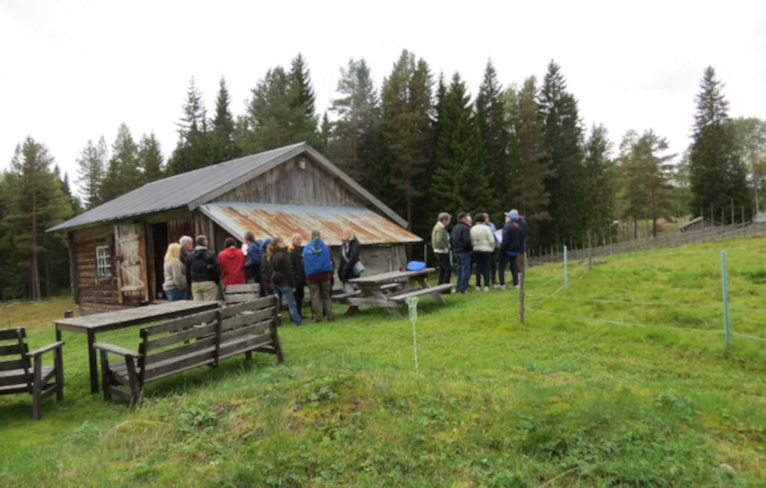
Figure 16.1: A theme day on the use of outlying land was arranged in the Våsbo Fäbodar Summer Farm cultural heritage reserve. Eighty people interested in summer farming, local food production and conservation of the open and biodiverse cultural landscape assembled for the day. Photography: Fia Johannessen

16.2.2 What facilities and financial resources are (or will be) available for these activities?
The municipalities, Region Gävleborg and the County Administrative Boards provide a range of supportive functions that can be used in communication work. The Predator Centre The Big 5 have premises and other infrastructure available for education in questions of predatory animals. Local associations can provide their specific fields of knowledge and local knowledge for guiding at outdoor events and excursions.
This work may partially be financed through the biosphere reserve organisation’s core funding (Section 17.4.11). The biosphere reserve organisation will be applying to the government, Region or trusts etc. for various forms of project funding.

16.3 Contribution to the World Network of Biosphere Reserves:

16.3.1 How will the proposed biosphere reserve contribute to the World Network of Biosphere Reserves, its Regional and Thematic Networks?
The contribution of Voxnadalen to the World Network of Biosphere Reserves comprises a region that centres around the use of the forest, flourishing lakes and streams, open farmland and a unique natural and cultural heritage in the form of summer farms and the Decorated Hälsingland Farmhouses World Heritage Site.
Currently, there are relatively few biosphere reserves that are located in northern Europe and the fertile parts of the Taiga. Voxnadalen belongs to a region where the use of ecosystem services generated by the forest is a vital part of the economy and growth of the area, in a historical and contemporary perspective. There is a long tradition here of refining raw material from the forest; there is also a substantial knowledge of handling various forms of biomass. Voxnadalen possesses favourable prospects, in reference to the rich access to high quality timber (Hälsingland pine, Fact file 7), of continuing development within the field of bio-economy, thus contributing useful examples to the World Network of Biosphere Reserves. The extensive and unlimited access to uninhabited quiet woodlands provides excellent possibilities of illuminating the multitude of ways of living on what the forest provides. This can be done by showing the values of the forest in various outdoor-experience contexts and by developing business models for commercial use of the forest as a resource for e.g. eco-tourism.
In the work of restoring waterways that were cleared for log driving, the vision of the planned biosphere reserve is to be a leading organisation in integrated cooperation between nature conservation, heritage enviroment management and the tourist industry, with the aim that the work should be conducted on equal terms. In regard to the current work of promoting recreational fishing tourism in the area (FIMS, Section 15.1), the planned biosphere reserve can contribute useful examples that link together water and fish conservation, recreational fishing and rural development.
Summer farms are a unique core value of the planned biosphere reserve. Today, most of the summer farms are no longer in traditional use, although knowledge and traditions of use of the outlying land still exist. By making use of the competence and tradition of using outlying land in Voxnadalen, a natural and cultural heritage that is unique for the area can be conserved, developed and brought to life. In this work, the planned biosphere reserve hopes to contribute positive examples of rural development and the collaboration between nature conservation, heritage environment managment, landowners, farmers, tourism and people who work with food.
The historical use of the landscape has shaped the entire area, from the farmland of the River Voxnan valley to the forest settlements, summer farms and the decorated Hälsingland farmhouses, making the area unique. The World Heritage Site is concerned with the decorations and interior design of the buildings. Designation as a biosphere reserve would provide the possibility of strengthening the area as a whole, by accentuating natural and cultural heritage values that originate in the utilisation of land and forest. The designation of decorated Hälsingland farmhouses as a World Heritage Site illustrates the positive experiences that people have of preserving as well as developing earlier traditions through successful collaboration.
The planned biosphere reserve hopes to provide positive examples for the benefit of the World Network of Biosphere Reserves and other relevant thematic networks (e.g. EuroMAB and NordMAB). During the candidature, the biosphere reserve organisation has already participated in several network meetings with other biosphere reserves in Sweden (e.g. national workshops and committee conferences) as well as internationally (e.g. NordMAB 2016). Furthermore, Voxnadalen hosted the annual workshop of Biosphere Programme Sweden in 2015.

16.3.2 What are the expected benefits of international cooperation for the biosphere reserve?
One of the most important benefits of international cooperation for the area is the exchange of knowledge, experience and positive examples for sustainable development – among people and biosphere reserves.
Examples of benefits from international collaboration for Voxnadalen, and exchange of experience with other biosphere reserves, involve dealing with the issue of interaction between humans and large predators, but also the development of a sustainable tourist industry associated with the forest and with water.
The intention of the biosphere reserve is to contribute to existing national and international networks e.g. NordMAB and EuroMAB. Designation as a biosphere reserve would also set the Decorated Farmhouses of Hälsingland World Heritage Site into a context in which both are able to strengthen each other and contribute to each other’s development.
Universities, businesses and entrepreneurs within reach of the area are also provided a further channel for dissemination of reserach results and to establish national and international collaboration/contacts.

16.4 Internal and external communication channels and media used by the biosphere reserve:

16.4.1 Is (will) there (be) a biosphere reserve website? If yes, what is its URL?
Website url: www.voxnadalen.org

16.4.2 Is (will) there (be) an electronic newsletter? If yes, how often will it be published?
An electronic newsletter is sent out to subscribers and is published on the website. The newsletter was issued twice during the first year in 2015. If the area is designated as a biosphere reserve, the aim is to publish the newsletter twice a year.

16.4.3 Does (will) the biosphere reserve belong to a social network (Facebook, Twitter, etc.)?
Facebook: www.facebook.com/biosfarivoxnadalen.
Instagram: @Voxnadalen and #biosfarvoxnadalen.
Chapter 17

GOVERNANCE, BIOSPHERE RESERVE MANAGEMENT AND COORDINATION

17.1 Management and coordination structure:

17.1.1 What is the legal status of the biosphere reserve?
The biosphere reserve will be subject to general Swedish legislation and so will not be covered by any national laws or regulations specific to the biosphere reserve. However, parts of the biosphere reserve will be covered by special conservation orders (Section 17.1.2).

17.1.2 What is the legal status of the core area(s) and the buffer zone(s)?
The legal status of the core areas and buffer zones has been set out in detail in Section 9.3. In summary, the legal status of the core areas and buffer zones is regulated by the Swedish Environmental Code (Miljöbalken) and/or the Heritage Conservation Act (Kulturmiljölagen).

17.1.3 Which administrative authorities have competence for each zone of the biosphere reserve (core area(s), buffer zone(s), transition area(s))?
Section 9.3 includes a detailed description of the authorities responsible for managing all or part of the biosphere reserve. In summary, the municipalities are responsible for planning how the area’s land and water resources are used, while the County Administrative Boards in the two counties involved (Gävleborg and Dalarna) are responsible for the management of all the core areas in the biosphere reserve. The Swedish Forest Agency has responsibility for the management of any forest-related issues in the buffer zones and the transition area.

17.1.4 Clarify the respective competence of each of these authorities. Make a distinction between each zone if necessary and mention any decentralized authority.

Core areas
The County Administrative Boards have full jurisdiction in terms of the management of Hamra National Park and its nature reserve. The Boards also have overall responsibility for the Natura 2000 sites and the Våsbo Fäbodar Summer Farm cultural heritage reserve. The Decorated Farmhouses of Hälsingland World Heritage Site is managed by the World Heritage Council (Section 17.1.7).

Buffer zones
The County Administrative Boards have official responsibility for parts of the buffer zones. The steps to be taken to uphold national interests in respect of nature conservation, outdoor recreation or heritage environment conservation are clarified during permit application processes. As part of any process, consideration must be given as to whether or not the proposed development, e.g. a new windfarm, will enable the national interest to be upheld. If the requirements of the national interest are not met, the state can intervene through the County Administrative Board, irrespective of whether the proposed development relates to land within or outside the area of national interest itself. In the case of woodland nature conservation agreements, e.g. for the Eco Park at Grytaberg, each individual agreement specifies what forestry activity is permitted.

The transition area
Each individual municipality has a ’planning monopoly’ in respect of the use of land and water (Section 9.3). County Administrative Boards oversee historic buildings, churches and ancient monuments and remains. The Swedish Forest Agency is responsible for overseeing and investigating forest-related issues. Any landowner wishing to fell trees must submit an application to the Swedish Forest Agency, and approval must be granted before felling can take place.

17.1.5 Indicate the main land tenure (ownership) for each zone.

Core Areas
50% state-owned (6,503 ha of a total of 13,062 ha)
45% commercially-owned
5% privately-owned

Buffer Zones
60% commercially-owned
40% privately-owned

The Transition Area
70% privately-owned
30% commercially-owned

17.1.6 Is there a single manager/coordinator of the biosphere reserve or are several people in charge of managing it? If one manager/coordinator, who designates and employs him/her (national authorities, environmental administrative agency, local authorities)?
The Voxnadalen Biosphere Reserve body that will manage the UNESCO remit following official designation is coordinated by a Biosphere Coordination Office, currently consisting of two employees, including one Coordinator – 1.6 posts in total. The Biosphere Coordination Office staffs are employed by Ovanåker Municipality.

17.1.7 Are there consultative advisory or decision-making bodies (e.g., scientific council, general assembly of inhabitants of the reserve) for each zone or for the whole biosphere reserve?
The authorities and other bodies with an advisory and/or decision-making role in respect of all or part of the biosphere reserve are as follows:
• Municipalities and County Administrative Boards The municipalities have an important advisory function in the management of issues relating to areas of national interest. The County Administrative Boards also provide advice in this context to the municipalities.
• World Heritage Council The World Heritage Council is responsible for the management of the Decorated farmhouses of Hälsingland World Heritage Site. The Council comprises the County Governor, Gävleborg County (Landshövdingen Gävleborgs Län) (chair); the owners of the World Heritage Site farmhouses; Bollnäs, Ljusdal, Ovanåker, Söderhamn, Hudiksvall and Nordanstig municipalities; Gävleborg County Administrative Board (Länsstyrelsen Gävleborg); Region Gävleborg; Gävleborg County Museum (Länsmuseet Gävleborg); Hälsingland Museum and the University of Gävle (Högskolan i Gävle).
• Local community councils and associations There are a large number of volunteer-run local community councils and associations in Voxnadalen working to keep rural areas alive and to promote the interests and well-being of local residents. Community associations and councils may have an advisory role in that they sometimes contribute to consultations relating to their interests. They also often organise social activities to create a sense of well-being and community.
• Local interest groups The area is home to a large number of interest groups operating on a voluntary basis. These sometimes contribute to consultations relating to their interests and therefore have an advisory role in various decision-making contexts. Some interest groups have special expertise that means they are consulted about various municipal projects.
• Voxnadalen Biosphere Reserve The body that will manage the biosphere reserve as a whole and its input into the Man and the Biosphere Programme global strategy is described in detail in Section 17.1.8.

17.1.8 Has a coordination structure been established specifically for the biosphere reserve?
A Steering Group (Section 13.4) was set up in 2014 at the start of the biosphere reserve candidacy process as part of the Biosphere Candidate Voxnadalen project. The group’s role has been to lead and support the work of preparing an application for biosphere reserve status. As part of this, the group worked up a proposal for an organisational structure for the biosphere reserve, which was launched in April 2018 in conjunction with the handover from the Steering Group to the initial biosphere reserve Management Board (Section 13.3).
Figure 17.1 shows Biosphere Reserve Voxnadalen’s organisational structure. The task of this body is to coordinate and progress the work on the biosphere reserve and to manage the UNESCO remit that comes with an award of biosphere reserve status. The various functions shown in Fig. 17.1 are described below:
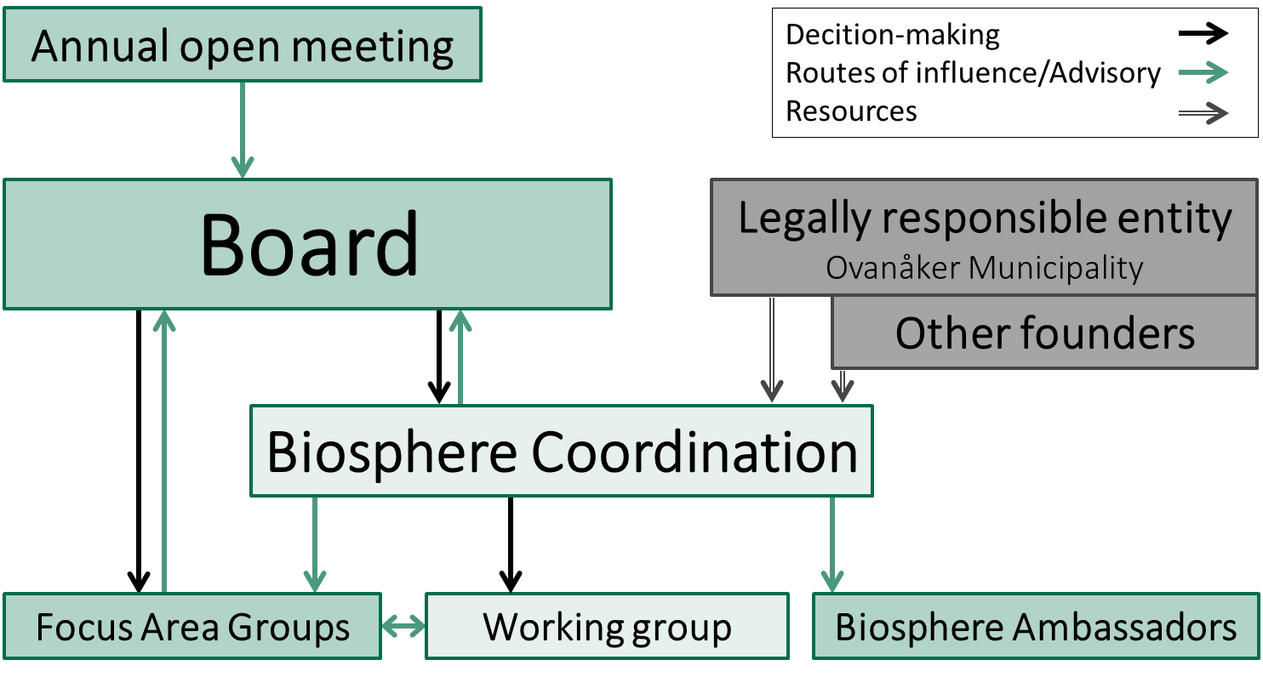
Figure 17.1: Voxnadalen Biosphere Reserve’s organisational structure.
• Management Board The organisation’s Management Board is based on representation from a broad range of stakeholder organisations (Section 13.3). Each organisation is voted in for a two-year period, and each individual organisation appoints its own representative to the Board. The Board will meet minimum four times a year and will make the ultimate decisions in respect of the biosphere reserve’s development and operational plans and its allocated funds. The organisation’s statutes govern the composition of the Board and its decision-making processes (Appendix – Development Plan).
• Annual meeting An open annual meeting will give members of the public, including stakeholders not represented on the Board, an opportunity to give their views on the composition of the Board (applies to private/voluntary sector stakeholders), its development plans and activities. The general public thus has an advisory role in respect of the Board.
• Ovanåker Municipality The municipality is the legal owner and core funder of the biosphere reserve. Funding is in the form of direct financial contributions and support for the Biosphere Coordination Office (e.g. personnel and payroll administration, premises and IT support). Ovanåker Municipality is represented on the organisation’s Board, but does not have a majority and has no decision-making powers of its own.
• Other funders The Swedish Environmental Protection Agency and Ljusdal and Bollnäs municipalities contribute to the Biosphere Office’s core finances by providing annual funding. The municipalities also provide staff for the Working Group.
• Biosphere Coordination Office The organisation’s various functions and the biosphere reserve’s day-to-day, practical work will be coordinated by a Biosphere Coordination Office that currently consists of two employees, including one Coordinator. The Biosphere Coordination Office staff are employed by Ovanåker Municipality.
• The Working Group The Working Group will be responsible for preparing material to support the Board’s decision-making and will support and act as a sounding board for the Coordinator. The Group will also function as the Board’s nominations committee, basing its recommendations on comments received from stakeholders and the general public. The Group will be staffed by officers from Ovanåker, Ljusdal and Bollnäs municipalities.
• Focus Area Groups Project activity focusing on the three focus areas (Section 13.2) will be undertaken by special Focus Area Groups. The Groups will be dynamic, their make-up depending on the specific project being run at any given time, and members will be drawn from a wider group of stakeholders than the Board. The work of the Focus Area Groups will be coordinated by the Biosphere Coordination Office and by designated individuals from the Board.
• Biosphere Ambassadors Biosphere Ambassadors will be tasked with raising awareness of the Voxnadalen Biosphere Reserve and encouraging engagement. The role is voluntary, and training will be provided by the Biosphere Coordination Office.

17.1.9 How is the management/coordination adapted to the local situation?
The proposed biosphere reserve will be officially managed by several parties and there are several special-interest organisations active in Voxnadalen, and so the composition of the Board has been devised to reflect this. The member organisations of the Board (Section 13.3) also mirror the three focus areas (Section 13.2).
Since municipalities, authorities, companies and special-interest organisations are already working in various ways to promote a society that is environmentally, socially and financially sustainable, it is not the task of the biosphere reserve to develop a new sustainability strategy of its own. The reserve will instead aim to:
• Inspire residents, companies and organisations to take action for environmentally, socially and financially sustainable community development
• Act as a broker between new and existing ideas, initiatives and projects that help develop a sustainable community and break down silo mentalities
• Lead projects and processes that individual players are unable or have no mandate to run themselves
• Provide a forum by acting as a neutral hub for collaboration for and by local stakeholders

17.1.10 Is there a procedure for evaluating and monitoring the effectiveness of the management?
The official management of the biosphere reserve, which will mainly be the responsibility of the municipalities and the County Administrative Boards, will be governed by the principles of administrative law. The effectiveness of the authorities will in turn be reviewed and evaluated by the Swedish National Audit Office (Riksrevisionen).
Work undertaken by the biosphere reserve body itself (Fig. 17.1) will be the subject of a public annual operational report. A more comprehensive review of the organisation’s work will be undertaken for the 10-yearly evaluation required by UNESCO. Criteria and indicators for the evaluation of the organisation’s work and effectiveness will be detailed in Voxnadalen Biosphere Reserve’s five-year development plans (Section 17.4).

17.2 Conflicts within the biosphere reserve:

17.2.1 Describe any important conflicts regarding the access or the use of natural resources in the area considered (and precise period if accurate). If the biosphere reserve has contributed to preventing or resolving some of these conflicts, explain what has been resolved or prevented, and how this was achieved for each zone.

Use of the forest
The major natural resource in the area is forest. The forest has an important role to play in ending society’s dependence on energy from fossil fuels and replacing the latter with renewable resources. The climate benefits this can bring will help to meet the national environmental objective of ’Reduced Climate Impact’. At the same time, more intensive use of the forest, shorter rotation periods and use of non-indigenous but faster-growing species of trees (e.g. lodgepole pine) will conflict with the national environmental objective of ’Sustainable Forests’ that seeks to achieve greater biodiversity.
There have also been conflicts of interest between the need to protect species and their habitats, in line with the Swedish Species Protection Ordinance (Section 9.3), and the right of an individual landowner to use/fell their forest. In one notable case from Hälsingland, five landowners were refused permission by the Swedish Forest Agency to fell a total of 29.5 ha of forest, without financial compensation. The proposed felling was halted due to the presence of the Siberian jay (Perisoreus infaustus, LC), which is protected by the EU Habitats Directive and the Species Protection Ordinance (Section 9.3). The matter is currently the subject of a legal review. This case has contributed to the heated debate that sometimes flares up between the Swedish forestry sector and the environmental movement around forestry, the rights of landowners and species protection.
There is increasing recognition of the forest’s social values, i.e. the values created by people’s own experiences of the forest. Many people feel that even-aged stand management, especially in the case of clear-felling when a whole stand is harvested at the same time, diminishes a forest’s aesthetic and social values. Planned forestry activity that means a forest is no longer considered attractive may lead to conflict with the interests of those taking part in outdoor recreation activities and wilderness tourism businesses.

River Voxnan, hydropower and fishing
The major expansion of hydropower in Sweden took place mainly during the first half of the 20th century. Several hydropower stations are still operating today on the basis of permissions granted under the 1918 Water Act, which means that they are not always fully environmentally compatible. Opposition to hydropower comes chiefly from the recreational fishing sector and those involved in other outdoor activities, as the dams block migration routes for fish and fish risk being sucked into the turbines and killed. In addition, the artificial regulation of water, dictated by electricity needs, has a negative impact on the whole ecosystem. The Voxnan east of Runemo is covered by an area of national interest for energy supply and is part of the national hydropower plan. However, the national interest conflicts with Ovanåker Municipality’s investment in rural development and fishing tourism, as further expansion of hydropower is likely to lead to the loss of good fishing waters.
Reinstating watercourses cleared for log driving to promote ecological values can conflict with the heritage value of the remains of the log-driving activity. While the reinstatement of such watercourses improves conditions for living organisms, it also removes the traces of a shared cultural heritage site that illustrates the basis of the history and fortunes of the area.
The interests of the tourism industry may also be affected if watercourses previously cleared for log driving are reinstated. For example, returning large stones and boulders to the water may make canoeing more difficult. However, a watercourse with a more natural flow may be more interesting for canoeists, for example if they gain access to tributaries that have previously been closed off.

Spread of major predators
All Sweden’s major predators can be found in the middle region of the country. The presence of predators can give rise to various conflicts of interest, and there is an extremely polarised debate in Sweden around the spread of predators, in particular the re-establishment of the wolf. Some people want to significantly reduce, or eradicate, the Swedish wolf population, while others want to allow wolves to flourish. Poaching of wolf and other major predators are occurring in the area.
The various conflicts of interest that arise in relation to the spread of major predators include concerns about predators attacking domestic cattle and dogs used for hunting. Some hunters also see the major predators as competitors for the wild game that is permitted quarry. The presence of predators in a forest may also be off-putting to some potential visitors. In 2013, the Swedish Parliament decided that concentrations of predators should be reduced where they are highest and that the population of wolves should be 170-270 in total. The difficulties experienced by the authorities in achieving these targets have led to further polarisation in the conflict.

Expansion of wind power
There are differences of opinion around a proposed expansion of wind power just outside the south-eastern section of the proposed biosphere reserve, as some groups feel it will have a negative impact on the landscape and local birdlife.

Successful conflict management – an example from the biosphere reserve
In winter 2010-2011, trees were felled along the Voxnan within the Sässman area Natura 2000 site (Table 7.2). The Sässman area is also an area of national interest for nature conservation and a consultation area under the Swedish Environmental Code (Section 9.3). The felling was reported to the relevant administrative authority (Gävleborg County Administrative Board/ Länsstyrelsen Gävleborg), who in turn reported a suspected offence to the police.
It became clear from the incident that there was lack of knowledge about the specific rules that applied to the individual landowner in the area concerned, leading to worry and frustration. As a result, Ovanåker Municipality and the Federation of Swedish Farmers (LRF) invited all the area’s landowners on a field visit. They were joined by representatives from Gävleborg County Administrative Board, the Swedish Society for Nature Conservation (SNF) and the Maskinringen company. The visit facilitated constructive conversations both about what had happened and about the challenges in the area and potential developments.
Following on from this, Ovanåker Municipality successfully applied for project funding to carry out a detailed landscape analysis of the Sässman area (completed in 2014) in order to conserve and develop the area and establish the basis on which it is to be used and managed. The analysis was undertaken in close consultation with users of the area and relevant special-interest organisations (the LRF, SNF, Swedish Forest Agency and Gävleborg County Administrative Board).

17.2.2 If there are any conflicts in competence among the different administrative authorities in the management of the biosphere reserve, describe these.
The biosphere reserve is officially managed through a well-functioning partnership between the constituent municipalities and the public authorities (the County Administrative Boards, the regions and the Swedish Forest Agency).

17.2.3 Explain the means used to resolve these conflicts, and their effectiveness.

Use of the forest
The Swedish Forest Agency has been holding local meetings for companies in the forestry sector on an annual basis for several years. The Agency uses the meetings to present information on its work on production and nature conservation and to provide an annual update of news and plans. The companies are also given an opportunity to describe their own work on production and nature conservation. One common focus for the meetings is an exchange of views on how the forestry sector’s shared objectives for various habitats (Section 14.2.4) apply in practical terms to forestry activity. Attendees also discuss the Agency’s ’dialogue project’, which involves field visits in conjunction with felling applications and post-felling feedback.
Increased allocations of funding for the protection of particular sites, e.g. nature reserves, has made it easier for the County Administrative Boards to acquire areas that need protection. Since the start of the 2000s, there has also been a national debate about forestry methods that avoid clear-felling. The use of these methods means the ground is not left bare and so the forest feel is retained. One advantage of this is that the structure of older forest remains intact, which is better for species associated with these environments and also for preserving the forest’s social values.

River Voxnan, hydropower and fishing
Various types of restorative work in the area’s watercourses is undertaken by the municipalities and the County Administrative Boards and by volunteers from fishery conservation area associations. Recently, large areas of the Voxnan and its tributaries have been surveyed to assess the ecological qualities of the watercourses and the number of obstacles to migration, with the results being used to draw up new municipal water and fisheries conservation plans. This work forms part of the Development Plan for Fishery Resources and Water Conservation in the Ljusnan-Voxnan Catchment Area (Utvecklingsplan för fiskresursen och vattenvård i Ljusnan-Voxnans avrinningsområde), a joint project of Bollnäs, Ljusdal and Ovanåker municipalities.
Hydropower installations with permits dating from the 1918 Water Act may be re-examined in line with new provisions in Swedish environmental legislation. Where there are plans to reinstate watercourses cleared for log driving, consultation with the heritage environment conservation section of the County Administrative Board is mandatory. For any activity impacting watercourses, it is important that all the stakeholders concerned (hydropower, nature conservation, heritage environment conservation and tourism, etc.) are involved at an early stage in the decision-making process so that they are aware of each other’s views. In this context, the biosphere reserve can play an important role as a neutral forum (Section 13).

Spread of major predators
The County Administrative Board is responsible for the management of major predators in accordance with a regional management plan. The management plan is drawn up with the assistance of a wildlife management delegation comprising representatives from amongst the residents of the county. In addition to politicians, Gävleborg County’s delegation comprises stakeholders from summer farming, the forestry industry, nature conservation, outdoor recreation, agriculture and hunting. The plan sets out how the County Administrative Board is to achieve its political aims in respect of predators, i.e. a favourable conservation status and a viable long-term population. The County Administrative Boards have management responsibility for surveys, preventive measures (e.g. putting up predator secure fences), overseeing hunting and monitoring unlawful hunting. The Boards also provide briefings on larger predators and deal with cases of injury to domestic animals. In addition, they are authorised to make decisions on protective hunting and licensed hunting and pay compensation to the owners of domestic animals injured by predators.
The Predator Centre The Big 5 (De 5 Stora) provides extensive information about the major predators and how they interact with humans. Its vision is to be the best provider of information on these issues in Sweden.

Expansion of wind power
The installation of wind turbines requires a permit under the Swedish Environmental Code (Section 9.3), and an application for a permit must include an Environmental Impact Assessment (miljökonsekvensbeskrivning, MKB). Under the terms of the Swedish Environmental Code, anyone proposing to engage in any activity requiring a permit must consult with the County Administrative Board, the municipality, any individuals who may be particularly affected by the activity and the general public.
In its Thematic Structure Plan ”Wind power and large unexploited areas” (Vindkraft och stora opåverkade områden), Ovanåker Municipality has designated an area (a ’large unexploited area’, SOO; Section 9.3) that must be protected as far as possible from any activity that may significantly impact the unbroken nature of the landscape (e.g. expansion of wind power, establishment of major roads or quarries).

17.3 Representation, participation and consultation of local communities:

17.3.1 At what stages in the existence of a biosphere reserve have local people been involved: design of the biosphere reserve, drawing up of the management/cooperation plan, implementation of the plan, day to day management of the biosphere reserve? Give some specific examples.
The consultative process used during the process of developing the biosphere reserve has been detailed in Section 13.4.

17.3.2 Describe how the local people (including women and indigenous communities) have been, and/or are represented in the planning and management of the biosphere reserve (e.g., assembly of representatives, consultative groups).
The consultative process used when developing the biosphere reserve, and which has been detailed in Section 13.4, involved local people in a variety of ways. For example, the Steering Group for the Biosphere Candidate Voxnadalen project (Section 13.4) includes local, elected municipal politicians who represent the interests of the residents of the municipality. Elected local politicians also sit on the new Management Board that was launched in April 2018 (Section 13.3).
The membership organisations on the biosphere reserve Board represent the various interests of their members, i.e. groups of local residents. Through the involvement of the Federation of Swedish Farmers (Lantbrukarnas Riksförbund), the Mellanskog forest owners’ association, the Swedish Society for Nature Conservation (Naturskyddsföreningen), the Swedish Association for Hunting and Wildlife Management (Svenska Jägareförbundet) and the Swedish Association of Summer Farmers (Föreningen Sveriges Fäbodbrukare), the interests of landowners, the agriculture and forestry sectors, hunters and wildlife wardens, summer farmers, and those with a general interest in nature conservation are all represented in the processes that are taking the work forward. In addition, the biosphere reserve’s open annual meeting will give local people the opportunity to put forward their views and ideas about the composition of the Board, development plans and activities etc. (Section 17.1.8).

17.3.3 Describe the specific situation of young people in the proposed biosphere reserve (e.g., potential impacts of the biosphere reserve on youth, consideration of their interests and needs, incentives to encourage them to participate actively in the governance system of the biosphere reserve).
Young people aged 0 to 25 comprise approximately 27% of the population of the area. Region Gävleborg has the highest level of youth unemployment in Sweden, reaching 14.5% within the biosphere reserve. There is no post-secondary education and training in the biosphere reserve itself. However, the University of Gävle and Dalarna University (Section 16) are within commuting distance either by public transport or by car. Both institutions also offer several online and web-based distance-learning programmes. Young men are more likely to stay in the area, while a higher proportion of young women leave. The biosphere reserve’s vision ’Voxnadalen – a significant part of the world’ (Section 13) aims to highlight and enhance the unique assets of the biosphere reserve and to promote the vitality of its rural areas, thus making Voxnadalen an attractive place in which to live and work. If the biosphere reserve is successful in this, young people may see the potential of staying in the area or returning after completing studies elsewhere, which would be a positive demographic development. With the area seen as more attractive, the various local employers will find it easier to attract people with sought-after professional skills who perhaps did not have a previous connection with the area.
The main means of communicating and interacting with young people in the biosphere reserve is through the local compulsory schools. The Biosphere Candidate Voxnadalen project has included activities aimed at children, school pupils and/or whole families in partnership with local stakeholders. For example, in September 2017 the Biosphere Coordination Office, the Sveaskog forestry company and the Swedish Society for Nature Conservation organised two forest days at the Eco Park at Grytaberg, one targeted at school classes (10-12 years old) and the other at families. The aim of the days was to teach the children and families about forests and forestry, to raise the profile of the Eco Park at Grytaberg as a destination and to increase awareness of the application for biosphere reserve status. Similar activities taking place in partnership with various organisations will be an important part of the work of engaging children and young people in the work of developing the biosphere reserve.
There is currently no young person on the biosphere reserve Board, but this may be an objective for the future. Older young people will also be able to get involved with the biosphere reserve as Biosphere Ambassadors (Section 16).

17.3.4 What form does this representation take (e.g., companies, associations, environmental associations, trade unions)?
The representation of local people and various stakeholders in the biosphere reserve organisation has been detailed in Sections 13.3, 13.4 and 17.1.8.

17.3.5 Are there procedures for integrating the representative body of local communities (e.g., financial, election of representatives, traditional authorities)?
The representation of local people and various stakeholders in the biosphere reserve organisation has been detailed in Sections refsec:13.3, 13.4 and 17.1.8.

17.3.6 How long-lived are consultation mechanisms (permanent assembly, consultation on specific projects)? Make a complete description of this consultation. What are the roles of involved stakeholders compared to the role of the biosphere reserve?
Consultation on the formulation of the actual application for biosphere reserve status took place between January 2014 and January 2018 (Section 13.4). An open, annual meeting will allow residents and other stakeholders without a position on the Board to put forward their views on the general development of the biosphere reserve, the composition of the Board, development plans and activities (Section 17.1.8).
Parallel to the candidacy, ad hoc consultation groups were established for specific, time-limited projects run by the Biosphere Coordination Office along with local players (such as the LONA Project, a local nature conservation initiative). Future projects coordinated by the Biosphere Coordination Office will employ the same working method.

17.3.7 What consultation mechanisms have been used, and who has been involved? Are they for specific purposes or long-term? What impacts have they had on decision-making processes (decisional, consultative or merely to inform the population)?
Consultation mechanisms used during the biosphere reserve candidacy process are described in Sections 13.4 and 17.3.1.

17.3.8 Do women participate in community organizations and decision-making processes? Are their interests and needs given equal consideration? What incentives or programmes are in place to encourage their representation and participation (e.g.: was(were) a ”gender impact assessment(s)” carried out)?
Both women and men are active in community organisations and take part in municipal and political decision-making processes. Men have traditionally had greater involvement in planning and consultation than women. However, when a new Structure Plan was produced for Ovanåker Municipality (ÖP 2030, adopted 2017), an evaluation showed that more women than men had taken an active part in the civil dialogue. Ovanåker and Bollnäs municipalities have also signed the Council of European Municipalities and Regions’ ’European Charter for Equality of Women and Men in Local Life’.

17.4 The management/cooperation plan/policy:

17.4.1 Is there a management/cooperation plan/policy for the biosphere reserve as a whole?
Work started on a development plan for the proposed Voxnadalen Biosphere Reserve during the candidacy process, and the current draft document is appended to this application (Appendix – Development Plan). At the point when the earlier Steering Group (Section 13.4) handed over to the biosphere reserve’s first Board (section 13.3) in April 2018, several new stakeholders became involved in the process, including two nearby universities, the University of Gävle and the Dalarna University, and two member organisations, the Swedish Association for Hunting and Wildlife Management (Svenska Jägareförbundet) and the Swedish Association of Summer Farmers (Föreningen Sveriges Fäbodbrukare). It is very important that the new stakeholders are co-creators of the biosphere reserve’s development plan, and so this work on the plan will continue throughout 2018 and 2019. A timetable (Table 17.1) has been produced for the co-creation process, showing that the development plan should be adopted by the Board in November/December 2019. The timetable has been set out to lead up to a possible award of biosphere reserve status in summer 2019.
3GROEN!30!white
Table 17.1: Timetable for Voxnadalen Biosphere Reserve’s Development Plan 2020-2025, from draft to adopted plan.

Process/Activity | Responsibility | Completion date
Launch of the new organisation | Steering Group/ Management Board | 10 April 2018
Gathering of ideas from the Board – Board meetings | Board/Biosphere Coordination Office | Seven Board meetings in 2018-2019
Theme day for focus area ’Forest as a sustainable resource’ | Biosphere Coordination Office/Board | September 2018
Gathering of ideas from the general public – open meeting | Biosphere Coordination Office/Board | November 2018
Theme day for focus area ’Living water’ | Biosphere Coordination Office/Board | Spring 2019
Further development of focus area ’An open, living landscape’ | Focus Area Groups/Board/Biosphere Coordination Office | Ongoing activities to August 2019 (Theme day already completed, September 2017)
Formulation of SMART objectives for each focus area | Groups/Board/Biosphere | Coordination Office October 2019
Development Plan for Voxnadalen Biosphere Reserve 2020-2025 adopted by Board | Board | November-December 2019 Possible award of biosphere reserve status by UNESCO

17.4.2 Which actors are involved in preparing the management/cooperation plan? How are they involved?
A development plan for the biosphere reserve will be produced by the biosphere reserve body (Section 17.1.8), with the Board having ultimate responsibility. This means that all members of the Board (Section 13.3) will be co-creators of the plan. The Board will meet at least four times a year and so provide guidance to the Biosphere Coordination Office and Working Group who will do the practical work of drawing up the plan. A first open meeting to gather information from local people and other stakeholders is planned for November 2018 (Table 17.1). Any views gathered from various stakeholders during the earlier period of the candidacy (Section 13.4) will also be included in the material informing the work. For example, views gathered from almost 80 participants during a day on the theme of the cultivation of outfields (Fig. 16.1) will form the basis of sections of the development plan (Focus area ’An open, living landscape’; Section 13.2).
For the 2018-2019 period, the Biosphere Coordination Office has also been granted funding by Region Gävleborg to organise various activities for the three focus areas – SEK 100,000 each for ’Forest as a sustainable resource’, ’Living water’ and ’An open, living landscape’. One of the aims of the activities, which may take the form of theme days, is to promote the active involvement of various stakeholders in the development plan.

17.4.3 Do local authorities formally adopt the management/cooperation plan? Are local authorities making reference to it in other policies and/or plans? If so, please provide details.
The biosphere reserve’s Board (Section 13.3) will formally approve and adopt the development plan when completed. No local authorities are currently making reference to the biosphere reserve development plan as the document is not yet complete.

17.4.4 What is the duration of the management/cooperation plan? How often is it revised or renegotiated?
The development plan will run over a five-year period, i.e., the biosphere reserve’s initial development plan will cover the period 2020-2025. The development plan will be reviewed at the start of each new year. Depending on how the work evolves, the outcomes achieved and whether new challenges have arisen, the development plan may then be revised on behalf of the Board. One reference point for the revision of the 2020-2025 development plan is the start of the EU’s new programme period in 2021. It will be announced at this point which areas will be prioritised in future aid programmes.

17.4.5 Describe the contents of the management/cooperation plan. Does it consist of detailed measures or detailed guidelines? Give some examples of measures or guidelines advocated by the plan?
The development plan for the biosphere reserve is currently in preparation and a draft is appended to this application (Appendix – Development Plan). The plan will give a clear and straightforward outline of the biosphere reserve’s values, visions, goals and actions. It should be seen as a living document and will be easily accessible to local people and other stakeholders, including via the biosphere reserve website. The draft ’Development Plan for Voxnadalen Biosphere Reserve 2020-2025’ currently consists of the following sections:
• A timetable for completion of the Development Plan for Voxnadalen Biosphere Reserve 2020-2025
• A description of the biosphere reserve ranging from a global to a local perspective, and an outline of the added value an award of biosphere reserve status will bring to the population of Voxnadalen and its many stakeholders
• A description of the biosphere reserve organisational structure. The regulations that the Board must comply with in relation to, for example, its composition and decision-making processes are appended to the development plan
• Voxnadalen Biosphere Reserve’s set of values along with SMART objectives, i.e. specific, measurable, agreed, realistic and time-bound objectives for the reserve’s input into the Man and the Biosphere Programme’s global strategy (Lima Action Plan, LAP)
• A description of the aspirations for the Voxnadalen Biosphere Reserve’s three focus areas ’Forest as a sustainable resource’, ’Living water’ and ’An open, living landscape’. The plan will include SMART objectives for all three focus areas, to be completed during the 2018-2019 period
• A strategy and SMART objectives for communications and branding
• A strategy and SMART objectives for the training of local Biosphere Ambassadors
• A strategy and SMART objectives for the long-term funding of the biosphere reserve

17.4.6 Indicate how this management/cooperation addresses the objectives of the proposed biosphere reserve (as described in section 13.1)
The objectives and the three focus areas of the biosphere reserve (Sections 13.1 and 13.2) themselves form the basis of the development plan that is in preparation. See Section 17.4.5.

17.4.7 Is the plan binding? Is it based on a consensus?
The biosphere reserve’s development plan will not be binding in the legal sense. However, the development plan will be jointly adopted by the members of the Board, and by adopting the plan they undertake to work towards its implementation.

17.4.8 Which authorities are in charge of the implementation of the plan, especially in the buffer zone(s) and the transition area(s)? Please provide evidence of the role of these authorities.
The biosphere reserve organisation – and ultimately its Board (Section 13.3) – are responsible for coordinating the work and implementing the development plan. The Biosphere Coordination Office will have the practical responsibility for the coordination of the work. Responsibility for the implementation of management and other stewardship plans that affect core areas and parts of the buffer zones (e.g. the Eco Park at Grytaberg) lies with the County Administrative Boards and the Swedish Forest Agency (Section 9.3).

17.4.9 Which factors impede or help its implementation (e.g.: reluctance of local people, conflicts between different levels of decision-making).
Some of the factors that assist with the implementation of the biosphere reserve’s development plan are as follows:
• The Board members/member organisations demonstrate a good ability to work together and a good understanding of their differing perspectives
• Local people and other stakeholders show a strong interest in the functions of the biosphere reserve and the various initiatives that are undertaken
• Local people and stakeholders are generally aware and appreciative of the biosphere reserve’s function as a neutral forum for collaboration
• Stable, long-term core funding
Some of the factors that may hamper the implementation of the biosphere reserve’s development plan are as follows:
• The Board members/member organisations show a lack of understanding of, and trust in, each other
• Local people and other stakeholders show a lack of interest in, and commitment to, the functions of the biosphere reserve and the work that is carried out
• The stakeholders in the area are not very aware of the biosphere reserve’s function as a neutral forum for collaboration
• Global environmental challenges, such as climate change and air pollution
• Absence of adequate core funding and lack of suitable project funds to apply for
• National and global changes in the economy and political circumstances

17.4.10 Is the biosphere reserve integrated in regional/national strategies? Vice versa, how are the local/municipal plans integrated in the planning of the biosphere reserve?
The biosphere reserve’s development plan has not yet been integrated into any national or regional strategies as the plan is not yet complete. At the local level, the biosphere reserve has been integrated into Ovanåker Municipality’s new Structure Plan 2030 (ÖP 2030) and environmental objectives (Lokala miljömål 2020). For example, the Structure Plan states that the Municipality sees a biosphere reserve as ’a practical way for a smaller Municipality to work on sustainability in a broad sense’. Ljusdal and Bollnäs municipalities have new, updated Structure Plans that align with the objectives and development of the proposed biosphere reserve.
Conversely, the biosphere reserve will incorporate other organisations’ action plans and strategies into its own development plan where these align with the biosphere reserve’s own visions and objectives. For example, the water and fisheries conservation plans for Voxnan and its tributaries will be integrated into the biosphere reserve’s development plan as part of the ’Living water’ focus area. Gävleborg County Administrative Board and Region Gävleborg are currently developing a regional food strategy, due to be completed by autumn 2018. Similarly, parts of the regional food strategy may be integrated into the biosphere reserve’s development plan as part of the ’An open and living landscape’ focus area.

17.4.11 Indicate the main source of the funding and the estimated yearly budget.
The core funding for the Biosphere Coordination Office will primarily come from public sources. In the 2018-2019 period, core funding will come from the following funders:
• the Swedish Environmental Protection Agency (Naturvårdsverket) (state level), SEK 400,000/year
• Region Gävleborg (regional level), SEK 800,000/year
• Municipalities (local level): Ovanåker, SEK 250,000/year, Ljusdal SEK 100,000/year, Bollnäs SEK 75,000/year
• Total budget, SEK 1,625,000/year
The three municipalities also provide staff for the Working Group (Section 17.1.8). As Ovanåker Municipality is the entity with legal responsible for the organisation, it also provides support in the form of personnel and payroll administration, IT support, premises and other staff expertise. As part of the funding from Region Gävleborg, SEK 100,000 has been allocated to each focus area to support various activities.
Provided that Voxnadalen is awarded official UNESCO Biosphere Reserve status, the Swedish Environmental Protection Agency and the municipalities will all continue to contribute to the core funding of a Biosphere Coordination Office. In addition to direct funding, the municipalities will also continue to provide staff for the Working Group and Ovanåker Municipality will continue to provide various support functions.
• the Swedish Environmental Protection Agency (state level), SEK 400,000/year
• Municipalities (local level): Ovanåker, SEK 250,000/year, Ljusdal SEK 100,000/year, Bollnäs SEK 75,000/year
• Total budget, SEK 825,000/year
To complement the core funding, the Biosphere Coordination Office will seek external funding from regional and national authorities, EU programmes, e.g. LEADER, and other funds to finance specific projects. The estimated basic annual operating costs for the Biosphere Coordination Office are currently expected to break down as follows:
• Salaries including pension on-costs, equivalent of 1 post, SEK 575,000/year
• Premises, SEK 50,000/year
• Administration, SEK 75,000/year
• Operational costs SEK 125,000/year
• Total cost: SEK 825,000/year

17.5 Conclusions:

17.5.1 In your opinion, what will ensure that both the functioning of the biosphere reserve and the structures in place will be satisfactory? Explain why and how, especially regarding the fulfillment of the three functions of biosphere reserves (conservation, development, logistic) and the participation of local communities.
Voxnadalen Biosphere Reserve has already launched an organisation that will ensure the participation of both local people and diverse stakeholders and also act as a neutral forum for collaboration and the sharing of knowledge across non-traditional boundaries. Partnership working of this type, which enables common goals to be identified and sectoralised initiatives to be avoided, has been identified by the UN as a key tool for achieving the Sustainable Development Goals (SDG 17: Partnerships for the Goals). The fact that Ovanåker Municipality is the legal owner of the biosphere reserve organisation ensures that the organisation will be stable, since it will be less dependent on the commitment of individual enthusiasts and so less vulnerable.
Biosphere Programme Sweden provides Sweden’s biosphere reserves with excellent support around many issues and the biosphere reserves also constantly share their experiences and discuss joint strategies with one another. Voxnadalen has benefited from this during its candidacy for biosphere reserve status, thus developing a good basis for collaboration, networking and contacts.
The area also benefits from the expertise and experience gained from coordinating and managing a UNESCO World Heritage Site. This experience and the commitment involved will be of value in the work of managing UNESCO Biosphere Reserve status, as the Decorated Farmhouses of Hälsingland World Heritage Site and Voxnadalen Biosphere Reserve will be able to offer each other mutual support, and help to create an overall picture of the importance of the natural and cultural heritage assets for the development of the area.
During the candidacy period, links have been made with the higher education institutions closest to Voxnadalen geographically. As a result, two universities are now represented on the biosphere reserve Board, which is an important step in ensuring the fulfilment of the biosphere reserve logistic support function (Section 16).
These qualities together build a strong foundation that will enable all three biosphere reserve functions to be fulfilled, i.e. conservation, development and logistic support.
Chapter 18

Special designations

(X) UNESCO World Heritage Site
• Decorated farmhouses of Hälsingland World Heritage Site

(-) RAMSAR Wetland Convention Site

(X) Other international/regional conservation conventions/directives (specify)
• The EU Council directive 79/409/EEG of 2 April 1979 on the conservation of wild birds (the Birds Directive, linked to Natura 2000)
• The EU Council directive 92/43/EEG of 21 May 1992 on the conservation of habitats and of wild fauna and flora (the Habitats Directive, linked to Natura 2000)
• The EU Water Framework Directive

(X) Long term monitoring site (specify)
• Monitoring of receiving water The Ljusnan-Voxnan WaterConservation Association (Ljusnan-Voxnans vattenvårdsförbund, LVVF) has been responsible for the coordinated monitoring of receiving water since 1973. The majority of the Association’s members are municipalities and companies that have an impact on the catchment area, for example through emissions from wastewater treatment plants. The monitoring of the receiving water involves testing water quality, using methods such as measuring nitrogen and phosphorus content and examining sediment, flora and fauna etc. The LVVF has five sampling points within the proposed biosphere reserve.
• Water level and flow. The Group of Water Regulating Companies (Vattenregleringsföretagen, VRF) measures the water levels in around ten lakes in the Voxnan’s catchment area, and at four of these points water flow is also measured by the Swedish Meteorological and Hydrological Institute (SMHI), the VRF and the LVVF.
• Forest inventories. Since 1923, Swedish forests have been surveyed to assess volume of timber, types of tree, etc. in part to collect statistics on growth and felling. The proposed biosphere reserve has around twenty areas with 4-12 test sections that are surveyed once every five years.
• Metereological measurements. SMHI has several long-standing monitoring sites. See 11.3 Climate.

(-) Long Term Ecological Research (LTER site)

(-) Other (specify)
Chapter 19

Supporting documents (to be submitted with nomination form)

19.1 Location and zonation map with coordinates
The following maps are appended to the application:
[noitemsep]
• Zonation map (principal map): see page k_huvudkarta
• Location map (Sweden): see page fig_Sverige
• Location map (Central Sweden, showing major places): see page k_MelSv
• Map of places with over 50 inhabitants: see page k_orter
• Population distribution: see page fig_befolk
WGS84 coordinates are given in chapter 6. Other files (shapefiles) attached are:
[noitemsep]
• CoreAreas.zip
• Buffertzon.zip
• FullArea-TransitionArea.zip

19.1.1 Detailed description of all Core Areas
This section lists all the Core Areas along with detailed maps. Page fig_karn_numrerad includes a map of the whole biosphere reserve marked with all Core Areas. Natura 2000 sites designated under the Birds Directive are marked as SPAs, those designated under the Habitats Directive as SCIs.

1 Voxnan including Hylströmmen
Area: 1,043 ha
Form of protection: Natura 2000 (SCI) and partially nature reserve
Type of Buffer Zone: Area of national interest for nature conservation and area of national interest for outdoor recreation

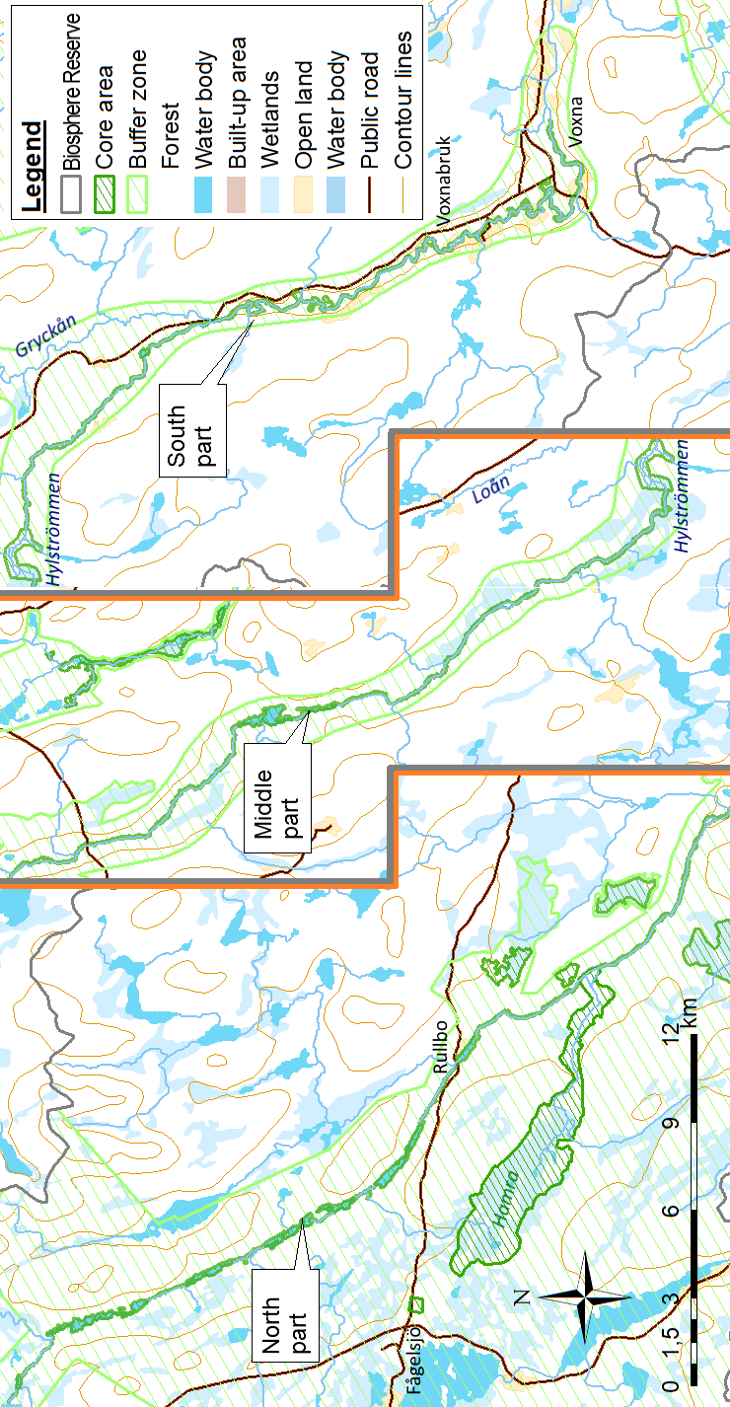
Figure 19.1: Map of the river Voxnan including Hylströmmen rapids
The area comprises Rullbosjön lake, Kontorslugnet, Värmlandströmmen rapids, Kringelströmmen rapids, Brännslåttströmmen rapids, Klöverhäll, Hylströmmen rapids, Kilströmmen rapids, Vinströmmen rapids, Frostkilen embankment, Kilen, Finnstuga hamlet and the former settlement of Voxna: a 190 km-long glittering string of pearls, with Hylströmmen as the jewel in the crown. Hylströmmen is the biggest, wildest and most beautiful stretch of rapids in the southern Norrland region, with a drop of 23 metres.

2 Stormyran-Blistermyran
Area: 1,524 ha
Form of protection: Natura 2000 (SCI)
Type of Buffer Zone: Area of national interest for nature conservation

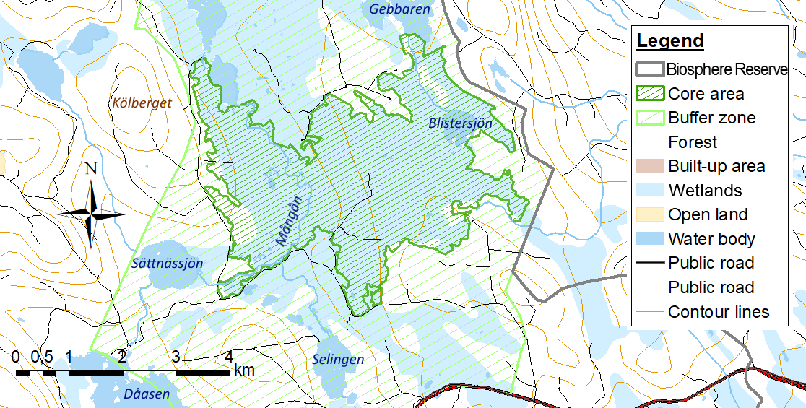
Figure 19.2: Map of Stormyran-Blistermyran
The area comprises a range of different types of peatlands, mainly aapa mire and soligenous fen. Around Blistersjön lake, to the east, there is an eccentric raised bog and a slightly sloping bog. Typical aapa mire comprises mosaic mixed mire, string fen and string mixed mire. Along the river Mångån, in the western section of the peatlands, there is lush limnogenic fen to the north. These areas have previously been used for haymaking.
Stormyran, the western part of the area, is rich in birdlife. Large numbers of waders and ducks breed here, including the common crane , wood sandpiper, northern lapwing, European golden plover, Eurasian teal and mallard. Other breeding species include the red grouse and three-toed woodpecker.
There is a small amount of red-listed wolf lichen on standing dead trees out in the peatlands. Insect species reported in the area include various typical and common peatland-dwelling species such as the bog fritillary, the Baltic grayling and the azure hawker.
The area has been designated as an area of national interest for nature conservation and is included in Sweden’s Mire Protection Plan.

3 Fågelsjö Gammelgård
Area: 6 ha
Form of protection: World Heritage Site
Type of Buffer Zone: Area of national interest for nature conservation and area of national interest for outdoor recreation

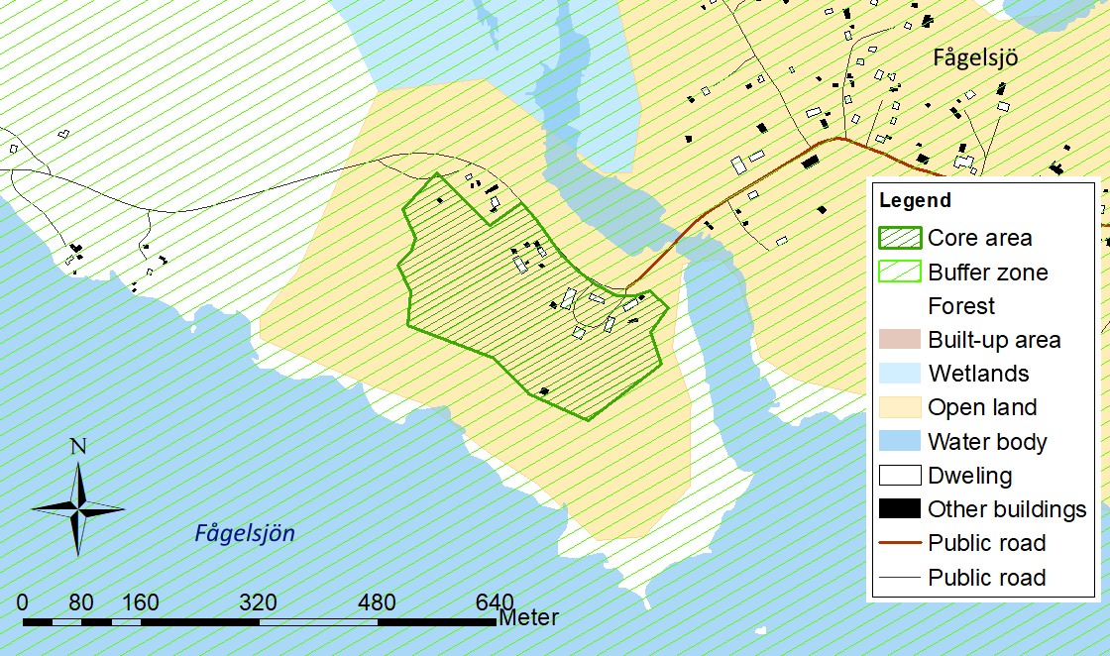
Figure 19.3: Map of Fågelsjö Gammelgård
The forest village of Fågelsjö, situated on the border between Dalarna and Hälsingland provinces, is home to the World Heritage Site of Bortomåa or Fågelsjö Gammelgård (Fågelsjö Old Farmhouse). The site features one of the best-preserved 19th century farmhouses in Sweden, which was for many years the home and workplace of a single family originally from Finland. The owners prospered over the generations, as the farm provided diverse ways to make a living, both from agriculture and from making rifles in the on-site gunsmith’s workshop that they then sold across the country. In 1910, a new dwelling was built at the farm, called the ‘America House’. When the family moved into the America House, Bortomåa was locked up and everything was left as it was – with the result that the farmhouse became a fascinating time capsule. Bortomåa’s history is also unusually well documented thanks to the diaries written by the father of the family, Jonas Olsson.
Today, in addition to the Old Farmhouse and the America House, there are around ten outbuildings on the site, including a grain store with as many as seven locks. The Old Farmhouse is a ’parstuga’ on two floors, with twelve rooms furnished with remarkably well-preserved 19th century paintings and wallpaper. The farm is now owned by Ljusdal Municipality and run as a museum by Fågelsjö local history society.

4 Näveråsen
Area: 20 ha
Form of protection: Nature reserve and Natura 2000 (SCI)
Type of Buffer Zone: Area of national interest for outdoor recreation

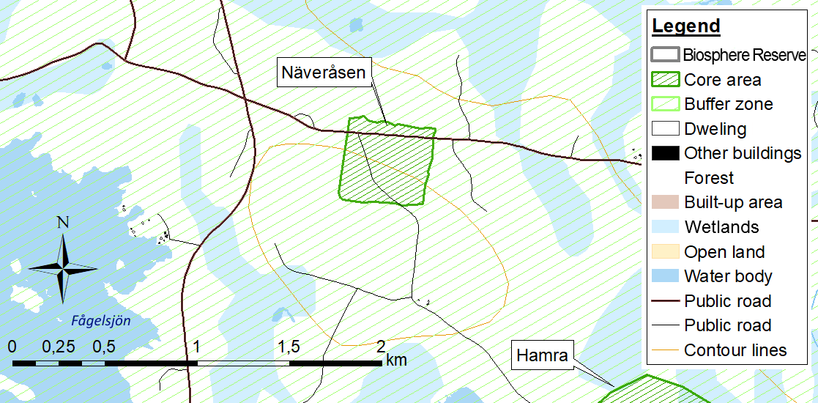
Figure 19.4: Map of Näveråsen
Näveråsen ridge features a small section of mixed coniferous woodland with the appearance of a primeval forest; it has centuries-old spruce and pine trees reaching up to the skies like lichen-covered giants. Very occasionally, the quiet that reigns is broken by the noise of an old tree finally surrendering and falling to the ground. Trunks and branches then quickly become home to fungi and mosses, and the resulting space enables new, smaller trees to seek out the light as they fight for the best position.
Flowers such as the alpine sowthistle, creeping lady’s tresses and the heath spotted-orchid are amongst the many species that are features of this ancient woodland. Lung lichen is sometimes found on old goat willows and the chocolate-brown Phellinus ferrugineofuscus fungus can be seen on the fallen trunks of spruce trees.

5 Gryssjömyran
Area: 235 ha
Form of protection: Nature reserve
Type of Buffer Zone: Area of national interest for nature conservation and area of national interest for outdoor recreation

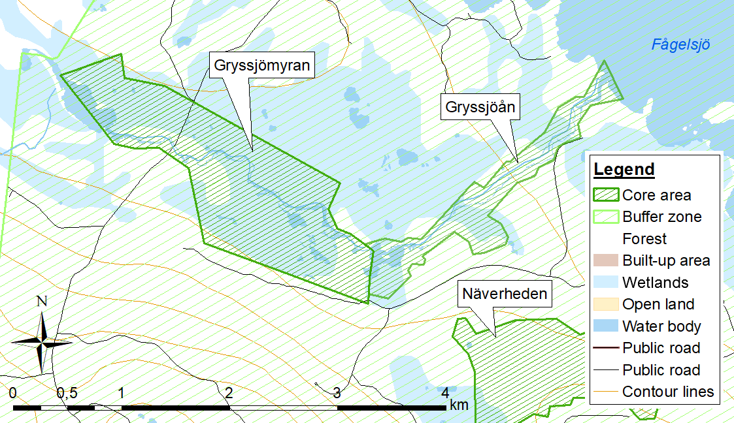
Figure 19.5: Map of Gryssjömyran and the river Gryssjöån
Gryssjömyran is a large and varied area with a mosaic of different types of peatlands, wooded islets and small tarns. The river Gryssjöån has a wilderness feel as it meanders through the reserve, and has high natural values. Fire-affected pine trees of varying ages grow on many of the islets. Parts of the woodland have the characteristics of natural forest, with deadwood and old hold-over pines 250-300 years old. On several of the islets there are also old spruce trees draped in lichen, and in some places there are large stands of deciduous trees in the form of old goat willows and aspen.
The diversity of the reserve and its small, shallow tarns attract many birds, with species including the yellow wagtail and waders such as the wood sandpiper and common greenshank.

6 Gryssjöån
Area: 83 ha
Form of protection: Nature reserve being established
Type of Buffer Zone: Area of national interest for nature conservation and area of national interest for outdoor recreation
The river Gryssjöån flows through the Gryssjömyran peatlands, a previously-established nature reserve. Old log-driving channels and stone embankments bear witness to earlier log-driving activity, and there are also beaver lodges and newly-built dams along the river.

7 Hamra
Area: 1,382 ha
Form of protection: National park, partly Natura 2000 (SPA and SCI)
Type of Buffer Zone: Area of national interest for nature conservation and area of national interest for outdoor recreation

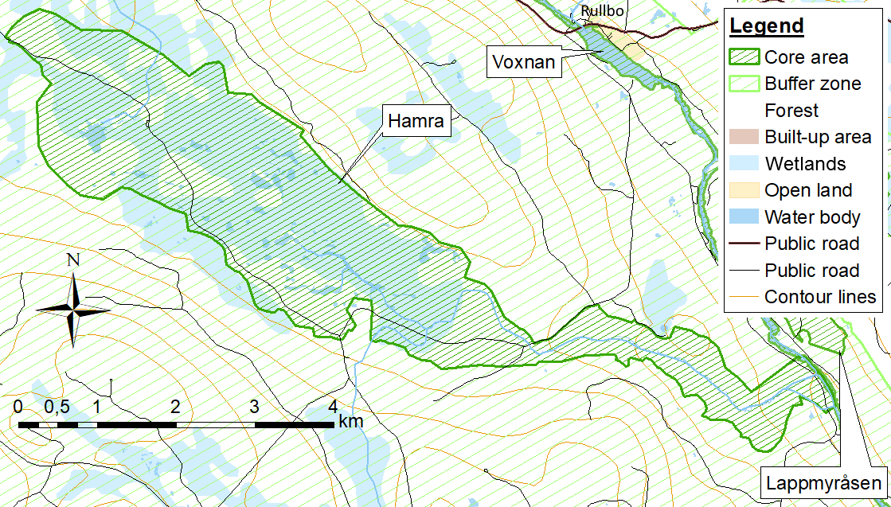
Figure 19.6: Map of Hamra
National parks are located on land owned by the state, and they are maintained and managed by the County Administrative Board in accordance with the purposes for which they have been established. Hamra was established to ensure that the natural environment and wildlife experiences of the area remain essentially undisturbed, within a section of plains and rocky hilltops that includes forested areas with elements of ancient woodland, a mixed-species mire complex, other types of wetland and a watercourse with unaffected hydrology.
Hamra national park lies in an undulating landscape of rolling hills on Precambrian bedrock. The national park covers 1,383 hectares and consists of forest, peatlands and watercourses. It is best known for its forest; the oldest part of the national park is one of the few untouched forests in central Sweden. Many of the ancient forest’s flora and fauna species live in old or dead trees.
Almost half of the national park is a large area of contiguous mire complex consisting of fen, streams, small tarns, quagmire and islets with pine trees. The large, undisturbed peatlands are popular with both birds and walkers. The river Svartån, which drains the peatland, has never been used for log driving, and so there is still a jumble of stones in the water to provide a suitable habitat for fish and small aquatic animals.
Part of the national park is also protected under the Natura 2000 scheme.

8 Fågelsjö
Area: 2 ha
Form of protection: Natura 2000 (SCI)
Type of Buffer Zone: Area of national interest for outdoor recreation
The area is located about 1 km northwest of Sjöändan at the western end of Ljusdal Municipality.
The forest is mixed conifer with a field layer rich in plants. The various vascular plants include herb-paris, mountain everlasting, wood crane’s-bill, one-flowered wintergreen, stone bramble, coralroot orchid, lesser twayblade and mountain melick. The forest has been impacted by thinning and fertiliser application and by some more recent felling in the northern part of the area.

9 Näverheden
Area: 138 ha
Form of protection: Nature reserve
Type of Buffer Zone: Area of national interest for outdoor recreation

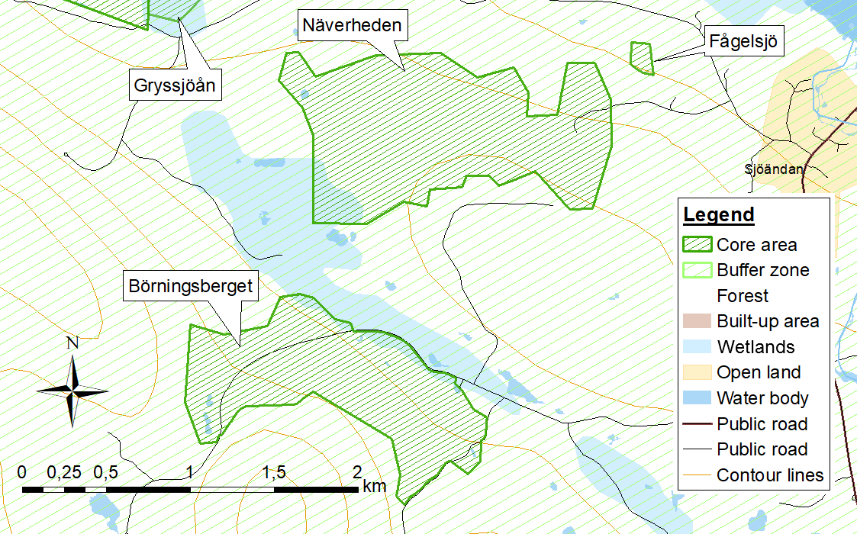
Figure 19.7: Map of Fågelsjö, Näverheden and Börningsberget
Näverheden is a large, contiguous area of natural forest with pine and mixed conifers. It comprises old hold-over pines, 250-300 years old, small bodies of water, peatland, depressions with spruce trees and areas of pure pine forest. There is also a large volume of deadwood in the form of fallen and standing trees.
To the west, there are peatlands. Two islets are home to some very fine old natural woodland. Evidence of fire can be seen in the large old tree stumps left behind after earlier dimension felling. One standing dead tree shows the effects of four forest fires. In the eastern part of the reserve, the forest is characterised by stones and boulders. A glaciofluvial channel, formed by glacial retreat, slopes down towards the north east.
Some areas of the reserve have large numbers of deciduous trees, and red-listed species such as lung lichen and the Haploporus odorus fungus grow on old goat willows and aspens. Other species evidencing the area’s high natural values are Nadvornik’s horsehair lichen and creeping lady’s tresses. The reserve is also home to the three-toed woodpecker and various members of the grouse family: western capercaillie, black grouse and hazel grouse.

10 Börningsberget
Area: 102 ha
Form of protection: Nature reserve and Natura 2000 (SCI)
Type of Buffer Zone: Area of national interest for outdoor recreation
The western and eastern sections of Börningsberget nature reserve boast old spruce and mixed conifer woodland, while the intervening section is natural forest, mainly pine. Much of the forest consists of 300 year-old pine trees, with some trees almost 40 metres high. There is also deadwood in the form of fallen and standing trees. The reserve hosts a number of threatened species, including various mosses, lichens, fungi and insects. In the southern section of the reserve, a stream and several pools make the ground fertile and rich in plant species.
There were more forest fires in the past than there are today, and there is evidence of earlier fires in Börningsberget, primarily in the form of wounds on ancient pine trees.
A forest museum in the west of the reserve features charcoal-burners’ huts, tools, sledges and other equipment used when working in the forest. The museum is managed by Ljusdal Municipality.
The reserve’s majestic forest with its tall trees is an impressive sight and a popular visitor destination. The area previously consisted of two ’domänreservat’ reserves, totalling 27 hectares, but was extended in 2013 into one continuous nature reserve.

11 Långtjärnsmyrarna-Flåmhalsen
Area: 95 ha
Form of protection: Natura 2000 (SCI)
Type of Buffer Zone: Area of national interest for nature conservation

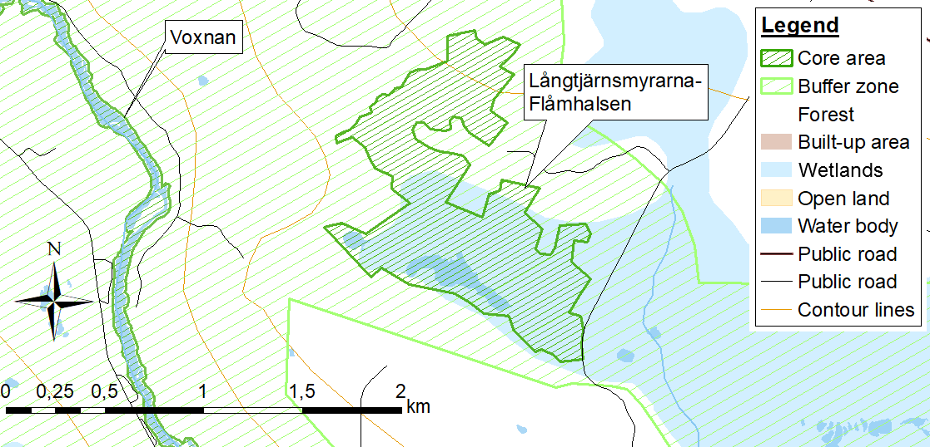
Figure 19.8: Map of Långtjärnsmyrarna-Flåmhalsen
The Långtjärnsmyrarna-Flåmhalsen Natura 2000 site is part of one of the classic areas of rich fen around the village of Los. The basic greenstone of the bedrock has led to the formation of well-developed rich fens.
The area is a mixture of open wet flark fen, rich fen that is firmer and wooded, and wooded solid ground. The western and northern sections are mainly wooded peatlands, while in the south and east there are mostly large, open peatlands. In the southern section there are two small humic tarns, Lilltjärn and Långtjärn. The wooded morainic landscapes and islands have been affected in varying degrees by forestry. The types of wetland vary considerably, but virtually all the constituent peatlands are rich fen and many of them are extremely rich fen. The only known occurrence in Hälsingland of the bird’s-eye primrose is in the south-southwest section alongside the stream between the tarns. There is also a population here of the lady’s-slipper orchid, which is protected under the Habitats Directive.

12 Lappmyråsen
Area: 30 ha
Form of protection: Natura 2000 (SCI)
Type of Buffer Zone: Area of national interest for nature conservation and area of national interest for outdoor recreation

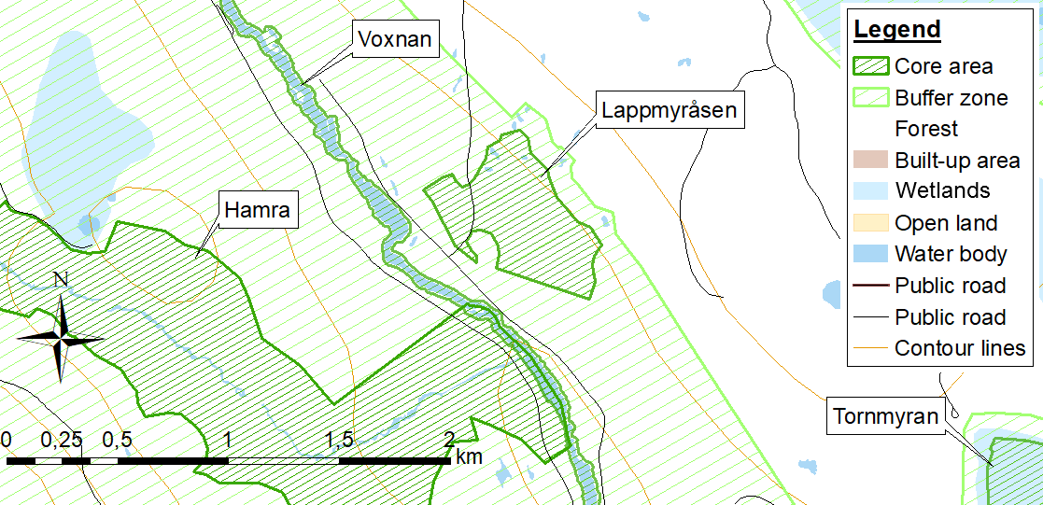
Figure 19.9: Map of Lappmyråsen
Lappmyråsen is located about 11 km west of the village of Los, not far from the north-eastern bank of the river Voxnan, and consists of an undulating area with a mosaic of tree-covered/open fen, wet hollows that sometimes dry out and wooded ridges. The woodland is subject to conventional forestry except where there are dips in the landscape and around the wetlands. It is particularly in these areas that the natural values are apparent. The effects of the occurrence of greenstone on the vegetation can be seen in hollows in the ground. The forested areas here are species-rich and the fen is intermediate fen bordering on rich fen.
The area hosts several rare and threatened species that are associated with forest continuity. Several of the rare species are also dependent on the ground having a high base cation content and elements of fen and wet terrain. Amongst the red-listed and flagship species are the liverworts Scapania glaucocephala, Scapania apiculata, Scapania carinthiaca, Calypogeia suecica, Hamatocaulis vernicosus and Lophozia ascendens, and the fungi Sarcodon fennicus, Cortinarius aureopulverulentus, Cortinarius aureofulvus, Hydnellum gracilipes, Byssomerulius albostramineus and Postia lateritia.
Vascular plants also include several species typical of calcareous soil, for example lady’s-slipper orchid, common hepatica, herb-paris, baneberry, mezereon and common twayblade.

13 Tornmyran
Area: 118 ha
Form of protection: Natura 2000 (SPA and SCI)
Type of Buffer Zone: Area of national interest for nature conservation

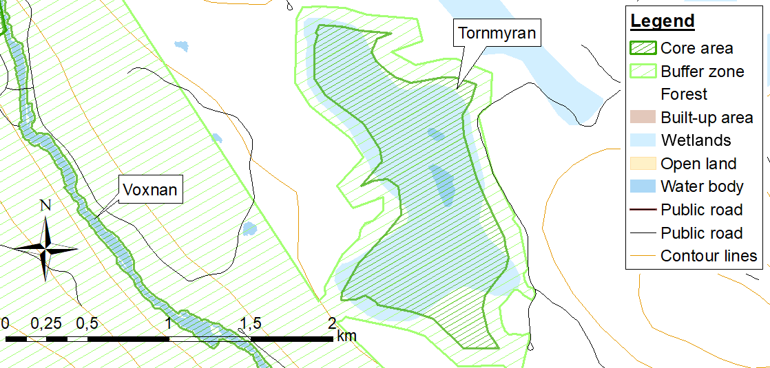
Figure 19.10: Map of Tornmyran
Tornmyran is a large area of flark fen sloping slightly to the south, with long, 50 cm-high strings that are generally highly branched towards the edges. The flarks have either mud-bottoms or clear water . There are a small number of deep tarns in the fen, dammed by sturdy peat embankments with gnarled birch trees reminiscent of alpine woodland . The richest vegetation is probably that found adjacent to the outflow of the peatland, where rich fen species such as the early marsh-orchid have been observed. Tornmyran has various interesting and valuable species of peatland birds, including several waders, ducks and passerines.

14 Hägenlammsmyran
Area: 457 ha
Form of protection: Natura 2000 (SPA and SCI)
Type of Buffer Zone: Area of national interest for nature conservation and area of national interest for outdoor recreation

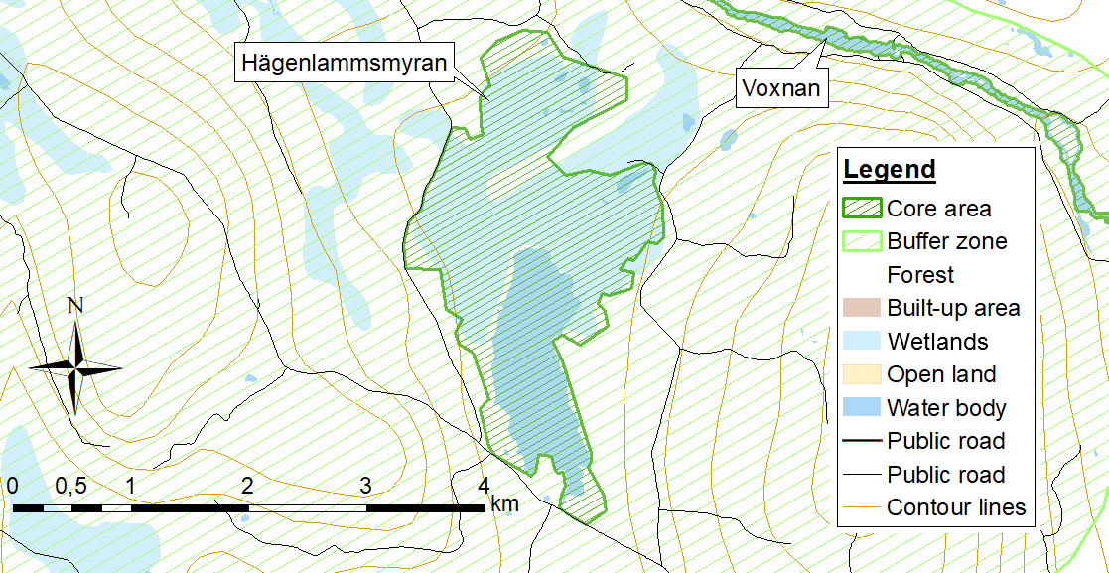
Figure 19.11: Map of Hägenlammsmyran
Hägenlammsmyran is a large, continuous, mixed-species mire complex comprising several areas of different types of peatland. The Hägenlammsmyran peatland itself is an extensive flark fen with flarks and extensively winding strings that are normally wooded and often branching as they reach the edges of the solid ground. There is usually a considerable difference in level between adjacent flarks, and in some cases the differences are extremely significant – up to 1.5 m – giving the fen a terraced appearance. The flark fen is mainly a rich fen, hosting species such as the early marsh-orchid, broad-leaved cotton grass, Scottish asphodel, bog rush, common butterwort and scant occurrences of bog orchid. The vegetation on the strings is notably lush in some places. The south-eastern section differs in topography, and is more like a mixed mire.
Fastersmyran also largely consists of flark fen with wet limnogenic fen along the stream running through it.
The western section of Västersjömyran consists of unilaterally sloping bog, which is traversed by several belts of fen. The eastern section is separated from the western section by a small curtain of trees. Eastern Västersjömyran mainly consists of wet sedge fen with springy carpets.
The mire complex is rich in bird life, with a large number of species breeding on the peatland. It is also an excellent resting site for groups such as waders; the Eurasian curlew is one wader that has nested in the area. Wolf lichen can be found growing in the northern section.
The area features in Sweden’s Mire Protection Plan.

15 Fräkentjärn
Area: 13 ha
Form of protection: Natura 2000 (SCI)
Type of Buffer Zone: Area of national interest for nature conservation

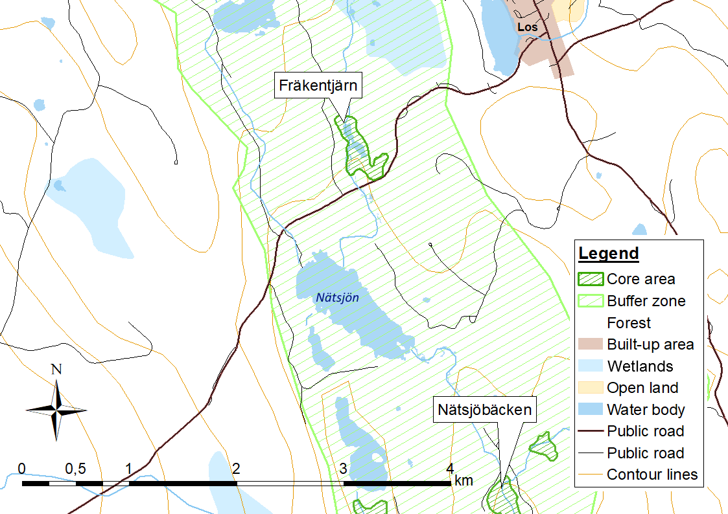
Figure 19.12: Map of Fräkentjärn
The area is situated just over 2 km south west of Los Church (Los kyrka) and consists of a tarn (Fräkentjärn) and its surrounding peatlands and forest lands.
The area around Los is well-known for its rich fen. The bedrock is basic, comprising calcareous greenstone that influences most of the wetlands in the area. In the rich fen and extremely rich fein around Fräkentjärn there is a large population of lady’s-slipper orchid. In and close to the area there are also species such as the sedge Schoenus ferrugineus, common twayblade, common hepatica, mezereon, baneberry, Solomon’s seal, fragrant orchid, bearded couch, hair sedge, slender green feather moss, tufted fen-moss and the textured lungwort lichen. Just south of secondary road 310, the Geyer’s whorl snail, a Natura 2000 species, has been observed in an area of extremely rich fen along the reaches of the Hästtjärnsbäcken stream.
The area is included in Sweden’s Mire Protection Plan and also forms a small part of an area of national interest for nature conservation. This status has been awarded in recognition of the area’s natural values, including values relating to flora, rich fens and swamp forests.

16 Nätsjöbäcken
Area: 138 ha
Form of protection: Natura 2000 (SCI)
Type of Buffer Zone: Area of national interest for nature conservation

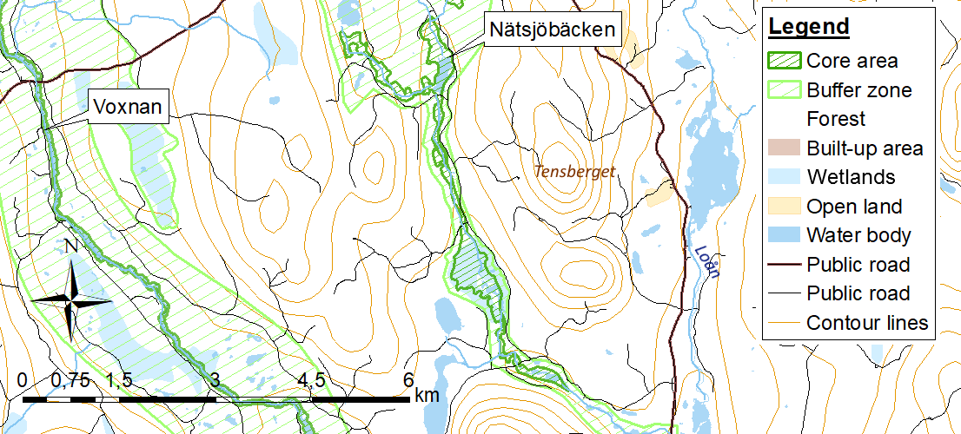
Figure 19.13: Map of Nätsjöbäcken
The Nätsjöbäcken Natura 2000 site lies about 10 km south of Los at the western end of Hälsingland. It follows the course of the Nätsjöbäcken stream, including surrounding shore wetlands, from just north of Rotsjön lake down to Storlugnan lake. The area also includes sections of the Mårdsjöbäcken and Uttertjärnsbäcken tributaries.
Nätsjöbäcken has been cleared and used for log-driving, and at the outflow from the Stortallbergsmyran peatlands the remains of a log-driving dam can just be made out. At the point where Storlugnan lake flows out into Nätsjöbäcken there is an embankment across the peatlands on the northern side of the watercourse, probably left over from the log-driving period. Nätsjöbäcken downstream of Storlugnan has undergone quite significant clearance for log-driving, and there are some remains of stone dams.
The terrain around the streams and lakes is relatively flat and there are wide areas of shore wetland in several places. Around Rotsjön lake there are several small areas of peatland, mostly wooded lawn and a rich fen. Some of the peatland along the Mårdsjöbäcken stream is string fen. Stortallbergsmyran lies in the southern part of the Natura 2000 site. This is a large peatland area, the western part of which consists of a large, well-developed, limestone-influenced string fen, while the remainder is open or sparsely wooded topogenous fen. The open topogenous fen also shows the influence of limestone.
The mire complex is strongly limestone influenced in several places, and has a well-developed rich fen flora, making it of great interest to botanists. Of the vascular plants, there are several typical rich fen species and other moisture-loving species such as Selkirk’s violet, wavy bittercress, narrow-leaved marsh-orchid, lady’s-slipper orchid, bog orchid, the sedge Carex capitata, the grass Poa remota and the sedge Schoenus ferrugineus.
There is diverse moss flora. At the time of writing, approximately 190 different species of moss have been reported from the area or just adjacent to it on the Artportalen (Swedish Species Observation System). These include several red-listed and flagship species such as Philonotis calcarea/thick-nerved apple-moss, Philonotis fontana/fountain apple-moss, Philonotis tomentella/woolly apple-moss, Meesia longiseta/long seta hump moss, Palustriella decipiens/lesser curled hook-moss, Hamatocaulis vernicosus/slender green feather moss, Neckera complanata/flat neckera, Buxbaumia viridis/green shield moss, Hylocomiastrum pyrenaicum/Oake’s wood-moss, Dicranum flagellare/whip fork-moss, Tortella tortuosa/frizzled crisp-moss, Anastrophyllum hellerianum/Heller’s notchwort, Lophozia longiflora, Scapania apiculata/pointed earwort and Scapania carinthiaca/Carinthian earwort.
The European bullhead, common minnow, northern pike, brook lamprey and burbot have been observed in Nätsjöbäcken during electrofishing. Other wildlife in the area includes the Geyer’s whorl snail (a Natura 2000 species) and the European otter.

17 Grytaberget
Area: 303 ha
Form of protection: Natura 2000 (SPA and SCI)
Type of Buffer Zone: Ecopark

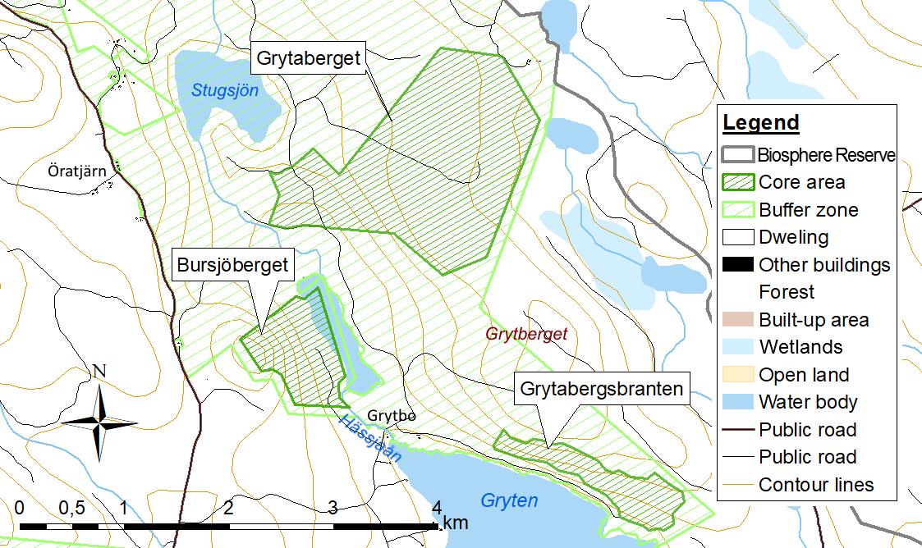
Figure 19.14: Map of Grytaberget, Bursjöberget and Grytebergsbranten, all within Ekopark Grytaberg
The area lies within Sveaskog’s Grytaberg ecopark, approximately 20 km north of Edsbyn.
Grytaberg features both old, multilayered spruce forests, pine forests with hold-over pines up to 240 years old, an area of slightly flowing water in swamp forest with mature alder, goat willow, birch and spruce, and younger woodland similar to that growing naturally after a fire . Many of the stands are about 110-150 years old. Topographically, the area is flat with gentle slopes. The dominant soil type is boulder-poor till. One characteristic of the area is the unusually large number of substantial, fallen dead pine trees, often showing fire damage. Some of these have been left behind after felling. Between 1295 and 1866 (the time of the most recent fire), there was a fire somewhere in the area on average at least every 13 years. The frequency of the fires suggests that they must have been caused at least to some extent by human action (probably during burn-beating and when burning off pasture land).
The area was impacted by dimension felling in the 1890s and forest protection measures between the 1930s and 1950s. There has been little human impact on the forest since the 1950s and there has been no felling in recent times apart from that recently undertaken to create a roadway and two logging areas. Between the areas of forest deemed by the Swedish Forest Agency to be of special significance for floral and fauna, there is slightly younger woodland that currently lacks structures such as deadwood. Stands in the area have been affected by fertilisation work in the forest in 1983.
Among the red-listed and flagship species reported from the area are pendulous wing-moss, the liverwort Calypogeia suecica, Heller’s notchwort, the lichens Collema occultatum and Collema curtisporum, the fungi Antrodia albobrunnea, Cinereomyces lenis, Postia lateritia, Skeletocutis stellae and Gloiodon strigosus, and the beetles Tragosoma depsarium and Necydalis major.

18 Bursjöberget
Area: 67 ha
Form of protection: Nature reserve
Type of Buffer Zone: Ecopark
Visitors to the forest in Bursjöberget nature reserve will notice that it has been strongly affected by fire. The reserve lies in an area in which regular forest fires in earlier times left their mark on the forest landscape.
The highest natural values are to be found on the steep, bouldered eastern slopes of the mountain. There is pine forest here showing substantial evidence of fire, with many old pine trees between 250 and 300 years old. Large amounts of standing deadwood and high stumps together with isolated large, old fallen pine trees help make this a valuable environment. Species noted that are worthy of protection include the Carbonicola anthracophila lichen and wolf lichen (Letharia vulpina).
Below the scarp there is pine forest whose natural values are a little lower, and the County Administrative Board carried out prescribed burning here in August 2006. This increases the natural values considerably, so that the fire-dependent species still resident after previous fires can continue to live there.

19 Grytabergsbranten
Area: 52 ha
Form of protection: Natura 2000 (SPA and SCI)
Type of Buffer Zone: Ecopark
Grytabergsbranten lies within Sveaskog’s Grytaberg ecopark, just over 15 km north of Edsbyn.
The area consists of a wooded and sometimes steep south/south-west sloping hillside. Its main assets are the natural forest, the high proportion of deciduous trees and the rich flora. The old forests also make good habitats for birds, including various species of woodpecker and grouse.
Several red-listed and flagship species have been observed in the area. Amongst the species associated with deciduous trees are neckera moss (Neckera pennata), the Collema subflaccidum and Collema furfuraceum lichens, the bearded jellyskin lichen (Leptogium saturninum), Parmeliella triptophylla lichen, lung lichen (Lobaria pulmonaria) and crown coral fungus (Artomyces pyxidatus). The Cinereomyces lenis, Junghuhnia collabens and Fomitopsis rosea fungi have been observed on fallen dead spruce trees. One species with a liking for plant-rich, moist and shaded forest with mobile soil water is the ghost orchid, which has been recorded in the eastern part of the site.

20 Våsbo fäbodar
Area: 22 ha
Form of protection: Cultural Heritage Reserve
Type of Buffer Zone: Area of national interest for nature conservation and area of national interest for cultural heritage preservation

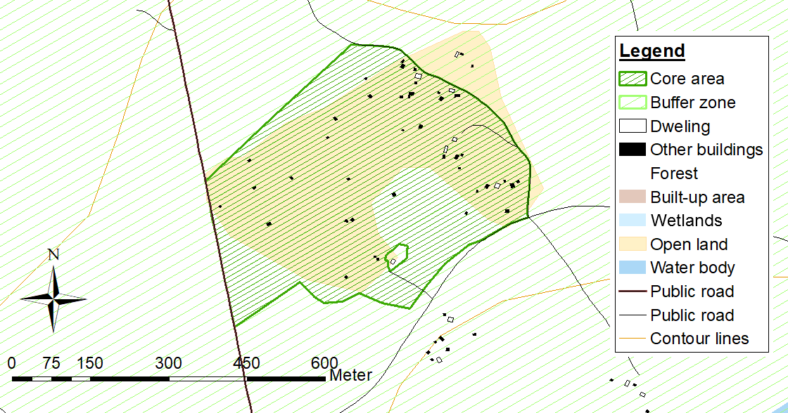
Figure 19.15: Map of Våsbo fäbodar
In the past, the ‘fäbodar’ (summer farms) and their land were a very important part of Hälsingland farms’ finances. The farmers used not only the enclosed land around the summer farm buildings but also the forest lands surrounding them.
Forest grazing provided most of the animals’ summer feed. The cows and goats milked most in the summer and were dry in the spring. The lush pasture provided plenty of fresh milk, which the farm girls would turn into dairy products that would keep over the winter. Much of the livestock’s winter fodder consisted of hay from peatlands, leaves and moss from the forest surrounding the summer farm buildings.
The forested areas belonging to Ovanåker Municipality in Hälsningland are home to some of the best-preserved summer farm sites in the country. As a result, Ovanåker’s summer farm forest has been designated as being of national interest for cultural heritage preservation. Våsbo was chosen from amongst these farms to be the county’s second cultural heritage reserve in 2008.
With its preserved buildings, flora and well-tended land, Våsbo is a good example of how summer farming worked in Hälsingland at the end of the 19th century.
The aim of the Våsbo fäbodar cultural heritage reserve is to preserve and develop the area’s high cultural heritage and biological values through continued, careful use of the land. One reason why Våsbo was chosen was the involvement of the summer farm owners who were keen to protect the environment for the future.
Settings like Våsbo were part of the everyday landscape for Hälsingland farmers in the 19th century, but the agricultural economy and food sector today are completely different. Våsbo can be seen as a very good educational example of a late 19th century summer farm. The area is open to visitors and used for teaching, science and immersive experiences.

21 Morabo
Area: 1 ha
Form of protection: Natura 2000 (SCI)
Type of Buffer Zone: Area of national interest for nature conservation and area of national interest for cultural heritage preservation

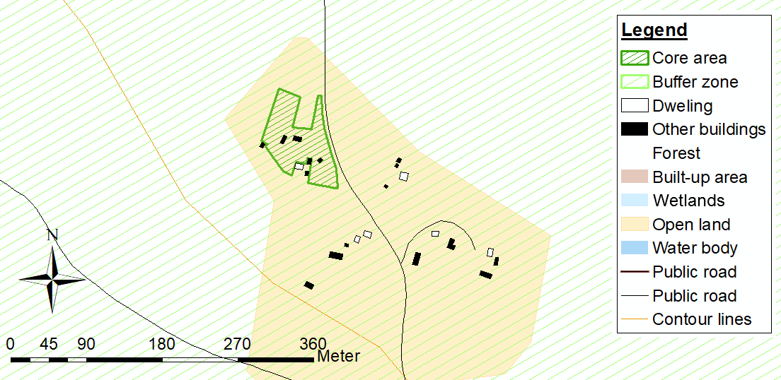
Figure 19.16: Map of Morabo
Morabo summer farms are located in the hilly forested area that lies approximately 9 km north of Edsbyn. The Natura 2000 site consists of an old stony meadow at Lövbergsvallen which has been grazed along traditional management lines since 1969. Prior to this, it had been a hay meadow for a long period. The setting has been very well preserved, with a number of old buildings, wooden fences and clearance cairns all giving some indication of how the farm would traditionally have operated. A long, unbroken period of traditional management with no outside intervention has resulted in a flora that is very rich in species. The land is mainly mat grass heath and is almost completely open, with some scattered junipers, with the exception of the area close to the road where there are greater numbers of juniper and small spruce trees.
The area hosts a large number of species indicative of long-term traditional grassland management, for example frog orchid, alpine bistort, mouse-ear hawkweed, imperforate St. John’s wort, ox-eye daisy, harebell, red clover, ragged robin, mat grass and heather. Around the summer farm there are also several species of meadow fungi, such as the dark purple earthtongue, violet coral and several different members of the Hygrophoraceae family. A marginalised population of field gentians can also be found in the location. The species has probably been disadvantaged by management unsuited to it, i.e. too little traditional management (high-growing shading vegetation, accumulation of organic debris) and sheep put out to graze too early. It is expected that this will have been resolved for the 2017 season through a more controlled maintenance regime for the site designed to benefit the gentians. A survey in 2016 did not find any field gentians at the location. However, the County Administrative Board did find a number of plants earlier the same year in spring, probably because they were easier to find before the vegetation developed. The variety of field gentian growing at Morabo is likely to be the early-flowering variety (Gentianella campestris var. Suecica).

22 Sässmanområdet
Area: 644 ha
Form of protection: Natura 2000 (SPA)
Type of Buffer Zone: Area of national interest for nature conservation and area of national interest for cultural heritage preservation

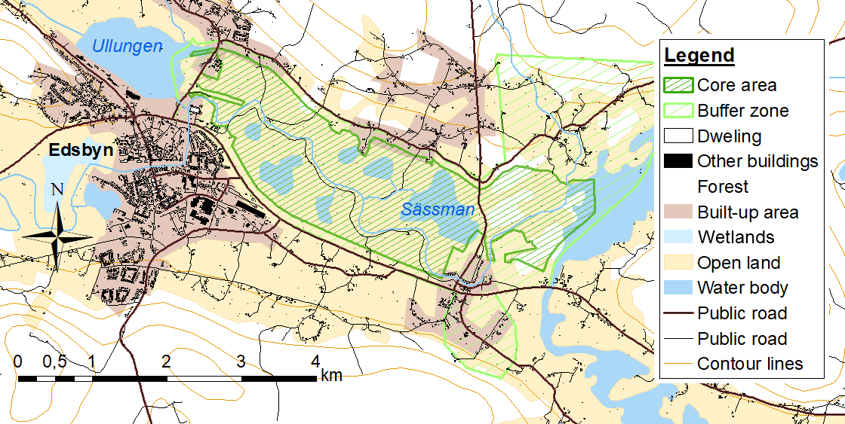
Figure 19.17: Map of Sässmanområdet
Here, the river Voxnan takes a gently meandering course between the Ullungen and Vägnan lakes. It is surrounded on both sides by a mosaic landscape, with fields edged with areas of deciduous woodland, different-sized tarns and various types of wetland. The edge zones along the river and around the tarns and wetland areas are dominated by deciduous woodland. In the outlying areas of the site there are some sections of coniferous forest.
The area is noted for its numerous lakes and tarns. Most of them are to be found in the northern part of the area, where sediment-covered end moraines have formed pockets, later cut off by the river meandering down into the basement rocks. In the eastern part of the area, the Voxnan has formed a small delta at the outflow from Vägnan.
The rate of flow varies greatly over the course of the year and the area is often flooded when the snow melts in spring. The levels of most of the lakes in the area have been lowered and water inflow is regulated by sluices in the Voxnan, as the river is sometimes higher than the lakes.
Sässmanområdet is very rich in bird life. Around 150 species have been recorded here, of which approximately 60 breed. In terms of migratory birds, it is one of the most interesting locations in the interior of the province. Large numbers of ducks, grebes, waders etc are drawn to the area when there is flooding in the spring following the snow melt. The rich variety of habitats also provides suitable conditions for large numbers of different species of passerines.

23 Pallars
Area: 3 ha
Form of protection: World Heritage Site
Type of Buffer Zone: Area of national interest for cultural heritage preservation
Pallars, a World Heritage Site, is one of Hälsingland’s biggest farms, located in the village of Långhed, outside Alfta. Built in 1858, the large, white farmhouse is two and a half storeys high and unusually wide, with three windows in a row on the gable end. The impression of grandeur is enhanced by the special shape of its roof – a mansard roof with sloping gable ends. The farm dates from the time in Hälsingland when the trend for building large residences known as ‘wooden castles’ was at its peak. The story goes that the house was built for the marriage of Jonas Nilsson and Brita Olofsdotter, and that the bride demanded a home that was as imposing as the house where she was born (Sjols in Näsbyn).

24 Jon-Lars
Area: 2 ha
Form of protection: World Heritage Site
Type of Buffer Zone: Area of national interest for cultural heritage preservation

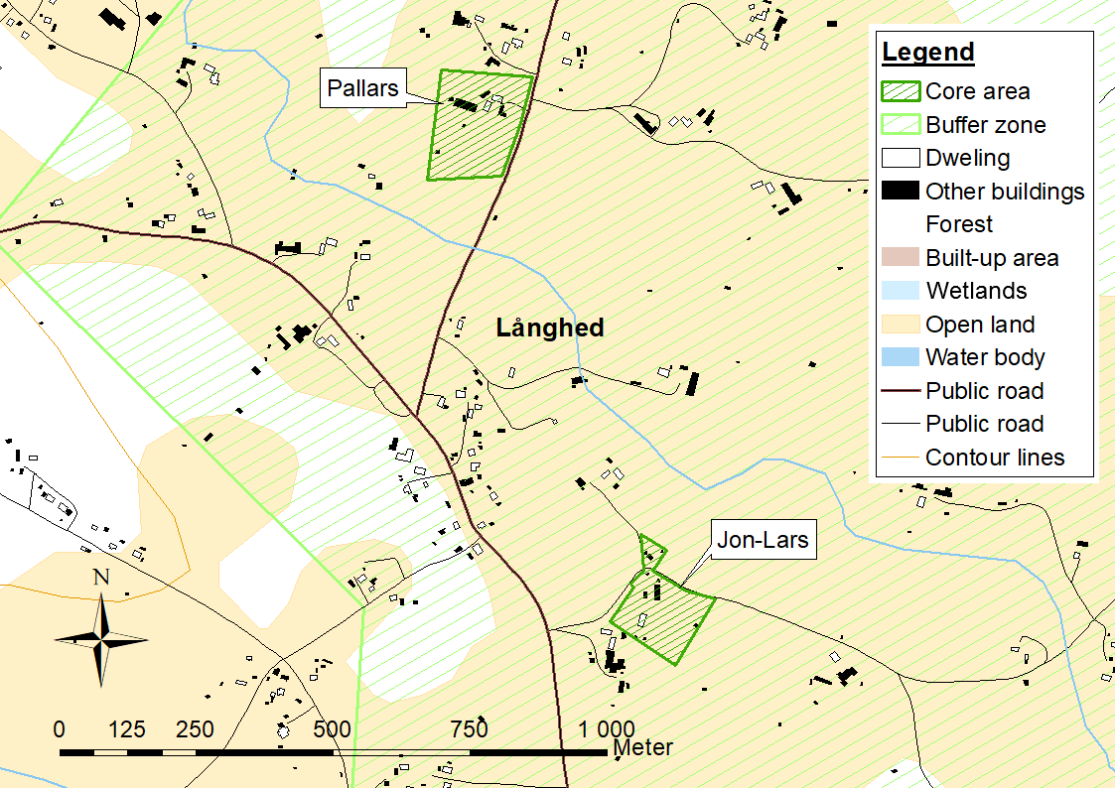
Figure 19.18: Map of Pallars and Jon-Lars
The Jon-Lars World Heritage Site farmhouse is also located in the village of Långhed just outside Alfta. The main building is one of the biggest residential buildings to be found on a Hälsingland farm. The enormous house also has an unusual layout, having been built as two mirroring apartments with a shared porch and two entrances. The porch is one of the biggest in the Voxnan valley. There are 700 square metres of living space, split over 17 rooms with a total of more than 60 windows. In addition to the house, there are ten outbuildings on the site. The house was built by two brothers after the original main building was destroyed by a fire in 1851. The brothers each lived in one of the apartments with their respective wives, and both households had shared use of a hall for celebrations and entertainment. Half the building has now been modernised, but the 19th century interior of the other half has been preserved. The house is still occupied by the same family-lineage that originally built it.

25 Tälningsbrännan
Area: 493 ha
Form of protection: Nature reserve being established
Type of Buffer Zone: Large unexploited area

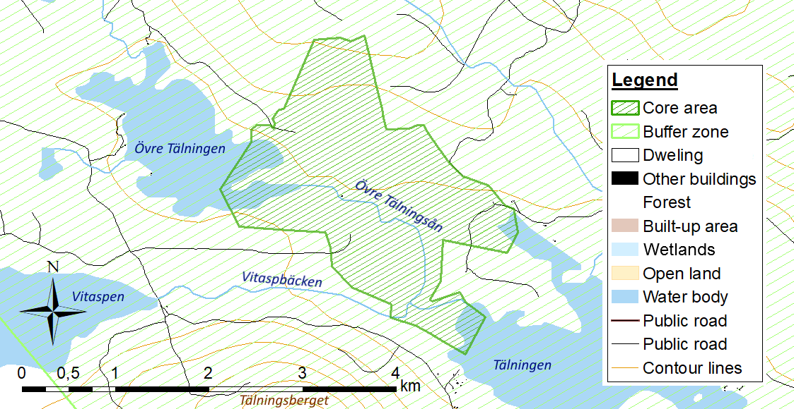
Figure 19.19: Map of Tälningsbrännan
Tälningsbrännan is a valuable area of land along and around the Övre Tälningsån river. Historically, it has been much affected by fire. This is probably due to the strong burn-beating culture of immigrant Finns, but also to a locally continental climate. Övre Tälning lake lies to the north west, and Tälningen lake is to the south east. The Övre Tälingsån flows through the area, starting from Övre Tälning lake. The Övre Tälningsån has previously been used for log driving and log-driving channels, stone dams and blasted stone are still visible.

26 Stormyran-Grannäsen
Area: 1038 ha
Form of protection: Natura 2000 (SPA and SCI)
Type of Buffer Zone: Area of national interest for nature conservation

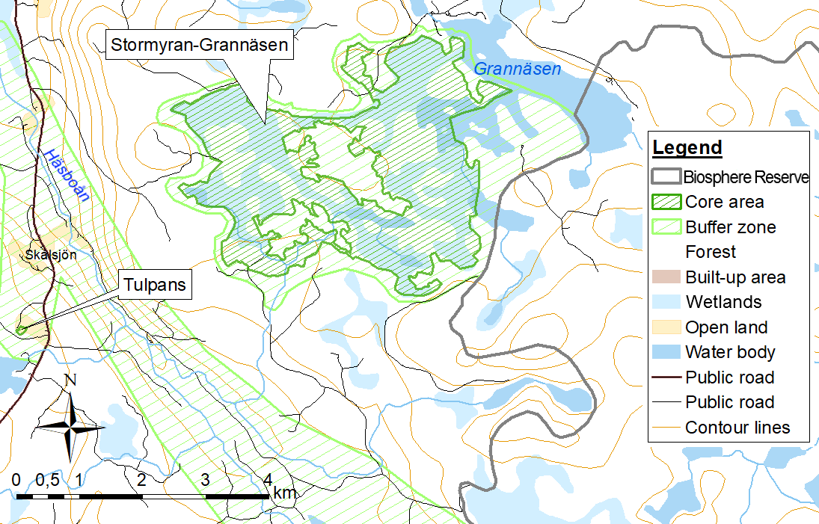
Figure 19.20: Map of Stormyran-Grannäsen and Tulpans
The site is located west of Grannäsen lake, approximately 17 km south of Alfta. It consists of a high peatland plateau of mosaic-like character that is drained in several directions. Stormyran and the adjoining peatlands by Grannäsen together form an extensive mire complex which, in addition to various types of bog and fen, also has around 30 tarns, streams and areas of dry land of various dimensions.
With the exception of the ditch between Bladtjärn tarn and Grannäsen, the area has not been impacted by earth works. The commonest types of peatland in the area are unilaterally sloping bogs, usually sparsely wooded, smooth sloping fens and level fens that turn into quagmire around the tarns. There is also some flark fen in the area. The boundaries between fen and bog are often indistinct, with strings of bog projecting into the fen.
In the peatland north of Häståsen ridge, there is a partially spring-fed rich fen with species such as alpine bistort, marsh violet and Hornemann’s willowherb. Birdlife in the area includes several species typical of peatlands, tarns and coniferous forest, such as the red-throated diver, black-throated diver, whooper swan, common crane, golden plover, wood sandpiper and black grouse. Wolf lichen has been recorded in several places in the area.
The area features in Sweden’s Mire Protection Plan and has been designated as being of national interest for nature conservation.
Grannäsen is included in the liming action plan. It has been limed several times and will be limed again in 2018.

27 Tulpans
Area: 1 ha
Form of protection: Natura 2000 (SCI)
Type of Buffer Zone: Area of national interest for nature conservation and area of national interest for cultural heritage preservation

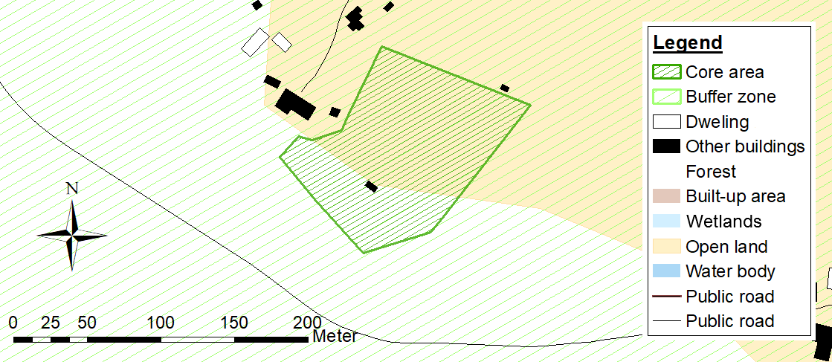
Figure 19.21: Detailed map of Tulpans
Tulpans is one of three farms in the village of Skålsjön in Alfta ‘Finn woods’. The farm is on a hill that rises to 380 m above sea level. This is a very old landscape incorporating a farm, grazing land and areas of stony meadow and surrounded by tree-clad hills. The land at Tulpans consists of the farm’s naturally occurring fodder lands, i.e. stony meadows, open pastureland and grazed woodland.
The vegetation types in the area are mat grass heath and Calluna heathland, mesic grassland with common bent and wood crane’s bill, and wet meadows. The area also has a small number of fields and a small amount of former farmland. Wooden fences still surround much of the infields, and there are 17 large clearance cairns scattered across the area. The farm operated on a two-field system and there are traces of several different phases of cultivation.
The land has been continuously traditionally managed, at least since the immigration of Finns in the 16th and 17th centuries , and is thus very species-rich. The area hosts a large number of species indicative of long-term traditional management. These include pyramidal bugle, moonwort, harebell, pill sedge, frog orchid, heath spotted-orchid, eyebright, fen bedstraw, ox-eye daisy, mat grass, grass of Parnassus, alpine timothy, lesser butterfly-orchid, alpine bistort and the spikemoss Selaginella selaginoides. Birch, pine and rowan are the dominant types of tree in the area, and there are also good numbers of juniper bushes, Various species of the Hygrophoraceae family of fungi have also been observed around the area’s grasslands, and wolf lichen grows on one of the hay barns.
Previously, there has also been a population of field gentians within the Natura 2000 site. They have probably disappeared because of an unsuitable sheep-grazing regime. However, there are still field gentians growing on four small sites nearby, only a hundred metres or so further north. They grow along a damp hollow, on both sides of a large stone cairn bordering farmland and also next to a small hay barn. In a survey of field gentians in Hälsingland in 2016, the field gentians at Tulpans were recorded as the early-flowering variety (Gentianella campestris var. suecica), which flowers in mid July. The survey found 241 plants that were either flowering or had finished flowering at these locations.

19.2 Vegetation map or land cover map
[noitemsep]
• Land use map: see page k_markanv
• Map of rock types: see page k_berg
• Map of soil types: see pagek_jord

19.3 List of legal documents (if possible with English, French or Spanish synthesis of its contents and a translation of its most relevant provisions)

19.4 List of land use and management/cooperation plans

19.5 Species list (to be annexed)

19.5.1 Characteristic species
Characteristic species are listed according to their habitats as described in section 11.6

Forests

Table 19.1: Characteristic forest species
 |  | Red Listed
Vascular plants |  | Table 19.9
Pine | Pinus sylvestris
Spruce | Picea abies
Silver Birch | Betula pendula
Aspen | Populus tremula
Willow | Salix caprea
Rowan | Sorbus aucuparia
Alder | Alnus incana
Spring Pasque Flower | Pulsatilla vernalis | X
Ghost Orchid | Epipogium aphyllum
Creeping Lady’s tresses | Goodyera repens | X
Mosses and lichens
Sw.Taigakolflarnlav | Carbonicola anthracophila
Lung Lichen | Lobaria pulmonaria | X
Fungi
Sw.Taigaporing | Inonotopsis subiculosa | X
Sw.Tallticka | Phellinus pini | X
Mammals
Brown Bear | Ursus arctos | X
Wolf | Canis lupus | X
Lynx | Lynx lynx | X
Wolverine | Gulo gulo | X
Elk | Alces alces
Roe Deer | Capreolus capreolus
Birds
Capercaillie | Tetrao urogallus
Black Grouse | Lyrurus tetrix
Hazel Grouse | Tetrastes bonasia
Willow Grouse | Lagopus lagopus
Great Grey Owl | Strix nebulosa | X
Ural Owl | Strix uralensis
Boreal Owl | Aegolius funereus
Pygmy Owl | Glaucidium passerinum
Siberian Jay | Perisoreus infaustus
Goshawk | Accipiter gentilis | X
Wood Sandpiper | Tringa glareola
Green Sandpiper | Tringa ochropus
Wood peckers
Garden Warbler | Sylvia borin
Common Whitethroat | Sylvia communis
Lesser Whitethroat | Sylvia curruca
Icterine Warbler | Hippolais icterina
Thrush Nightingale | Luscinia luscinia
River Warbler | Locustella fluviatilis | X
Sparrow Hawk | Accipiter nisus
Common Buzzard | Buteo buteo
Honey Buzzard | Pernis apivorus | X
Golden Eagle | Aquila chrysaetos

Lakes, rivers and streams

Table 19.2: Characterteristic species in lakes, rivers and streams
 |  | Red Listed
Vascular plants |  | Table 19.9
Marsh Clubmoss | Lycopodiella inundata | X
Pillwort | Pilularia globulifera
Sw. Ävjepilört | Persicaria foliosa
Molluscs
Freshwater Pearl Mussel | Margaritifera margaritifera | X
Fish
European Eel | Anguilla anguilla | X
Brown Trout | Salmo trutta
Arctic charr | Salvelinus alpinus
Perch | Perca fluviatilis
Pike | Esox lucius
Invertebrates
Noble crawfish | Astacus astacus | X
Mammals
Beaver | Castor fiber
Otter | Lutra lutra | X
Birds
White-throated Dipper | Cinclus cinclus
Red-thoated Diver | Gavia stellata | X

Wetlands

Table 19.3: Characteristic species in wetlands
 |  | Red Listed
Vascular plants |  | Table 19.9
Capitate Sedge | Carex capitata
Fibrous Tussock-sedge | Carex appropinquata
Fragrant Orchid | Gymnadenia conopsea
Narrow-leaved Marsh-orchid | Dactylorhiza traunsteineri
Early Marsh-orchid | Dactylorhiza incarnata
Club Mosses | Lycopodiaceae
Birds
Common Tea | Anas crecca
Wigeon | Anas penelope
Northern Shoveler | Anas clypeata
Wood Sandpiper | Tringa glareola
Greenshank | Tringa nebularia
Common Snipe | Gallinago gallinago
Lapwing | Vanellus vanellus
Yellow Wagtail | Motacilla flava
Meadow Pipit | Anthus pratensis | X
River Warbler | Locustella fluviatilis | X
Common Grasshopper Warbler | Locustella naevia
Common Reed Bunting | Emberiza schoeniclus | X
Short-eared Owl | Asio flammeus
Long-eared Owl | Asio otus
Corncrake | Crex crex | X
Whinchat | Saxicola rubetra | X
Northern Wheatear | Oenanthe oenanthe
Goldfinch | Carduelis carduelis
Marsh Harrier | Circus aeruginosus
Hobby | Falco subbuteo
Kestrel | Falco tinnunculus

Grassland

Table 19.4: Characteristic species in grassland
 |  | Red Listed
Vascular plants |  | Table 19.9
Alpine Bistort | Bistorta vivipara
Greater Bur-marigold | Bidens radiata | X
Meadow Rue | Thalictrum simplex
Needle Spike-rush | Eleocharis acicularis
Bitter-vetch | Lathyrus linifolius
Fungi
Dark Purple Earth Tongue | Microglossum atropurpureum | X
Honey Waxcap | Hygrocybe reidii
Invertebrates
Spotted Caddis Fly | Semblis phalaenoides
Butterflies
Long-horned Beetles | Cerambycidae
Mammals
Hare | Lepus europaeus
Cattle | Bos taurus
Sheep | Ovis aries
Horse | Equus caballus
Birds
Skylark | Alauda arvensis | X
Whinchat | Saxicola rubetra | X
Northern Wheatear | Oenanthe oenanthe
Reed Bunting | Emberiza schoeniclus | X
Ortolan Bunting | Emberiza hortulana | X
Hen Harrier | Circus cyaneus | X

Farmland

Table 19.5: Characteristic species in farmland
 |  | Red Listed
Vascular plants |  | Table 19.9
Oats | Avena sativa
Barley | Hordeum vulgare
Wheat | Triticum aestivum
Meadow Fescue | Festuca pratensis
Timothy | Phleum pratense
Red Clover | Trifolium pratense
Invertebrates
Bumblebees | Bombus
Däggdjur
Field Vole | Microtus agrestis
Common Shrew | Sorex araneus

Communities

Table 19.6: Characteristic species for built areas
 |  | Red Listed
Vascular plants |  | Table 19.9
Norway Maple | Acer platanoides
Birch | Betula pendula
Rowan | Sorbus aucuparia
Common Toadflax | Linaria vulgaris
Wild Lupin | Lupinus polyphyllys
Rosebay Willowherb | Chamerion angustifolium
Tansy | Tanacetum vulgare
Mammals
Hedgehog | Erinaceus europaeus
Squirrel | Sciurus vulgaris
Birds
Common Swift | Apus apus | X
Blackbird | Turdus merula
Willow Warbler | Phylloscopus trochilus
Barn Swallow | Hirundo rustica
House Martin | Delichon urbicun | X
House Sparrow | Passer domesticus

19.5.2 Red Listed Species
This list contains all species that have been observed at least once in the area, are listed on the national red list, Rödlista 2015, and have been reported to Artportalen. International red-listing by IUCN, listing in the EU Species and Habitats Directive or EU Birds Directive is noted. Abbreviations in table:

Int | International red-listing
Swe | Swedish red-listing
AH, F | EU Species and Habitats Directive and EU Birds Directive. These are the abbreviations used in the Swedish implementation of the Directives (Artskyddsförordningen):

 | B | The species is of interest at a Union level and specific protection areas (Birds Directive) or Priority Habitats (Species and Habitats directive) need to be designated. It is listed in appendix 1 in the Birds Directive or in Appendix 2 in the Species and Habitats Directive.
 | P | A priority species in the Species and Habitat Directive. The species is listed in appendix 2 in the Species and Habitat Directive.
 | N | The species requires special protection according to the Species and Habitat Directive. It is listed in appendix 4 in the Species and Habitat Directive.
 | F | The species is of such an interest at a Union level that special administrative measures must be taken if the species is collected in nature or if the area is to be developed. It is listed in appendix 5 in the Species and Habitat Directive.

Table 19.7: Red Listed Species
Common name | Latin name | Int | Swe | AH, F
Vascular plants
Marsh Clubmoss | Lycopodiella inundata | LC | NT
Northern Moonwort | Botrychium boreale |  | NT
Common Moonwort | Botrychium lunaria |  | NT
Multifid Moonwort | Botrychium multifidum |  | NT
Pillwort | Pilularia globulifera | LC | VU
Arrowhead | Sagittaria sagittifolia | LC | NT
Creeping Lady’s Tresses | Goodyera repens |  | NT
Hudson Bay Sedge | Carex heleonastes | DD | EN
Drooping Woodreed | Cinna latifolia |  | VU | B, N
Meadow grass (remota) | Poa remota |  | NT
Spring Pasque Flower | Pulsatilla vernalis | LC | EN
Pygmyweed | Crassula aquatica |  | NT
Brown Moor Clover | Trifolium spadiceum |  | NT
Burnet Rose | Rosa spinosissima |  | RE
Wych Elm | Ulmus glabra |  | CR
(Sw) Nordslamkrypa | Elatine orthosperma |  | VU
(Sw) Ävjepilört | Persicaria foliosa |  | NT | B, N
Bird’s-eye Primrose | Primula farinosa |  | NT
Fragrant Bedstaw | Galium triflorum | LC | NT
Field Gentian | Gentianella campestris subsp. campestris |  | EN
Mudwort | Limosella aquatica | LC | NT
Bristly Bellflower | Campanula cervicaria |  | NT
Greater Bur-marigold | Bidens radiata |  | VU
(Sw) Kopparbergsfibbla | Hieracium cuprimontanum |  | EN
(Sw) Gripfibbla | Hieracium gripharium |  | EN
(Sw) Lofibbla | Hieracium subterscissum |  | VU
(Sw) Stor hagfibbla | Hieracium megavulgatum |  | NT
(Sw) Smyckefibbla | Hieracium ornatum |  | NT
Mosses
Ovate tetrodontium moss | Tetrodontium ovatum |  | VU
Thick-nerved apple-moss | Philonotis calcarea |  | NT
(Sw) Liten trumpetmossa | Tayloria tenuis |  | NT
Slender green feather moss | Hamatocaulis vernicosus |  | NT | B
(Sw) Blå säckmossa | Calypogeia azurea |  | NT
(Sw)Vedsäckmossa | Calypogeia suecica |  | VU
A liverwort | Cephalozia affinis |  | NT
cephalozia | Cephalozia catenulata |  | NT
A liverwort | Anastrophyllum hellerianum |  | NT
Michaux’s anastrophyllum | Anastrophyllum michauxii |  | NT
Small Notchwort | Lophozia ascendens |  | VU
Delicate Notchwort | Lophozia capitata |  | NT
(Sw) Vedflikmossa | Lophozia longiflora |  | NT
Pointed Earwort | Scapania apiculata |  | EN
Short-stemmed Earwort | Scapania brevicaulis |  | VU
Carinthian Earwort | Scapania carinthiaca |  | EN | B
Glaucous-headed Earwort | Scapania glaucocephala |  | EN
Lichen
Needle lichen | Chaenotheca gracillima |  | NT
Needle lichen | Chaenotheca subroscida |  | NT
(Sw) Blågrå svartspik | Chaenothecopsis fennica |  | NT
Chaenothecopsis lichen | Chaenothecopsis nana |  | NT
chaenothecopsis lichen | Chaenothecopsis viridialba |  | NT
sphinctrina lichen | Sphinctrina anglica |  | EN
(Sw) Blanksvart spiklav | Calicium denigratum |  | NT
Notaris’ soot lichen | Cyphelium notarisii |  | EN
Soot lichen | Cyphelium tigillare |  | NT
(Sw) Kolflarnlav | Carbonicola anthracophila |  | NT
(Sw)Mörk kolflarnlav | Carbonicola myrmecina |  | NT
Parasite cup lichen | Cladonia parasitica |  | NT
(Sw) Allékantlav | Lecanora impudens |  | VU
Witch’s hair lichen | Alectoria sarmentosa |  | NT
Twocolor horsehair lichen | Bryoria bicolor |  | EN
Spiny Gray Horsehair Lichen | Bryoria nadvornikiana |  | NT
Mountain Oakmoss Lichen | Evernia divaricata |  | VU
Powdered Tube Lichen | Hypogymnia bitteri |  | NT
Wolf lichen | Letharia vulpina |  | NT
Norwegian ragged lichen | Platismatia norvegica |  | VU
(Sw)Ladkantlav | Protoparmelia oleagina |  | VU
(Sw) Gropig skägglav | Usnea barbata |  | VU
(Sw) Långskägg | Usnea longissima |  | VU
Hedlund’s dot lichen | Micarea hedlundii |  | VU
(Sw) Mjölig dropplav | Cliostomum leprosum |  | NT
(Sw) Trådbrosklav | Ramalina thrausta |  | EN
(Sw) Vedflamlav | Ramboldia elabens |  | NT
(Sw) Staketflamlav | Ramboldia insidiosa |  | VU
(Sw) Vedskivlav | Hertelidea botryosa |  | NT
(Sw) Skorpgelélav | Rostania occultata |  | NT
Effervescent Tarpaper Lichen | Collema furfuraceum |  | NT
Jelly Lichen | Collema curtisporum |  | VU
Jelly Lichen | Collema subflaccidum |  | EN
Jelly Lichen | Collema subnigrescens |  | NT
Lung Lichen | Lobaria pulmonaria |  | NT
Textured Lungwort Lichen | Lobaria scrobiculata |  | NT
(Sw) Staketflarnlav | Pycnora praestabilis |  | VU
Ahlner’s microcalicium lichen | Microcalicium ahlneri |  | NT
(Sw) Solfjäderlav | Cheiromycina flabelliformis |  | NT
Fungi
Dark purple earth tongue | Microglossum atropurpureum |  | VU
Witches Cauldron | Sarcosoma globosum | NT | VU
(Sw) Gammelgransskål | Pseudographis pinicola |  | NT
(Sw) Vaddporing | Anomoporia kamtschatica |  | NT
Pendent bracket | Irpicodon pendulus |  | NT
(Sw)Vridfingersvamp | Clavaria amoenoides |  | VU
Smoky Spindles | Clavaria fumosa |  | NT
(Sw) Brun fingersvamp | Clavaria pullei |  | EN
Magenta coral | Clavaria zollingeri |  | VU
(Sw) Gyllenspindling | Cortinarius aureofulvus |  | VU
(Sw) Puderspindling | Cortinarius aureopulverulentus |  | NT
(Sw) Blekspindling | Cortinarius caesiostramineus |  | NT
(Sw) Porslinsblå spindling | Cortinarius cumatilis |  | VU
(Sw) Kopparspindling | Cortinarius cupreorufus | NT | VU
(Sw) Doftskinn | Cystostereum murrayi |  | NT
(Sw) Hagnopping | Entoloma turci |  | NT
Scarlet Waxy Cap | Hygrocybe punicea |  | NT
Spicy Knight | Tricholoma matsutake |  | VU
(Sw) Gröntagging | Kavinia alboviridis |  | NT
(Sw) Gultoppig fingersvamp | Ramaria testaceoflava |  | NT
(Sw) Vitplätt | Chaetodermella luna |  | NT
(Sw) Tallstocksticka | Osmoporus protractus |  | VU
(Sw) Kolticka | Gloeophyllum carbonarium |  | EN
(Sw) Stjärntagging | Asterodon ferruginosus |  | NT
(Sw)Taigaporing | Inonotopsis subiculosa |  | VU
(Sw) Harticka | Onnia leporina |  | NT
(Sw) Granticka | Phellinus chrysoloma |  | NT
(Sw) Ullticka | Phellinus ferrugineofuscus |  | NT
(Sw) Gränsticka | Phellinus nigrolimitatus |  | NT
(Sw) Tallticka | Phellinus pini |  | NT
(Sw) Stor aspticka | Phellinus populicola |  | NT
(Sw) Violmussling | Trichaptum laricinum |  | NT
(Sw) Lappticka | Amylocystis lapponica |  | VU
(Sw) Fläckporing | Antrodia albobrunnea |  | VU
(Sw) Urskogsporing | Antrodia infirma |  | EN
(Sw) Urskogsticka | Antrodia primaeva |  | EN
(Sw) Veckticka | Antrodia pulvinascens |  | NT
(Sw) Kritporing | Antrodia crassa/creatcea |  | CR
(Sw) Rosenticka | Fomitopsis rosea |  | NT
(Sw) Lateritticka | Postia lateritia |  | VU
(Sw) Laxporing | Rhodonia placenta |  | VU
(Sw) Vågticka | Spongiporus undosus |  | VU
Soft bracket | Leptoporus mollis |  | NT
(Sw) Laxgröppa | Byssomerulius albostramineus |  | VU
(Sw) Laxticka | Hapalopilus aurantiacus |  | VU
(Sw) Rynkskinn | Phlebia centrifuga |  | VU
(Sw) Kådvaxskinn | Phlebia serialis |  | NT
(Sw) Asptagging | Radulodon erikssonii |  | VU
(Sw) Kristallporing | Gelatoporia subvermispora |  | NT
(Sw) Nordtagging | Odonticium romellii |  | NT
(Sw) Gräddporing | Cinereomyces lenis |  | VU
Aniseed Polypore | Haploporus odorus |  | VU
(Sw) Gräddticka | Perenniporia subacida |  | VU
(Sw) Kristallticka | Skeletocutis stellae |  | VU
(Sw) Ostticka | Skeletocutis odora |  | VU
(Sw) Ulltickeporing | Skeletocutis brevispora |  | VU
(Sw) Grantickeporing | Skeletocutis chrysella |  | VU
 | Skeletocutis borealis |  | DD
(Sw) Sprickporing | Diplomitoporus crustulinus |  | VU
(Sw) Blackticka | Junghuhnia collabens |  | VU
(Sw) Kandelabersvamp | Artomyces pyxidatus |  | NT
Coral Tooth | Hericium coralloides |  | NT
Spruce Tooth | Bankera violascens |  | NT
Drab Tooth | Bankera fuligineoalba |  | NT
Grey falsebolete | Boletopsis grisea |  | VU
Orange Tooth | Hydnellum aurantiacum |  | NT
Blue Tooth | Hydnellum caeruleum |  | NT
(Sw) Gul taggsvamp | Hydnellum geogenium |  | NT
(Sw) Smalfotad taggsvamp | Hydnellum gracilipes | VU | VU
(Sw) Dofttaggsvamp | Hydnellum suaveolens |  | NT
(Sw) Svartvit taggsvamp | Phellodon connatus |  | NT
Black Tooth | Phellodon niger |  | NT
(Sw) Tajgataggsvamp | Phellodon secretus |  | VU
(Sw) Bitter taggsvamp | Sarcodon fennicus |  | VU
Bitter Tooth | Sarcodon scabrosus |  | NT
(Sw) Motaggsvamp | Sarcodon squamosus |  | NT
(Sw) Hornvaxskinn | Crustoderma corneum |  | NT
(Sw) Rostskinn | Crustoderma dryinum |  | VU
Roothole Rosette | Stereopsis vitellina |  | VU
Invertebrates
Powder-post Beetle | Stephanopachys substriatus |  | NT | B
A Longhorned Beetle | Tragosoma depsarium |  | NT
(Sw) Reliktbock | Nothorhina muricata |  | NT
(Sw) Guldkantad rörbock | Donacia aureocincta |  | DD
 | Mantura rustica |  | NT
A Bark-gnawing Beetle | Calitys scabra |  | NT
(Sw) Stubbfuktbagge | Cryptophagus lysholmi |  | VU
 | Atomaria alpina |  | NT
(Sw) Svartvingad svampbagge | Leiestes seminiger |  | NT
(Sw) Granbarkmögelbagge | Enicmus planipennis |  | NT
 | Corticaria interstitialis |  | NT
 | Corticaria polypori |  | NT
 | Gonotropis dorsalis |  | NT
(Sw) Stor plattnosbagge | Platyrhinus resinosus |  | NT
(Sw) Stor sumpvivel | Lixus paraplecticus |  | NT
(Sw) Cholodkovskys bastborre | Carphoborus cholodkovskyi |  | NT
Sharp-dentated bark beetle | Ips acuminatus |  | NT
(Sw) Tallfjällknäppare | Danosoma conspersum |  | NT
(Sw) Svart ögonknäppare | Denticollis borealis |  | NT
(Sw) Sexstrimmig plattstumpbagge | Eblisia minor |  | NT
(Sw) Heddyngbagge | Aphodius sordidus |  | NT
A Rove Beetle | Olisthaerus substriatus |  | NT
 | Dropephylla clavigera |  | NT
 | Scaphisoma subalpinum |  | NT
(Sw) Tiofläckig vedsvampbagge | Mycetophagus decempunctatus |  | NT
(Sw) Rödhalsad vedsvampbagge | Mycetophagus fulvicollis |  | NT
 | Dolichocis laricinus |  | NT
(Sw) Gulbandad brunbagge | Orchesia fasciata |  | NT
(Sw) Gropig brunbagge | Zilora ferruginea |  | NT
(Sw) Gransvartbagge | Bius thoracicus |  | VU
(Sw) Tvåfärgad barksvartbagge | Corticeus bicolor |  | NT
(Sw) Tallbarksvartbagge | Corticeus fraxini |  | VU
(Sw) Mindre barkplattbagge | Pytho abieticola |  | VU
(Sw) Urskogsvedfluga | Xylophagus kowarzi |  | NT
(Sw) Silversandbi | Andrena argentata |  | NT
(Sw)Tallvägstekel | Dipogon vechti |  | NT
(Sw) Baltiskt skogsfly | Xestia baltica |  | NT
(Sw) Turkos blåvinge | Aricia nicias |  | VU
(Sw) Skiktdynemott | Apomyelois bistriatella |  | NT
(Sw) Jättesvampmal | Scardia boletella |  | NT
Freshwater Pearl Mussel | Margaritifera margaritifera | EN | EN | B, F
Geyer’s whorl snail | Vertigo geyeri | LC | NT | B
Noble crayfish | Astacus astacus | VU | CR | F
Fish
European Eel | Anguilla anguilla | CR | CR
Birds
Bean Goose | Anser fabalis | LC | NT
Tundra Bean-Goose | Anser fabalis rossicus |  | NT
Northern Pintail | Anas acuta | LC | VU
Garganey | Anas querquedula | LC | VU
Common Pochard | Aythya ferina | VU | VU
Greater Scaup | Aythya marila | LC | VU
White-winged Scoter | Melanitta fusca | VU | NT
Common Quail | Coturnix coturnix | LC | NT
Red-throated Loon | Gavia stellata | LC | NT | B
Bittern | Botaurus stellaris | LC | NT | B
White Stork | Ciconia ciconia | LC | CR | B
Honey Buzzard | Pernis apivorus | LC | NT | B
Black Kite | Milvus migrans | LC | EN | B
White-tailed Sea-eagle | Haliaeetus albicilla | LC | NT | B
Hen Harrier | Circus cyaneus | LC | NT | B
Northern Goshawk | Accipiter gentilis | LC | NT | B
Rough-legged Buzzard | Buteo lagopus | LC | NT
Golden Eagle | Aquila chrysaetos | LC | NT | B
Peregrine Falcon | Falco peregrinus | LC | NT | B
Spotted Crake | Porzana porzana | LC | VU | B
Corncrake | Crex crex | LC | NT | B
Ruff | Calidris pugnax | LC | VU
Great Snipe | Gallinago media | NT | NT | B
Black-tailed Godwit | Limosa limosa | NT | CR
Bar-tailed Godwit | Limosa lapponica | NT | VU | B
Eurasian Curlew | Numenius arquata | NT | NT
Lesser Black-backed Gull | Larus fuscus | LC | NT
Herring Gull | Larus argentatus | LC | VU
Black Tern | Chlidonias niger | LC | VU | B
Eagle-owl | Bubo bubo | LC | VU | B
Great Grey Owl | Strix nebulosa | LC | NT | B
Common Swift | Apus apus | LC | VU
Kingfisher | Alcedo atthis | LC | VU | B
Common Hoopoe | Upupa epops | LC | RE
Green Woodpecker | Picus viridis | LC | NT
Black Woodpecker | Dryocopus martius | LC | NT | B
Lesser Spotted Woodpecker | Dendrocopos minor | LC | NT
Three-toed Woodpecker | Picoides tridactylus | LC | NT | B
Sky Lark | Alauda arvensis | LC | NT
Collared Sand Martin | Riparia riparia | LC | NT
Northern House Martin | Delichon urbicum | LC | VU
Meadow Pipit | Anthus pratensis | NT | NT
Red-throated Pipit | Anthus cervinus | LC | VU
River Warbler | Locustella fluviatilis | LC | NT
Blyth’s Reed-warbler | Acrocephalus dumetorum | LC | NT
Great Reed-warbler | Acrocephalus arundinaceus | LC | NT
Greenish Warbler | Phylloscopus trochiloides | LC | NT
Arctic Warbler | Phylloscopus borealis | LC | EN
Goldcrest | Regulus regulus | LC | VU
Black Redstart | Phoenicurus ochruros | LC | NT
Whinchat | Saxicola rubetra | LC | NT
Northern Nutcracker | Nucifraga caryocatactes | LC | NT
Spotted Nutcracker | Nucifraga caryocatactes macrorhynchos |  | NT
Common Starling | Sturnus vulgaris | LC | VU
Twite | Linaria flavirostris | LC | VU
Common Rosefinch | Carpodacus erythrinus | LC | VU
Lapland Longspur | Calcarius lapponicus | LC | VU
Yellowhammer | Emberiza citrinella | LC | VU
Ortolan Bunting | Emberiza hortulana | LC | VU | B
Rustic Bunting | Emberiza rustica | VU | VU
Reed Bunting | Emberiza schoeniclus | LC | VU
Corn Bunting | Emberiza calandra | LC | EN
Mammals
Eurasian Otter | Lutra lutra | NT | NT | B, N
Grey Wolf | Canis lupus | LC | VU | B, P
Brown Bear | Ursus arctos | LC | NT | N
Lynx | Lynx lynx | LC | VU | F
Wolverine | Gulo gulo | LC | VU | B,P

19.6 List of main bibliographic references (to be annexed)
=2em

Voxnadalen
Ekeland, K (2006) ”Ovanåkersbygden med Voxnan och fäbodskogen. En studie av förutsättningarna att bilda Biosfärområde i Ovanåker. (First pilot study exploring the possibilities of establishing a Unesco Biosphere Reserve in Ovanåker municipality.)”, Pilot study, Ovanåkers municipality.
Berglund, O, Törngren, Å (2013) ”Bruka utan att förbruka. Förstudie till kandidatansökan för att utveckla biosfärområdet: Hälsingebygden i Voxnadalen. (Second pilot study exploring the possibilities of establishing a Unesco Biosphere Reserve in Ovanåker municipality.)”, Pilot study, Ovanåkers municipality.

Decorated Farm Houses of Hälsingland
Örhnell, G & Yunchen, S (2017) ”Attitude, activity and destination brand identity among Swedish entrepreneurs in heritage tourism. A case study of the UNESCO site of decorated farmhouses in Hälsingland.”, Degree project work, 15 ECTS, Uppsala University, id:1113603 at: http://uu.diva-portal.org/
Akander, J & Morberg, Å (2017) ”Sustainability of world heritage: who inherits the ownership of decorated farmhouses of Hälsingland?”, In: Fagerström, A & Cunningham, GM. 2017. A good life for all. Essays on sustainability celebrating 60 years of making life better. ISBN 978-91-7527-174-3
Paju, M (2016) ”Hälsingegården i omvandling. En studie av världsarvsprocessen i Hälsingland./The Decorated Farms of Hälsingland in transition - a study of a World Heritage process in Hälsingland.”, PhD Thesis, Acta Universitatis agriculturae Sueciae 2016:60. ISBN 978- 978-91-576-8622-0
Grundberg, P & Häll, F (2016) ”Energieffektivisering av en Hälsingegård med avseende på bevarandekrav. (Energy efficiency of a decorated farmhouse in Hälsingland with respect to conservation requirements.)”, Degree project work, 15 ECTS, University of Gävle. id:955225 at: http://uu.diva-portal.org/
Svenshammar, I (2015) ”Tillgänglighetsanpassning av världsarvsmärkta hälsingegårdar. Dilemmat mellan bevarandekrav och krav på tillgänglighet. (The World Heritage of The Decorated Farmhouses of Hälsingland and the dilemma between conservation requirements and accessibility.)”, Degree project work, 15 ECTS, University of Gävle. id:822231 at: http://uu.diva-portal.org/
Lundin, S (2015) ”Lokalitet, globalitet och folklighet: Hälsingegårdarna som världsarv. (Locality, globality and popularity: The Decorated Farm Houses of Hälsingland as a World Heritage.)”, Degree project work, 30 ECTS, Uppsala University. id:814496 at: http://uu.diva-portal.org/
Knutsson, J (2015) ”Hälsinglands möbel- och inredningsmåleri: En forskningsöversikt. (Furnishing and interior painting in Hälsingland: a research survey.)” In: RIG Kulturhistorisk tidskrift. nr 1.
Nyström, I & Wilken, S (2015) ”FT-Raman analyses of dyes and lac pigments in folk arts and crafts in the interiors of Decorative Farmhouses of Hälsingland, Sweden, UNESCO World Heritage”, Book of abstracts. 8th International Conference on the Application of Raman spectroscopy in Art and Archaeology Wroclaw 1-5 September 2015, Polen.
Jakobsson, S & Marklund, J (2013) ”Hälsingegårdarna som världsarv. Möjligheter och svårigheter som världsarvsägare. (The Decorated Farm Houses of Hälsingland as a World Heritage. Possibilities and challenges for farm house owners.)”, Degree project work, 15 ECTS, University of Gävle. id:633076 at: http://uu.diva-portal.org/
Göllas, M, Lööv, L & Kristofers, SE (2012) ”7 världsarvsgårdar i Hälsingland. (7 World Heritage farms in Hälsingland.)” Publishing house Sju Gårdar, Järvsö. ISBN 978-91-637-1350-7
Bedoire, F & Hogdal, L (2000) ”Den stora Hälsingegården: gårdar och befolkning i Voxnans dalgång. (The grand Decorated Farm Houses of Hälsingland: farms and population in the Voxnan valley.)” Publishing house Byggförlaget. ISBN 9179881971

Swedish summer farms
Linkowski, W (2017) ”Managing mountains, past and present conditions for traditional summer farming and sami reindeer husbandry in northern Scandinavia.”, PhD Thesis, Acta Universitatis agriculturae Sueciae 2017:80. ISBN 978-91-7760-050-3
Ekeland, K (2014) ”Mångfaldens utmark. (The ecological and cultural diversity of traditional pastoral farm lands.)”, Publishing house Carlsson Bokförlag. ISBN 978-91-7331-618-7
Tunón, H, Bele, B, Axelsson Linkowski, W & Kvarnström, M (2014) ”Slutrapport. Utmarksbete - ett biologiskt kulturarv som en resurs för en hållbar framtid. (Final report: The ecological and cultural heritage of traditional pastoral farming - a resource for a sustainable future.)”, CBM:s skriftserie nr 82. Centrum för Biologisk Mångfald, Uppsala & Bioforsk Midt-Norge, Stjordal. ISBN 978-91-89232-93-8
Eriksson, K (2014) ”Arkeologisk undersökning Våsbo Fäbodar. (An archaeological investigation of Våsbo summer farm.)”, Balder arkeologi och kulturhistoria, Rapport 2014:01. samla.raa.se/xmlui/handle/raa/7735
Eriksson, C (2013) ”Fäboden som politiskt rum. Att vara fäbodbrukare i den gemensamma jordbrukspolitiken./The Summer Farm as a Political Space: Being a Summer Farmer in the Common Agricultural Policy.”, PhD Thesis, Acta Universitatis agriculturae Sueciae 2013:25. ISBN 978-91-576-7788-4
Håård, U (2013) ”Kan man leva på mat? Lokal utveckling och nyföretagande genom närproduktion - en processtudie från Hälsingland. (Is it possible to sustain a livelihood on local food production? Local development and new enterprise through local food production - a case study from Hälsingland.)”, In: Rytkönen, P, Bonow, M, Wramner, P. 2013. Från matproduktion till gastronomi. Södertörn University. ISBN 978-91-975017-7-4
Eriksson, C (2011) ”What is traditional pastoral farming? The politics of heritage and ”real values” in Swedish summer farms (fäbodbruk).”, Pastoralism 1:25. https://doi.org/10.1186/2041-7136-1-25
Larsson, J (2009) ”Fäbodväsendet 1550-1920: Ett centralt element i Nordsveriges jordbrukssystem. (Swedish Summer Farms during the time period 1550-1920: a central part of the agricultural system in Northern Sweden.)”, PhD Thesis, Sveriges Lantbruksuniversitet. Acta Universitatis agriculturae Sueciae vol. 2009:51. ISBN 978-91-794-8228-2

Forest Finns or burnbeating Finns
Welinder, S (2016) ”Vilka var och är skogsfinnarna? En historisk begreppsdiskussion. (Which were and are the Forest Finns?. A conceptual discussion in a historical perspective.)”, Finnbygdens Förlag, Falun, ISBN 978-91-88644-34-3
Welinder, S (2014) ”Skogsfinsk arkeologi: etnicitet i det materiella. (The archeology of Forest Finns: ethnicity in the material.)”, Finnbygdens Förlag, Falun, ISBN 91-88644-30-8
Wedin, M (2014) ”Skogsfinnarna i Skandinavien. (The fForest Finns in Scandinavia.)”, Finnbygdens Förlag, Falun, ISBN 91-88644-32-4
Bergholm, H (2013) ”Minne och livsmönster. Skogsfinsk identitet i tre undersökta bosättningar från tidigmodern tid. (Reminiscence and life styles. The identity of Forest Finns in three investigated settlements from early modern time.)”, Degree project work, 15 ECTS, Lund University., lup.lub.lu.se/student-papers/record/4227753
Wedin, M (2007) ”Den skogsfinska kolonisationen i Norrland. (The colonisation of Forest Finns in Northern Sweden.)”, PhD Thesis, published in book form by Finnbygdens Förlag, Falun., ISBN 91-88644-16-2
Wedin, M (2004) ”Den skogsfinska kolonisationen i Alfta, Bollnäs och Hanebo. (The colonisation of Forest Finns in Alfta, Bollnäs och Hanebo.)”, Finnbygdens Förlag, Falun, ISBN 91-88644-06-5

Terrestrial ecosystems and forestry
von Schenck, A & Berglin, N (2016) ”Region Gävleborgs förutsättningar och möjligheter i en framtida bioekonomi. (The conditions and possibilites for Gävleborg County in a future bioeconomy.)”, NiNa Innovation AB.
Johnson, S (2014) ”Retention forestry as a conservation measure for boreal forest ground vegetation.”, PhD Thesis, Acta Universitatis agriculturae Sueciae 2014:96. ISBN 978-91-576-8140-9
Hansen, J (2014) ”Detaljerad landskapsanalys och utveckling av Sässmanområdet. (Detailed landscape analysis and development proposal for the Natura 2000 area Sässman.)”, Ovanåkers kommun 2014-02.
Nordström EM (2003) ”Människan i urskogen - vegetationshistoria i Hamra nationalpark under 2500 år. (The man and the virgin forest - vegetation history of Hamra Nationalpark during 2500 years.)”, Svensk Botanisk Tidsskrift 97:1
Nord, B, Unger, G & Lidén, S-Å, Staland, P (1989) ”Guldådern i din skog. Kvalitetsproduktion av tallvirke. (The golden vein in your forest. Quality production of pine timber.)”, Skogsvårdsstyrelsen and Mellanskog.
Björklund, G (1985) ”Geovetenskapliga naturvärden inom Voxnans dalgång mellan Vallhagaforsen och Siksjön. (Geological monuments and natural values within the Voxnan valley.)”, Länsstyrelsen Gävleborg id:880171 at: http://uu.diva-portal.org/

Aquatic ecosystems and resources
Nerhagen, L & Jonsson, M (2017) ”Sportfiske och fisketurism för landsbygdens utveckling: Om intäktspotential, framgångsfaktorer och förvaltning av gemensamma naturresurser. (Development of recreational fishing and fishing tourism as a way to support living and working in rural areas. Revenues, success factors and managment of common natural resources.)”, Jordbruksverket Rapport 2017:18. id:1147894 at: http://uu.diva-portal.org/
Zetterlund, S (2017) ”Potential för återintroduktion av lax (Salmo salar L.) i Bollnäsströmmarna: en sårbarhetsanalys./Potential for reintroduction of Atlantic salmon (Salmo salar L.) in Bollnäsströmmarna, Sweden: a population viability analysis.”, Degree project work, 15 ECTS, Karlstad University. id:1107626 at: http://uu.diva-portal.org/
Andersson-Sköld, Y & Nyberg, L (2016) ”Effective and sustainable flood and landslide risk reduction measures: An investigation of assessment frameworks. ”, International Journal of Disaster Risk Science, Vol. 7 (4), 374-392.
Hallgren, P (2016) ”Fiskevårdsplan Ljusnan 2016. Restaureringsplan för vattendrag inom Ljusnans tillrinningsområde. (Action plan regarding restoration of river ecosystems and fish conservation measures in Ljusdals municipality.)”, Ljusdals kommun 2016-12-12.
Andersson, S (2015) ”Mapping uncertainties. A case study on a hydraulic model of the river Voxnan.”, Degree project work, 30 ECTS, KTH Royal Institute of Technology. id:855446 at: http://uu.diva-portal.org/
Rickström, D (2014) ”Levande vatten - en förstudie om fiskevårdsåtgärder Ovanåkers kommun. (Living waters - a pilot study regarding restoration of river ecosystems and fish conservation measures in Ovanåkers municipality.)”, Ljusnan Voxnans Vattenvårdsförbund 2014-11-03.
Englund, D (2006) ”Syrgasrika hyporheiska flödens påverkan på förekomst av juvenila flodpärlmusslor (Margaritifera margaritifera). (The relationship between oxygenrich hyporheic flows and the occurrence of juvenile freshwater pearl mussels (Margaritifera margaritifera). A study from a tributary to Voxnan.)”, Degree project work, 30 ECTS, Uppsala University.

History and archeology
Eriksson, K (2015) ”Kartering och skadeinventering av erosionshotade fornlämningar vid Getryggen. (Mapping and damage survey of ancient monuments subject to erosion.)”, Balder Arkeologi och Kulturhistoria, Rapport 2015:03.
Eriksson, K (2015) ”Kulturhistorisk studie av Sässmanområdet. (Survey highlighting the cultural history and values of the Natura 2000-area Sässman.) ”, Balder Arkeologi och Kulturhistoria, Rapport 2015.
Eriksson, K (2014) ”Fornlämningar och kulturmiljöer i Ovanåkers kommun. (Ancient monuments and historical environments in Ovanåkers municipality.)”, Balder Arkeologi och Kulturhistoria, Rapport 2014:02.
Wejryd, C (2002) ”Läsarna som brände böcker: Erik Janson och erikjansarna i 1840-talets Sverige./The book burning lay readers: Erik Jansson and the Erikjansonists in Sweden during the 1840’s.”, PhD Thesis, Uppsala University, Published in book form by Svenska kyrkohistoriska föreningen. ISBN 91-86024-06-X
Eriksson Trenter, A (2002) ”Anspråk och argumentation: En studie av användning och uttolkning av lag vid naturresurskonflikter i nordvästra Hälsingland, ca 1830-1870. (Use, interpretation and practice of law during law cases concerning natural resources in north-west Hälsingland, year 1830-1870.)”, PhD Thesis, Uppsala University, Acta Universitatis Upsaliensis. ISBN 91-554-5428-3

Society and sustainable development
Schultz, L & Heinrup, M (2017) ”Swedish biosphere reserves as arenas for implementing the 2030 Agenda. Analysis and practice.”, Naturvårdsverket Rapport 6742, ISBN 978-91-620-6742-7 http://naturvardsverket.se/Om-Naturvardsverket/Publikationer/
Karlsson, Johan (2017) ”Energieffektiv samhällsplanering med hjälp av multikriterianalys: Fallstudie i Ovanåkers kommun. (Incorporating climate and environmental aspects in spatial planning using GIS and Multicriteria Analysis. A case-study from Ovanåkers municipality.)”, Degree project work, 15 ECTS, University of Gävle. id:1163320 at: http://uu.diva-portal.org/
Wahlström, N (2016) ”Gemensamt ansvar? En studie av flyktingmottagande och civilsamhälle i Ovanåkers kommun. (The role of civil society and official agencies during reception of refugees in Ovanåkers municipality - a survey.)”, Degree project work, 15 ECTS, Swedish University of Agricultural Sciences.
Lundberg, I (2016) ”Miljökonsekvensbeskrivningens roll i översiktplaner. En granskning med fokus på transparens, integrering och avvägningar./The role of Environmental Impact Assessments in comprehensive plans. A review with focus on transparency, integration and trade-offs.”, Degree project work, 15 ECTS, Swedish University of Agricultural Sciences.
Edvardsson, M (2015) ”Jämställdhetsintegrering i den fysiska planeringen: Normer, genuskontrakt och samhällsstrukturer som påverkar jämställdhetsarbetet. (Integrating equality in comprehensive plans. Values, gender equality and social structures.)”, Degree project work, 15 ECTS, Uppsala University. id:790838 at: http://uu.diva-portal.org/
Kellner, E & Attorps, I (2014) ”Kollegialt lärande om progression i biologi- och matematikundervisning. (The study concerns joint learning between fellow teachers in order to progress the students learning in biology and mathematics. The study is based on a collaboration between teachers at the primary school Alftaskolan, Ovanåkers municipality, and researchers at Gävle University.)”, Nämnaren No. 4.
Olsson, C (2013) ”En förstudie om generering och sammansättningen av hushållsavfall i Ovanåkers kommun. (Generation and composition of household waste in Ovanåkers municipality - a pilot study.)”, Degree project work, Linnaeus University. id:635135 at: http://uu.diva-portal.org/
Feldreich, A (2007) ”Vargen och känslorna. En artikelserie om människorna som lever nära vargen. (An article series describing the emotions of people living near a wolf territory.)”, Degree project work, 15 ECTS, Södertörn University. id:15223 at: http://uu.diva-portal.org/

19.7 Original Endorsement letters according to paragraph 5
Here follows Endorsement letters
[pages=-,fitpaper]text/EndorsementletterCBM.pdf
[pages=-,fitpaper]text/EndorsementletterHiG.pdf
[pages=-,fitpaper]text/EndorsementletterRG.pdf

19.8 Further supporting documents.
Chapter 20

Addresses

20.1 Contact address of the proposed biosphere reserve:
Name: Biosphere Reserve Voxnadalen
Street or P.O. Box: Ovanåkers Kommun
City with postal code: 828 32 Edsbyn
Country: Sweden
Telephone: +46 271-57000
E-mail: info@voxnadalen.org
Web site: www.voxnadalen.org

20.2 Administering entity of the core areas:
address …

20.3 Administering entity of the buffer zones:
address …

20.4 Administering entity of the transition area:
address …

Appendix A

[frame] Annex to the Biosphere Reserve Nomination Form, January 2013 20pt
Part IV
Annex
Appendix B

MABnet Directory of Biosphere Reserves

Biosphere Reserve Description

Administrative details
Country: Sweden
Name of BR: Voxnadalen
Year designated:
Administrative authorities: (17.1.3)
Name Contact:(20.1)
Contact address: phone: +46 271 - 57 000
address: Biosphere Reserve Voxnadalen, Ovanåkers kommun, 82880 Edsbyn, Sverige
e-mail: info@voxnadalen.org
Related links: www.voxnadalen.org
Social networks: Facebook: www.facebook.com/biosfarivoxnadalen
Instagram: @Voxnadalen

Description
General description:
Cirka 25 rader.
...
Major ecosystem type: (14.1)
Major habitats & land cover types:
Bioclimatic zone: Semi-arid and Dry Subhumid
Location: (latitud & longitud) 61 31’49 N, 15 30’10 E
Total Area (ha): 375 100 ha
Core area(s): ha
Buffer zone(s): ha
Transition area(s): ha
Different existing zonation: N/A
Altitudinal range (metres above sea level): 51 m to 686 m
Zonation map(s): See page ? weblänk!!
_______________________________

Main objectives of the biosphere reserve
Brief description (13.1)
Cirka 5 rader.
...

Research
Brief description (16.1.1)
Cirka 5 rader.
...

Monitoring
Brief description (16.1.1)
Cirka 5 rader.
...

Specific variables

Abiotiska variabler |  | Variabler för biologisk mångfald
Abiotiska variabler |  | Variabler för biologisk mångfald
Abiotic factors (abiotiska faktorer) | x | Afforestation/Reforestation (ny-/återplantering av skog) | x
Acidic deposition/Atmospheric factors (surt nedfall/atmosfäriska faktorer) |  | Algae (alger)
Air quality (luftkvalitet) | x | Alien and/or invasive species (främmande och/eller invasiva arter) | x
Air temperature (lufttemperatur) | x | Amphibians (amfibier) | x
Climate, climatology (klimat, klimatologi) |  | Arid and semi-arid systems (arida och semi-arida system)
Contaminants (föroreningar) | x | Autoecology (autekologi)
Drought (torka) |  | Beach/soft bottom systems (strand-/mjukbottensystem)
Erosion (erosion) |  | Benthos (bentos) | x
Geology (geologi) | x | Biodiversity aspects (aspekter rörande biologisk mångfald) | x
Geomorphology (geomorfologi) |  | Biogeography (biogeografi)
Geophysics (geofysik) |  | Biology (biologi) | x
Glaciology (glaciologi) |  | Biotechnology (bioteknik)
Global change (globala förändringar) | x | Birds (fåglar) | x
Groundwater (grundvatten) | x | Boreal forest systems (boreala skogssystem) | x
Habitat issues (habitatfrågor) | x | Breeding (förädling) | x
Heavy metals (tungmetaller) | x | Coastal/marine systems (kust-/marina system)
Hydrology (hydrologi) | x | Community studies (studier av växt- och djursamhällen)
Indicators (indikatorer) | x | Conservation (naturvård/-skydd) | x
Meteorology (meteorologi) | x | Coral reefs (korallrev)
Modeling (modellering) | x | Degraded areas (skadad mark)
Monitoring/methodologies (övervakning/metodik) | x | Desertification (ökenspridning)
Nutrients (näringsämnen) | x | Dune systems (sanddynssystem)
Physical oceanography (fysisk oceanografi) |  | Ecology (ekologi) | x
Pollution, pollutants (miljöförstöring, miljöfarliga ämnen) |  | Ecosystem assessment (ekosystembedömning) | x
Siltation/sedimentation (slamavsättning/sedimentering) |  | Ecosystem functioning/structure (ekosystemfunktion/-struktur) | x
Soil (jordmån) | x | Ecosystem services (ekosystemtjänster) | x
Speleology (speleologi) |  | Ecotones (ekotoner)
Topography (topografi) | x | Endemic species (endemiska arter)
Toxicology (toxikologi) |  | Ethology (etologi)
UV radiation (UV-strålning) | x | Evapotranspiration (evapotranspiration) | x
 |  | Evolutionary studies/Palaeoecology (evolutionära studier/paleoekologi)
 |  | Fauna (fauna) | x
 |  | Fires/fire ecology (bränder/brandekologi) | x
 |  | Fishes (fiskar) | x
 |  | Flora (flora) | x
 |  | Forest systems (skogssystem) | x
 |  | Freshwater systems (sötvattensystem) | x
 |  | Fungi (svampar) | x
 |  | Genetic resources (genetiska resurser) | x
 |  | Genetically modified organisms (genetiskt modifierade organismer)
 |  | Home gardens (hemträdgårdar) | x
 |  | Indicators (indikatorer)
 |  | Invertebrates (evertebrater) | x
 |  | Island systems/studies (ösystem/östudier)
 |  | Lagoon systems (lagunsystem)
 |  | Mammals (däggdjur) | x
 |  | Mangrove systems (mangrovesystem) | x
 |  | Mediterranean type systems (system av medelhavstyp)
 |  | Microorganisms (mikroorganismer) | x
 |  | Migrating populations (migrerande populationer) | x
 |  | Modeling (modellering) | x
 |  | Monitoring/methodologies (övervakning/metodik) | x
 |  | Mountain and highland systems (bergs- och höglandssystem)
 |  | Natural and other resources (naturresurser och andra resurser) | x
 |  | Natural medicinal products (naturmedicinprodukter) | x
 |  | Perturbations and resilience (störningar och återhämtningsförmåga) | x
 |  | Pests/Diseases (skadedjur/sjukdomar)
 |  | Phenology (fenologi) | x
 |  | Phytosociology/Succession (fytosociologi/succession)
 |  | Plankton (plankton) | x
 |  | Plants (växter) | x
 |  | Polar systems (polarsystem) | x
 |  | Pollination (pollinering) | x
 |  | Population genetics/dynamics (populationsgenetik/-dynamik) | x
 |  | Productivity (produktivitet) | x
 |  | Rare/Endangered species (sällsynta/utrotningshotade arter) | x
 |  | Reptiles (reptiler) | x
 |  | Restoration/Rehabilitation (återställning/rehabilitering)
 |  | Species (re) introduction ((åter)införande av arter)
 |  | Species inventorying (artinventering) | x
 |  | Sub-tropical and temperate rainforest systems (subtropiska och tempererade regnskogssystem)
 |  | Taxonomy (taxonomi)
 |  | Temperate forest systems (skogar i tempererat klimat) | x
 |  | Temperate grassland systems (gräsmarksområden i tempererat klimat) | x
 |  | Tropical dry forest systems (torrskogar i tropiskt klimat)
 |  | Tropical grassland and savannah systems (gräsmarksområden och savanner i tropiskt klimat)
 |  | Tropical humid forest systems (fuktskogar i tropiskt klimat)
 |  | Tundra systems (tundrasystem)
 |  | Vegetation studies (vegetationsstudier) | x
 |  | Volcanic/Geothermal systems (vulkaniska/geotermiska system)
 |  | Wetland systems (våtmarkssystem) | x
 |  | Wildlife (vilda djur och växter) | x
Socioekonomiska variabler |  | Variabler för integrerad övervakning
Agriculture/Other production systems (jordbruk/andra produktionssystem) | x | Biogeochemical studies (biogeokemiska studier)
Agroforestry (skogsjordbruk) |  | Carrying capacity (bärförmåga)
Anthropological studies (antropologiska studier) |  | Climate change (klimatförändringar) | x
Aquaculture (vattenbruk) |  | Conflict analysis/resolution (konfliktanalys/-lösning) | x
Archaeology (arkeologi) | x | Ecosystem approach (ekosystembaserad strategi) | x
Bioprospecting (bioprospektering) |  | Education and public awareness (utbildning och information till allmänheten) | x
Capacity building (kapacitetsuppbyggnad) |  | Environmental changes (miljöförändringar) | x
Cottage (home-based) industry (hantverks-/hemslöjdsproduktion) | x | Geographic Information System, GIS (geografiska informationssystem, GIS) | x
Cultural aspects (kulturella aspekter) | x | Impact and risk studies (konsekvens- och riskbedömningar)
Demography (befolkningsfrågor) |  | Indicators (indikatorer) | x
Economic studies (ekonomiska studier) |  | Indicators of environmental quality (miljökvalitetsindikatorer)
Economically important species (ekonomiskt viktiga arter) | x | Infrastructure development (infrastrukturutveckling)
Energy production systems (energiproduktionssystem) | x | Institutional and legal aspects (institutionella och rättsliga aspekter)
Ethnology/traditional practices/knowledge (etnologi/sedvänjor/traditionell kunskap) | x | Integrated studies (integrerade studier)
Firewood cutting (vedavverkning) | x | Interdisciplinary studies (tvärvetenskapliga studier)
Fishery (fiske) | x | Land tenure (besittningsrätt till mark)
Forestry (skogsbruk/skogsskötsel) | x | Land use/Land cover (markanvändning/marktäcke) | x
Human health (människors hälsa) | x | Landscape inventorying/monitoring (naturtypsinventering/-övervakning) | x
Human migration (befolkningsrörelser/migration) | x | Management issues (förvaltnings-/skötselfrågor
Hunting (jakt) | x | Mapping (kartering) | x
Indicators (indikatorer) | x | Modelling (modellering) | x
Indicators of sustainability (hållbarhetsindikatorer) |  | Monitoring/methodologies (övervakning/metodik) | x
Indigenous people’s issues (frågor som rör urfolksgrupper) |  | Planning and zoning measures (planerings- och zoneringsåtgärder) | x
Industry (industri) | x | Policy issues (policy-/strategifrågor) | x
Livelihood measures (försörjningsmöjligheter) | x | Remote sensing (fjärranalys)
Livestock and related impacts (boskapsskötsel och effekter av detta) | x | Rural systems (landsbygdssystem) | x
Local participation (lokalt deltagande) | x | Sustainable development/use (hållbar utveckling/hållbar användning) | x
Micro-credits (mikrokrediter) |  | Transboundary issues/measures (gränsöverskridande frågor/åtgärder)
Mining (gruvdrift) | x | Urban systems (urbana system)
Modelling (modellering) |  | Watershed studies/monitoring (avrinningsområdesstudier/-övervakning) | x
Monitoring/methodologies (övervakning/metodik) | x
Natural hazards (naturliga risker/hot) | x
Non-timber forest products (skogsprodukter förutom timmer) | x
Pastoralism (nomadiserande boskapsskötsel)
People-Nature relations (förhållanden människa/natur) | x
Poverty (fattigdom)
Quality economies/marketing (kvalitetsstyrd ekonomi/marknadsföring)
Recreation (rekreation) | x
Resource use (resursanvändning) | x
Role of women (kvinnors roll) | x
Sacred sites (heliga platser) | x
Small business initiatives (småföretagsinitiativ) | x
Social/Socio-economic aspects (sociala/socioekonomiska aspekter) | x
Stakeholders’ interests (berörda aktörers intressen) | x
Tourism (turism) | x
Transports (transporter) | x

Appendix C

Promotion and Communication Materials

For the Proposed Biosphere Reserve
Provide some promotional material regarding the proposed site, notably high quality photos, and/or short videos on the site so as to allow the Secretariat to prepare appropriate files for press events. To this end, a selection of photographs in high resolution (300 dpi), with photo credits and captions and video footage (rushes), without any comments or sub-titles, of professional quality – DV CAM or BETA only, will be needed.

In addition, return a signed copy of the following Agreement on Non-Exclusive Rights. A maximum of ten (10) minutes on each biosphere reserve will then be assembled in the audiovisual section of UNESCO and the final product, called a B-roll, will be sent to the press.

2025 is the final year of the first five-year development plan for Voxnadalen Biosphere Reserve (2020-2025; see Section 17.4).

